CLIMATE AND DISASTER RESILIENT
CITIES PROJECT

SAKARYA PROVINCE ENVIRONMENTAL AND SOCIAL MANAGEMENT PLAN

FEBRUARY, 2026

Table of Content
1. PROJECT DESCRIPTION 12
1.1 Objectives of the Climate and Disaster Resilient Cities Project 14
1.2. Potential Sub-Projects and Project Activities in Sakarya 15
1.3. Project Benefits and Positive Impacts 16
2. ENVIRONMENTAL AND SOCIAL BASELINE AND PROJECT AREA CONDITIONS 18
2.1. Environmental Baseline Conditions 18
2.1.1. Water Resources and Potential of Sakarya Province 18
2.1.1.1. Surface Waters 18
2.1.1.1.1. Rivers and Streams 18
2.1.1.1.2. Natural Lakes, Ponds 21
2.1.1.2. Ground water 22
2.1.2 Current Status of Sakarya Province Wastewater 24
2.1.3. Sakarya Province Surface Water Resources and Underground Water Resources 25
2.1.4. Nature 34
2.1.5. Protected Nature 36
2.1.6. Seismicity 38
2.1.7. Air Quality 41
2.1.8. Waste Management 42
2.2. Social Baseline 46
2.2.1. Sakarya Province Population Status 46
2.2.2. Education in Sakarya Province 49
2.2.3. Socio-Economic Status of Sakarya Province 52
2.2.4. Vulnerable Groups 55
2.2.5. Cultural Heritage 60
2.2.6. Health Status in Sakarya Province 64
2.2.7. Sakarya Province Agriculture and Livestock Status 67
2.2.7.1. Agriculture and Animal Husbandry Situation in Sakarya Province 70
2.2.7.2. Profile of Manufacturing Industry in Sakarya 73
2.2.8. Retirement Status in Sakarya Province 78
3. ASSESSMENT OF POTENTIAL ENVIRONMENTAL, SOCIAL AND KEY POTENTIAL LABOR RISKS AND IMPACTS 80
3.1. Potential Environmental and Social Risks and Impacts 80
3.2. Assessment of Key Potential Labor Risks 82
4. SUB-PROJECT SCREENING PROCESS 84
5. MITIGATION AND ENVIRONMENTAL AND SOCIAL COMPLIANCE MANAGEMENT MEASURES 88
5.1. Mitigation Plan 88
5.2. Roles and Responsibilities 109
6. STAKEHOLDER ENGAGEMENT 114
6.1 Stakeholder Engagement Plan 114
6.2. Consultation of This ESMP 115
7. GRIEVANCE MECHANISM 116
7.1. Worker’s Grievance Mechanism 116
7.2. Receiving & Registering Grievance 117
7.3. Assessment of the Grievance 118
7.4. Complaint Resolution 118
7.5. Close out of the Grievance 119
7.6. Registration and Evaluation of Anonymous Complaints 119
7.7. GM Contact Information 119
8. ENVIRONMENTAL & SOCIAL MONITORING 122
8.1. E&S Monitoring, Supervision and Reporting 129
8.1.1. Monitoring and Supervision 129
8.1.2. Reporting 130
8.1.3. Trainings for Other Staff 133
8.1.4. Training for Contractors 133
8.1.5 Application Process for the Sub-Projects 135
ANNEX 1- LEGAL AND REGULATORY FRAMEWORK 137
1.1.1. Legal Framework for Environmental Protection & Conservation in Türkiye 137
1.2. National Laws on Social Impacts 145
1.2.1. National Laws on Labor & Working Conditions 145
1.2.2. National Laws on Community Health and Safety 146
1.2.3. National Laws on Land Acquisition 151
1.2.4. Overview of Labor Legislation: Terms and Conditions 151
1.2.5. International Agreements & Conventions 153
ANNEX 2- CODE OF CONDUCT 159
ANNEX 3- GRIEVANCE REGISTRATION FORM (GRF) 162
ANNEX 4- SAMPLE GRIEVANCE CLOSEOUT FORM 163
ANNEX 5- GRIEVANCE REGISTRATION LOG 164
ANNEX 6- COMMUNITY SAFETY AND TRAFFIC MANAGEMENT PLAN 165
ANNEX 7- RESOURCE EFFICIENCY AND POLLUTION PREVENTION PLAN 173
ANNEX 8- WASTE MANAGEMENT PLAN 180
ANNEX 9- ASBESTOS MANAGEMENT PLAN 195
ANNEX 10- CHANCE FIND PROCEDURE 211
ANNEX 11- ENVIRONMENTAL & SOCIAL SCREENING CHECKLIST FOR SUBPROJECTS 221
ANNEX 12- LIST OF NON-ELIGIBLE TYPES OF SUB-PROJECTS 235
ANNEX 13- OCCUPATIONAL HEALTH AND SAFETY MANAGEMENT PLAN 236
ANNEX 14- CONTRACTOR ENVIRONMENTAL AND SOCIAL MANAGEMENT PLAN CHECKLIST TEMPLATE 251
ANNEX 15 - E&S AUDIT REPORT TEMPLATE 253
ANNEX 16 – MINUTES OF THE MEETING FOR SAKARYA ESMP 255

List of Figures

Figure 1: Türkiye Earthquake Hazard Map 15
Figure 2: Rivers and Streams of Sakarya 20
Figure 3: Important Plant Areas in Sakarya Province 37
Figure 4: Past Earthquakes and Their Distribution 39
Figure 5: Locations of Waste Management Facilities in Sakarya Province 43
Figure 6: Sakarya Province Waste Facilities 45
Figure 7: Population Trend of Sakarya 47
Figure 8: Change in the Population Pyramid of Sakarya Province 49
Figure 9: Adult Education Levels in Sakarya Province 50
Figure 10: Percentages of Adult Education Levels in Sakarya and Türkiye 50
Figure 11: Sakarya Province Education Level Percentage 52
Figure 12: 2025 SEGE Studies 53
Figure 13: 2025 SEGE Study of Sakarya Province 53
Figure 14: Sakarya Province Address Based Population Registration System Syrian Population by Districts 57
Figure 15: Sakarya Province Address Based Population Registration System Foreign National Population by Districts 58
Figure 16: Sakarya Protected Areas and Registered Areas 64
Figure 17: Türkiye and Sakarya Employment Rates by Years in the Province 69
Figure 18: Türkiye and Sakarya Employment Rates by Years in the Province 69
Figure 19: Sub-Project Approval Flowchart 136

List of Tables

Table 1: Sakarya Province Risky Building Status by Districts 16
Table 2: Characteristics of Rivers in Sakarya Province 19
Table 3: Existing Lakes, Ponds and Reservoirs 22
Table 4: Sakarya Province Groundwater Potential 23
Table 5: Status of Urban Wastewater Treatment Plants in Sakarya Province 24
Table 6: The Status of Surface Water and Groundwater 26
Table 7: Trophic Level Interpretation Table of Sakarya Water Resources 33
Table 8: Endemic Species - Sakarya 34
Table 9: Internationally Recognized Areas in Provinces and Related Trigger Types 36
Table 10: Values Calculated for the Magnitude-Earthquake Frequency Relationship 39
Table 11: Summary of PM10 Results According to 24-Hour Measurements in Sakarya Province in 2024 41
Table 12: Sakarya Province Excavation Soil Sites and Construction / Demolition Waste Recovery Facilities 42
Table 13: Sakarya Province Age Dependency Ratio and Average Household Size 48
Table 14: Data Table Showing Education Status in Sakarya Province 51
Table 15: Socioeconomic Development Ranking of Sakarya Districts 54
Table 16: SuTP Population and Percentage of Sakarya Province 56
Table 17: In Sakarya Province Immovable Cultural Assets 61
Table 18: Protected Areas in Sakarya Province 62
Table 19: Institutions and Infrastructures Providing Health Services 65
Table 20: Healthcare Usage 1 65
Table 21: Healthcare Utilization 2 66
Table 22: Human Resources in Health 66
Table 23: Emergency Medical Services 67
Table 24: Distribution of Arable Land in Sakarya Province by Product and Usage Area 71
Table 25: Agriculture and Livestock Status of Sakarya Province by Districts 72
Table 26: Organized Industrial Zones in Sakarya Province 74
Table 27: Sectoral Distribution of Industrial Enterprises in Sakarya Province 77
Table 28: 2019-2024 Sakarya Province Pension Data 78
Table 29: Potential Environmental and Social Risks and Impacts 80
Table 30: Mitigation Measures for Retrofitting/Demolition/Reconstruction Work Risks and Impacts 88
Table 31: Roles and Responsibilities within the Scope of Sakarya Province ESMP Implementation 111
Table 32: Environmental and Social Monitoring of Retrofitting/Demolition/Reconstruction Works 122
Table 33: Reporting Requirements Regarding ESMP Implementation 131

List of Abbreviations

ARAAD | Transformation of Areas Under Disaster Risk (management information system)
ABPRS | Address Based Population Registration System
AFAD | Disaster and Emergency Management Presidency
C-ESMP | Contractor-ESMP
CDRC | Climate and Disaster Resilient Cities
CERC | Contingent Emergency Response Component
CoC | Code of Conduct
CIMER | Presidential Communications Center
DSİ | General Directorate of State Hydraulic Works
E&S | Environmental and Social
EHS | Environmental, Health and Safety
EIA | Environmental Impact Assessment
ESAP | Environmental and Social Action Plan
ESCP | Environmental and Social Commitment Plan
ESF | Environmental and Social Framework
ESHS | Environmental, Social, Health and Safety
ESIA | Environmental and Social Impact Assessment
ESMF | Environmental and Social Management Framework
ESMP | Environmental and Social Management Plan
ESS | Environmental and Social Standard
EU | European Union
GDP | Gross Domestic Product
GHG | Greenhouse Gas
GIIP | Good International Industry Practices
GM | Grievance Mechanism
GRF | Grievance Registration Form
GRS | Grievance Redress Service
GT | Government of Türkiye
GPS | Global Positioning System
GW | Groundwater
IFC | International Finance Cooperation
ILBANK | Bank of Provinces (İller Bankası A.Ş.)
ILO | International Labor Organization
KPI | Key Performance Indicator of the Implementation Regulation of Law No. 6306
LMP | Labor Management Procedures
MoEUCC | Ministry of Environment, Urbanization and Climate Change
MoH | Ministry of Health
MoLSS | Ministry of Labor and Social Security
NDELV | Number of Days Exceeding the Limit Value
O.G. | Official Gazette
OHS | Occupational Health and Safety
OIZ | Organized Industrial Zone
PDO | Project Development Objective
PIF | Project Introduction File
PM10 | Particulate Matter (with diameter ≤ 10 µm)
PAP | Project Affected Person
PPE | Personal Protective Equipment
PMU | Project Management Unit
Project | Climate and Disaster Resilient Cities Project
RF | Resettlement Framework
RP | Resettlement Plan
SAIS | Communiqué on Continuous Wastewater Monitoring Systems
SEA/SH | Sexual Exploitation and Abuse / Sexual Harassment
SEGE | Socio-Economic Development Index
SEP | Stakeholder Engagement Plan
SSK | Social Insurance Institution
SuTP | Syrians under Temporary Protection
SASSKİ | Sakarya Water and Sewerage Administration General Directorate
TOKİ | Directorate of Housing Development Administration
TurkStat | Turkish Statistical Institute
UNESCO | United Nations Educational, Scientific and Cultural Organization
UTP | Urban Transformation Presidency
WB | World Bank
WBG | World Bank Group
WHO | World Health Organization
WWTP | Waste Water Treatment Plant

PROJECT DESCRIPTION
The Climate and Disaster Resilient Cities (CDRC) Project, funded by the World Bank, aims to enhance access to seismic and climate resilient housing, urban infrastructure, and services in selected provinces in Türkiye. This Project will support the Government of Türkiye (GT) in tackling the challenges related to climate and disaster resilient housing and infrastructure interventions, focusing on the provinces of Istanbul, Izmir, Kocaeli, Sakarya, Kahramanmaraş, Manisa and Tekirdağ. These provinces were selected as all are highly vulnerable to the impacts of natural hazards and climate change such as flooding, drought, and heat waves; and, most importantly, all are located in areas with high seismic risk.
The Project includes five components with different implementing agencies:
- Component 1: Institutional strengthening to enable conditions for urban resilience (Urban Transformation Presidency (UTP), Ministry of Environment, Urbanization and Climate Change [MoEUCC])
- Component 2: Expanding access to resilient housing (UTP, MoEUCC)
- Component 3: Investments in climate and seismic resilient urban infrastructure (ILBANK)
- Component 4: Project Management, Monitoring and Evaluation
4a: For Component 1, 2 and 5 (UTP, MoEUCC)
4b: For Component 3 (ILBANK)
- Component 5: Contingent Emergency Response Component (CERC)
This Environmental and Social Management Plan (ESMP) for Sakarya Province focuses on Component 2 of the Project and is designed to inform the stakeholders, especially those who will implement and be parties to the subprojects for resilient housing, of the potential environmental and social risks and impacts as well as the ways to address these impacts and risks in line with the Türkiye’s legislation and the World Bank’s (WB) environmental and social (E&S) standards.
This province-based ESMP lays out the legal and institutional framework pertaining to the matters of environmental and social governance to which the stakeholders must adhere.
Sakarya ESMP introduces environmental features of the province in terms of water resources, nature, natural protected areas, urban areas, seismicity, air quality, waste management etc. The document also provides a comprehensive overview of the socioeconomic context of Sakarya and its districts as well as other social baseline conditions. This ESMP is intended to serve as a reference document for preparation of E&S governance documents such as E&S impact assessments, Contractor ESMP (C-ESMP) checklists, Environmental and Social Action Plan (ESAP), other documents for screening, monitoring & evaluation and so on.
The CDRC Project involves significant construction activities which are expected to generate numerous environmental and social impacts and risks that need to be addressed. Potential environmental and social risks and impacts may arise during the implementation of demolition and reconstruction activities of risky buildings in the scope of Component 2, which finances sub-loans for rightsholders to retrofit or rebuild their housing units to be more resilient to the impacts of seismic and other hazard risks. Some of the primary environmental risks/impacts include air pollution, noise pollution, water pollution, traffic accidents due to improper signs and planning, asbestos and its related incidents and so on. On the other hand, livelihood loss, temporary and permanent displacement of owners and tenants resulting from the rehabilitation/reconstruction of housing units/workspaces, inadequate outreach and stakeholder engagement, lack of dissemination of information about or access to grievance mechanisms for workers and/or Project-affected people, exclusion of poorer or vulnerable/disadvantaged individuals/groups from Project benefits can be highlighted as some of the major social risks/impacts. This ESMP details and classifies these risks and impacts and helps users explore acceptable ways to address them.
The ESMP also outlines the mitigation measures, monitoring and administrative roles and responsibilities to be taken during Project implementation to prevent or eliminate adverse environmental and social impacts in Sakarya Province. This ESMP is aligned with Environmental and Social Management Framework (ESMF), Stakeholder Engagement Plan (SEP) and Labor Management Procedures (LMP) of the CDRC Project. Sub-project (building or residential complex) specific C-ESMP Checklists (see Annex 14 for the template) will be developed, based on this ESMP, to address the potential environmental and social risks of each relevant sub-project in Sakarya province.
The Sakarya ESMP is a living document that will be updated whenever necessary, and it is the responsibility of the sub-project contractors to be fully aware of its contents. The Contractors are expected to provide relevant training to staff and ensure that measures/commitments are implemented to ensure compliance with this ESMP.
The national legal framework, including environmental and social legislation, OHS legislation as well as labor-related regulations relevant to the implementation of the project are presented in Annex 1.

Objectives of the Climate and Disaster Resilient Cities Project
Türkiye is prone to climate and disaster risks with about 70 percent of Türkiye’s population living in high and medium-high risk seismic zones. Moreover, many settlements are increasingly exposed to flooding and extreme weather events. In 2023 alone, 1475 extreme events occurred, caused mainly by heavy rains/floods, windstorms, snow and hail. Climate models predict this trend to continue with increasing anomalies in precipitation patterns with more frequent extreme rain and flooding, as well as protracted drought and wildfires, and sea-level rise. Accordingly, climate and disaster risks pose a significant risk to lives and livelihoods, and housing & other assets in parallel.
Thus, Project Development Objective (PDO) of the CDRC Project is to increase access to seismic and climate resilient housing, urban infrastructure and services in selected provinces in Türkiye. This Project will support the GT in tackling the challenges related to climate and disaster resilient housing and infrastructure interventions, focusing on the provinces of Istanbul, Izmir, Kocaeli, Sakarya, Kahramanmaras, Manisa and Tekirdag. These provinces were selected as all are highly vulnerable to the impacts of natural hazards and climate change such as flooding, drought, and heat waves; and, most importantly, all are located in areas with high seismic risk (see Figure 1). The main activity carried out by the UTP in Sakarya within the scope of this project is supporting resilient housing through financing urban transformation in the province in line with the new code.

Figure 1: Türkiye Earthquake Hazard Map
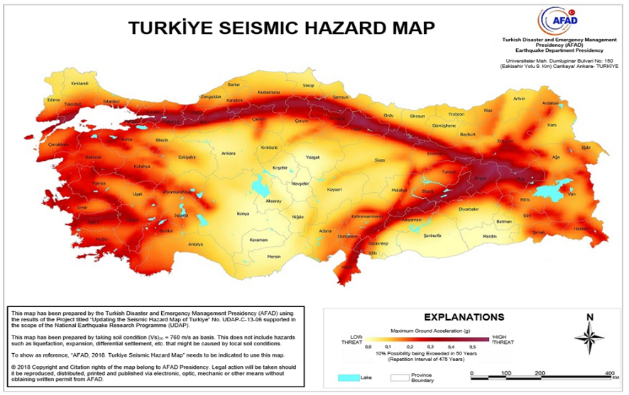
Source: AFAD, 2018

Potential Sub-Projects and Project Activities in Sakarya
The specific justification of Component 2 is the requirement for climate and disaster resilient housing, which will highly contribute to the overall resilience of the selected provinces against climate and disasters. Specifically, the GT faces several challenges in the implementation of the national regulatory framework supporting seismic and climate-resilient urban transformation. Key challenges include the need for greater affordability of retrofitting or demolishing and reconstructing risk-prone housing to meet resilient and energy-efficient standards, leveraging available resources and mobilizing finance for municipalities to increase investments in resilient urban infrastructure. Accordingly, the sub-project types relevant to the activity to be performed can be listed as follows:
- Type-I: The sub-projects with demolition and reconstruction - buildings were registered as risky buildings, however, no demolition activity has been performed at the time of loan application,
- Type-II: The sub-projects with retrofitting - buildings were registered as risky buildings, however, loan application is made only for retrofitting rather than demolition and reconstruction, and
- Type-III: The sub-projects with only reconstruction - buildings were registered as risky buildings and demolished before loan application, and the application is only made for reconstruction.
According to the records of the Urban Transformation Presidency there are a total of 694 risky structures in Sakarya province. These risky structures comprise a total of 6,560 independent units. Buildings that have not yet been demolished (Types 1 and 2) and those that have been demolished but are pending reconstruction (Type 3) are anticipated to form the potential subprojects of the Project in Sakarya Province under Component 2.Apart from the application and implementation processes of the three types of sub-projects, Component 2 of CDRC Project involves also a lot of communication, stakeholder engagement, information dissemination and consultation activities. A dedicated project office will be established in Sakarya and staffed by consultants responsible for E&S monitoring and evaluation, documentation and reporting, day-to-day coordination with the UTP PMU, and stakeholder engagement with owners of risky structures, contractors, and other local stakeholders.
Table 1: Sakarya Province Risky Building Status by Districts
Districts | Number of Buildings | Number of Residences | Number of Workplaces | Number of Independent Sections (Total)
Adapazarı | 253 | 1145 | 274 | 1419
Akyazı | 41 | 396 | 111 | 507
Arifiye | 11 | 57 | 14 | 71
Erenler | 29 | 169 | 21 | 190
Ferizli | 7 | 54 | 9 | 63
Geyve | 53 | 462 | 72 | 534
Hendek | 53 | 606 | 145 | 751
Karapürçek | 1 | 7 | - | 7
Karasu | 46 | 354 | 111 | 465
Kaynarca | 11 | 32 | 20 | 52
Kocaali | 11 | 510 | 83 | 593
Pamukova | 77 | 523 | 85 | 608
Sapanca | 34 | 482 | 25 | 507
Serdivan | 65 | 655 | 136 | 791
Söğütlü | 2 | 2 | - | 2
Taraklı | - | - | - | -
Total | 694 | 5,454 | 1,106 | 6,560

Source: Sakarya Metropolitan Municipality, 2025

Project Benefits and Positive Impacts
The main potential positive environmental and social benefits and impacts of the activities and sub-projects linked to resilient housing are as follows:
- The fact that risky buildings are generally built at an earlier date than non-risky buildings cause the energy efficiency of the former residences failing to meet current standards and practices. Within the scope of the Project, the reconstruction of buildings will reduce the use of energy for air conditioning and heating, with the construction of well-insulated houses.
- Emissions, which decrease directly with the decrease in the use of fuel for heating and indirectly with the decrease in the use of electricity for air conditioning, will have a positive impact on both air quality and climate change.
- Within the scope of Component 2, during the reconstruction of structures in certain neighborhoods in Sakarya where coal is still used for heating purposes, the heating systems can be operated with fuels with lower carbon emissions, thus positive effects will emerge in terms of both air quality and climate change.
- In the scope of national legislation, the Planned Areas Zoning Regulation was amended at the beginning of 2021 and a new obligation was introduced. Accordingly, the mechanical installation projects of the buildings to be built on parcels larger than 2000 m² must include a rainwater collection system for the rainwater to be collected from the roof surface, if necessary, to be filtered and collected in a tank and used in building toilet flushes. Within the scope of the Project, sub-projects that will be included in this scope will indirectly contribute to water efficiency.
- Risky structures will be reconstructed into disaster-resistant structures by demolishing the structures identified as risky and constructing or reinforcing safe structures in compliance with the standards.
- Low-income households or vulnerable groups living in risky structures will be able to obtain safe housing by taking advantage of appropriate loan opportunities and rent support.
- Awareness about risky structure and urban resilience will be raised by explaining the Project to the public within the scope of stakeholder engagement activities and making it public.

ENVIRONMENTAL AND SOCIAL BASELINE AND PROJECT AREA CONDITIONS
This section presents some of the environmental and social baseline conditions for Sakarya Province where the CDRC Project will be implemented. The environmental baseline provides information on the province's water resources, natural protected areas, urban areas, seismic activity, air quality and waste management. The social baseline describes the existing social conditions in the province, such as the demographic situation in the province and districts, including information on vulnerable groups, such as Roma population and Syrians under temporary protection (SuTP), education and socioeconomic situation as well as cultural heritage. The baseline presents relevant issues for specific investments in Sakarya Province under the CDRC Project.

Environmental Baseline Conditions

Water Resources and Potential of Sakarya Province
Sakarya is a province located in the northwest of Türkiye, in the eastern part of the Marmara Region. Sakarya possesses a northern coastline on the Black Sea and share borders with the provinces of Kocaeli, Bilecik, Bolu, an Düzce. The province is situated between 40°17′ and 41°13′ north latitude and 29°57′ and 31°05′ east longitude. Sakarya, with a total area of 4,878 km², consists of 16 districts. The highest altitude in the province reaches about 1,725 meters above sea level. Within the borders of Sakarya, there are low plains along the Black Sea coast in the north and the extensions of the Samanlı Mountains and Köroğlu Mountains in the south. The Sakarya River, one of the important rivers of Türkiye, flows through the province and empties into the Black Sea. In addition, Sapanca Lake, located within the borders of the province, is one of the important water resources of the region both ecologically and economically.

Surface Waters

Rivers and Streams
The Sakarya River, the third longest river in Türkiye, is one of the important surface water resources of the province. The river, formed by the combination of various branches originating from Afyon and Eskişehir provinces, enters the province of Sakarya through the Pamukova and Geyve Strait, incorporating the Porsuk and Ankara Streams. The river flows from the borders of Karasu district to the Black Sea. Apart from the Sakarya River, there are other rivers of various sizes within the borders of the province. The main rivers in Sakarya province are presented in Table 2.
Table 2: Characteristics of Rivers in Sakarya Province
Name of the Stream | Total Length (km) | Length within the Provincial Borders (km) | The stream of which it is a branch
Sakarya River | 824 km | 150 km | -
Mudurnu Stream | 65 km | It flows within the borders of the province. | Sakarya River
Dinsiz Stream | 34 km | It flows within the borders of the province. | Mudurnu Stream
Çark Creek | 45 km | It flows within the borders of the province. | Sakarya River
Maden Creek | 30 km | It flows within the borders of the province. | Karasu
Eşmegölü Creek | 22 km | It flows within the borders of the province. | -
Darıçayır Deresi | 33 km | It flows within the borders of the province. | Sakarya River
Melen Creek | 30 km | It flows within the borders of the province. | Black Sea
Sapanca Aygır Creek | 15 km | It flows within the borders of the province. | Sapanca Lake
Kurtköy Creek | 13 km | It flows within the borders of the province. | -
Gevye Doğançay Creek | 18 km | It flows within the borders of the province. | Sakarya River
Değirmendere | 12 km | It flows within the borders of the province. | -
Yırtmaç Creek | 10 km | It flows within the borders of the province. | Acarlar Lake
Akçay Creek | 26 km | It flows within the borders of the province. | -
Karaçay Creek | 23 km | It flows within the borders of the province. | Sakarya River
Sapanca Yanık River | 7 km | It flows within the borders of the province. | -

Source: DSI 3. Regional Directorate, 2024
Figure 2: Rivers and Streams of Sakarya
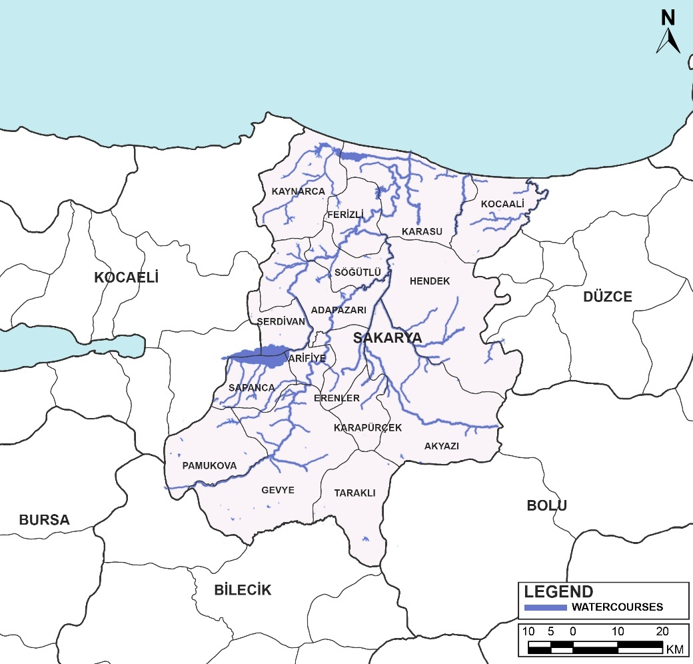
Source: Sakarya Metropolitan Municipality
A large number of watercourses located within the provincial boundaries of Sakarya play an important role in shaping the hydrological structure of the region. The Sakarya River, which is the largest watercourse in the area, has a total length of 824 km, of which approximately 150 km flows within the borders of the province. The main tributaries discharging into the Sakarya River include Mudurnu Stream, Çark Stream, Darıçayır Stream and Geyve Doğançay Stream. These watercourses flow across the province and contribute to the regional drainage network.

Melen Stream, located in the province, flows westward and discharges into the Black Sea. Sapanca Aygır Stream directs its flow towards Lake Sapanca and contributes to the lake’s water regime. Yırtmaç Stream is also among the significant surface water resources in the region and ultimately reaches Acarlar Lake.
Small-scale streams such as Dinsiz, Maden, Esmegölü, Kurtköy, Değirmendere, Akçay, Karacay and Sapanca Yanık Stream complete their flow courses within the provincial boundaries of Sakarya. The flow rates of these watercourses vary depending on seasonal precipitation, with noticeable increases particularly during the spring and autumn periods. The stream network of Sakarya constitutes one of the key components ensuring the continuity of the region’s natural water resources.

Natural Lakes, Ponds
There are natural lakes of various sizes within the borders of Sakarya province. As a result of the fractures and folds that occurred within the provincial area, the compressional movements directed toward the Black Sea led to the formation of a watershed between the Marmara Sea and the Black Sea. Subsequently, lakes were formed as the depressional zones on the Black Sea–facing slope of this barrier became filled.
Sapanca Lake: Lake Sapanca, which has a total surface area of 42 km², is situated largely within the administrative boundaries of Sakarya Province. Geomorphological accretions that developed to the east of the Gulf of İzmit resulted in the interruption of the lake’s former hydrological connection to the Sea of Marmara. In this context, Lake Sapanca is regarded as a geomorphological and hydrological continuation of the Gulf of İzmit and Lake İznik.
Poyrazlar (Teke) Lake: Poyrazlar Lake, which has a surface area of 60 hectares, was formed in the old bed of the Sakarya River. The lake has a very deep structure, and the southern shores consist of shallow and reed areas. Various freshwater fish live in the lake.
Küçük Akgöl: Küçük Akgöl, which has a surface area of 20 hectares, is fed by boiling water from the bottom. The lake, which discharges its excess water into Çark Water, has a freshwater feature, and its water is turbid. There are no freshwater fish in the lake.
Büyük Akgöl: Büyük Akgöl, which has a surface area of 190 hectares, consists of reeds and swamps spread over large areas. There is an abundant fish population in the lake, and wild geese and ducks can be found in the vicinity.
Acarlar Gölü: Acarlar Lake, with a surface area of 1,562 hectares, has 261 hectares of swampy area. The excess waters of the lake discharge into the Sakarya River. The forested areas around the lake extend to the swampy part.
The main lakes, ponds, and dams in Sakarya province are presented in Table 3.

Table 3: Existing Lakes, Ponds and Reservoirs
Name of Lake, Reservoir or Pond | Types | Volume (hm³) | Irrigation Area (ha) | Amount of Water Withdrawn, (m³) | Intended Use
Sapanca Lake | Natural Lake | 1356x10₆ |  | 120x10₆ (Tahsisli) | Drinking, Using,  Industry, Agriculture
Akgöl Lake | Natural Lake
Poyrazlar Lake | Natural Lake
Asırlar Pond | Pond | 876,239 | 177 |  | Watering
Kemaliye Pond | Pond | 292,000 | 164.29 |  | Watering
Çilekli Pond | Pond | 915,000 | 277 |  | Watering
Nalköy Pond | Pond | 3,650,000 | 677.18 |  | Watering
Topçu Pond | Pond | 973,000 | 296 |  | Watering
Elmalı Pond | Pond | 836,800 | 211 |  | Watering
Source: DSI 3. Regional Directorate, 2024

Ground water
Most of the groundwater in Sakarya province is used for industrial purposes, as well as for drinking and utility water supply.
The most important aquifers that store and transmit groundwater in Sakarya province are the alluviums located on the Sakarya Plain and the Karasu coastline.
The Sakarya Plain, which includes the city center of Sakarya, is a tectonic plain formed as a result of the filling of a depression area developed due to faulting with alluvium carried by the Sakarya River and its tributaries.
The difference in the topographic and geological features of the Sakarya River and the drainage area of its tributaries causes the physical properties of the alluvium carried in these areas to change; therefore, it leads to variations in hydraulic parameters concerning groundwater. This results in different groundwater yields being encountered in wells drilled in plain alluvium.
In addition to alluvium, Eocene sandstones and conglomerates, particularly in the west of Adapazarı, can also be defined as weak-to-medium aquifers. The thickness of these formations throughout the plain exceeds 300 meters.
Table 4: Sakarya Province Groundwater Potential
 | Intended use and quantity used, hm₃ / year
Type of Water Source | Drinking and utility water | Energy | Irrigation water | Industrial water supply
Groundwater | 56.22 | - | 3.58 | 46.61
Source: DSI 3. Regional Directorate, 2024
In Sakarya, the center of the province is completely on river sediments. Adapazarı Plain, located in the depression area; Sakarya, Çark water consists of thick alluvium brought and deposited by rivers such as Mudurnu and Uludere. The groundwater level in this alluvium is quite high; In some regions, there are swampy situations.
The ground in Arifiye district is flat and full; The groundwater level is 2-2.5 meters deep in the plain. In Söğütlü district, the ground consists of deposits brought by the Sakarya river and groundwater provides continuity at a depth of 3-4 m. The groundwater level in Akyazı district is 3-5 m deep and the city is generally located on the alluvial parcel. In Pamukova and Taraklı districts, there is no significant groundwater resources. The groundwater level in the residential area of Hendek district is 2-3 m deep and 10-15 m deep in the north. In Karasu, Kocaali and Kaynarca districts, the groundwater level varies between 0-10 m depending on the topography. In Sapanca district, the groundwater level is 2 meters in the areas close to the lake and deepens towards the southeast.
The formations that provide groundwater in Sakarya province consist of alluvium, pebbles, and siltstones. Efforts to remove illegal structures around Lake Sapanca and to clean the lakebed are ongoing. Although there are seasonal decreases in the groundwater level due to water withdrawals, particularly during the irrigation season, these decreases do not yet pose a risk to the groundwater potential.

2.1.2 Current Status of Sakarya Province Wastewater
As of 2022, the total length of the sewer line in Sakarya province is 3,202,595 meters. The existing sewerage network serves 885,665 people. Wastewater treatment services are provided by 6 facilities located in Adapazarı, Akyazı, Hendek, Geyve, Karasu, and Kocaali districts. With these 6 wastewater treatment plants, 12 district municipalities, including Adapazarı, Serdivan, Erenler, Sapanca, Arifiye, Akyazı, Karapürçek, Hendek, Geyve, Pamukova, Karasu, and Kocaali municipalities, are served. The ratio of the population receiving wastewater treatment services to the total municipal population is 80% in 2023.
Table 5: Status of Urban Wastewater Treatment Plants in Sakarya Province
Settlement | Name of Wastewater Treatment Plant | Type of Treatment Plant |  |  | Current Capacity (tons/day) | Treated/  Discharged Wastewater (m³/year) | Discharge Point | Population Served
Settlement | Name of Wastewater Treatment Plant | Physical | Biological | Advanced
City Center | Karaman AAT |  |  | X | 198,800 | 1 | Çark Creek | 575,339
County | Hendek WWTP |  | X |  | 12.97 | 0.09 | Mute  Creek | 63,102
County | Akyazı WWTP |  |  | X | 15 | 0.21 | Karacasu  Creek | 64,138
County | Karasu AAT |  |  | X | 9.5 | 0.12 | DSI  Drying Channel | 49,858
County | Kocaali WWTP |  |  | X | 2 | 0.03 | Imsirli  Creek | 13,920
County | Geyve  AAT |  |  | X | 7.6 | 0.1 | Sakarya  River | 58,033
County | Caferiye WWTP |  | X |  | 1.6 | 0.001 | Dry  Stream Bed | 2,500
County | Taraklı |  |  | X | 1.9 | 0.023 | Göynük Creek | 17,000

Source: General Directorate of Sakarya Water and Sewerage Administration, 2022

*Within the scope of the "Continuous Wastewater Monitoring Systems (SAIS) Communiqué" published in the Official Gazette dated 22.03.2015 and numbered 29303, flow rate, pH, Conductivity, Dissolved Oxygen, Temperature and COD (Chemical Oxygen Demand) and AKM (Suspended Solids) parameters are monitored online 24/7 in the
effluent of the wastewater treatment plant with an installed capacity of 5,000 m3/day and above throughout the country. In this way, facilities are prevented from discharging their wastewater into our water resources without treatment.

In Table 5, the WWTPs in Sakarya are classified by also the technique they use for treatment. Physical treatment mechanically removes coarse debris and settleable solids via screening, grit removal, and primary settling. Natural wastewater treatment systems—such as constructed wetlands, stabilization ponds, and soil infiltration basins—use vegetation, soils, sunlight, and native microbial communities to remove pollutants with low energy and maintenance needs. Biological treatment uses microorganisms (e.g., activated sludge, sequencing batch, membrane bioreactors) to degrade dissolved organics and, when designed, remove nitrogen and phosphorus. Advanced treatment polishes effluent for strict discharge or reuse—adding chemical phosphorus removal, filtration, disinfection (ultraviolet light or chlorine), and options like activated carbon, membranes, or advanced oxidation to cut nutrients, pathogens, and micropollutants to very low levels.

Sakarya Province Surface Water Resources and Underground Water Resources
As shown in Table 6, water resources in Sakarya are supplied through both surface water and groundwater. Surface water resources are monitored through stations established to track trophic levels. Although measurements taken in various boreholes for groundwater resources are not included in the water quality classification, these wells are primarily used for irrigation. However, excessive fertilization and improper irrigation techniques pose a risk of increasing the trophic levels in these groundwater sources over time, leading to increased nitrate pollution.
Table 6: The Status of Surface Water and Groundwater
Type of Water Source | Name of the Water Source | General Water Quality  Class | Trophic Level of the Water Source
Surface | Sakarya River | IV | Hypereutrophic
Surface | Mudurnu Stream | III | Eutrophic
Surface | Çark Creek | III | Eutrophic
Surface | Acarlar Lake | IV | Hypereutrophic
Surface | Sapanca Lake | II | Mesotrophic
Surface | Büyük Akgöl | IV | Hypereutrophic
Surface | Taşkısığı Lake | IV | Hypereutrophic
Surface | Küçük Akgöl | IV | Hypereutrophic
Surface | Poyrazlar Lake | II | Mesotrophic
Surface | Dinsiz Stream | III | Eutrophic
Surface | Maden Creek | III | Eutrophic
Surface | Esmegölü Creek | III | Eutrophic
Surface | Darıçayır Creek | IV | Hypereutrophic
Surface | Melen Creek | IV | Hypereutrophic
Surface | Sapanca Aygır Creek | III | Eutrophic
Surface | Kurtköy Creek | III | Eutrophic
Surface | Gevye Doğançay Creek | III | Eutrophic
Surface | Değirmendere | III | Eutrophic
Surface | Yırtmaç Creek | III | Eutrophic
Surface | Akçay Creek | III | Eutrophic
Surface | Karaçay Creek | III | Eutrophic
Groundwater | Akyazı Drilling Tm 3 | X | X
Groundwater | Acella Plateau Drilling | X | X
Groundwater | Mekece Drilling 3 | X | X
Groundwater | Akyazı Drilling Tm 3 | X | X
Groundwater | Karasu Mine Drilling 12 | X | X
Groundwater | Kocaali Maden Drilling-4 | X | X
Groundwater | Acella Plateau Drilling | X | X
Groundwater | Uzunçarşı Drilling 2 | X | X
Groundwater | Sarıbeyli Drilling - | X | X
Groundwater | Karadiken Drilling 2 New | X | X
Groundwater | Şeyhtımarı-1 Drilling | X | X
Groundwater | Ihsanıye Drilling | X | X
Groundwater | Sıraköy Drilling | X | X
Groundwater | Dip Survey | X | X
Groundwater | Karasu Gölköprü Welding-Itm | X | X
Groundwater | Batakköy Drilling 2 | X | X
Groundwater | Yağbasan Drilling | X | X
Groundwater | Akyazı Drilling Tm 1 | X | X
Groundwater | Bacı Neighborhood Drilling Station | X | X
Groundwater | Valveless Yahyalı Drilling | X | X
Groundwater | Karachay-1 Drilling -  Bayırakçasehir Drilling Tm | X | X
Groundwater | Alifuatpaşa-2 Drilling | X | X
Groundwater | Kırkpınar Manors 2 Drilling | X | X
Groundwater | Sign-1-2 and Crane Drilling | X | X
Groundwater | Esenköy Pumping Station | X | X
Groundwater | Kuzuluk New Drilling | X | X
Groundwater | Kırkpınar Stadium Drilling | X | X
Groundwater | Qamishli_Drilling | X | X
Groundwater | Poydular (Mehmet Efendi) Drilling | X | X
Groundwater | Red Grape Drilling | X | X
Groundwater | Kuzuluk Thousand Warehouse Top Drilling | X | X
Groundwater | Kırkpınar New-1 Drilling | X | X
Groundwater | Kr-02 | X | X
Groundwater | Karapürçek Drilling Tm 1 | X | X
Groundwater | Muradiye Drilling | X | X
Groundwater | Yeşilvadi Drilling | X | X
Groundwater | Karasu Konacık Welding Itm | X | X
Groundwater | Seyhvarmaz Drilling Tm | X | X
Groundwater | Kestanepınarı Drilling | X | X
Groundwater | Ömeraga Probing-1 | X | X
Groundwater | Çardak Drilling | X | X
Groundwater | Burn Drilling 3 | X | X
Groundwater | Güldıbı New Drilling Tm | X | X
Groundwater | Pazarköy Drilling 1 | X | X
Groundwater | Zongildik-2 Drilling | X | X
Groundwater | Kocaali Maden Prodaj-1 | X | X
Groundwater | Pirler Probing | X | X
Groundwater | Sarıbeyli Drilling 2 | X | X
Groundwater | Kocaali Maden Drilling-5 | X | X
Groundwater | Sapanca Stadium Drilling | X | X
Groundwater | Darıçayırı Drilling | X | X
Groundwater | Pazarköy Drilling 3 | X | X
Groundwater | Kirazlı Drilling | X | X
Groundwater | Akyazı Drilling Tm 10 | X | X
Groundwater | Akyazı Drilling Tm 5 | X | X
Groundwater | Eastern Region Irrigation | X | X
Groundwater | Kurtköy Creek | X | X
Groundwater | Eşme Drilling - Without Valve | X | X
Groundwater | Karasu Konacık Welding Itm | X | X
Groundwater | Şerbetpınar Drilling | X | X
Groundwater | Karasu Maden Drilling-2 | X | X
Groundwater | Çamtepe Drilling- | X | X
Groundwater | Kocaali Maden Drilling-3 | X | X
Groundwater | Karasu Maden Çamdağı Drilling | X | X
Groundwater | Karaçay-4 Drilling | X | X
Groundwater | Paşalar Drilling | X | X
Groundwater | Karasu Karapınar Pumping Drilling | X | X
Groundwater | Akçakaya Drilling | X | X
Groundwater | Doğancı Drilling | X | X
Groundwater | Dereköy Drilling Tm 4 | X | X
Groundwater | Cardigan Drilling | X | X
Groundwater | Aksekı Drilling | X | X
Groundwater | Sucati _Drilling | X | X
Groundwater | Büyükyanık Drilling | X | X
Groundwater | Gümüşoluk Drilling | X | X
Groundwater | Eski Yayla Drilling | X | X
Groundwater | Tile-4 Drilling - | X | X
Groundwater | Hacıkışla 1 | X | X
Groundwater | Batakköy New Drilling Tm | X | X
Groundwater | Akdoğan_Drilling | X | X
Groundwater | Kocaali Maden Drilling-6 | X | X
Groundwater | Sin therefore 1 | X | X
Groundwater | Dereköy Drilling Tm 6 | X | X
Groundwater | Muezzins Group Drilling - Archers Drilling | X | X
Groundwater | Kestanepınar Drilling | X | X
Groundwater | Soguksu Drilling Tm | X | X
Groundwater | Karasu Mine Drilling 6 | X | X
Groundwater | Akyazı Drilling Tm 2 | X | X
Groundwater | Dumanköy Hut Drilling | X | X
Groundwater | Alifuatpaşa-1 Drilling - | X | X
Groundwater | Karasu Maden Drilling-5 | X | X
Groundwater | Yanıksayvant New Drilling | X | X
Groundwater | Bayonet Sounding 2 | X | X
Groundwater | Karateke Drilling | X | X
Groundwater | Zongildik-1 Drilling | X | X
Groundwater | Gökgöz Drilling Tm 2 | X | X
Groundwater | Ferizli Drilling 2 | X | X
Groundwater | Ömeraga Probing-2 | X | X
Groundwater | Ahiler Drilling Tm | X | X
Groundwater | Karachay-7 Drilling | X | X
Groundwater | Ferizli Drilling 1 | X | X
Groundwater | You Were Amazed by the Sound of Music. | X | X
Groundwater | Darıçayırı Drilling | X | X
Groundwater | Tile-2 Drilling - | X | X
Groundwater | Şeyhtımarı-2 Drilling | X | X
Groundwater | Karasu Maden Drilling-8 | X | X
Groundwater | Dereköy Drilling Tm 7 | X | X
Groundwater | Derekenarı (Chestnut) Drilling | X | X
Groundwater | Karasu Maden Drilling-9 | X | X
Groundwater | Taraklı Central Ulucami Drilling 1 | X | X
Groundwater | Süngüt Drilling | X | X
Groundwater | Karapürçek Drilling Tm 2 | X | X
Groundwater | Taraklı Central Grand Mosque Drilling 2 | X | X
Groundwater | Kocatöngel Drilling Tm 1 | X | X
Groundwater | Strawberry Drilling | X | X
Groundwater | Kırkpınar Manors Drilling | X | X
Groundwater | Örencik_Drilling | X | X
Groundwater | Karachay-5 Drilling | X | X
Groundwater | Dereköy Drilling Tm 1 | X | X
Groundwater | Kazımıye Bağlar Drilling Tm | X | X
Groundwater | Aktaş Drilling | X | X
Groundwater | Beylice | X | X
Groundwater | Tile Drilling 5 | X | X
Groundwater | Pazarköy Drilling 2 | X | X
Groundwater | Kocatöngel Drilling Tm 2 | X | X
Groundwater | Ferizli Drilling 3 | X | X
Groundwater | Tile-1 Drilling | X | X
Groundwater | Taraklı Central Ulucami Drilling 3 | X | X
Groundwater | Streamside 2 Drilling | X | X
Groundwater | Chechen Drilling | X | X
Groundwater | Dereköy Drilling Tm 1 | X | X
Groundwater | Dereköy Drilling Tm 2 | X | X
Groundwater | Kocatöngel Drilling Tm 3 | X | X
Groundwater | Eşme Drilling Tm | X | X
Groundwater | Esenköy Depo Arıtma | X | X
Groundwater | Karachay-9 Drilling | X | X
Groundwater | Karasu Maden Drilling-7 | X | X
Groundwater | Kayabaşı Drilling Tm 1 | X | X
Groundwater | Arifağa-2 Drilling | X | X
Groundwater | Sapanca Yanık Drilling Tm 1 | X | X
Groundwater | Hacıyakup Kabaklar Drilling Tm | X | X
Groundwater | Karapelit Drillingı | X | X
Groundwater | Yörükyerı Drilling Tm | X | X
Groundwater | Kocaali Maden Drilling 2 | X | X
Groundwater | Oruçlu Soda | X | X
Groundwater | Yanıksayvant Old Drilling | X | X
Groundwater | Karachay-6 Drilling | X | X
Groundwater | Kirazlı Drilling | X | X
Groundwater | Karasu Mine Drilling 10 | X | X
Groundwater | Eşme Drilling 2 | X | X
Groundwater | Kuzuluk Bin Depot Bottom Drilling | X | X
Groundwater | Vertical Drilling Tm | X | X
Groundwater | Doğantepe Drilling | X | X
Groundwater | Turnalı Drilling 1 | X | X
Groundwater | Kıran Drilling Tm | X | X
Groundwater | Ferizli Drilling 4 | X | X
Groundwater | Karasu Maden Drilling-1 | X | X
Groundwater | Karasu Mine Drilling 11 | X | X
Groundwater | Görele Yalpankaya Drilling | X | X
Groundwater | Akyazı Drilling Tm 4 | X | X
Groundwater | Karasu Maden Drilling-4 | X | X
Groundwater | Karapürçek Therefore, | X | X
Groundwater | Akçapınar New Drilling | X | X
Groundwater | Güldıbı Drilling Tm | X | X
Groundwater | Burhaniye Drilling | X | X
Groundwater | Tile-3 Drilling | X | X
Groundwater | Kamışlı Drilling | X | X
Groundwater | Dried Oak Drilling | X | X
Groundwater | Yanık New Drilling | X | X
Groundwater | Karachay-3 Drilling | X | X
Groundwater | Kırkpınar New-2 Drilling | X | X
Groundwater | Alifuatpaşa Drilling 3 | X | X
Groundwater | Kurtköy Derekenarı New | X | X
Groundwater | Dam Drilling Tm | X | X
Groundwater | Kırkpınar Mosque Drilling | X | X
Groundwater | Acella Plateau Drilling 2 | X | X
Groundwater | Karachay-2 Drilling | X | X

Source: Sakarya University, 2018
Sakarya’s water resources are categorized into four trophic levels, each indicating the degree of nutrient enrichment and ecological condition (Sakarya University, 2018). Oligotrophic (Quality I) waters are very clean with minimal nutrients; Mesotrophic (Quality II) waters contain moderate nutrients and maintain good ecological diversity; Eutrophic (Quality III) waters experience nutrient-driven algal and vegetative growth; and Hypereutrophic (Quality IV) waters suffer from extreme nutrient overload, oxygen depletion, and severe ecological degradation. An examination of the surface water sources listed in the table shows that most rivers, lakes, streams, and creeks in the region fall within the eutrophic or hypereutrophic categories, demonstrating widespread nutrient pollution across the basin. Several major water bodies—including Sakarya River, Akgöl Lake, Büyükgöl, Taşkısığı Lake, Küçük Akgöl, and others—are classified as hypereutrophic, while many additional creeks and streams appear as eutrophic. Only a few surface waters, such as Sapanca Lake and Poyrazlar Lake, fall into the mesotrophic class, indicating comparatively healthier ecological conditions. The detailed definitions and explanations of each trophic level are provided in Table 7.
Table 7: Trophic Level Interpretation Table of Sakarya Water Resources
Trophic Level Status of Water Source | Explanation
Quality I Water Class - Oligotrophic | Very good, generally at the level of the natural background, clean and clear water.
II. Quality Water Class - Mesotrophic | It contains moderate nutrients; ecological diversity is high.
III. Quality Water Class - Eutrophic | Contaminated water with an increase in algae and vegetation due to excessive nutrient load.
IV. Quality Water Class - Hypereutrophic | Water without oxygen, foul odor and degraded ecosystem with nutrient overload.

Source: Sakarya University, 2018

Nature

Flora
The vegetation of Sakarya province consists of 34% mountains, 44% plateaus, and 22% plains, and the vegetation is very rich. The natural vegetation in Sakarya is predominantly forest. Sakarya province is suitable for forest cultivation due to its climate and growing environment. The soils where the forests are located are of the brown forest soil type. The total forest area in the province is 204,708 hectares. These forests are mostly humid Black Sea forests. The main tree species in these forests include beech, oak, hornbeam, poplar, chestnut, linden, plane tree, maple, ash, alder, and pine species. Above the 700-meter elevation belt, coniferous trees begin to mix with the beech and oak communities.
The endemic plant species identified in Sakarya and its surroundings are unique to Türkiye and are of high ecological importance. A significant number of these species are narrowly distributed, vulnerable, or susceptible to habitat loss, with some being internationally threatened. In particular, Centaurea Kilaea and Galanthus Plicatus ssp. Byzantinus species are classified in the "Endangered (EN)" category on the IUCN Red List. Other species require protection due to their rarity, dependence on fragile habitats, or limited range. Natural areas in the provinces of Kocaeli, Istanbul, Bursa, and Düzce, especially Sakarya, are critical for the sustainability of these species. Therefore, the preservation of endemic flora in the region is a priority issue for the continuation of biodiversity and ecosystem health.
Table 8: Endemic Species - Sakarya
Type Name | Common Turkish Name | Endemicity Status | Places of Occurrence | Status (Literature + IUCN)
Centaurea Kilaea | Kilyos Düğmesi | Endemic of Türkiye | Sakarya (Kaynarca), Kocaeli (Kandıra), Istanbul (Sarıyer – Kilyos) | EN – Endangered (IUCN Red List)
Verbascum Bugulifolium | Riva Sığırkuyruğu | Endemic of Türkiye | Sakarya (Karasu), Kocaeli (Kandıra), Istanbul (Beykoz – Riva) | Narrow Spread – Sensitive
Verbascum Degenii | Degen Sığırkuyruğu | Endemic of Türkiye | Sakarya (Karasu, Kocaali) Kocaeli (Kandıra), Istanbul (Şile) | Regional Distribution – Rare
Lophiolepis Ligularis | Kör Kazankulpu | Endemic of Türkiye | Sakarya (Akyazı, Hendek) Kocaeli (KartepeAkyazı, Hendek (Iznik), Istanbul (Şile) | Rare – Susceptible to Habitat Loss
Cardamine Anatolica | Anadolu Köpükotu | Endemic of Türkiye | Sakarya (Taraklı, Geyve), Bolu (Mengen), Düzce (Yığılca) | Dependent on Humid Forests – Fragile Habitat
Galanthus Plicatus ssp. Byzantinus | Boğaz Kardeleni | Endemic of Türkiye | Sakarya (Karasu, Kaynarca), Çanakkale (Biga, Bayramiç Kaynarca) Balıkesir (Manyas) | EN – Endangered (IUCN Red List)
Jurinea Kilaea | Kilyos Moru | Endemic of Türkiye | Sakarya (Karasu, Kaynarca), Kocaeli (Kartepe, Başiskele) Istanbul (Çatalca) | Rare – Restricted Distribution
Peucedanum Obtusifolium | Kral Otu | Endemic of Türkiye | Sakarya (Karasu, Kaynarca), Kocaeli (Karamürsel) Istanbul (Çatalca) | In Forest Clearings – Sensitive Habitat
Silene Sangaria | Karadeniz Salkımı | Endemic of Türkiye | Sakarya (Geyve, Akyazı, Karasu), Istanbul (Sarıyer – Kilyos) | Local endemic – Potentially threatened
Source: Nature Association, Sakarya Delta

Fauna
As a result of the literature reviews and field observations conducted in Sakarya province, the species diversity of various fauna groups, including mammals, birds, inland fish, reptiles, and amphibians, has been thoroughly documented. In terms of mammal species, a total of 57 species have been recorded in the literature, of which 44 have been directly identified during field studies. In terms of bird species, 1 out of 197 species recorded in the literature is endemic. A total of 207 bird species were observed through field studies, 21 of which were newly recorded. As a result, the number of bird species in the province reached 218. In this context, the endemism rate for birds was calculated to be 0.40%.
In terms of freshwater fish, Sakarya province exhibits significant biological diversity. A total of 42 species are registered in the literature, 1 of which is endemic. Through field studies, 37 species were identified, and 6 of these species were determined to be endemic. Additionally, with the registration of 2 new species, the total number of freshwater fish species increased to 44, and the endemism rate in this group reached a remarkable 15.90%. In the reptile group, a total of 28 species were identified in the province, 21 of which were observed in field studies, and 7 were based on literature records. One of these species was found to be endemic, and the rate of endemism in reptiles was determined to be 3.57%.
There are 10 species recorded in the literature regarding amphibians, 9 of which have been confirmed through field studies, and 1 species was added as a new record. As a result, the total number of amphibian species in Sakarya increased to 11. All these findings reveal that Sakarya province has a rich and diverse fauna structure. They also demonstrate the province's remarkable ecological importance, especially due to its high endemism rates, particularly in inland fish and reptiles.

Protected Nature
Information on internationally recognized areas is presented in Table 9, along with the province and relevant trigger species information:
Table 9: Internationally Recognized Areas in Provinces and Related Trigger Types
Province | Internationally Recognized Area | Trigger Types | Threats
Province | Internationally Recognized Area | Trigger Types | Grade 1 Threats | Grade 2 Threats | Grade 3 Threats
Sakarya- Kocaeli | Sapanca Lake | Aves, Kuş (Elmabaş Patka) | Natural System Degradation | Dams and Water Management | Groundwater Withdrawal (Agricultural Use)
Sakarya- Kocaeli | Sakarya Delta | Aves, Bird (Velvet Duck) | Pollution | Industrial and Military Wastewater | Agro-Industrial Farms
Sakarya- Kocaeli | Sakarya Delta | Aves, Bird (Velvet Duck) | Agriculture and Aquaculture | Annual and Perennial Non-Wood Products | Agro-Industrial Farming
Sakarya- Kocaeli | Sakarya Delta | Aves | Agriculture and Aquaculture | Annual and Perennial Non-Wood Products
Sakarya | Acarlar Floodplain | Aves, Plants (Endemic Aquatic Species) | Habitat Loss and Desiccation | Agricultural Drainage Activities | Recreational Printing and Pollution
Sakarya | Poyrazlar Lake | Aves, birds (migratory species) | Forest and Wetland Destruction | Fishing and Visitor Pressure | Motor Vehicles and Noise
Source: Key Biodiversity Areas
The natural areas located within the boundaries of Sakarya Province possess high ecological value within the framework of Important Plant Areas (IPA) criteria, they are found to have high ecological value due to their wetland ecosystems, forested areas, and high-altitude habitats. In particular, Acarlar Floodplain is considered one of the priority IPA areas on a national scale, as it is one of the largest continuous floodplain forests in Europe and hosts numerous endemic and rare species.
Additionally, Sapanca Lake, Poyrazlar Lake Nature Park, and Taşkısığı Lake have the potential to meet IPA criteria due to their protection of unique aquatic flora and fauna communities and wetland ecosystems. Lake ecosystems such as Büyük Akgöl, Akgöl, and Keremali Lake are also significant in terms of both aquatic plant diversity and the continuity of semi-natural habitats surrounding them.
In terms of forest ecosystems, Sakarya Provincial Forest Nature Park, Kuzuluk Nature Park, and Karagöl Plateau can be considered as micro-IPA areas, thanks to their high floristic diversity, presence of rare species, and habitat integrity. These areas are critical for maintaining biodiversity on a regional scale, protecting rare and endemic species, and ensuring the continuity of ecosystem services.
Figure 3: Important Plant Areas in Sakarya Province
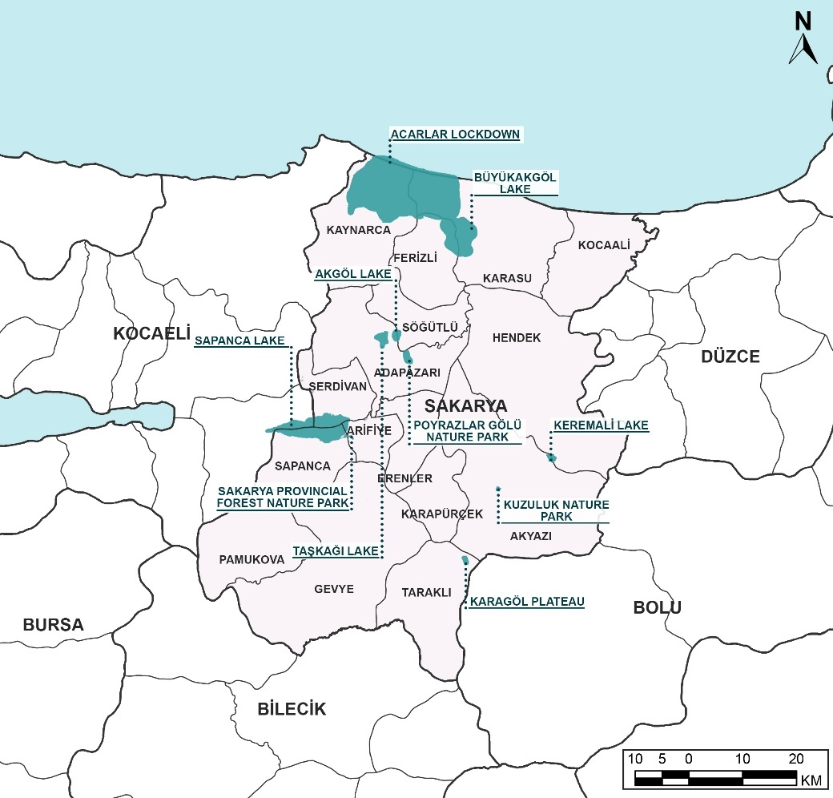
Source: Sakarya Metropolitan Municipality.

Seismicity
Sakarya province is located on the North Anatolian Fault Zone (NAFZ), one of the most active tectonic systems in Türkiye, and lies within a right-hand strike-slip shear zone. The active fault lines developed along this zone directly shape the geological and geomorphological structure of the province. The northern part of the province is located on the Eurasian Plate, the middle part is situated directly on the NAFZ, and the southern part lies within the borders of the Anatolian Plate. In particular, geomorphological units such as the Gulf of İzmit, Sapanca Lake, Adapazarı Plain, Mudurnu Stream Valley, and Pamukova have been shaped under the control of this fault zone and exhibit morphologically distinct features due to the tectonic dynamics in the region. The formation of the high relief in the Samanlı and Almacık Mountains is also associated with vertical tectonic movements along the zone.
The North Anatolian Fault is divided into two main branches, north and south, starting from the Dokurcun Valley within the borders of Sakarya province. The northern branch of the North Anatolian Fault starts north of Akyazı, crosses through Sapanca Lake, and continues towards the Sea of Marmara. The southern branch, on the other hand, passes south of Lake İznik via Geyve and Pamukova and reaches the Gulf of Gemlik. Among these branches, the northern branch exhibits a more active tectonic character compared to the southern branch, with a higher sliding speed.
A large part of the active fault lines within the borders of Sakarya province were displaced by the earthquakes of July 22, 1967, and August 17, 1999, which occurred in the 20th century. However, the segment in the southern branch, extending along the Dokurcun-Pamukova line, has not been displaced for a long time, suggesting that this section may have a low recurrence interval, but it still poses a significant seismic hazard.
Figure 4: Past Earthquakes and Their Distribution
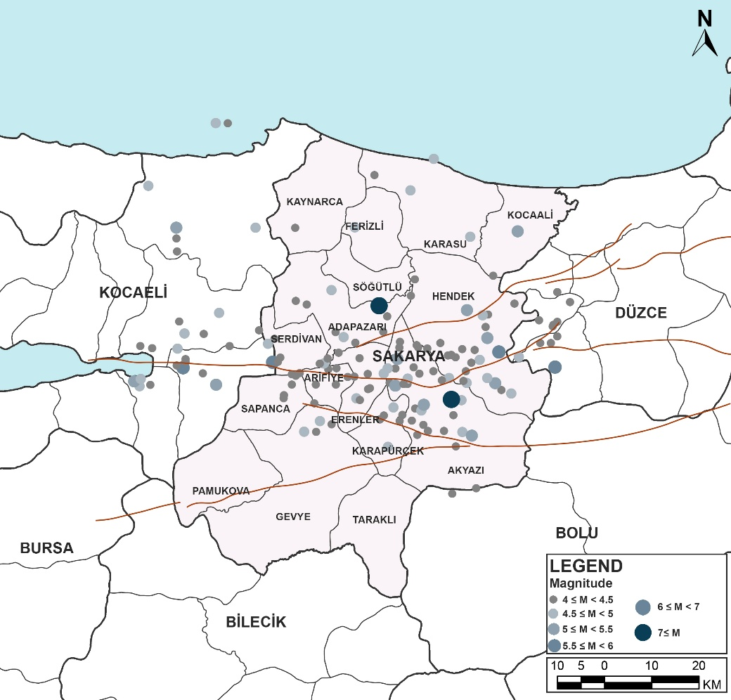
Source: AFAD, 2025
Table 10: Values Calculated for the Magnitude-Earthquake Frequency Relationship
Size Range (M) | Number of Earthquakes (N) | Mean Magnitude (M<sub>avg</sub>) | Cumulative Number of Earthquakes (ΣN) | Annual Frequency (ΣN/t)
4.0 ≤ M < 4.5 | 146 | 4,160959 | 240 | 2,4
4.5 ≤ M < 5.0 | 64 | 4,664063 | 94 | 0,94
5.0 ≤ M < 5.5 | 16 | 5,1625 | 30 | 0,30
5.5 ≤ M < 6.0 | 10 | 5,67 | 14 | 0,14
6.5 ≤ M < 7.0 | 2 | 6,7 | 4 | 0,04
7.0 ≤ M < 7.5 | 2 | 7,1 | 2 | 0,02
Source: AFAD, 2025
The southern branch segment between Geyve and Gemlik consists of stepped faults along its length of approximately 100 kilometers and is divided into two sub-segments: the Geyve Fault and the İznik Fault. The Geyve segment extends for approximately 45 km, starting from the east of Mudurnu Valley to Mekece, while the İznik segment continues for 60 km from Mekece to Sölöz. It has been determined that there is a displacement of 14 to 21 kilometers in the Geyve Basin of the Sakarya River due to the right-lateral strike-slip fault movement. Additionally, it has been observed that the section between Bozviran and Mekece exhibits characteristics of an expansion zone operating together with normal faults, in addition to its strike-slip fault characteristics.
The section located in the Eastern Marmara part of the NAFZ, extending for approximately 125 km between Sapanca and Gölcük, is defined as the segment between Sapanca and Çınarcık. While the fault line cannot be traced in the Akyazı Plain, it becomes evident on the surface to the south of Sapanca Lake. This segment formed a surface rupture approximately 150 km long during the İzmit Earthquake on August 17, 1999, and attracted attention due to its maximum displacement value reaching 5.2 meters, particularly to the east of Sapanca Lake. The İzmit-Sapanca segment extends in an east-west direction, starting from the Gulf of İzmit to the west of Sapanca Lake, and is 25 kilometers long. The highest displacement value on this segment was recorded in Arifiye district, with 5.1 meters. Additionally, vertical displacements of up to 80 cm were observed in this segment.
The Karadere segment follows the Karadere Valley for approximately 25 km, starting from the east of Akyazı to the Düzce Plain. Right-lateral displacement of up to 1.55 meters was measured on this segment. During the August 17, 1999 İzmit Earthquake, small fractures characterized by low displacements occurred to the south of Gölyaka, and this area was later significantly displaced during the November 12, 1999 Düzce Earthquake, showing vertical displacements.
A significant portion of urban and rural settlements throughout Sakarya province has developed in alluvial plain areas. While these areas are advantageous for agricultural production and transportation, they carry a high level of earthquake risk due to their location on active tectonic systems and the tendency of soil properties to undergo liquefaction. Additionally, the high prevailing vibration periods of these soils increase the destructive effect in the event of possible earthquakes. According to ground analysis, Ferizli district has the highest value, with 87%, in terms of the ratio of residential areas on solid ground. Kocaali district ranks second with a rate of 63%, and Kaynarca ranks third with a rate of 47%. On the other hand, 93% of the residential areas in Karapürçek district are located on grounds suitable for third-degree settlement, while nearly all of the other 12 district centers are located in fourth-degree settlement areas. It has been determined that more than 60% of the residential areas, especially in districts such as Söğütlü, Taraklı, Akyazı, Erenler, Hendek, and Adapazarı, are situated on poor ground conditions. This situation poses an important challenge in terms of both the high risk of disaster and the pressure on the construction of productive agricultural areas.

Air Quality
The most significant parameter affecting air quality in the scope of demolition and construction activities is the release of particulate matter. The evaluation of particulate matter measurement values for Sakarya province was conducted according to the data from the Continuous Monitoring Center of the Ministry of Environment, Urbanization, and Climate Change of the Republic of Türkiye.
According to national legislation, to protect human health, the annual average PM10 value should meet the limit of 40 μg/m³, and the 24-hour average should not exceed the limit of 50 μg/m³ more than 35 times a year. These limits were in line with the internationally accepted World Health Organization (WHO) guideline values until September 2021. However, the new guideline values published by the WHO in September 2021 specify a 24-hour average value of 45 μg/m³ for PM10 and 15 μg/m³ for the annual average.
Measurement stations established to monitor air quality in Sakarya province were located with consideration of different pollutant sources. Stations were set up at the Meteorology Directorate and Ozanlar District to monitor pollution caused by heating, on Sakarya Street to monitor traffic-related pollution, and in the Hendek Organized Industrial Zone to monitor pollution from industrial activities.
The monitoring of particulate matter parameters, specifically PM10, in Sakarya province was carried out through these four fixed stations between 01.01.2024 and 01.01.2025. The measurement results obtained are presented in Table 11 below.:
Table 11: Summary of PM10 Results According to 24-Hour Measurements in Sakarya Province in 2024
Station | Minimum Measured Value (μg/m³) | Maximum Measured Value (μg/m³) | Date on which the minimum value was measured | Date Measured Maximum Value | Annual Average (μg/m³) | NDELV* | Valid Data Percentage (%)
Center | 0,23 | 180,20 | 15.03.2024 | 08.02.2024 | 22,46 | 18 | 58,09
Poets | 0,52 | 431,79 | 30.09.2024 | 23.12.2024 | 45,37 | 31 | 98,36
Sakarya | 1 | 291,60 | 18.12.2024 | 27.12.2024 | 41,40 | 31 | 98,32
Hendek OIZ | - | - | - | - | - | - | -
*Number of days exceeding the limit value of 40 μg/m3 that must be complied with according to national legislation
Source: Republic of Türkiye Ministry of Environment, Urbanization and Climate Change, General Directorate of Geographic Information Systems.
When the data presented in Table 11, national legislative limits, and WHO reference values are examined together:
- The annual averages of the measurements made at Ozanlar and Sakarya stations for 2024 exceeded both the national legislative limit value (40 μg/m³) and the WHO reference value (15 μg/m³).
- It is observed that the annual measurement averages of all stations, except for the Hendek OIZ station, exceed the WHO reference value (15 μg/m³)

Waste Management

Excavation and Construction/Demolition Waste Management Capacity and Details
Within the scope of excavation and construction-demolition waste management, information on excavation soil storage areas, excavation soil recovery, and construction-demolition waste recovery facilities in Sakarya province is provided in Table 12.
Table 12: Sakarya Province Excavation Soil Sites and Construction / Demolition Waste Recovery Facilities
Name of the Facility | Activity | Place | Operates
Arifiye Sezerler Tourism Construction Industry and Trade Limited Company | Filling Area for Preparation for Rehabilitation | Arifiye District | Kent Konut
Karacanlar Construction Industry and Trade Limited Company. | Filling Area for Preparation for Rehabilitation | Akyazı District | Kent Konut
Cave New Area Excavation Soil Areas | Filling Area for Preparation for Rehabilitation | Hendek District | Kent Konut
Source: Sakarya Metropolitan Municipality

Three of the areas listed in Table 12 are operated by Kent Konut. These areas are located in different districts of Sakarya, specifically in the Akyazı, Arifiye, and Hendek districts. The areas are classified as fill areas designated for the purpose of preparation for rehabilitation.
Figure 5: Locations of Waste Management Facilities in Sakarya Province
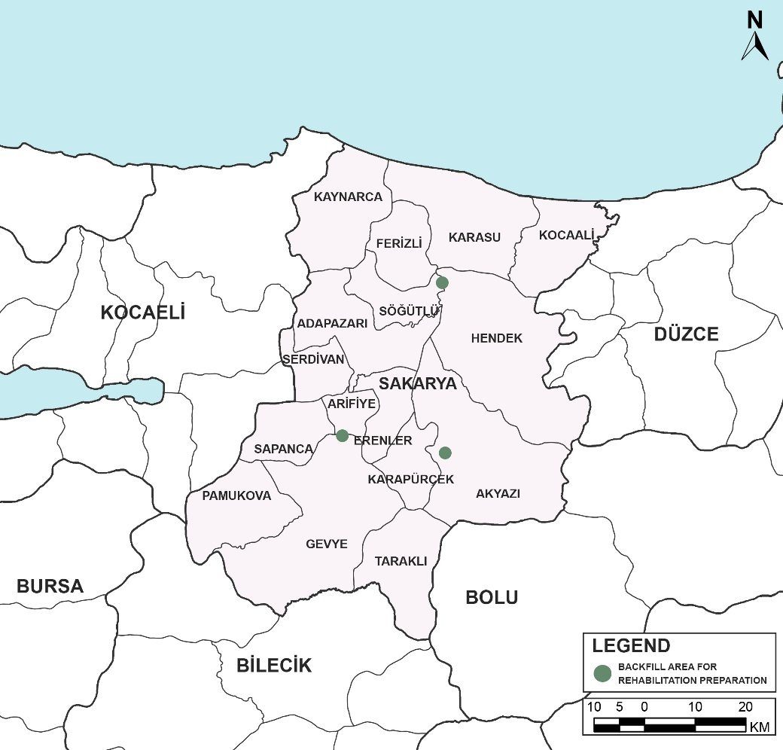
Source: Sakarya Metropolitan Municipality, 2024.

Hazardous Waste Management Capacity
There is no hazardous waste recovery, incineration, or storage facility in Sakarya province. Within the scope of hazardous waste management, wastes are sent to the İZAYDAŞ facility located in Kocaeli province. The facility in question accepts and disposes of hazardous wastes, excluding radioactive, explosive, cadaver, and battery wastes. In addition to waste incineration and power generation activities, the facility also has a class 1 landfill. The facility, with a daily capacity of 130 tons, is located approximately 50 km from the Sakarya city center and is a preferred facility for the disposal of hazardous wastes.
There are only solid waste storage facilities within the borders of Sakarya province. Solid waste storage facilities in Sakarya are spread across different parts of the province. As shown in Figure 6, the density of these facilities is especially noticeable around Adapazarı, Serdivan, Erenler, and Arifiye. Additionally, Karasu and Kocaali are located in the northern part, while Geyve and Taraklı are located in the southern part of the province, where the facilities are also situated. Thanks to this distribution, waste can be regularly collected and managed without harming the environment, both in the city center and in rural areas.
The most important investment in solid waste facilities in Sakarya is the SEKAY Integrated Solid Waste Facility, which was put into service on 06.08.2021. The facility, located in the Tekeler Neighborhood of Adapazarı, has a daily domestic waste acceptance capacity of 1,500 tons. At this facility, the waste is separated and subjected to various processes. Packaging waste is baled and directed for recycling, while waste that can be used as fuel is dried and sent to cement factories. Organic waste is processed in the biogas unit at the facility and used for electricity generation. As a result, approximately 70 percent of the incoming waste is processed, with only 30 percent being sent to the landfill. Thanks to the facility’s location and technology, there is no odor problem, and wild storage is completely prevented. With eight transfer stations established throughout the province, the waste from ten districts far from the center are also delivered to this facility, thereby increasing the efficiency of the system.
Another important component of waste management is the Medical Waste Sterilization Facility, which has been operating in the Tekeler Neighborhood since 2010. Here, medical waste collected from all health institutions is sterilized with an autoclave device, its volume is reduced, and it is then safely sent to the landfill.
As a result of the integrated system established in Sakarya, the recovery, recycling, and disposal of both municipal and medical waste are carried out in an orderly manner, extending the lifespan of disposal sites and minimizing potential environmental impacts.
Figure 6: Sakarya Province Waste Facilities
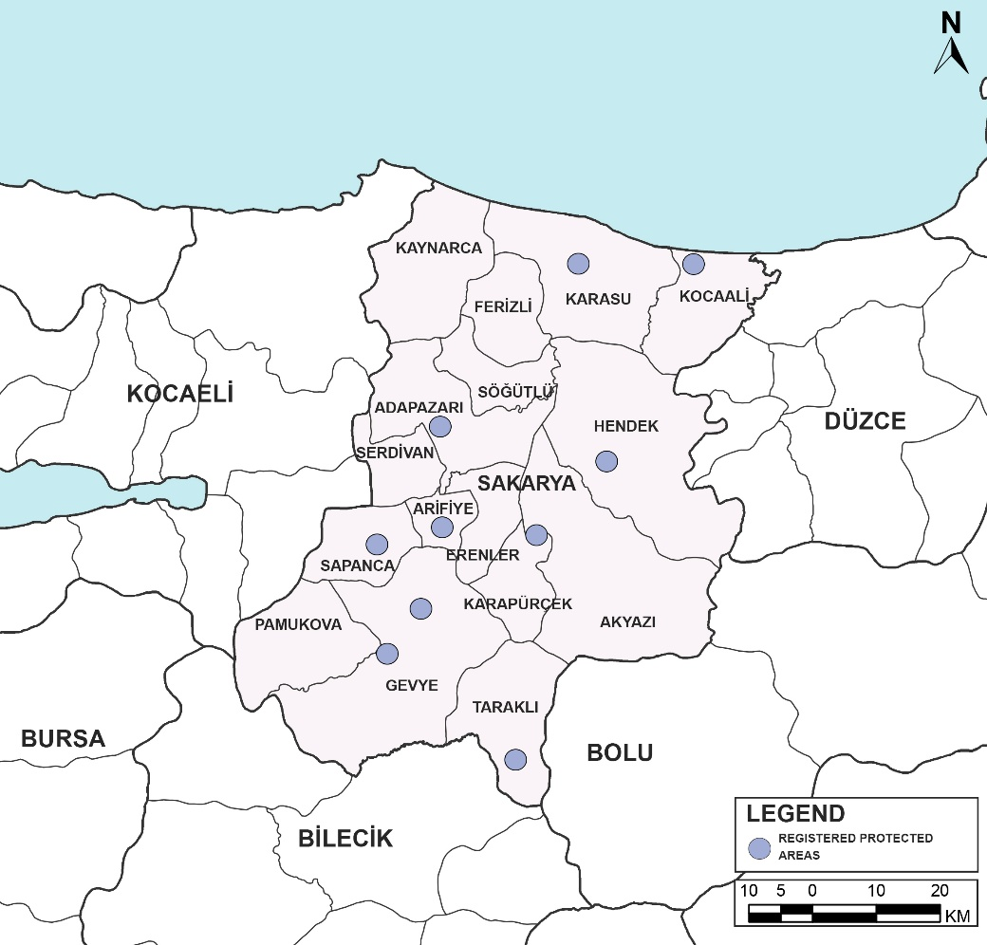
Source: Sakarya Metropolitan Municipality, 2024.

Asbestos
Asbestos is another issue that needs to be addressed in terms of both environmental/public health and occupational health and safety. However, it should be noted that it is not possible to make a quantitative or spatial assessment of the asbestos status of the building stock in the provinces. Furthermore, it will be mandatory to conduct asbestos inventory studies before the demolition of any building within the scope of the sub-projects. Currently, some municipalities require an asbestos inventory study to be carried out prior to any demolition. Furthermore, the Regulation on the Demolition of Buildings, which came into force on July 1, 2022, mandates asbestos inventory studies at the national level.
Asbestos inventory studies can only be conducted by an accredited company licensed to identify asbestos in solid samples under national legislation. According to the list of approved organizations from the Ministry of Labor and Social Security (MoLSS), General Directorate of Occupational Health and Safety, there are a total of 10 laboratories authorized in this context in Türkiye, all of which are located in Istanbul (7 on the Anatolian side and 3 on the European side). Therefore, services from these accredited companies in Istanbul will be necessary before any demolition activities can take place.
The management of asbestos wastes with the codes 17 06 01 (insulation materials containing asbestos) and 17 06 05 (construction materials containing asbestos) in Sakarya province is carried out by İZAYDAŞ (İzmit Waste and Residues Treatment, Incineration, and Evaluation Inc.), which operates within the borders of İzmit District in Kocaeli Province. İZAYDAŞ is Türkiye's first waste disposal facility and is a competent organization throughout the country in the disposal of hazardous wastes without harming the environment and human health. In this context, the acceptance, transportation, and disposal processes of asbestos wastes generated throughout Sakarya province are carried out under the authority and responsibility of İZAYDAŞ.

Social Baseline

Sakarya Province Population Status
According to 2024 data, the population of Sakarya province is 1,110,735 people (TURKSTAT). The population of the province tends to increase rapidly due to reasons such as rapid industrialization, the need for labor, rich and fertile soils, its geographical structure suitable for development, the suitability of climate and vegetation, its proximity to big cities, and the abundance of investments and incentives. The population of Sakarya province, which has a total of 16 districts, has been increasing regularly every year since 2007. Population trend of Sakarya is presented in Figure 7. As of 2011, the annual population growth rate of Sakarya province is above the average of Türkiye.

Figure 7: Population Trend of Sakarya

Source: Turkish Statistical Institute, Address Based Population Registration System Results, 2007-2024
The population of Sakarya has steadily increased from 835,222 in 2007 to 1,110,735 in 2024, reflecting a growth of over 33% in 18 years, with 51% of the population being male and 49% female. When the population structure of Sakarya province is examined, it shows that it has a strong demographic dynamic in terms of both natural population growth and migration potential. It is seen that the annual population growth rate reached 19.06 per thousand in 2008, and the growth rate reached the highest levels with 21.71 and 24.63 per thousand in the 2015-2016 period. There have been sudden increases, major unexpected developments, economic attractiveness and migration movements observed in these years. There has been a slowdown compared to the increase in 2017, but in general, it has a strong impact in the range of 17-20 in the 2018-2022 period. In 2020, the rate of increase of the pandemic in Türkiye decreased significantly (5.51 per thousand), while Sakarya had a relatively more resilient period (12.55 per thousand). In 2023 and 2024, the loss of increases is noteworthy (16.56 and 11.43 per thousand, respectively). This can be explained as slowing migration flows, decreases in birth rates and the distribution of economic conditions.
When the population structure of Sakarya province is examined, it is seen that the total age dependency ratio is lower than the average of Türkiye and the average household size is higher than the average of Türkiye, as seen in Table 13.

Table 13: Sakarya Province Age Dependency Ratio and Average Household Size
Population | Türkiye | Sakarya
Total Age Dependency Ratio (%) | 46.12 | 45.02
Average Household Size (Number) | 3.11 | 3.18
Source: TurkStat, Address Based Population Registration System,2024.
The age pyramid of Sakarya province is given in Figure 8. The age pyramids for 2007 and 2024 are shown comparatively. These pyramids show a significant change in the demographic structure of Sakarya province over time.
The age pyramid of 2007 points to the type of "young population" whose base is wide and narrows upwards. This structure shows the high fertility rates and the weight of the social structure of youth. The distribution observed especially according to the 0-14 age groups reveals that the increase in the child and youth population is high in this period.
The 2024 pyramid shows a significant expansion in middle-aged groups, particularly in the 30-49 age range. This situation shows that the demographic structure of the province is a formation in which the predominantly young population is more balanced and the productive age group is in the majority. While there is a relative development in the 0-14 age group, there is an observable increase in the population aged 65 and over. These trends reveal declining fertility rates in the region, increasing health and lifespan, and thus a shift towards an aging but productive population structure.
In general, a large demographic part of the individuals (25-64 years old) currently in the working order in Sakarya province is formed. However, the increase in the elderly population and the decrease in the young population necessitate the improvement of new approaches in social service, health, education, and employment policies in the regional area.

Figure 8: Change in the Population Pyramid of Sakarya Province
POPULATION 2024

Source: TurkStat, Address Based Population Registration System 2007 and 2024

Education in Sakarya Province
Education data of Sakarya province show that the literacy and education level in Sakarya province is higher than the average of Türkiye. Educational attainment, which is the highest level of education completed by an individual, is given in Figure 9 and Figure 10. Although there is a difference between the education levels of male and female individuals at the primary and high school levels, this difference decreases at the higher education level.
Figure 9: Adult Education Levels in Sakarya Province

* Adult refers to people between the ages of 25 and 64.
Source: Turkish Statistical Institute, National Education Statistics, 2024
A high level of education is a significant factor that contributes to an individual's employability or income. Overall, as shown in Figure 10, the percentage of adults with higher education in Sakarya province is lower than in Türkiye.
Figure 10: Percentages of Adult Education Levels in Sakarya and Türkiye
Other
Lower Secondary Education
Upper Secondary Education
* Adult refers to people between the ages of 25 and 64.
Source: Turkish Statistical Institute, National Education Statistics, 2024
As seen at the 2023/24 academic year, there are 1,923 (one thousand nine hundred twenty-three) public schools and 9,368 (nine thousand three hundred sixty-eight) classrooms affiliated to the Ministry of National Education at all levels of education in Sakarya province, and 227,176 (two hundred twenty-seven thousand one hundred seventy-six) students receive education in these schools. A total of 124,403 (one hundred twenty-four thousand four hundred three) of these students are in primary education, 65,126 (sixty-five thousand one hundred twenty-six) of whom are in primary school and 59,277 (fifty-nine thousand two hundred seventy-seven) are in secondary school. 68,007 (sixty-eight thousand seven) students continue secondary education.
There are two state universities operating in Sakarya province: Sakarya University and Sakarya University of Applied Sciences. Sakarya University and Sakarya University of Applied Sciences cooperate closely with the agricultural sector, with education, research and application activities supporting the province's strong agricultural support. In particular, units such as the Faculty of Agriculture, Agricultural Sciences and Technologies Application and Research Center within Sakarya University of Applied Sciences support agricultural production in the region.
Table 14: Data Table Showing Education Status in Sakarya Province
Education Status
Education Status (6+ years) | Total | Male | Female | Male Proportion | Female Proportion
Unknown | 5507 | 2640 | 2867 | 0.5 | 0.5
Doctorate | 2985 | 1897 | 1088 | 0.6 | 0.4
High School or Equivalent Vocational School | 265729 | 150424 | 115305 | 0.6 | 0.4
Literate, No Formal Education Completed | 81386 | 36438 | 44948 | 0.4 | 0.6
Illiterate | 18280 | 3194 | 15086 | 0.2 | 0.8
Middel School or Equivalent Vocational School | 165968 | 91411 | 74557 | 0.6 | 0.4
Master's Degree and Above | 17929 | 9690 | 8239 | 0.5 | 0.5
College or Faculty | 154428 | 78176 | 76252 | 0.5 | 0.5
Primary school | 227629 | 93007 | 134622 | 0.4 | 0.6
Primary | 67780 | 36958 | 30822 | 0.5 | 0.5
TOTAL | 1007621 | 503835 | 503786 | 5.3 | 5.2
Source: Higher Education Council
Figure 11: Sakarya Province Education Level Percentage

Source: Turkish Statistical Institute, Population Statistics, 2024

Socio-Economic Status of Sakarya Province
According to the Socio-Economic Development Ranking of Provinces and Regions Research conducted by the Ministry of Industry and Technology, in 2025, Sakarya Province was ranked as the 12th most developed province in Türkiye with a score of 0.729. The study employs SEGE (Socio Economic Development Index) which analyzes the development levels of provinces via using 52 different variables that focusing on socio-economic dimension. Sakarya is part of the TR42 NUTS-2 Region, which consists of the provinces of Kocaeli, Sakarya, Düzce, Bolu, and Yalova.
Figure 12: 2025 SEGE Studies
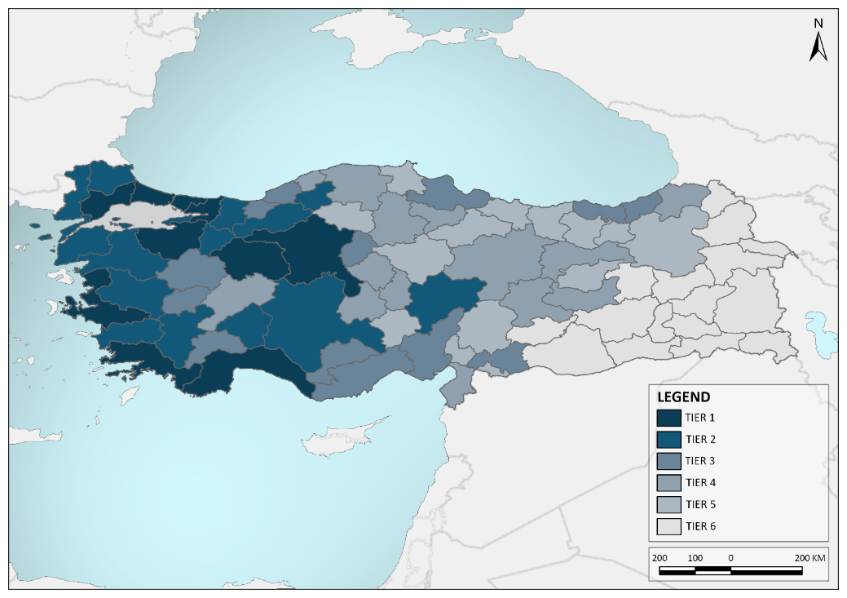
Source: Republic of Türkiye Ministry of Industry and Technology, General Directorate of Development Agencies. SEGE Studies, 2025.

Figure 13: 2025 SEGE Study of Sakarya Province
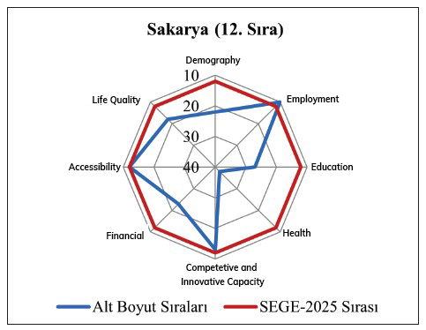
Sakarya (11th Rank)
Sub-dimension Rankings
SE-GE 2025 Rank
Source: Republic of Türkiye Ministry of Industry and Technology, General Directorate of Development Agencies. SEGE Studies, 2025.

It is seen that the developed provinces in the second tier have created an important center of attraction at the regional level and create positive economic and social effects for the less developed provinces around them.
According to the SEGE-2025 study conducted by the Ministry of Industry and Technology, Sakarya Province ranks 12th nationwide in Türkiye. When assessed across seven sub-dimensions, the province ranks 12th in demography, 18th in quality of life, 38th in healthcare, 10th in employment, 23rd in education, 23rd in fiscal capacity, 12th in accessibility, and 13th in competitiveness and innovation capacity.
Table 15: Socioeconomic Development Ranking of Sakarya Districts
District | National Development Rank |  |  | Development Order in Sakarya Province |  |  | Development Level
District | 2004 | 2017 | 2022 | 2004 | 2017 | 2022 | 2004 | 2017 | 2022
Serdivan | - | 145 | 77 | - | 1 | 1 | - | 2 | 2
Adapazarı | - | 152 | 87 | - | 2 | 2 | - | 2 | 2
Arifiye | - | 190 | 106 | - | 3 | 3 | - | 2 | 2
Sapanca | - | 222 | 177 | - | 4 | 4 | - | 3 | 3
Erenler | - | 234 | 179 | - | 5 | 5 | - | 3 | 3
Ditch | - | 215 | 253 | - | 6 | 6 | - | 3 | 3
Akyazi | - | 237 | 288 | - | 7 | 7 | - | 3 | 4
Pamukova | - | 273 | 346 | - | 8 | 8 | - | 4 | 4
Geyve | - | 265 | 355 | - | 9 | 9 | - | 4 | 4
Ferizli | - | 284 | 397 | - | 10 | 10 | - | 4 | 4
Söğütlü | - | 292 | 367 | - | 11 | 11 | - | 4 | 4
Karasu | - | 275 | 285 | - | 12 | 12 | - | 3 | 3
Kaynarca | - | 298 | 520 | - | 13 | 13 | - | 5 | 5
Kocaali | - | 305 | 468 | - | 14 | 14 | - | 4 | 4
Taraklı | - | 319 | 584 | - | 15 | 15 | - | 5 | 5
Karapürçek | - | 326 | 597 | - | 16 | 16 | - | 5 | 5
* In 2004, no development ranking was made at the district level for Sakarya province, and since the SEGE-2004 study only covered certain central districts, Sakarya districts were excluded from the scope of the research. In the SEGE reports prepared in the following years, all districts were included in the evaluation according to the current administrative boundaries.
Source: Republic of Türkiye Ministry of Industry and Technology, General Directorate of Development Agencies. SEGE Studies, 2022.

According to the "Socio-Economic Development Ranking of Districts Survey" conducted by the Ministry of Industry and Technology in 2022, Serdivan is the most developed district of Sakarya. Serdivan ranks 77th in Türkiye with 1,527 points, Adapazarı ranks 87th with 1,392 points, and Arifiye ranks 106th with 1,148 points. When 2017 and 2022 are compared throughout the province, an increase in the national development ranking was observed in some districts, while partial declines were observed in others.
Serdivan district, in particular, has shown remarkable development, rising from 145th to 77th place. Arifiye and Adapazarı districts also maintained their first three places in the province. While Sapanca and Erenler districts continue to be at the 3rd level development level, Hendek and Karasu districts have approached the upper levels in the 2022 ranking. On the other hand, districts such as Kaynarca, Taraklı and Karapürçek continue to be the districts with the lowest level of development in Sakarya province.
In general, as of 2022, the development differences between the districts in Sakarya continue; however, significant progress has been made in socio-economic development indicators in central districts such as Serdivan, Adapazarı and Arifiye.

Vulnerable Groups
Potential vulnerable groups in Sakarya are considered but not limited to, the following:
- Female-headed households,
- Disabled people,
- Elderly persons,
- Poor households (including those with many children) & people without any social security insurance (including unemployed young population, households with child workers),
- Immigrants / Syrians under temporary protection (SuTP) / Other ethnic groups,
- Persons and groups whose livelihoods are dependent on the structures subject to the Project who will be permanently displaced, economically and physically (e.g., supers).
All the vulnerable groups listed above — regardless of whether they are rights holders, tenants, or limited real rights holders — will be identified in advance during the application process of the buildings that will apply for financing under the CDRC Project. Following the acceptance of the building into the Project, these groups will be further detailed within the building-based Resettlement Plans (RPs), will be defined as beneficiaries under the Project, and will be eligible for the additional interest rate discount.

Migrants and Syrians under Temporary Protection (SuTP)
Households with migrants and SuTPs who are residing/working as owners or tenants in the project provinces will be able to benefit from supports or rental assistance when they meet the conditions for applying for credit or assistance.

As of October, 2025, the number of SuTP in Türkiye is 2,555,560. Only 1.5% of Syrians live in temporary accommodation centers, while 98.5% reside in cities and villages. In Sakarya, which is among the project provinces, the number of SuTP is 12,352 people. When evaluated in proportion to the provincial population, it ranks 21st among 81 provinces with a rate of 1.10 percent. The number and rate of SuTP and the ranking of the province in terms of both number and rate are given in Table 16.
Table 16: SuTP Population and Percentage of Sakarya Province
Province | Population of Province | Population of SuTP | Percentage of SuTP | Rank of the province in terms of population of SuTP | Ranking of the Province in Terms of SuTP Percentage
Sakarya | 1,110,735 | 12.352 | 1.10 | 21 | 25
Source: Republic of Türkiye Ministry of Interior, Directorate General of Migration Management, 2025.

Figure 14: Sakarya Province Address Based Population Registration System Syrian Population by Districts
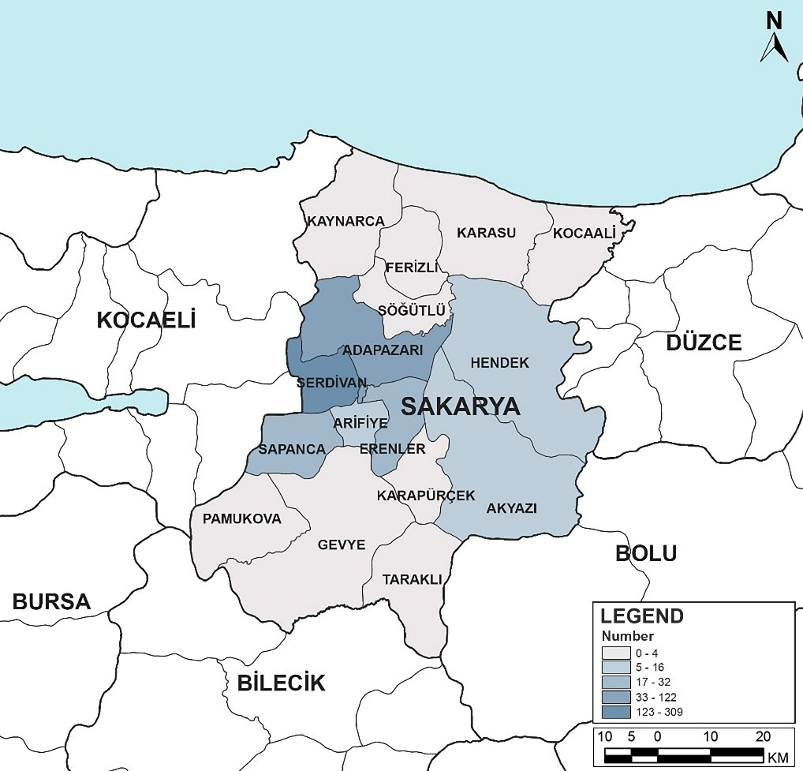
Source: TurkStat, 2024.

According to the data of the Address Based Population Registration System (ABPRS) as of December 2024, a total of 25,227 foreign nationals live in Sakarya province. According to the foreign population, the first five districts were determined as Adapazarı, Serdivan, Erenler, Sapanca and Karasu, respectively.

Figure 15: Sakarya Province Address Based Population Registration System Foreign National Population by Districts
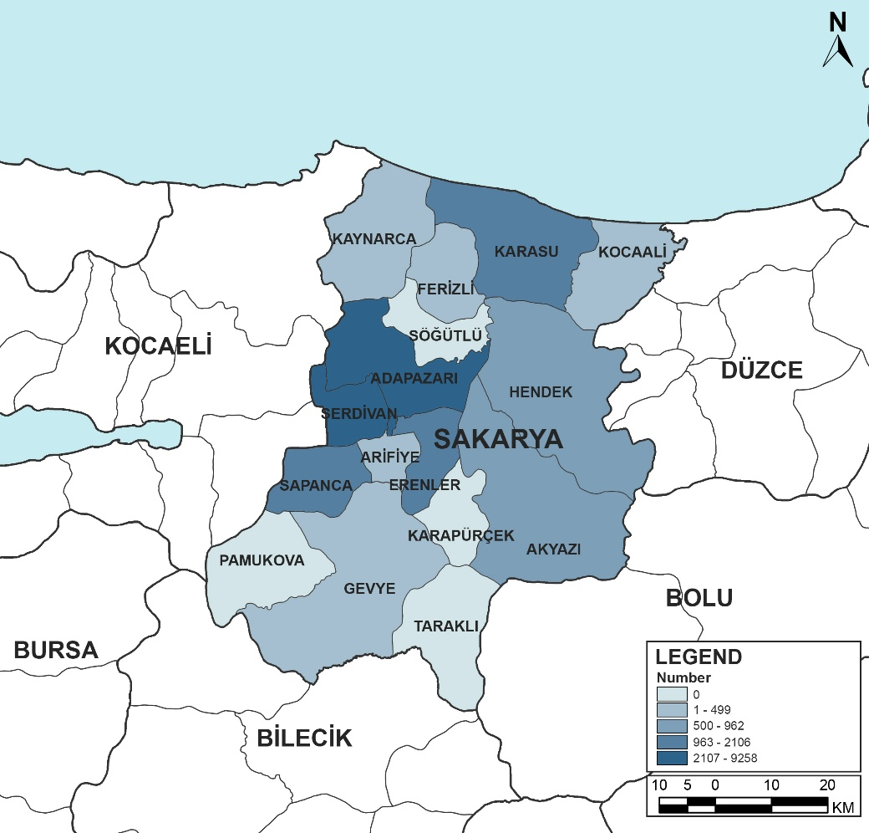
Source: TurkStat, 2024.

Roma Population
Within the scope of the project, the Roma were evaluated as the ethnic group that stands out in terms of vulnerability. There are 14 non-governmental organizations in Adapazarı, Akyazı, Arifiye, Erenler, Ferizli, Geyve, Hendek, Karapürçek, Karasu, Kaynarca, Pamukova, Sapanca, Söğütlü and Taraklı districts of the Roma in Sakarya, and these non-governmental organizations are affiliated to the Sakarya Roma Federation.
Roma population generally lives in the most disadvantaged areas and in the poorest districts of cities. The main policy areas that Roma should receive support from, which are stated in the “Strategy Document for Roma Population” of the Ministry of Family and Social Policies, and the observations made during the preparation of the strategy document regarding these policy areas are as follows:
- Education: Roma children have limited access to educational opportunities and experience high levels of absenteeism. Some Roma children are unable to continue their education because their families cannot afford to pay for their education or they have to work to support their families, while some of the children who attend school drop out because they think they are facing social exclusion.
- Employment: There is not enough data on the situation of Roma population in the labor market. However, the general opinion and observations are that Roma population mostly work in precarious, unqualified and low-status jobs. Thus, their income is not regular and is far from satisfying the needs of their families.
- Shelter: The houses they live in are physically inadequate. In fact, the Roma population mostly lives in makeshift shacks that they build themselves on public or private lands. In the urban transformation area projects carried out to improve the living environments of the Roma in the past, the fact that the houses were generally built far from the city center and multi-storey increased the integration and employment problems of the Roma population with the society.
- Health: Both the general health literacy of Roma population and—although varies from region to region—the level of awareness of health services they can benefit from is generally low.
- Social services and social assistance: The low employment level of Roma population and the fact that they work in temporary/precarious jobs bring along the risk of poverty. Since they do not have the ability to pay premiums, they are generally not included in the social insurance system and are not supported through the social service and assistance system.
It is estimated that the Roma population in Sakarya province is approximately 65.7 thousand people. The district where the Roma population lives most densely is Adapazarı, followed by Erenler. The districts that do not have Roma settlement areas are Serdivan and Kocaali Districts. Roma neighborhoods exist in all other districts. It reveals that the Roma population in Sakarya province is concentrated in the central districts, while there is no settlement in rural and certain districts. Roma communities residing in Sakarya make their living mainly in areas such as musicianship, porter, shoe shiner, bundling and scrap collection. However, it is observed that Roma citizens do not benefit sufficiently from the socio-economic resources in the region. The work done by Roma citizens living in Sakarya province is generally unqualified.
The main considerations of Roma regarding urban transformation are :
- Lack of zoning plans Many neighborhoods where Roma are densely populated do not have a zoning plan.
- Poor physical condition of buildings: Some Roma living in tents and barracks are vulnerable to natural disasters. In addition, although they do not live in tents and barracks, the buildings where some of the Roma live are in a very poor condition and should be reinforced in terms of earthquake risk.
- Risky buildings and risky areas: Although there are different opinions on this subject, it is generally seen that it is more appropriate to reconstruct existing risky buildings on the basis of buildings instead of areas in the transformation of risky buildings. In the implementations made on the basis of risky-area, the increase in the value of the newly constructed buildings causes social segregation and Roma cannot live in these buildings. In addition, they cannot continue their previous social life, which they were accustomed to, in these restructured regions, and their social networks are interrupted.

Cultural Heritage
Sakarya is a relatively important city in terms of cultural heritage with its historical buildings, monuments, religious and civil architecture examples in the Marmara Region.
The Cultural and Natural Heritage Protection Law (No. 2863) of Turkiye outlines a comprehensive framework for the identification, protection, and management of various types of protected areas that hold cultural and natural significance. The law defines several types of areas to be protected:
Archaeological Sites: Areas containing remnants of past civilizations, including ruins, artifacts, and structures. These sites are carefully excavated and conserved, with restrictions on construction and development to prevent damage.
Historical Sites: Locations with significant historical buildings, monuments, and structures. Efforts focus on preserving the architectural integrity and historical context, often through restoration projects and maintenance regulations.
Urban Conservation Areas: Sections of cities or towns with significant historical and cultural value, often featuring a concentration of heritage buildings. Regulations control alterations to buildings and urban development to maintain the area's historical character.
Natural Sites: Areas with unique natural features, landscapes, or ecosystems that have cultural or scientific importance. Conservation efforts include preserving the natural state, restricting harmful activities, and promoting sustainable use.
Mixed Areas: Areas with both cultural and natural heritage values, such as landscapes with archaeological significance or historic rural areas. Management strategies aim to balance the preservation of both natural and cultural elements, often integrating conservation practices for both types of heritage. Immovable cultural heritage values in Sakarya province are presented in Table 17, and protected areas are presented in Table 18.
Table 17: In Sakarya Province Immovable Cultural Assets
Immovable Cultural Heritage | Number
Administrative Structures | 24
Cultural Structures | 44
Martyrs' Cemetery | 4
Military Buildings | 19
Industrial and Commercial Buildings | 49
Religious Structures | 55
Cemeteries | 58
Civil Architecture Example | 323
Remains | 15
Total | 591
Source: General Directorate of Cultural Heritage and Museums

Table 18: Protected Areas in Sakarya Province
Conservation Areas | Number
Urban Conservation Area | 3
Archeological Site | 59
Natural Conservation Area | 5
Mixed Conservation Area | -
Total | 67
Source: Ministry of Culture and Tourism, General Directorate of Cultural Heritage and Museums
Urban conservation areas are zones that reflect the unique urban fabric through their historical, cultural, and architectural characteristics, hold significance in terms of settlement history, and contain immovable cultural assets that require protection. These areas are registered by the Cultural and Natural Heritage Preservation Boards and are planned in line with conservation-oriented zoning plans. The identification, planning, and management of urban conservation areas are important for preserving cultural heritage for future generations, maintaining urban identity, and ensuring sustainable urban development.
Since the sub-projects will be implemented in urban areas, the main cultural heritage elements have been evaluated mainly in this direction. According to the data of the Ministry of Culture and Tourism, there is a total of three urban conservation areas throughout the province.
Below are the important urban conservation areas in Sakarya province:
- Adapazarı Uzunçarşı Urban Protected Area: Located in the city center of Adapazarı, Uzunçarşı bears the traces of the commercial life that has developed since the end of the 19th century. This bazaar, which consists of shops located on the main street extending in the north-south direction, is one of the rare examples of the urban trade texture of the Ottoman period that has survived to the present day. The bazaar is an important urban protected area in terms of both keeping the traditional artisan culture alive and preserving the historical urban identity of Adapazarı.
- Taraklı Urban Protected Area - 1: Located in the district center of Taraklı, this protected area contains the traditional housing texture and street layout from the Ottoman period. Two or three-storey houses, in which wood and stone materials are used together, constitute original examples of Ottoman civil architecture with their projecting facades and bay windows. This area is an important cultural landscape representing the rural-urban transition character of Sakarya with its residential texture reflecting the traditional lifestyle and its preserved settlement plan.
- Taraklı Urban Protected Area - 2: The protected area in Taraklı covers the traditional settlement texture developed around religious buildings and public spaces. Structures such as the Yunus Pasha (Kurşunlu) Mosque, historical baths, inns and fountains, and the surrounding Ottoman-era houses reveal the socio-cultural life and architectural diversity of the region. This area, which constitutes the historical identity of Taraklı, has a strategic importance in terms of preserving cultural continuity.

Figure 16: Sakarya Protected Areas and Registered Areas
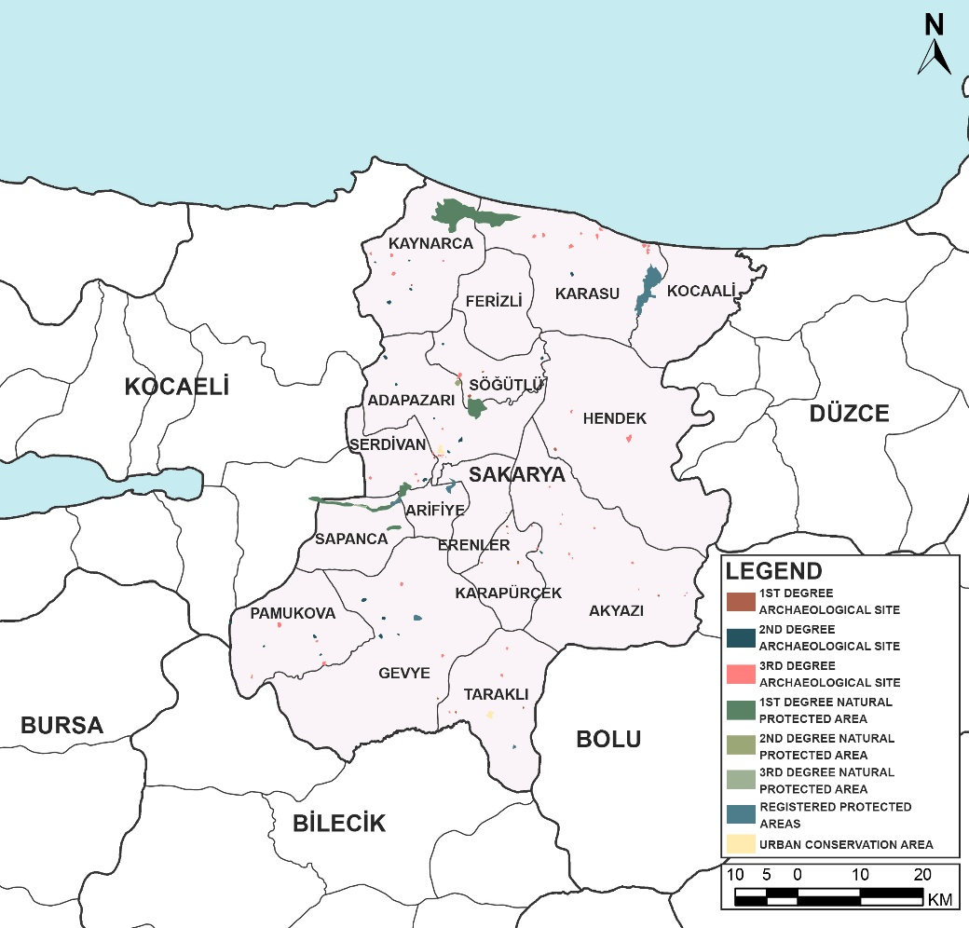
Source: Sakarya Metropolitan Municipality, 2025.

Health Status in Sakarya Province
During the 2020-2023 period, the number of hospitals in Sakarya increased from 18 to 19, while the total bed capacity rose from 2,265 to 2,447. The rate of qualified beds increased slightly from 92.1% to 92.6% during this period. The number of intensive care beds decreased from 520 to 440, and the number of intensive care beds per 10,000 people decreased from 5.0 to 4. The number of family medicine units increased from 314 to 332, and in parallel with this, the population per unit decreased from 3,321 to 3,308. These indicators reveal that the health infrastructure in the province has been strengthened in terms of both capacity and accessibility over the past four years.
By reviewing the Health Statistics Yearbooks (2023) published by the Ministry of Health for Sakarya Province, the following annual data for Sakarya province have been obtained.
Table 19: Institutions and Infrastructures Providing Health Services
Year | Number of Hospitals | Number of Beds | Number of Beds per 10,000 People | Number of Qualified Beds | Number of Intensive Care Beds | Qualified Bed Ratio* | Number of Intensive Care Beds per 10,000 People | Number of Family Health Center | Number of Family Health Center per Population
2023 | 19 | 2,447 | 22.3 | 1,895 | 440 | 92.6 | 4 | 332 | 3,308
2022 | 18 | 2,392 | 22.1 | 1,865 | 406 | 94 | 3.8 | 330 | 3,273
2021 | 18 | 2,338 | 22 | 1,815 | 446 | 95.9 | 4.2 | 317 | 3,347
2020 | 18 | 2,265 | 21.7 | 1,605 | 520 | 92.1 | 5.0 | 314 | 3,0321
*Intensive care beds are not included.
Source: Republic of Türkiye Ministry of Health, 2023. Health Statistics Yearbook.

During the 2020-2023 period, there was a significant increase in the number of applications for health services in Sakarya. The number of primary care applications increased from 3.38 million to 5.64 million, and the number of secondary and tertiary applications increased from 4.27 million to 7.47 million. Accordingly, the number of physician applications per capita increased from 7.3 to 12. Applications to dentists doubled during the same period, from 305 thousand to 725 thousand, while the number of applications per capita increased from 0.29 to 0.66 (see Table 20).
Table 20: Healthcare Usage 1
Year | Number of Primary Care Referrals | Number of Second and Third Step Redirects | Number of Physician Referrals per Person | Number of Visits to Dentist | Number of Dentist Visits Per Person
2023 | 5,645,648 | 7,478,346 | 12 | 725,133 | 0.66
2022 | 4,439,013 | 6,509,186 | 10.1 | 595,294 | 0.55
2021 | 3,203,023 | 5,352,162 | 8.1 | 361,504 | 0.34
2020 | 3,389,235 | 4,277,120 | 7.3 | 305,839 | 0.29
Source: Republic of Türkiye Ministry of Health, 2023. Health Statistics Yearbook.

As shown in Table 20, during the 2020-2023 period, the number of inpatients in Sakarya increased from 102,233 to 141,452 while the total number of hospitalized days rose from 497 thousand to 560 thousand. The number of surgeries increased from 39,768 to 55,096 in the same period, indicating the intensity of healthcare services. The bed occupancy rate increased from 55% in 2020 to 62.8% in 2023, and the average length of stay decreased from 4.4 days to 4 days. The bed turnover rate increased from 45.1 to 57.8 and the bed turnover range decreased from 3.7 days to 2.3 days.
Table 21: Healthcare Utilization 2
Year | Number of Inpatients | Number of Hospitalized Days | Number of Surgeries | Bed Occupancy Rate | Average Days of Stay | Bed Turnover | Bed Speed Range
2023 | 141,452 | 560,900 | 55,096 | 62.8 | 4 | 57.8 | 2.3
2022 | 126,582 | 512,924 | 50,449 | 58.7 | 4.1 | 52.9 | 2.8
2021 | 110,388 | 497,104 | 46,205 | 58 | 4.5 | 47.2 | 3.2
2020 | 102,233 | 497,104 | 39,768 | 55 | 4.4 | 45.1 | 3.7
Source: Republic of Türkiye Ministry of Health, 2023. Annals of Health Statistics.
Table 22: Human Resources in Health
Year | Specialist Physician | General Practitioner | Assistant Physician | Total Physicians | Total Dentists | Pharmacist | Nurse | Midwife | Other Health Personnel
2023 | 1,004 | 722 | 461 | 2,187 | 496 | 503 | 2,682 | 851 | 2,773
2022 | 937 | 667 | 352 | 1,956 | 451 | 444 | 2,608 | 801 | 2,294
2021 | 857 | 657 | 247 | 1,761 | 440 | 397 | 2,374 | 754 | 2,084
2020 | 845 | 644 | 293 | 1,782 | 353 | 366 | 2,373 | 752 | 1,963
Source: Republic of Türkiye Ministry of Health, 2023. Annals of Health Statistics.
In the 2020-2023 period, there was an increase in the capacity of emergency health services in Sakarya. The number of emergency aid stations increased from 38 to 47 and the number of ambulances increased from 61 to 68. On the other hand, due to population growth, there has not been a significant improvement in the population ratio per station and ambulance, and the values have remained relatively stable over the years. The rate of false reports increased from 6% in 2020 to 7.7% in 2023.
Table 23: Emergency Medical Services
Year | Number of Emergency Aid Stations | Population per Emergency Aid Station | Number of Emergency Ambulances | Population per emergency ambulance | False Report Rate (%)
2023 | 47 | 23,364 | 68 | 16,149 | 7.7
2022 | 43 | 25,118 | 62 | 17,421 | 6.8
2021 | 39 | 27,202 | 63 | 16,839 | 6.4
2020 | 38 | 27,438 | 61 | 17,093 | 6
Source: Republic of Türkiye Ministry of Health, 2023. Annals of Health Statistics.

Sakarya Province Agriculture and Livestock Status
Sakarya Province is a province with advantages such as being located in the Marmara Region, which is the most socio-economically developed region of Türkiye, and being on the main transportation routes connecting to other regions of Anatolia. Sakarya province has made significant developments in the industrial sector in recent years. The main reasons for these developments are the fact that Sakarya is in a suitable position for investment, ease of access to raw materials and finished product resources, the availability of suitable investment areas, the choice of large holdings as an investment base, and qualified manpower opportunities have made the province an attractive investment center for foreign investors. In recent years, there have been great developments in the province, especially in the automotive, textile and food sectors. There are 13 separate Small Industrial Site areas. In addition, there are Organized Industrial Zones (OIZs) in five different districts: Adapazarı 1st OIZ (161 Hectares), Hendek 2nd OIZ (357 Hectares), Söğütlü 3rd OIZ (254 Hectares), Karasu and Ferizli. In addition to these, the establishment of new OIZs in Kaynarca and Akyazı districts continues. Significant investments have been made in the food sector, especially in the fields of dairy products and poultry. Again, companies that have a say in the production of machinery and equipment, especially related to the processing of dairy products, have started to grow even more. These developments also contributed to the development of animal husbandry. Significant investments have also been made in the textile sector in recent years. One of the most important reasons for this is Sakarya's proximity to the provinces of Istanbul and Bursa, which are important centers of textile. Sakarya is an important investment center of Türkiye with its location suitable for investment in areas such as automotive and sub-industry, textile, food, forestry products, electrical-electronics, building-construction materials, ornamental plants.
The share of agriculture and animal husbandry in economic activity branches in Sakarya province ranks second after industry with a rate of 20.5% at current prices. The share of agriculture in the gross product is 22%, above the average of Türkiye (14.5%), the average of the Marmara Region (5.2%) and the provinces of the region, however, the development rate of the agricultural sector is behind the average of Türkiye (67.5%) and the average of the Marmara Region (33.8%). The concentration of industry in the provinces of Istanbul, Bursa and Kocaeli in the Marmara region, in a way, directs Sakarya to an agriculture-centered economic development. 50% of the active population in Sakarya province is engaged in agriculture and animal husbandry, and approximately 95% of those who make up the sector are Small and Medium-Sized Enterprises (especially family businesses), which we describe as SMEs. A significant part of these enterprises focus on large and small cattle breeding. With this potential, Sakarya is the main supplier of Istanbul's red meat needs (57% of the total need on average). Sakarya's proximity to big provinces where the need for meat is high makes agriculture and animal husbandry one of the main sectors in this province, rather than an alternative sector.

Figure 17: Türkiye and Sakarya Employment Rates by Years in the Province

Source: TurkStat, 2022-2024
In Sakarya, 24% of the employees are employed in the industrial sector, 59% in the service sector and 17% in the agricultural sector. According to the 2023 current price data of gross domestic product (GDP) on the basis of provinces; Sakarya ranked 17th with 310 billion 359 million TL. It ranked and had a share of 1.17% in total GDP. While Sakarya had a 2.1% share of the industrial sector in 2023, the share of the industrial sector in the total GDP of the province is 39%.
Figure 18: Türkiye and Sakarya Employment Rates by Years in the Province
Other
Agriculture
Industry
Sakarya Province Sectoral Distribution
Source: Republic of Türkiye, Sakarya Governorship, Provincial Briefing Report, 2018

Agriculture and Animal Husbandry Situation in Sakarya Province
Although the relative importance of the agricultural sector in gross domestic product (GDP) in Türkiye has decreased over the years, real production has shown a steady upward trend. While the agricultural sector accounted for 25.8% of national income in 1980, this rate decreased rapidly due to the export-oriented macroeconomic policies implemented in the 1980s, and the contribution of the agricultural sector to GDP was 4.8% in 2022. According to the data of the Turkish Statistical Institute (TurkStat), the share of the agricultural sector (agriculture, livestock, fisheries and forestry) in GDP at current prices according to the chained volume index was 4.8% in 2022. In the same year, the agricultural sector recorded a moderate growth of 0.6%, while its contribution to the 5.4% growth in the economy remained limited.
In the first quarter of 2023, the agricultural sector contracted by 3.8%. This contraction was the sharpest contraction recorded since the third quarter of 2021. However, in the second quarter of 2023, the agricultural sector grew by 1.2% and its share in GDP was 4.4%. Although the share of agriculture in the Turkish economy has decreased over the years, the sector maintains its strategic importance. In 2022, it employed 4.9 million people, accounting for 15.8% of total employment (30.8 million). However, the agricultural sector's share of employment decreased from 17.2% to 15.8% compared to 2021, reflecting a shift from agriculture to services and construction. On the other hand, according to the household labor force statistics published by TurkStat, as of the first quarter of 2023, the labor force working in the agricultural sector (4.7 million) accounted for 14.9% of total employment (31.6 million).
Agricultural Activities
The region provides highly favorable conditions for the cultivation of various types of grains, fruits and vegetables, supported by fertile soils, suitable climatic characteristics, and improvements in agricultural practices. The main agricultural products include wheat, corn, sunflower, potatoes, onions, tomatoes, apples, pears, cherries and hazelnuts. Sakarya's agricultural sector plays an important role in the economic development of the region because of its high productivity, use of modern technology and qualified workforce. Farmers in the region produce for both domestic and foreign markets and make significant contributions to Türkiye's food security.
45.68% of Sakarya's land consists of arable land, 1.47% pasture, 43.18% forest and heath and 9.67% other land, and 50,304 registered people are engaged in farming activities.

The distribution of arable land by crop and usage area in 2023 is given in Table 24. 38.49% of the arable land is field crops land, 3.6% is vegetable land, 46.48% is fruit land, 0.02% is greenhouse land and 0.49% is ornamental plant land.

Table 24: Distribution of Arable Land in Sakarya Province by Product and Usage Area
Arable Land Distribution | Area (ha) | Share (%)
Field Crops | 786,594 | %38.49
Fruit Field | 949,833 | %46.48
Vegetable Area | 73,633 | %3.6
Under Cover | 503 | %0.02
Ornamental Plants Area | 10,094 | %0.49
Other Lands for Use | 222,938 | %10.91
Total | 793,596 | 100
Source: Sakarya Province Environmental Status Report, 2023.
The agricultural areas in the province consist of fertile alluvial soils under the influence of the Sakarya River. The lands are small and fragmented; It has directed agricultural activities in the province to areas where higher income can be obtained from the unit area. Nitrogen, Phosphorus and Potassium fertilizers are used throughout the province and the amount is 105,244 tons. (Year 2021)
Livestock Activities
Animal husbandry in Sakarya was examined as two sub-sectors. The reason for this is that meat poultry farming has an important place in the Turkish economy as an industrial sector in Sakarya. Red meat farming has an important place in reducing unemployment in rural areas and preventing migration from village to city, as well as increasing the welfare level by realizing the development in the country in a balanced way, and supplying raw materials to other sub-sectors such as meat, milk, leather, cosmetics, medicine, etc. In addition, animal manures are used in plant production to improve the physical structure of the soil and increase its fertility. Animal husbandry allows the utilization of the vacant labor force in agricultural enterprises, especially in the winter period when there are no plant production activities. Due to the dependence of crop production on climatic conditions, livestock is an additional source of income for agricultural enterprises.
As of 2024, there are 193,600 cattle, 79,313 sheep and goats, and 443 riding animals in the province. Adapazarı (35 thousand 469 heads), Kaynarca (26 thousand 422 heads), Akyazı (25 thousand 245 heads) districts come to the fore in cattle breeding. As of the same date, Geyve (15 thousand 552 heads), Kaynarca (18 thousand 620 heads), Pamukova (8 thousand 765 heads) and Adapazarı (8 thousand 484 heads) are the leading districts in small ruminant breeding. In addition, Geyve (103 units) and Taraklı (64 units) districts come to the fore in mounted animals. Agriculture and livestock data of Sakarya province are given in Table 25.
Table 25: Agriculture and Livestock Status of Sakarya Province by Districts
County | Crop Production | Livestock | Viticulture | Aquaculture
Adapazarı | Grain, Vegetables, Fruits, Forage Crops | Cattle, Small cattle | - | No
Akyazi | Grain, Vegetables, Fruits, Forage Crops | Cattle, Small Cattle | - | Fish Farms
Arifiye | Grain, Vegetables, Fruits, Forage Crops | Few Cattle, Few Small Cattle | - | No
Erenler | Grain, Vegetables, Fruits, Forage Crops | Few Cattle, Few Small Cattle | - | No
Ferizli | Grain, Vegetables, Fruits, Forage Crops | Few Cattle, Few Small Cattle | - | No
Geyve | Grain, Vegetables, Fruits, Forage Crops | Cattle, Small Cattle | Exist | No
Hendek | Grain, Vegetables, Fruits, Forage Crops | Cattle, Small Number of Small Cattle | - | Fish Farms
Karapürçek | Grain, Vegetables, Fruits, Forage Crops | Few Cattle, Small Cattle | - | Fish Farms
Karasu | Grain, Vegetables, Fruits, Forage Crops | Cattle, Small Number of Small Cattle | - | No
Kaynarca | Grain, Vegetables, Fruits, Forage Crops | Cattle, Small Cattle | - | No
Kocaali | Vegetables, Fruits, Forage Crops | Few Cattle, Few Small Cattle | - | Fish Farms
Pamukova | Vegetables, Fruits, Grains, Olives | Few Cattle, Small Cattle | Exist | Fish Farms
Sapanca | Vegetables, Fruits, Forage Crops | Few Cattle, Few Small Cattle | - | Fish Farms
Serdivan | Grain, Vegetables, Fruits, Forage Crops | Few Cattle, Few Small Cattle | Exist | No
Söğütlü | Grain, Vegetables, Fruits, Forage Crops | Few Cattle, Few Small Cattle | - | No
Taraklı | Grain, Vegetables, Fruits, Forage Crops | A small number of Cattle, Small Cattle | Exist | Fish Farms
Source: Sakarya Provincial Directorate of Agriculture and Forestry, Annual Report 2018

Profile of Manufacturing Industry in Sakarya
The province of Sakarya has become an attractive center for industrial investments due to its geographical location, transportation infrastructure, and natural resources. Sakarya's industrial profile covers a wide range from automotive to metal industry, from food production to construction sector. Especially the automotive industry stands out throughout the province. Sakarya is one of Türkiye's leading automotive production centers and many brands have factories here. In particular, the factories of large domestic companies such as Toyota, Otokar and Türk Traktör are located here. This situation makes a significant contribution to the region’s economic growth and increases employment opportunities. In addition, infrastructure investments and incentives for the industry make Sakarya even more attractive for industrial investments. It is especially supported by local innovation and R&D activities. Universities and research centers in the city work in collaboration with the industry to develop innovative solutions and technologies, thus increasing the efficiency of production.
Sakarya is one of Türkiye's leading production and export centers. In 2023, the gross domestic product (GDP) per capita was 284,969 TL, and Sakarya was among the top 20 provinces in Türkiye. In the same year, according to the chained volume index, it became the 8th province that contributed the most to Türkiye's economic growth. The automotive sector is the locomotive of Sakarya's industry. In the province, where major manufacturers such as Toyota, Otokar and TürkTraktör operate, a total of 269,284 vehicles were produced in 2023; 75.5% of this production was exported. Automotive exports alone exceeded 5.7 billion dollars. In addition, the chemical, machinery, metal, defense and steel industries and the developing production infrastructure have made Sakarya an important industrial base on a regional scale. Karasu Port is also in a strategic location in terms of logistics thanks to its high-speed train line and Northern Marmara Motorway connections. Sakarya continues to contribute increasingly to the economy of both the region and the country with its industrial production capacity and foreign trade potential.

There is a total of 9 Organized Industrial Zones (OIZs) in Sakarya province. These OIZs; Sakarya 1st OIZ, Sakarya 2nd OIZ, Sakarya 3rd OIZ, Karasu OIZ, Ferizli OIZ, Kaynarca Furniture Specialized OIZ, East Marmara Machinery Manufacturing Specialized OIZ, Sakarya Automotive and Metal Specialized OIZ and Sakarya Söğütlü OIZ. These OIZs ensure that industrial activities are carried out more efficiently in terms of infrastructure, transportation and logistics by gathering them in certain areas. Production activities are mainly concentrated in machinery manufacturing, automotive sub-industry, furniture, metal processing and chemical sectors. This industrial structuring carried out in OIZs increases the production potential of the province based on medium and high technology; it also plays an important role in terms of employment and regional development.
Table 26: Organized Industrial Zones in Sakarya Province
No | Organized Industrial Zone (OIZ) | County
1 | Sakarya 1st OIZ | Arifiye
2 | Sakarya 2nd OIZ | Hendek
3 | Sakarya 3rd OIZ | Söğütlü
4 | Karasu OIZ | Karasu
5 | Ferizli OIZ | Ferizli
6 | Kaynarca Furniture Specialized OIZ | Kaynarca
7 | East Marmara Machinery Manufacturers Specialized OIZ | Kaynarca
8 | Sakarya Automotive and Metal Specialized OIZ | Ferizli
9 | Sakarya Söğütlü OIZ | Söğütlü
Source: Sakarya Chamber of Commerce and Industry
When the sectoral distribution of industrial enterprises in Sakarya province is examined; Automotive and Trailer Manufacturing with 22.93% in the first place, Metal Products Manufacturing with 15.27% in the second place, and the main Food Products Manufacturing sectors with 12.73% in the third place.
There is a total of nine Organized Industrial Zones in Sakarya province. The total area of these zones is 2,435.47 hectares, and 633 plots have been allocated. 280 enterprises are in production and employ a total of 31,941 people. In the current situation, the largest OIZ is Sakarya Automotive and Metal Specialized OIZ with 352 hectares, while Sakarya Automotive and Metal Specialized OIZ, which is under construction, will be the largest OIZ in Sakarya with 524 hectares when completed. As stated in the Organized Industrial Zones with the largest area;
Sakarya 1st OIZ (Hanlı) covers an area of 272 hectares. Established in 1993, this region is home to companies specializing in automotive sub-industry, textile, metal works, machinery manufacturing and production. It makes a significant contribution to the economic growth of the region with its 81 production facilities.
The largest organized industrial zone of Sakarya province is the Sakarya 2nd OIZ (Hendek) and has an area of 352 hectares. The Organized Industrial Zone, which was founded in 1997, stands out as one of the region’s major industrial hubs, characterized by its extensive production capacity spanning the metal, plastics, textile and apparel, wood and wood products, food, electrical equipment manufacturing, and chemical industries.
Sakarya 3rd OIZ (Söğütlü) draws attention with its 328-hectare area. This industrial zone, established in 1998, hosts companies operating in different industrial branches, especially in the food, textile, building materials, and Iron and Steel sectors. With its 66 facilities, it makes a great contribution to the production capacity of Sakarya province.
Karasu OIZ operates on an area of 44 hectares. This OIZ which was founded in 2007, hosts companies that produce especially for the metal, plastic-rubber, automotive sub-industry, food and construction materials sectors. Karasu OIZ employs 324 people.
Ferizli OIZ has an area of 154.17 hectares. This region, established in 2009, offers production areas for small and medium-sized enterprises. It has become an important center for companies operating in different fields of metal, machinery, wood and forestry products, construction materials industry. It supports industrial diversity with its 35 facilities.
Kaynarca Furniture Specialized OIZ has an area of 105 hectares. This industrial zone, which was established in 2010, hosts Furniture Production companies. With its 10 facilities, it makes a great contribution to the furniture production capacity of Sakarya province.
East Marmara Machinery Manufacturers Specialized OIZ has started to be built on an area of 427 hectares. When the construction phase is completed, it will be the 2nd largest OIZ in Sakarya province. This region, which is under construction, will host companies that produce especially for the machinery sector.
Sakarya Automotive and Metal Specialized OIZ has started to be built on an area of 524 hectares. When the construction phase is completed, it will be the largest OIZ in Sakarya province. This region, which is under construction, will host companies that produce especially for the automotive and metal sectors and will make great contributions to the country's economy.
Sakarya Söğütlü OIZ has an area of 229.3 hectares. Expropriation works continue in Sakarya Söğütlü OIZ. It hosts companies that produce for the agricultural sector.
Table 27 provides a structured overview of the sectoral distribution of enterprises operating in Sakarya in 2024, classified under NACE Rev. 2. It identifies the number of businesses and their proportional share within the provincial economy, together with Sakarya’s corresponding share at the national level.
Table 27: Sectoral Distribution of Industrial Enterprises in Sakarya Province
Sectors (Nace Rev 2) | 2024
Sectors (Nace Rev 2) | Sakarya |  | Sectoral Share in Türkiye (%)
Sectors (Nace Rev 2) | Number of Businesses | Percentage (%) | Sectoral Share in Türkiye (%)
Mining and Quarrying | 40 | 2.617 | 2.778
Crude Oil and Natural Gas Extraction | 3 | 0.157 | 0.111
Other Mining and Quarrying | 15 | 1.310 | 2.601
Activities of gravel and sand quarries; Extraction of clay and kaolin | 21 | 1.098 | 0.023
Mineral mining for chemical and fertilizing purposes | 1 | 0.052 | 0.043
Manufacturing | 1873 | 97.383 | -
Fruit and Vegetable Processing and Storage Activities | 35 | 1.830 | 2.050
Ice Cream Manufacturing | 5 | 0.261 | 2.050
Manufacture of Ground Grain and Vegetable Products | 15 | 0.784 | 1.877
Rusk and Biscuit Manufacturing; Durable Patisserie Products and Durable Cake Manufacturing | 4 | 0.209 | 9.731
Manufacture of Pasta, Noodle, Couscous and Similar Bakery Products | 1 | 0.052 | 1.321
Finishing Textile Products | 7 | 0.336 | 1.112
Underwear Manufacturing | 7 | 0.366 | 1.633
Water Collection, Treatment and Distribution Activities | 1 | 0.052 | 1.112
Painting and Glass Works Activities | 1 | 0.052 | 6.256
Wholesale Trade Activities of Fruits and Vegetables | 1 | 0.052 | 2.016
Wholesale Trade Activities of Textile Products | 1 | 0.052 | 1.077
Clothing and Footwear Wholesale Trade Activities | 1 | 0.052 | 2.155
Wholesale Trade Activities of Solid, Liquid and Gaseous Fuels and Related Products | 1 | 0.052 | 2.711
Waste and Scrap Wholesale Trade Activities | 2 | 0.105 | 1.043
Computer Programming Activities | 10 | 0.523 | 2.085
Other Manufacturing Activities n.e.c. | 1766 | 91.399 | 34.694
Industry Total | 3,292 | 100
Source: Republic of Türkiye Ministry of Industry and Technology and Sakarya Metropolitan Municipality.
As of 2024, a total of 3,292 businesses operate in Sakarya, with 97% concentrated in the manufacturing sector. Food products, plastics and rubber, metal goods, machinery manufacturing and automotive sub-industry are the prominent sectors. Sakarya has a high share in sub-sectors such as rusks and biscuit manufacturing, paint and glass work, water treatment-distribution and computer programming throughout Türkiye, and generally exhibits a manufacturing-oriented and highly competitive industrial structure.

Retirement Status in Sakarya Province
It is among the leading duties of the social state to ensure that our retirees, who have made a great contribution to the development of our country throughout their working lives, can use their retirement rights in the best way. In order to fulfill these duties, norm and standard unity has been ensured with the Social Security and General Health Insurance Law No. 5510, which was prepared to create a structure where all individuals receive social security services with equal scope and quality. Technological infrastructure studies have been accelerated by the Social Security Institution, and comprehensive studies are carried out in both insurance and health in order to provide better quality and sustainable services.

Table 28: 2019-2024 Sakarya Province Pension Data
Year | Scope | Number of Retirees | Total
2019 | 4a | 105,950 | 173,043
2019 | 4b | 45,112 | 173,043
2019 | 4c | 21,981 | 173,043
2020 | 4a | 109,895 | 177,220
2020 | 4b | 44,877 | 177,220
2020 | 4c | 22,448 | 177,220
2021 | 4a | 114,249 | 182,458
2021 | 4b | 45,141 | 182,458
2021 | 4c | 23,068 | 182,458
2022 | 4a | 120,821 | 189,380
2022 | 4b | 44,748 | 189,380
2022 | 4c | 23,881 | 189,380
2023 | 4a | 146,845 | 218,291
2023 | 4b | 46,178 | 218,291
2023 | 4c | 24,728 | 218,291
2024 | 4a | 154,027 | 226,138
2024 | 4b | 47,084 | 226,138
2024 | 4c | 25,027 | 226,138
Notes:
* The concepts 4A, 4B and 4C used in the pension system in Türkiye refer to the types of insurance covered by the Social Security Institution (SSI). 4A (SSK) includes those who work for the employer, 4B (Bağ-Kur) includes those who work on their own behalf (such as tradesmen, farmers, company partners) and 4C (Pension Fund) includes civil servants working in public institutions.
** The relevant data covers all retirees and beneficiaries who receive income/monthly.
Male and Female Retirees: Shows the gender distribution among total retirees.
These are the data for the December period of the relevant years.
The public/private distinction is only valid for insured persons working within the scope of 4/a.
Source: SSI

ASSESSMENT OF POTENTIAL ENVIRONMENTAL, SOCIAL AND KEY POTENTIAL LABOR RISKS AND IMPACTS

Potential Environmental and Social Risks and Impacts
As mentioned in section 1.2, approximately 650 Type 1 and Type 2 buildings and 44 Type 3 number of buildings are expected to constitute the potential sub-projects of CDRC Project in Sakarya province. Potential environmental and social risks and impacts may arise during construction or retrofitting of several buildings to be constructed or retrofitted within the scope of Component 2.
The Project has a standalone Resettlement Framework (RF) which has been prepared specifically for Component 2 in order to minimize the potential social risks and impacts of the project related activities, mitigate negative impacts and assist the Project Affected Persons (PAPs) to improve their living conditions. Accordingly, the potential foreseen risks and impacts relevant to the demolition, reconstruction or retrofitting of risky structures are provided below in Table 29.

Table 29: Potential Environmental and Social Risks and Impacts
Project Phase | Potential Risk/Impact
Preparing for Demolition | Inadequate outreach and stakeholder engagement
Preparing for Demolition | Temporary and permanent displacement of owners and tenants resulting from the rehabilitation/reconstruction of housing units/workspaces
Preparing for Demolition | Risk of impoverishment due to permanent or temporary physical or economic displacement
Preparing for Demolition | Lack of dissemination of information about or access to grievance mechanisms for workers and/or Project-affected people
Preparing for Demolition | Inadequate/fail in management of Project impacts on existing and potential vulnerabilities
Preparing for Demolition | Risks of exclusion of poorer or vulnerable/disadvantaged individuals/groups from project benefits, subsidies, etc.
Preparing for Demolition | Due to inadequate/fail in management of Project impacts on traffic and community safety  - Increased traffic: improperly selected routes and lack of correct orientation and warning signs at the entrance and exit of the construction site  - Traffic accidents: missing or incorrect warning signs  - Noise pollution: unnecessary use of klaxon  - Air and environment pollution: dust and soil from uncovered lorries, increased carbon emissions due to traffic jam.
Preparing for Demolition | Community health and safety risks that may result from insufficient public informing practices of the people of the neighborhood where the structure to be demolished is located.
Preparing for Demolition | Due to inadequate pre-planning,  - Potential damage to other structures, installations around the structure and to the community health,  - Traffic jams and the effects that may be caused by this.
Preparing for Demolition | Occupational accidents, environmental accidents and incidents that may arise from inadequate preliminary planning and non-compliance with national and international legislation.
Demolition Stage (the sub-projects which will require demolition) | Negative health effects on workers, service providers and society due to accidents and incidents that may occur during the asbestos inventory, removal, transportation and disposal process.
 | General occupational health and safety risks that may apply to any demolition activity
 | Demolished material is harmful to the environment if it is not disposed of adequately. Especially if the material or waste is dangerous or might be dangerous.
 | Temporary and permanent displacement due to project activities
 | Risks to public health due to the traffic to be created by the reconstruction activities
 | Livelihood loss
 | Inadequate demolition work may result in local landslide risk and damage to the areas under protection.
 | Impacts on air quality, especially related to possible contributions on particulate matter concentrations.
 | Blasting-Related Risks: The demolition phase can be carried out by blasting according to the demolition method. In this context, occupational and community health and safety risks will arise. -However, it should be noted that no blasting demolition has been performed in Türkiye since 2017 and the MoEUCC does not prefer this method. In any case, relevant mitigation measures are provided.
 | Noise generation (except from blasting, for blasting details provided above)
 | Potential negative impacts for cultural heritage
Pre re-construction stage of the Type-III sub-projects | Risks related to E&S due to the possibility of conducted demolition works were performed non-compliant with WB and national standards.
Reconstruction or Retrofitting Stage | Risks related with improper Waste Management which may create additional pressure to waste management facilities of the provinces and may cause harm on environment.
Reconstruction or Retrofitting Stage | During construction activities, construction machinery may damage trees in the construction area.
Reconstruction or Retrofitting Stage | Excessive Noise Generation which has possibility to impact human health and at least may cause disturbance
Reconstruction or Retrofitting Stage | Labor risks, given the extensive civil works
Reconstruction or Retrofitting Stage | Possibility of chance finds during excavation work
Reconstruction or Retrofitting Stage | Lack of information about or access to grievance mechanisms for workers and/or Project-affected people
Reconstruction or Retrofitting Stage | Public health and safety risks
Reconstruction or Retrofitting Stage | Possible negative impacts on Water Quality
Reconstruction or Retrofitting Stage | Risks to public health due to the traffic to be created by the reconstruction activities,
Reconstruction or Retrofitting Stage | Livelihood loss
 | Risk of SEA/SH (Sexual Exploitation and Abuse / Sexual Harassment) incidents during reconstruction activities

Assessment of Key Potential Labor Risks
The key labor risks related to OHS risks associated with construction activities of sub-projects such as exposure to physical, chemical and biological hazards are estimated as follows: heavy equipment use, trip and fall hazards, exposure to noise and dust, falling objects, exposure to hazardous materials and exposure to electrical hazards arising from the use of tools and machinery. Persons under the age of 18 will not be employed in the Project, as construction activities will involve hazardous work. Many workers will be exposed to OHS hazards, including but not limited to:
- Working at a height,
- Electric shocks and arc failure burns (use or faulty of electrical appliances such as cable plugs, cords, hand tools),
- Electrical works,
- Exposure to chemicals (such as paints, solvents, lubricants and fuels),
- Chainsaws and tree fall during logging,
- Traffic accidents,
- Excavation hazards,
- Lifting of heavy objects,
- Rebar accidents,
- Exposure to construction-induced air emissions (dust, silica and asbestos),
- Ergonomic hazards during construction,
- Welding hazards (smoke, burns and radiation),
- Steel erection (towers) hazards,
- Lack of awareness about OHS requirements such as the use of personal protective equipment (PPE) and safe workplace practices, and
- Use of rotating and moving equipment.
In Türkiye, overtime hours are a potential labor risk in the construction sector. Due to the limited time period of the Project and the seasonal constraint of the construction works, it is a possible risk for contracted workers to work overtime above the annual limit set by the Labor Law. Reducing this risk is described in the Terms and Conditions section.
In addition, some potential gender related risks may arise between the local community and Project workers or among the workers themselves. These risks include gender discrimination, sexual exploitation, abuse, and harassment (SEA/SH) in the workplace. Forced labor and child labor are prohibited under national law, and specific provisions addressing these issues are included in the LMP of the CDRC Project.
Since sub-projects will be carried out in urban areas, majority of the labor will be recruited from Project provinces and thus sub-projects are not expected to have labor influx risks. The majority of the workforce will be Turkish citizens. However, if other labor risks arise during Project implementation, the Project Management Unit (PMU) will develop procedures, in compliance with both the national legislation and LMP of the CDRC Project, to prevent further impact.

SUB-PROJECT SCREENING PROCESS
According to the World Bank Environmental and Social Policy, Projects are classified into one of four risk classes: Related potential risks and impacts, such as the type, location, sensitivity and scale of the Project can be summarized as High Risk, Substantial Risk, Medium Risk or Low Risk, taking into account the nature and magnitude of potential environmental and social risks and impacts, and other risk areas that may be relevant to the provision of environmental and social mitigation measures and results.
Unlike the national EIA Regulation (where the Projects are classified in two categories as Annex I and Annex II Projects), there are no clear limit values distinguishing the Project classes from each other or, there is no ready-made list of Project types for classification; instead, Projects are screened on a case-by-case basis in the World Bank's environmental and social risk classification.
Sub-project Identification and Screening Process
Screening will be performed to determine the environmental and social risk category of the proposed sub-project. Moreover, the screening will also cover an ineligibility assessment. These two steps should go along in an integrated way, which starts initially with an ineligibility assessment.
Accordingly, non-eligible sub-projects which will not be financed by the WB, and therefore excluded from the scope, are listed below:
- Any sub-project that is included in the World Bank Group / International Finance Corporation Exclusion List
- Any sub-project that includes the buildings registered as Cultural Heritage.
- Any sub-project that will have impacts on Natural Habitats/Critical Habitats such as alteration of environmentally important areas, including wetlands, native forests, grasslands, and other “critical” natural habitats and ecosystem services.
- Any sub-projects that in-situ transformation is not possible.
- The buildings which are not registered as risky building within the scope of Law no. 6306.
- Risky buildings within designated Disaster Exposed Areas.
- Any sub-project that would affect the quality and/or quantity of international waterways as defined in WB OP 7.50 and that would benefit from existing hydroelectric dams in a way, triggering any dam safety issues under the scope of ESS4.
- Any Type-III sub-project, whose demolishing works had been completed before October 1, 2020.
- Any sub-project which would be classified as “High Risk” in terms of environmental risks.

Sub-project Screening Procedures
Component 2 includes three kinds of sub- projects (for details please see Section 1.2). As one of them, Type-III, is defined as “Sub-projects that have been demolished after being registered as a risky structure and only reconstruction activities will be carried out under Component 2”, which implies that some pre-works have been performed before loan application; screening procedures are defined separately as below:

Screening for Type-I and Type-II
- First step will be checking if the subproject is in the non-eligible subproject list (Annex 12) or not; except the criteria defined as “any sub-project which would be classified as “High Risk” in terms of environmental risks”.
- If the proposed sub-project is not determined as non-eligible as a result of the step performed as above, Section II of the checklist presented in Annex 11 will be applied in order to identify a preliminary baseline of the site and its surroundings.
- Afterwards, Section III of the checklist presented in Annex 11 will be applied to foreseen scale of the impacts.
Finally, by taking the outcomes of the above two steps into account, environmental and social risk category of the sub-project will be determined. In case of determination of the sub-project category as “high risk” in terms of environmental risks; no loan will be provided.
Screening for Type-III
- First step will be checking if the subproject is in the non-eligible subproject list (please see Annex 12) or not; except the criteria defined as “any sub-project which would be classified as “High Risk” in terms of environmental risks”. Specific attention will be given to the cut-off date criteria, as described in non-eligible sub-project list as “Any Type-III sub-Project, whose demolishing works had been completed before October 1, 2020”.
- If the proposed sub-project is not determined as non-eligible as a result of the step performed as above, Section II of the checklist presented in Annex 11 will be applied in order to identify a preliminary baseline of the site and its surroundings.
- Afterwards, Section III of the checklist presented in Annex 11 will be applied to estimate the scale of the impacts.
- Subsequently, Type-III specific section of the checklist, which is Section IV, will be applied.
- Finally, by taking the outcomes of the above three steps into account, environmental and social risk category of the sub-project will be determined.
Guidance on Risk Category Identification
The risk category of sub-projects will be determined according to four qualitative and quantitative criteria; “type and scale”, “location”, “sensitivity”, and “size” together with using the checklist presented in Annex 11. In order for a sub-project under Component II to be designated as “High Risk”, these criteria will be addressed as explained below. If the category of any sub-project is not determined as “high risk” as a result of this evaluation, such evaluation will be proportioned to the professional judgment of the PMU and PMU individual specialists to determine relevant risk categorization.
Within the scope of the “Type and Scale” criterion, the existence of the following conditions may place the subproject in the “High Risk” category;
- Irreversible alteration or impact of environmentally important areas such as wetlands, native forests, meadows and other critically important natural habitats and ecosystem services due to the sub-project,
- Sub-project activities require discharges and emissions that will cause direct pollution and large enough to cause deterioration of environmental components such as air, water and soil,
- Sub-project activities will consume or transform the ecosystem or its components,
- Sub-project activities will change the hydrological cycle measurably,
- Sub-project activities which could lead to significant livelihood loss or social conflict,
- The sub-project activities will include the use or management of dangerous substances to a degree that cannot be managed with the prescribed management and capacity.
Within the scope of the “Location” criterion, the existence of the following conditions may place the Project in the “High Risk” category;
- The sub-project is located in sensitive and valuable ecosystems and habitats of high importance,
- The sub-project is located within areas designated as Cultural Heritage, such as urban sites (most likely within the scope of the Project),
- The sub-project is located in areas subject to intensive development activities or where there are conflicts over the allocation of natural resources and/or other significant social conflicts, and along watercourses, in aquifer recharge areas or in storage basins used for drinking water supply.
Within the scope “Sensitivity” criterion, the existence of the following conditions may place the Project in the “High Risk” category;
- The sub-project will affect endangered species and their habitats, as well as sensitive areas such as protected areas or sites,
- The sub-project will have an impact on international waterways,
- The sub-project will affect sensitive buyers who are currently under heavy environmental and social pressure (pollution, health and safety, security, etc.).
During the evaluation of the “size” criterion, in order for a subproject to be designated as “High Risk”, the relevant residual impacts must be high even when the mitigation measures given in are anticipated to be implemented, considering also the other criteria in an integrated manner.
It should also be noted that, as the whole Project is rated as “High Risk” in terms of social risks, sub-projects with “high risk” in terms of environmental risks will not be eligible. Therefore, professional judgement will be used to identify “high risk” categorization in terms of environmental aspects during screening phase.

MITIGATION AND ENVIRONMENTAL AND SOCIAL COMPLIANCE MANAGEMENT MEASURES
Activities to be carried out within the scope of the project will comply with the most current national legislation and World Bank standards. In cases where Turkish legislation differs from World Bank Policies, the more stringent policy will be applied in the implementation of the Project.
Although it is not currently possible to make a clear assessment of the cumulative impacts of resilient sub-loans will be financed, or the number of housing units to be reconstructed or retrofitted, subprojects within the scope of the project, a high cumulative enviro impact is not expected considering the possible sizes of the subprojects and its physical dispersion throughout Sakarya Province. However, it is assessed that these may be environmentally “moderate” to “substantial” due to some risks related to demolition and excavation as well as construction waste management, traffic management and general population safety; while on social side assessed as "high risk" due to the potential community health and safety risks that may arise while the structures are being rebuilt or strengthened and the vulnerable groups that are likely to be included in the sub-projects.

Mitigation Plan
Potential environmental and social risks and impacts that may arise during the implementation of sub-projects, along with relevant mitigation measures to be taken, within the scope of Component 2 are shown in the Table 30 below.

Table 30: Mitigation Measures for Retrofitting/Demolition/Reconstruction Work Risks and Impacts
Project Phase | Potential Risk/Impact | Mitigation Measure | Responsibility
Pre re-construction stage of the Type-III sub-projects | Risks related to E&S due to the possibility of conducting demolition works were performed non-compliant with WB and national standards. | Prior to commencement of any civil works on site, an E&S Audit will be conducted by individual PMU consultants in the provinces to identify the actions/measures to be taken to ensure that the proposed subproject is in compliance with Project standards. | PMU
Preparation for Demolition | Stakeholder Engagement/Citizen Engagement; Grievance Mechanism | - Preparation of the "Stakeholder Engagement in Transforming Risky Structures in the Province Level" with local NGOs and key stakeholders: By adhering to the guidelines outlined in the Stakeholder Engagement Plan for the project collaboration will be established with local NGOs and key stakeholders. This process includes identifying stakeholders, organizing regular meetings, determining needs and priorities, conducting informational sessions and trainings, and implementing feedback and monitoring phases. | PMU
Preparation for Demolition |  | - The province-based E&S specialists and contractor’s E&S specialists will organize visits/meetings and/or disseminate written materials to inform local authorities/authorities, the public and businesses, vulnerable groups in the Project Area of Influence (AoI) which will be identified in Contractor-ESMPs (C-ESMPs), verbally and in writing about Project activities, schedule, measures taken and potential risks before work commences,  - GM tools, process, workflow, contact addresses will be informed, written notifications will be made visible and posted in relevant public areas (coffee houses, muhtars' offices, mosques, public common areas, project site etc.). | PMU
Preparation for Demolition |  | - Implementation the information dissemination processes defined by the PMU on-site,  - Ensure that GM tools, and contact addresses are made visible at the project site,  Post written notifications in designated public areas (coffee houses, mukhtars' offices, mosques, public common areas, project site etc.).  Maintain communication throughout the project and continue providing updates to stakeholders. | Contractor
Preparing for Demolition | Temporary and permanent displacement of owners and tenants resulting from the rehabilitation/ reconstruction of housing units / workspaces | - Preparation and implementation of RPs based on the scope provided in the RF. | PMU
Preparing for Demolition |  | - Within the scope of the SEP, each sub-project will plan the stakeholder information to be made available and disseminate necessary relevant information with all stakeholders.  - Provide information on the GM of the Project and inform PAPs about GM with an approved written brochure, poster etc.  - Explaining and informing PAPs of their rights defined within the scope of the Project.  - Identifying vulnerable groups affected by the structure to be transformed within the scope of the Project and defining their entitlement status.  - Explaining and informing vulnerable groups about their rights defined within the scope of the Project. | PMU in close cooperation with the Contractor
Preparing for Demolition |  | - Distribute and display stakeholder information materials prepared by the PMU on-site.  - Place GM posters and brochures in designated areas.  - Inform PAPs and vulnerable groups as per the guidelines provided by the PMU.  - Implement and follow the rights and procedures defined by the PMU in the field. | Contractor
Preparing for Demolition | Labor issues | - Preparation of subcontracts in accordance with the Project's LMP.  - Signature by all employees of subcontractors of “Codes of Conduct” covering the requirements under the LMP,  - Ensure that a letter is included in the contractor's contract stating the Human Resources (HR) policies of the contractor involved in sub-projects and that it will follow a zero -tolerance policy on the right to fair treatment, right to form workers' associations, forced labor, child labor, sexual exploitation and abuse/sexual harassment SEA/SH and violence. | PMU
Preparing for Demolition | Labor issues | - Ensuring adequate distance and space for employees in areas such as meals, breaks, etc.  - Taking necessary precaution in line with the recommendations of the Ministry of Health with regards to occupational diseases.  - Making spatial arrangements to ensure equal opportunities for women employees in the workplace.  - Providing trainings that will raise the awareness of employees and reveal the project conditions, prohibited behaviors and the principle of equality before they start working.  - Ensuring their compliance with the national law requirements and ESS2 as described in the LMP of the Project.  - To be responsible for raising awareness and training of all employees in the Code of Conduct (Annex 2) and the procedures and principles in the GM. | Contractor
Preparing for Demolition | Managing the impacts of the project despite sensitivities | - The contractor should identify sensitive receptors within the Project area of influence, such as schools, health facilities, nursing homes, etc.  - Screening measures should be taken for dust and noise effects that may occur in these areas and working hours should be regulated.  - Consultation of potential risks and measures with representatives or managers of vulnerabilities. | PMU
Preparing for Demolition | Managing the impacts of the project despite sensitivities | - Take necessary precautions in the work area considering the sensitive locations identified by the PMU.  - Implement dust and noise reduction measures defined by the PMU.  - Adhere to the working hours regulations set by the PMU.  - Maintain communication with representatives of vulnerable groups and take necessary measures based on the risk assessment conducted by the PMU. | Contractor
Preparing for Demolition | Management of the project's traffic and community safety impacts | - Within the scope of the sub-project, before demolition, the contractor should identify the roads and streets that can and cannot be used by heavy vehicles and create a route map.  - Prevent the use of roads that endanger public health and safety by taking the opinions of local authorities such as muhtars and municipalities in the road risk analysis process.  - Sharing route information, including roads that will and will not be used within the scope of the project, with drivers and relevant subcontractors and provide necessary information. | Contractor
Preparing for Demolition | Community health and safety risks that may result from insufficient public informing practices of the people of the neighborhood where the structure to be demolished is located. | - Informing the muhtar of neighborhood in line with the SEP requirements. | PMU and the Contractor
Preparing for Demolition |  | - Implementing the information process as determined by the PMU.  - Ensuring that the necessary information is delivered to the muhtar of neighborhood in a timely and complete manner.  - Following the designated communication methods in the SEP to complete the process. | Contractor
Preparing for Demolition |  | - Ensuring the entrances and exits of the local people in a way to prevent unauthorized entrances and exits by enclosing with a mobile or fixed screen at a height to be determined by taking into account the boundaries of the area to be demolished, the height of the structure to be demolished, its distance to other structures and the parcel area, the selected demolition technique, and environmental construction, and making appropriate health and safety signs at the points where the local people can see them. | Contractor
Preparing for Demolition |  | - Ensuring that the Contactor shall not commence the demolition work unless it is proven or checked that the local people are informed, and health and safety signs and entry and exit measures are applied. | PMU
Preparing for Demolition | Due to insufficient preliminary planning,  - Potential damages to other structures, infrastructure and installations around the structure and to the community health, and  - Traffic jams and the effects that may be caused by this. | - Preparation of a Demolition Plan prior to demolition in order to determine which demolition method will be used, what measures will be taken for the safety of the building and other structures, infrastructure, installations, traffic and people that may be affected in the vicinity, the material and damage properties of the building, if any, and its bearing system, bearing capacity and all risk factors  - Obtaining all necessary permits, including the demolition permit. | Contractor
Preparing for Demolition |  | - Ensuring that demolition work is not started before the Demolition Plan is prepared and all necessary permits are obtained, including the demolition permit.  - Auditing identified responsibilities of the contractors regarding impacts related to insufficient preliminary planning. | PMU
Preparing for Demolition | Asbestos | Implementation of the Asbestos Management Plan provided in Annex 9, at least performing the following actions:  - Carrying out the Asbestos Inventory Study by an accredited company.  - Performing the asbestos removal work, before demolition, by persons or institutions that have a license for asbestos removal, if asbestos is found in the building, and managing the asbestos waste in agreement with the licensed waste transport and disposal company(s) within the scope of asbestos waste, if asbestos is found in the building and it is removed. | Contractor
Preparing for Demolition | Asbestos | - Ensuring proper implementation of the Asbestos Management Plan and providing support and guidance by PMU individual specialists of the provinces to contractors within that scope.  - Monitoring identified responsibilities of the contractors regarding impacts related with insufficient preliminary planning. | PMU
Preparation for Demolition (the sub-projects which will require demolition) | Occupational accidents, environmental accidents and non-compliance with national and international legislation that may result from insufficient pre-planning. | - Preparation of Occupational Health and Safety Plan (see Annex 13) and providing trainings to the demolition in line with the requirements of the Plan. | Contractor
 |  | - Giving the official assurance by the contractor that it will not harm the environment and neighboring settlements.  - Providing the relevant demolition personnel with all Personal Protective Equipment prior to demolition within the scope of best practices and national legislation.  - Giving the official assurance by the contractor that all demolition activities will be carried out in accordance with national legislation, the ESSs and World Bank Group (WBG) Environmental, Health and Safety (EHS) Guidelines.  - Auditing identified responsibilities of the contractors regarding measures to be implemented to minimize risks related to occupational accidents, environmental accidents and non-compliance with national and international legislation due to insufficient preliminary planning. | PMU
Demolition Stage (the sub-projects which will require demolition) | Negative health effects on workers, service providers and society due to accidents and incidents that may occur during the asbestos inventory, removal, transportation and disposal process. | - In the event of an accident in this context, the Contractor will immediately inform the UTP and individual OHS/environmental specialists hired for provinces. The UTP will notify the WB of any accident/incident (if it occurs) related to asbestos immediately. An asbestos-related accident/incident investigation report will be sent to the World Bank along with the Corrective Action Plan (CAP) with the guidance and the audits of the PMU.  - A regular site inspection will be conducted by the PMU to ensure and monitor that all demolition activities to be implemented are carried out in accordance with national laws and regulations and the requirements of World Bank standards. | PMU
 |  | - Immediately report any accident /incident to the PMU and relevant OHS/Environmental specialists.  - In case of an asbestos-related accident, promptly inform the PMU.  - Implement CAP as directed by the PMU and ensure necessary precautions are taken.  - Carry out demolition activities in full compliance with national regulations and WB standards.  - Cooperate with the PMU during site inspections and address any identified deficiencies. | Contractor
Demolition Stage (the sub-projects which will require demolition) | Demolished material is harmful to the environment if it is not disposed of adequately. Especially if the material or waste is dangerous or might be dangerous. | - Implementing a controlled and progressive selective demolition process, in accordance with national legislation and international standards, in order to allow for recycling of demolition wastes at a high rate, and to ensure that hazardous wastes, if any, are sorted and separated before rough demolition, and that other materials can be reused and recycled at the source.  - Implementing the Waste Management Plan (see Annex 8) in parallel to their responsibilities, and specifically:  - Transporting the construction and demolition wastes by licensed transfer vehicles and sending them to the licensed sites.  - Transferring the inert construction & demolition wastes after selective demolition process to central waste material recovery facilities in available locations  - Keeping all waste disposal records.  - Storing the waste properly for reuse in the process of construction of a new structure, if possible.  - Storing, in sealed containers, the hazardous wastes generated during the selective demolition process. | Contractor
 |  | - Supporting contractors for all sub-projects in Sakarya for proper implementation of selective demolition.  - Auditing identified responsibilities of the contractors regarding waste management. | PMU
Demolition Stage | Temporary and Permanent Displacement due to Project activities | - Prepare, consult upon, clear with the World Bank and disclose the Resettlement Plans (RPs) and implement the RPs before the commencement of any civil works  - Informing the Project beneficiaries and right holders about their rights, supports, application methods, and conveying the steps to be taken to benefit from the supports.  - Providing support to vulnerable groups in this process.  - Disclosure of grievance mechanism and GM tools, communication tools. | PMU
Demolition Stage |  | - Ensure facilitation of implementation of RPs on-site by the PMU and cooperate as required Giving the official assurance by the contractor that it will not harm the environment and neighboring settlements.  - Providing the relevant demolition personnel with all Personal Protective Equipment prior to demolition within the scope of best practices and national legislation.  - Giving the official assurance by the contractor that all demolition activities will be carried out in accordance with national legislation, the ESSs and the WBG EHS Guidelines.  - Auditing identified responsibilities of the contractors regarding measures to be implemented to minimize risks related with occupational accidents, environmental accidents and non-compliance with national and international legislation due to insufficient preliminary planning. | Contractor
Demolition Stage | Livelihood loss | - Providing verbal and written notifications for the people and groups affected by the Project due to the resettlement.  - Ensuring that the PAPs are aware as to how to benefit from livelihood supports and Project benefits.  - Preparation of brochures and promotional materials for PAPs, including support, what the beneficiaries should do, relevant contact numbers and addresses, complaint mechanism information.  - Providing verbal and written notifications to all PAPs directly affected and entitled. | PMU
Demolition Stage | Livelihood loss | - Conduct verbal and written notifications in the field for individuals and groups affected by the project, as determined by the PMU.  - Inform PAPs about how to access livelihood supports and project benefits.  - Distribute brochures and promotional materials prepared by the PMU, ensuring they reach the relevant individuals.  - Carry out the information process for all entitled and directly affected PAPs in a timely and complete manner. | Contractor
Demolition Stage (the sub-projects which will require demolition) | Impacts on air quality, especially related with possible contribution on particulate matter concentrations, which are already high in the provinces. | - Giving the assurance by the contractor that it will apply the dust suppression processes in order to minimize the intense dust formation that will occur during the demolition work, and that it will implement these processes.  - Preparation and implementation of at least C-ESMP Checklists. | Contractor
 |  | - Ensuring preparation of each C-ESMP checklists in compliance with Sakarya ESMP.  - Auditing identified responsibilities of the contractors regarding air quality management.  - Implementing GM for dust related grievances and closing them appropriately. Directing and auditing the contractor within that scope. | PMU
Demolition Stage (the sub-projects which will require demolition) | Blasting-Related Risks: The demolition phase can be carried out by blasting according to the demolition method. In this context, occupational and community health and safety risks will arise. -However, it should be noted here that no blasting demolition has been performed in Türkiye since 2017 and the MoEUCC does not prefer this method. In any case, relevant mitigation measures are provided | - The concrete strength and the reinforcement iron properties used on the columns and beams of the foundations of the buildings that are considered for blast demolition must be well determined, and a blasting pattern must be prepared accordingly.  - Before, during and after blasting, the necessary permission must be obtained from all administrative units, and traffic and environmental safety must be ensured. The igniter to detonate must be licensed and must make the ignitions by hiding in closed areas.  - In blast demolitions, the entire environment must be informed of it before blasting, and warning announcements must be made.  - Watering must be performed in order to suppress the dust that will be formed in all demolition techniques, especially during demolition and crushing processes.  - Suspended scaffolds and safety scaffolds must be installed and used in machine or mezzanine floor reduction methods.  - In all building demolition works, the area where the building will be demolished, and stacking and loading works will be performed must be enclosed by barricades at a height of at least 2.00 meters, and a security area must be created and isolated from the outside.  - The operators who work on all heavy equipment must have a G-Class driver’s license and experience.  - Firefighters or fire extinguishers, if any, must be available during the demolition work.  - No demolition work must be done at night.  - All personnel must have communication devices.  - Emergency escape and emergency assembly area must be determined outside the area to be demolished, and the related trainings must be given.  - In all demolition techniques, all personnel who will work in the demolition site must have and carry the Personal Protective Equipment listed below that comply with the CE brand and standards. The equipment includes the following:  - Helmet (with chin protection)  - Warning vest  - Headphones or earplugs  - Top boots with S3 steel toe and steel sole, and ankle-level boots  - Dust mask  - Occupational safety glasses  - Glass visor mask  - Welding and work gloves  - Parachute-type seat belt and life ropes  - Work safety clothes, coats and raincoats  - Light signals, funnel caution signs and orange safety barriers  - Audible sirens and loudspeakers  - Work must not be started before performing a Risk Analysis and Assessment.  - Blasting must be done under the supervision of qualified engineers, and the support, help and service from the occupational safety professionals must be obtained.  - Before starting the demolition work, an ambulance and sufficient number of healthcare personnel must be kept ready.  - It must be ensured that the electricity, water and natural gas lines of the structures to be demolished are completely closed and discharged, and the necessary procedures must be applied.  - If there are living spaces or live houses around the structures that are planned to be demolished, people must be evacuated from these housings and living spaces and taken to safe places, according to the risk assessment to be performed, if necessary. | Contractor
 |  | - Auditing to ensure not starting blasting demolition without taking necessary requirements. | PMU
Demolition Stage (the sub-projects which will require demolition) | Noise generation (except from blasting, for blasting details provided above) | - Preparation of ESMP Checklist by taking impact level on the closest sensitive receptors into account.  - Conducting demolition works as per the limited schedules to be defined in C-ESMPs. | Contractor
 |  | - Supporting contractors in the preparation of C-ESMP Checklists.  - Auditing identified responsibilities of the contractors regarding noise management. | PMU
Reconstruction or Retrofitting Stage | Risks related with improper Waste Management which may create additional pressure to waste management facilities of the provinces and may cause harm on environment. | - Implementing the Waste Management Plan (see Annex 8) in parallel to their responsibilities, and specifically;  - Separating the waste (hazardous/non-hazardous, recyclable/non-recyclable) and storing them temporarily in the designated waste storage areas,  - Ensuring that the waste storage areas meet the standards determined by the relevant national and international institutions:  - Determining the adequate temporary waste storage areas conforming to the standards, and ensuring that the conditions such as container types, labels, classifications, etc. are suitable,  - Providing impermeability on the grounds of the temporary waste storage areas against possible contamination of soil and groundwater,  - Establishing a suitable drainage system against leaks,  - Restricting physical access to the temporary waste storage areas (via gates, fences, etc.) and ensuring that only authorized people enter these areas,  - Placing the warning signs and the boards with the name and contact number of authorized personnel in the temporary waste storage areas,  - Detecting any possible spills/leaks rapidly by performing periodic visual checks in the hazardous waste areas,  - Ensuring that wastes are not spilled on the places other than the areas allocated for this purpose, and providing the necessary trainings and all necessary waste management trainings and repeating these trainings periodically,  - Avoiding the incineration of any wastes. | Contractor
Reconstruction or Retrofitting Stage |  | - Auditing identified responsibilities of the contractors regarding waste management. | PMU
Reconstruction or Retrofitting Stage | Excessive Noise Generation which has possibility to impact human health and at least may cause disturbance | - Performing the construction activities only during daylight hours.  - Selecting and using machines, equipment and vehicle models with lower sound power level and attenuated sound in accordance with the Noise Emission in the Environment by Equipment for Use Outdoors Regulations and Directive 2005/88/EC.  - Performing the regular maintenance of heavy equipment through periodic equipment maintenance and repair schedule as recommended by the manufacturer.  - Defining the speed limits for heavy equipment and complying with these limits. Giving the operators of heavy equipment the trainings and instructions on speed limits.  - Preventing the heavy equipment from passing through residential areas where possible.  - Using the designated site access routes. | Contractor
Reconstruction or Retrofitting Stage |  | - Auditing identified responsibilities of the contractors regarding noise management.  - Handling grievances regarding noise through implementation of SEP and directing contractors accordingly. | PMU
Reconstruction or Retrofitting Stage | Possible negative impacts on Water Quality | - Collection of the wastewater originating from the personnel to be generated during the retrofitting/reconstruction in sealed septic tanks, and then periodically transferring to the urban wastewater treatment plants through the protocol to be signed with the relevant municipality.  - Implementation of the specific mitigation measures to be defined, if a sub-project is to be carried out in a location where there is a possibility of a non-wastewater related impact to any surface water or groundwater.  - Preparing the ESMP Checklists by enlarging its scope to include the issues mentioned above. | Contractor
Reconstruction or Retrofitting Stage | Possible negative impacts on Water Quality | - Ensuring preparation of ESMP Checklists in parallel to sub-project specific impacts (if any, as explained above).  - Auditing identified responsibilities of the contractors regarding water quality management. | PMU
Reconstruction or Retrofitting Stage | Impacts on local traffic load | - Signs, warning signs, barriers and traffic directions in the construction site will be clearly visible and the public will be warned of all potential hazards.  - The traffic management system and staff training, especially for site access and heavy traffic near the construction site, will be provided. Safe crossings and passages will be provided for pedestrians at intersections with construction site traffic.  - Adjusting the working hours to local traffic patterns, e.g., avoiding major transport activities during rush hour or animal handling times  - Detailing the active traffic management practices in the province based ESMPs and Community Health and Safety and Traffic Management Plan to be prepared within the scope of the sub-project by trained and visible personnel at the sub-project site, if necessary, for safe and comfortable crossing of the public | Contractor
Reconstruction or Retrofitting Stage | Impacts on local traffic load | - Auditing identified responsibilities of the contractors regarding impacts on local traffic load. | PMU
Reconstruction or Retrofitting Stage | Livelihood loss | - Ensuring that people and groups affected by the Project due to resettlement have access to livelihood supports,  - Monitoring the related complaints to the grievance mechanism and solving delays or problems that may cause livelihoods in a timely manner by ensuring that they are closed within the required time limit,  - Providing information about the grievance mechanism and its functioning processes  - Ensure that all employees are trained in the grievance mechanism and awareness is raised on this issue.  - Ensuring that the grievance mechanism is easily accessible to all stakeholders  - Ensuring that the grievance process operates in an open and transparent manner  - Evaluate complaints in an impartial and fair manner  - To ensure that complaints are resolved quickly and effectively  - Protecting the confidentiality of complaints  - Providing feedback on process-related complaints  - Ensuring a detailed record of all complaints and how they are handled  - Ensure that the Contractor establish and operate a grievance mechanism to address internal and external stakeholders’ complaints. This GM shall include receiving, recording and assessing complaints, providing solutions in line with the relevant provisions of the ESMP, and communicating outcomes as feedback. | PMU
Reconstruction or Retrofitting Stage | Livelihood loss | - Ensure PAPs have access to livelihood support as determined by the PMU.  - Monitor complaints submitted to the grievance mechanism and address any delays or issues that may affect livelihoods, ensuring their resolution within the required timeframe.  - Provide information about the grievance mechanism and its operational processes.  - Train all employees on the grievance mechanism and raise awareness on the subject.  - Ensure that the grievance mechanism is easily accessible to all stakeholders.  - Ensure that the grievance process operates in an open and transparent manner.  - Evaluate complaints in an impartial and fair manner.  - Ensure that complaints are resolved quickly and effectively.  - Maintain confidentiality of complaints.  - Provide feedback on process-related complaints.  - Maintain a detailed record of all complaints and how they are handled.  - Establish and operate a grievance mechanism to address internal and external stakeholders’ complaints. This mechanism should include receiving, recording, and assessing complaints, providing solutions in line with the relevant provisions of the ESMP, and communicating outcomes as feedback. | Contractor
Demolition, reconstruction and retrofitting stages | Harm on Cultural Heritage | - In the cases of excavation chance find procedure shall apply in line with the details outlined in Annex 10. Report the find immediately to UTP PMU and WB.  - Inform and seek consultation with the relevant Regional Council on Protection of Cultural Assets and get permits in cases of working near registered cultural heritage assets.  - Seeking consultation with the museum directorates in the area.  - Train staff responsible for excavation works for possible historic objects underground. | Contractor
Demolition, Reconstruction and Retrofitting Stages | Harm On Trees and Flora in Project Site | - Seeking consultation with the relevant regional branch of the Directorate General of Nature Conservation and National Parks in case of protected flora and trees.  - Project revisions to preserve green spaces in urban areas when possible.  - Apply physical measures to ensure protection of identified trees, species and/or areas. | Contractor

Roles and Responsibilities
All of the sub-projects to be realized under Project Component 2 will be exempt from the requirements of the National Regulation on Environmental Impact Assessment as per relevant Law. In addition, sub-projects under Component 2 have potential difficulties that have been mentioned before, such as uncertainty about the exact location of sub-projects within the provinces, possibility of implementation of several sub-projects at the same time and the fact that UTP has no previous Project experience that was financed by World Bank. For this reason, UTP, MoEUCC recruited and will continue to recruit individual Environmental, Social and OHS Specialists as specific to the Project to meet the requirements of the World Bank's ESF and related environmental and social standards. Additionally, the individual specialists to be recruited in Sakarya as part of the PMU will especially be responsible for continuous monitoring of demolition/ retrofitting/ reconstruction works. The roles and responsibilities of the parties involved in the implementation of the ESMP are presented in Table 31. In respect to overall CDRC project management roles and responsibilities, please consult the Project level ESMF.

Table 31: Roles and Responsibilities within the Scope of Sakarya Province ESMP Implementation
Responsible Party | Responsibilities
Contractors | - Preparing and implementing the subproject-specific C-ESMP Checklist (along with its sub-management plans), based on the Sakarya ESMP developed by the PMU. Meeting mitigation requirements and management actions to be defined neighborhood-level ESIAs, if needed  - Ensuring that environmental, social, occupational health and safety, community health and safety measures are taken and implemented during the activities.  - Ensure that all sub-contractors follow the ESMP and all related plans.  - Implementing corrective actions for the grievances directed to the Contractors as per the GM. If the Contractor is not in a position to resolve the grievance received, they are responsible to inform the PIU/PMU immediately.  - Implementation and fulfillment of stakeholder engagement and grievance mechanism obligations specified in the Project SEP  - Implementation and fulfillment of workforce issues specified in the Project LMP’s.  - Implementation and fulfillment of resettlement and livelihood loss considerations specified in the Project RF  - Recruiting an OHS focal point whose competencies meet the requirements described in Section 5.2,  - Regularly carrying out the monitoring on the site, defined in the Sakarya ESMP, C-ESMP Checklists, and neighborhood-level ESIAs (if needed) through the Contractor’s OHS focal point,  - Performing the monthly reporting activities described in Table 32,  - Carrying out the environmental and social monitoring activities described in Section 8 under its own responsibility.  - Immediately notifying UTP and individual Environmental Specialists and OHS Specialists hired for provinces in case of an accident that may affect / threaten the environment, occupational health and safety & community health and safety - fatal work accident, environmental spills and accidents that will put community and environmental health at risk, a work accident that may cause disability etc. In such a case, the incident report, which includes (1) Root Cause Analysis studies, (2) measures to prevent the accident / incident from happening again, and specific compensation actions / corrective actions, will be submitted to UTP within 30 working days with the guidance and controls of PMU individual specialists.
Site Supervisors | - Planning, organizing, and coordinating the construction project.  - Ensuring the project meets specified quality standards.  - Enforcing safety regulations and ensuring the safety of all workers on site.  - Procuring and efficiently utilizing necessary materials and equipment.  - Creating and implementing a work schedule to ensure the project is completed on time.  - Maintaining communication and coordination with engineers, architects, subcontractors, and other stakeholders.  - Quickly and effectively resolving issues that arise on site.  - Preparing regular progress reports and presenting them to upper management
PMU | - Ensuring the recruitment of a total of eleven (11) individual experts, including three (3) experts for the head office and eight (8) experts (three experts for each province) as defined in the Chapter 6 Sub-section 6.1.2 of the ESMF.  - Following the progress of the Project and reporting it as described in Table 33.  - Preparing province-based ESMPs.  - Preparing neighborhood-level ESIAs, if needed.  - Taking part in the evaluation of the proposed sub-project within the scope of Non-Eligible Projects.  - Managing Grievance Mechanism.  - Notifying the WB of accidents and incidents within 48 hours, and sending the incident investigation report to the WB within 30 working days.  - Evaluating and approving the Environmental and Social Screening studies carried out on the site by the PMU individual specialists in the provinces.  - Providing the results of the first five screening studies to the WB just for information.  - Performing the monitoring and reporting activities by working in coordination with the PMU individual specialists in the provinces.  - Monitoring the execution of the contractors' activities within the scope of province-based ESMPs, C-ESMP Checklists, neighborhood-level ESIAs (if needed), and relevant sub-plans, by working in coordination with the PMU individual specialists in the provinces.  - Review and approval of the ESMPs, and  - Providing the detailed feedback to the WB when requested and required.  - Managing contractors and overseeing contract implementation and provide written reports to that effect.
PMU Individual Social Specialists in Provinces | - Ensures that the contractor informs the affected communities about the Project construction activities and other Project issues (Grievance mechanism, trainings etc.)  - Implementing SEP and Grievance Mechanism at provinces on sub-project basis. Receives and records applications/complaints/ requests from rights holders within the scope of the Grievance Mechanism related to social issues. Provide Daily reports on issues related to the SEP and the community.  - To provide guidance for the preparation and implementation processes of the C-ESMP Checklists to be developed by subproject contractors, support the assurance of the quality of these documents, and verify the competency of the contractor’s social liaison personnel responsible for the continuous implementation of the C-ESMPs at the subproject site.  - Serving as primary point of contact for affected communities and other stakeholders.  - Maintaining records and reporting of complaints and participation activities.  - Performing E&S Audits (see Annex 15 for the template) for Type-III sub-projects and following implementation of ESAPs to be prepared for Type-III sub-projects in accordance with the outcomes of the audit, if needed.
PMU Individual Occupational Health and Safety Specialists in Provinces | - Guiding and supporting the contractor and the contractor's OHS liaison officer during the preparation of ESMP Checklists  - Assessing the documents related to issues such as permits to be obtained, protocols to be made, personnel to be assigned within the scope of OHS legislation.  - Supervising the compliance of safety measures taken in the workplace with Occupational Health and Safety legislation and general occupational safety rules  - Examination of records regarding Occupational Health and Safety Training provided to personnel  - Supervision of periodic maintenance, control and measurements to be carried out in accordance with Occupational Health and Safety legislation in construction  - During the project reporting all accidents, incidents and near-miss events to the PMU.
PMU Individual Environment Specialist in Provinces | - Guiding and supporting the preparation and implementation of the C-ESMP Checklists to be developed by sub-project contractors, ensuring the quality of these documents, and verifying the adequacy of the contractors’ social focal point personnel, who will be responsible for the continuous implementation of the C-ESMP Checklists at the sub-project site.  - Ensures that the contractor informs the affected communities about the Project construction activities and other Project issues (Grievance mechanism, trainings etc.)  - Serving as primary point of contact for affected communities and other stakeholders.  - Maintaining records and reporting of complaints and participation activities.  - Performing E&S Audits for Type-III sub-projects and following implementation of ESAPs to be prepared for Type-III sub-projects in accordance with the outcomes of the audit, if needed.  - Ensures that the contractor informs the affected communities about the Project construction activities and other Project issues (Grievance mechanism, trainings etc.)  - Serving as primary point of contact for affected communities and other stakeholders.

STAKEHOLDER ENGAGEMENT
The main objective of the Stakeholder Engagement is to ensure that all relevant stakeholders (individuals, groups and organizations) affected by and/or interested in the Project are involved in the Project activities and the flow of information to and from these stakeholders is continuous throughout the Project. Stakeholder engagement is an important activity for such Projects; because it enables the stakeholders to be informed at every stage of the Project, to express their expectations and concerns, and to establish an open communication channel with the stakeholders in the activities carried out by the investor. The objectives of the stakeholder engagement are generally as follows:
- Identifying stakeholders directly or indirectly affected by the Project and/or are interested in the Project.
- Identification and planning of stakeholder engagement activities that will begin during Project preparation and planning and continue with the implementation of the Project.
- Determining the frequency, content, information sharing and level of participation of consultation activities
- Establishment of Grievance Mechanism that will create an open communication channel for stakeholders at every stage of the Project.
- Ensuring that concerns and expectations expressed by stakeholders are addressed during the decision-making and planning stages of the Project.

Stakeholder Engagement Plan
A separate Stakeholder Engagement Plan (SEP) has been prepared for the CDRC Project, based on the World Bank's Environmental and Social Standard 10 on Stakeholder Engagement and Disclosure.
Public consultation and information dissemination will be conducted by the Urban Transformation Presidency 's Project Management Unit Social Experts in accordance with the SEP. The Sakarya ESMP, sub-project specific C-ESMP Checklists, and other environmental and social documents (such as neighborhood-level ESIAs and ESAPs, if they are required to be prepared) will be disclosed in the UTP webpage created specifically for the Project. Stakeholders will be able to provide feedback on these documents.

6.2. Consultation of This ESMP
On January 16, 2026, a consultation meeting regarding the Sakarya draft ESMP for the CDRC Project was held at the Sakarya Social Development Center. Organized by the UTP PMU, the session aimed to inform stakeholders about potential environmental and social risks and impacts, the Grievance Mechanism, and the roles of various implementation parties. A total of 163 participants, including rights holders, contractors, neighborhood muhtars, and municipal representatives, attended the event. UTP PMU specialists delivered presentations covering the Environmental and Social Management Plan of the Sakarya Province, SEP, LMP, RF as well as the project site specific RPs to be prepared, occupational health and safety aiming to facilitate the upcoming process in Sakarya.
Following the presentations, a Q&A session addressed approximately written questions submitted by attendees regarding the technical and legal aspects of the project. Check out Annex 16 to see the Minutes of the Meeting including all the questions and answers. The UTP PMU team provided clarifications on critical issues such as safeguards for rights holders during construction, loan eligibility criteria for heirs and land title owners, and the application process via the ARAAD system. Significant attention was given to financial concerns, including rental assistance, interest rate discounts for vulnerable groups (such as retirees and female-headed households), and the specifics of contractor termination and building inspection.

GRIEVANCE MECHANISM
The Grievance Mechanism (GM) is an arrangement that provides channels for Project stakeholders to provide feedback and/or voice their concerns and grievances about Project activities.
In accordance with the international requirements, a GM has been established to receive, resolve and follow up the concerns and complaints of the Project-affected and relevant stakeholders within the scope of the Project.
The PMU, established under the Urban Transformation Presidency of the Ministry of Environment, Urbanization and Climate Change (MoEUCC), will be accessible to stakeholders through various grievance channels, ALO 181, Presidential Communications Center (CIMER), the project hotline, face-to-face meetings, grievance registration forms, email, phone, and the contact form on the project website. All complaints will be addressed in compliance with the timeframe and details described in the Project’s SEP. Stakeholders also have the right to submit complaints anonymously. (For further details, see Section 7, Subsection 7.4.1: Registration and Evaluation of Anonymous Complaints of SEP.) In addition, grievances may be submitted through the World Bank’s own Grievance Redress Service (GRS).

Worker’s Grievance Mechanism
Contractors undertaking any construction work will be required to develop a Grievance Mechanism (GM) and will be responsible for collecting, recording, evaluating, and, where possible, resolving grievances raised by any stakeholder regarding the construction activities. Grievances shall be recorded using the Grievance Registration Form and the Grievance Closure Form provided in Annex-1 and Annex-2 of the Project’s Labor Management Procedures (LMP). (See the Project SEP for further details on the grievance mechanism.) Verbal grievances will be documented by the designated personnel of the contractor through the completion of the Grievance Registration Form. Unresolved grievances must be escalated to the relevant persons or institutions. Contractors are also required to submit all grievance records—both resolved and unresolved—to the PMU at the beginning of each week.
Internal stakeholders include workers (direct and contracted), managers, representatives, and suppliers working for the contractor and subcontractors. The contractors and subcontractors will provide all direct employees and contract workers (and their organizations, where relevant) with access to a grievance mechanism to raise workplace-related concerns.
Necessary induction and training programs will be provided during the hiring process for all direct and subcontractor employees. These trainings will cover environmental, social, occupational health and safety (OHS), community health and safety, and the grievance mechanisms. Workers will also be informed about the grievance mechanism during recruitment, including measures in place to protect them against any retaliation for its use.
The requirements of the Sakarya Environmental and Social Management Plan (ESMP) and SEP and other relevant documents will be clearly communicated through toolbox trainings. Informational posters about the grievance process and grievance/suggestion boxes will be placed in common work areas.
Contractors will ensure that employees are informed about the anonymous grievance procedure and will encourage them to raise concerns in a safe environment by guaranteeing anonymity and confidentiality. Anonymous grievances will be evaluated in accordance with the steps outlined in the Project SEP. These will go through investigation/review processes, and each stage will be documented in the grievance mechanism system. Complaints requiring confidentiality will not be disclosed to third parties, and no official notifications or responses will be issued in such cases.
The key principles of the grievance and feedback mechanism are as follows:
- Ensure impartiality, confidentiality, and free of coercion or intimidation.
- Resolve concerns within the time frames specified in the Project SEP.
- Provide a transparent and understandable consultative process that is appropriate and easily accessible.
- Offer the option to submit grievances and feedback anonymously.
- Ensure access to the mechanism is free of charge and without retaliation against the complainant.
- Not restrict access to judicial or administrative remedies.

Receiving & Registering Grievance
All complaints received by the relevant administration through the telephone line, contact form or other channels are recorded using the Grievance Registration Form (GRF) (See Annex 3) and a hard copy of the form is given to the Complainant. The completed form is entered into the PMU grievance registration system of the MoEUCC within the same business day.
If the GRF cannot be filled, the following basic information is recorded:
- Complainant's full name (complaints may also be submitted anonymously);
- Subject of the grievance;
- Location of the grievance;
- Contact information (phone number, address, e-mail, etc.);
- Name of the organization name (if applicable);
- Date and time
Based on the information provided, project teams complete the GRF and register the grievance accordingly. Any corrective actions suggested by the complainant are also recorded in the GRF.

Assessment of the Grievance
- All grievances are reviewed to be classified to determine whether they are genuine or related to Project activities. If the issues/disputes raised are not related to the Project, the complainant is guided to contact the relevant institution or authority. Eligible complaints will be addressed in accordance with the Project's social and environmental standards.
- All grievances received through the hotline, email, or face-to-face communication are recorded, and the Project team contacts the complainant within two (2) business days of registration to explain the grievance response process.
- The GM will include a dedicated channel receiving and addressing confidential complaints related to Sexual Exploitation and Abuse/Sexual Harassment (SEA/SH). Special measures will be in place to ensure the confidentiality and sensitive handling of such complaints, and these will be managed in accordance with applicable national laws.
- The PMU will have investigated and responded to the grievance within fifteen (15) business days after the complaint’s submission. If the issue requires a more complex investigation, the complainant will be informed of the steps being taken and provided with an updated timeline for resolution.

Complaint Resolution
- Necessary corrective actions will be taken to satisfy the complainant.
- All parties involved will agree on the corrective actions during the resolution process.
- The PMU aims to resolve each complaint within thirty (30) Business Days following its initial response. This period may be extended by a written order from the Ministry. Complainants have the right to appeal the decision of the GM. The processing, hearing and communication of the appeal outcome will be completed within 30 business days from the date and appeal is received.
- If complainants are not satisfied with the decision of the PMU or the Ministry, they may pursue legal remedies through the court system.

Close out of the Grievance
Evidence of the corrective actions taken (such as photographs or other relevant documentation from the Site) is collected and a “Grievance Closure Form (See Annex 4) is signed between the PMU and the Complainant.
The grievance table will be prepared by the sub-project contractors will contribute to the effective management of the resolution process by ensuring that grievances are recorded and monitored.

Registration and Evaluation of Anonymous Complaints
When both external and internal stakeholders face issues, concerns or difficulties in providing their contact information and identity information, the complaints they submit will initially be evaluated and recorded as anonymous complaints/suggestions. Stakeholders may submit their concerns and feedback to the request (complaint hotlines without providing their names). Alternatively, they may use any of the defined communication tools to submit complaints about the Project anonymously, without sharing their names or contact address.
Anonymous complaints will be evaluated in accordance with the steps outlined in the grievance workflow. Each case will go through the investigation and examination processes, and every stage will be documented in the grievance mechanism system. Complaints requiring confidentiality will not be disclosed to third parties, and no official notifications or responses will be issued.
Although no direct feedback will be provided for anonymous complaints, if the issue is of public relevance and it is deemed necessary, the resolution or general response may be communicated to stakeholders via public notice boards or other general communication tools. A grievance registration log is prepared for the recording, tracking (See Annex 5) and resolution processes of complaints.

GM Contact Information
Stakeholders may use the following channels to formally submit grievances, requests, or suggestions regarding the Project:
ALO 181 (Ministry of Environment, Urbanization and Climate Change Call Center):
The MoEUCC receives and examines complaints, notices and information requests from all 81 provinces of Türkiye via ALO 181. Citizens can report issues related to environmental problems, including air, water, soil, radioactive pollution, urban transformation, noise and waste. All notifications received through the call center are forwarded to the relevant General Directorates within the MoEUCC based on the issue’s subject matter. Responses from these units are communicated back to the complainant by call center staff via phone, ensuring prompt feedback. Stakeholder may also contact the Urban Transformation Project (UTP) using this number for any project-related concerns. Stakeholders may also call the phone number 0 (312) 410 10 00 and request to speak with a contact person from the PMU.
CIMER (Presidency’s Communication Center):
Stakeholders may use CIMER to submit all types of requests, complaints, notices, opinions, suggestions, or information requests related to the Project. CIMER enables communication through multiple channels and ensures transparency and accessibility for all citizens.
Face to face Communication:
Complaints may be submitted in person directly to PMU staff during office hours.
Project Web Page and Contact Form:
Project specific website is established.
A dedicated project website has been established to facilitate access to project-related information and grievance submission. Stakeholders can use the email address dayanikli@kdb.gov.tr or the website contact form to submit grievances or inquiries.
The website includes:
- Announcements and news,
- General project information (purpose, components),
- The ARAAD application link,
- Guidance for uploading contractor documents,
- Contact details for the Istanbul liaison office,
- Environmental and social project documents,
- Application guides, and
- Frequently asked questions.
Awareness-Raising Activities:
The PMU also undertakes various efforts to raise awareness among stakeholders and affected parties about the grievance mechanism. These include the use of the project website, awareness campaigns, advertisements, brochures, posters, and other outreach materials to ensure that the grievance mechanism is well-publicized and accessible to all.
World Bank Grievance Redress System:
Communities and individuals who believe that they are adversely affected by a World Bank (WB) supported Project may submit complaints to existing Project-level grievance mechanisms or the WB’s Grievance Redress Service (GRS). The GRS ensures that complaints received are promptly reviewed in order to address Project-related concerns. Project affected communities and individuals may submit their complaint to the WB’s independent Inspection Panel which determines whether harm occurred, or could occur, as a result of WB non-compliance with its policies and procedures. Complaints may be submitted at any time after concerns have been brought directly to the World Bank’s attention, and Bank Management has been given an opportunity to respond. For information on how to submit complaints to the World Bank’s corporate Grievance Redress Service (GRS), please visit http://www.worldbank.org/en/projects-operations/products-and-services/grievance-redress-service. For information on how to submit complaints to the World Bank Inspection Panel, please visit www.inspectionpanel.org.

8. ENVIRONMENTAL & SOCIAL MONITORING
In the table below, the basic requirements and components of the environmental and social monitoring framework are presented. The Environmental and Social Monitoring Plan presented below (Table 32) can be expanded and adjusted during the screening activities to be implemented for the sub-projects.
Table 32: Environmental and Social Monitoring of Retrofitting/Demolition/Reconstruction Works
No | Parameter | Parameter Details / Mitigation | Monitoring Method and Location | Frequency | Responsibility
Preparatory stage of the sub-projects whose demolition works are completed and only reconstruction works will be performed
1 | Waste Management | Reuse / recycle / disposal of hazardous & non-hazardous wastes which are present in and around demolition area (if any), whose management were not carried out properly. | Visual observations on and around of the sub-project site.  Visual Inspection and review of the records and tools of the Grievance Mechanism such as grievance boxes, grievance forms etc. to be present on the impact area of the sub-project. | Daily | Contractor / Contractor’s OHS Focal Point
1 | Waste Management |  | Visual observations on and around of the sub-project site.  Visual Inspection and review of the records and tools of the Grievance Mechanism such as grievance boxes, grievance forms etc. to be present on the impact area of the sub-project. | Weekly | PMU Individual Specialists in the provinces
2 | Dust and Noise | Implementation of Grievance Mechanism to the grievances (if any) had been informed against dust and noise during the performed demolition works.  (The measures to be taken regarding these issues are presented in detail in Annex 7.) | Visual Inspection and review of the records of the Grievance  Mechanism to be implemented on and impact area of the sub-project. | Weekly  Daily | Contractor / Contractor’s OHS Focal Point PMU Individual Specialists in the provinces  Contractor / Contractor’s OHS Focal Point
3 | Community Health and Safety / Traffic | Resolving the traffic congestion problem (if any) which were caused by the demolition activities performed.  Develop Traffic Management Plan | Visual observations on and around of the sub-project site.  Visual Inspection and review of the records and tools of the Grievance Mechanism such as grievance boxes, grievance forms etc. to be present on the impact area of the sub-project. | Weekly | PMU Individual Specialists in the provinces
Preparatory stage of demolition/retrofitting/reconstruction sub-projects
4 | Plans, Procedures and Methods | Prior to initialization of activities;  - Sakarya ESMP including Waste Management Plan, Resource Efficiency and Pollution Prevention Plan,  - ESMP Checklists,  - Additional documents that should be prepared as per the sub-project’s relevant implementation (e.g., preparation of the documents within the scope of building implosion, if this is the method), and  - Plans and procedures that should be prepared in accordance with national legislation | Visual observations at sub-project’s offices and site. | Once in three days | PMU Individual Specialists in the provinces
4 | Plans, Procedures and Methods |  | Inspection of documents at PMU Head Office | Bi-weekly | PMU Head Office
4 | Plans, Procedures and Methods | Preparation of C-ESMP Checklists (prepared by the contractor) prior to the activity in line with the provincial ESMPs and the results of the screening process. | Inspection of documents at PMU Head Office | Bi-weekly | PMU Head Office
5 | Permits and Protocols | Receiving & signing permits & protocols (e.g., protocol with relevant municipality for personnel wastewater transfer to municipality’s WWTP) within the scope of national legislation before initialization of the activities. | Visual observations at sub-project’s offices and site. | Once in three days | PMU Individual Specialists in the provinces
5 | Permits and Protocols |  | Inspection of documents at PMU Head Office | Weekly | PMU Head Office
6 | Community Health and Safety | Taking precautions regarding community health and safety (signing, provision of safety lines, informing locals etc.).  Implement Traffic Management Plan | Visual observations on and around of the sub-project sites.  Visual observations on and around of the sub-project sites.  Visual Inspection and review of the records and tools of the Grievance Mechanism such as grievance boxes, brochures etc. to be present on the impact area of the sub-project. | Daily  Weekly | Contractor / Contractor’s OHS Focal Point
 |  |  |  |  | PMU Individual Specialists in the provinces
7 | OHS | Taking OHS precautions (e.g., performing risk assessments, provision of trainings to the construction personnel before works, provision of PPEs, taking structural and non-structural precautions regarding epidemic disease etc.) before initialization of the activities. | Visual observations at sub-project’s offices and sites. | Daily | Contractor / Contractor’s OHS Focal Point
7 | OHS |  | Visual observations at sub-project’s offices and sites and inspection of relevant records. | Weekly | PMU Individual Specialists in the provinces
8 | Asbestos | Performing asbestos inventories for all sub-projects include demolition and conducting removal and disposal works afterwards if needed. | Visual observations at sub-project site -with the condition of obeying asbestos safety precautions-. | Daily | Contractor / Contractor’s OHS Focal Point
 |  |  |  | Weekly | PMU Individual Specialists in the provinces
8 | Asbestos |  | Inspection of relevant records | Weekly | PMU Head Office
9 | Waste Management | Planning of selective demolition process for the sub-projects include demolition. | Visual observations at sub-project’s offices and sites | Daily | Contractor / Contractor’s OHS Focal Point
 |  |  |  | Weekly | PMU Individual Specialists in the provinces
Demolition/Retrofitting/Reconstruction stage of sub-projects
10 | OHS | Taking OHS measures (e.g., measures to be taken within the scope of national legislation in construction works such as the use of PPE, summary instructions to the site, precautions for working at height, and measures identified in the sub-project Health and Safety Plans to be prepared by including WB ESF and WBG Sectoral Guidelines and in this ESMP. | Visual observations and document inspections at sub-project offices and sites. | Daily | Contractor / Contractor’s OHS Focal Point
 |  |  |  | Weekly | PMU Independent Specialists of the cities
11 | Dust and Noise | Taking compulsory measures within the scope of national legislation and detailed in the C-ESMP Checklists and Sakarya ESMP related to dust and noise. | Visual observations at sub-project sites and impact areas. | Daily | Contractor / Contractor’s OHS Focal Point
 |  |  |  | Weekly | PMU Independent Specialists of the cities
11 | Dust and Noise | Performing air quality and noise measurements at nearest receptors upon complaint  Performing air quality and noise measurements at nearest receptors upon complaint | Measurements  Visual Inspection and review of the records and tools of the Grievance Mechanism such as grievance boxes, grievance forms etc. to be present on the impact area of the sub-project. | Upon compliant | Contractor / Contractor’s OHS Focal Point
12 | Pollution Prevention | - Taking pollution prevention actions except the ones regarding dust and noise which will be detailed as per the screening process.  - Keeping records of the generated wastewater | Visual observations at sub-project sites and impact areas. | Daily | Contractor / Contractor’s OHS Focal Point
 |  |  |  | Weekly | PMU Independent Specialists of the cities
12 | Pollution Prevention |  | Visual observations at sub-project sites and impact areas. | Quarterly | PMU Central Office
12 | Pollution Prevention | Performing soil and/or water sampling measures in case of complaint and taking necessary measures if needed. | Sampling and analysis | Upon complaint | Contractor / Contractor’s OHS Focal Point
13 | Waste Management | - Through implementation of selective demolition, separation of inert construction & demolition wastes from other waste types.  - Re-use / recycle /recovery of the wastes generated through selective demolition process, except the hazardous ones which are obliged to be disposed.  - Sending inert construction & demolition wastes to material recovery facilities where available and to sanitary landfills where not available.  - Implementation of waste management activities in accordance with waste management hierarchy during other retrofitting and re-construction  - activities in compliance with WB ESF and WBG General/Sectoral Guidelines.  - Tracking necessary records for the above implementations. | Visual observations at sub-project sites and review of documents / records such as;  - Waste logs,  - Waste receipts,  - Waste transfer records etc. | Daily | Contractor / Contractor’s OHS Focal Point
 |  |  |  | Weekly | PMU Individual Specialists in the provinces
 |  |  |  | Quarterly | PMU Head Office
14 | Sub-project Traffic | Implementation of mitigation measures to be defined in Community Safety and Traffic Management Plans which will be prepared for each province. | Visual observations on and around of the sub-project sites.  Review of documentation/records such as;  - training records,  - speed limit violations,  - traffic related grievances | Daily | Contractor / Contractor’s OHS Focal Point
 |  |  |  | Weekly | Contractor / Contractor’s OHS Focal Point PMU Individual Specialists of the cities
15 | Grievance Mechanism | Implementation of the Grievance Mechanism during all activities for both internal and external complaints. | Review of grievance records whose grievances received from and around sub-project site. | Daily | Contractor / Contractor’s OHS Focal Point
 |  |  |  | Weekly | PMU Individual Specialists in the provinces
 |  |  |  | Monthly | PMU Head Office
For all Stages
16 | General | Closure of environmental, social, OHS and community health and safety related non-conformities including the ones identified through implementation of grievance mechanism. | Visual observations at sub-project sites and impact areas and documentation / record control  Visual Inspection and review of the records and tools of the Grievance Mechanism such as grievance boxes, grievance forms etc. to be present on the impact area of the sub-project. | Daily | Contractor / Contractor’s OHS Focal Point
 |  |  |  | Weekly | PMU Individual Specialists in the provinces
 |  |  |  | Quarterly | PMU Head Office

8.1. E&S Monitoring, Supervision and Reporting

8.1.1. Monitoring and Supervision
The PMU will perform sub-project monitoring and control actions, as detailed previously, to ensure that the sub-project specific C-ESMP Checklists, neighborhood-level ESIAs (if needed) and the RF, SEP and LMP to be implemented specifically for the sub-project are properly implemented.
The PMU will also hire a supervision consulting firm (with experience, qualifications, and terms of reference acceptable to the Bank) for the supervision of the environmental and OHS issues associated with the implementation of the Project’s construction activities. Specifically, within the scope of field visits, supervision consulting firm, and the PMU individual Environmental and Social Specialists located in Sakarya, will supervise and monitor the contractors and notify the contractors and the contractor's focal points about the problems they have identified on-site and decide on the steps to correct these problems.
In case of an significant incident or accident that may affect / threaten the environment, OHS and community health and safety (such as fatal work accident or accident with 72hr or more lost time, environmental spills and accidents that will put community and environmental health at risk, a work accident that may cause disability etc.) contractors will immediately inform the UTP and individual Environmental Specialists hired for provinces and the WB will be informed within 48 hours by the UTP. In such a case, the incident report, which includes (i) Root Cause Analysis studies, (ii) measures to prevent the accident / incident from happening again, and specific compensation actions / corrective actions, will be submitted to the UTP by the contractor within 30 working days with the guidance and controls of the PMU individual specialists and the UTP will forward the incident report to the WB. The UTP PMU will also report its findings in this context to the WB with their reporting.
The WB Project team will also visit Project sites from time to time and/or specifically as needed as part of Project supervision.

8.1.2. Reporting
Within the scope of the Project and sub-projects, reporting will be performed in line with the following responsibilities, scope, frequency and requirements specified in the Table 33.

Table 33: Reporting Requirements Regarding ESMP Implementation
Reporting Party | Reporting Requirements | Reporting Frequency | Party To Which Reports Will Be Submitted
Contractor / Contractor's OHS Focal Point | - Summary of the progress of demolition/retrofitting/construction activities schedule.  - Summary of the compliance activities according to the Sakarya ESMP, neighborhood-level ESIAs (if needed) and sub-project-specific C-ESMP Checklists.  - Up-to-date list of all accidents, incidents and near-misses that occur during the Project.  - Records of E&S trainings provided to personnel.  - Tracking information of all past issues is still being resolved.  - Photos of the Project activities related to the implementation of the C-ESMP Checklist mitigation measures.  - Daily compliance checklist of the works that are performed every day on the site.  - Outputs of the performed activities in line with the Environmental and Social Monitoring Plan presented in Section 5. | Once a month | The PMU individual specialists in the provinces.
PMU individual specialists in the provinces | - Important points in the monthly reports of the Contractors / Contractor's focal points  - Outputs of the supervision, monitoring and auditing activities  - Progress of E&S Audits and ESAPs to be prepared for the Type-III sub-projects, if needed | Once a month | The PMU head office
PMU head office | Using the reports of contractors and the PMU individual specialists in the provinces and their quarterly site monitoring outputs:  - Summary of the completed demolition/retrofitting/construction activities.  - Estimated remaining demolition/retrofitting/construction works and their schedule.  - Summary of the compliance activities.  - Outputs of the activities in line with the province-based Environmental and Social Monitoring Plans, whose format is presented in Section 5.  - Environmental Social, Health and Safety Key Performance Indicators (KPIs), such as:  - Statuses of grievances resolved per province,  - Properly prepared and approved ESMP Checklist per sub-project,  - Occupational accidents / incidents per province,  - Number of ESAPs (which are specific to Type-III sub-projects) whose actions are completed per Type-III sub-projects, and  - Ration of recycled construction demolition waste per province (approximately).  - Up-to-date list of Environmental, Social and Safety events.  - Up-to-date list of all accidents, incidents and near-misses that occur during the Project.  - Tracking information on all past issues is still being resolved.  - Photos of Project activities.  The Project Progress Report, which will include not only the sub-project activities under Component 2, but also the activities under other components | Quarterly | WB

8.1.3. Trainings for Other Staff
The PMU will ensure that the following trainings will be given to the UTP personnel, who are not specialists in Environment, OHS and social issues, as well as to the personnel of the units responsible for environmental, OHS and social issues in the relevant Provincial Directorates and, if necessary, to the personnel of the infrastructure and urban transformation units of the Provincial Directorates:
- The World Bank Environmental and Social Framework,
- Project-specific tools, i.e., ESMF, ESMP, LMP, SEP and RF/RP,
- Environmental and social assessment methods,
- Community health and safety,
- Stakeholder engagement and close out of grievances,
- Code of conduct, and
- Measures on the SEA/SH and Gender-Based Violence

8.1.4. Training for Contractors
In the process of retrofitting/demolishing/reconstruction of the risky buildings, which are potential sub-projects under Component 2, the trainings of the inspection companies within the scope of the applicable national Construction Inspection System legislation and the practices under this legislation are quite detailed within the framework of the processes such as design, architecture and construction techniques. In addition, the applicable OHS legislation has defined the detailed trainings for workers, occupational physicians and healthcare professionals, as well as occupational safety specialists, especially for the activities to be carried out within the scope of the sub-projects of the Project. However, the trainings to be provided to contractors must also be in line with the ESF and WBG EHS General Guidelines. Therefore, for contractors and their personnel, the trainings mentioned in Section 8.1.3 should also be given.
In addition to training on how to comply with environmental and social requirements for the sub-project as a whole, contractors should train their employees on how to comply with applicable mitigation requirements when performing their work. In addition to the Health and Safety training, other environmental and social training (e.g., the Code of Conduct, waste management and sanitation) are described in the Sakarya ESMP. The trainings will include;
- OHS, environmental and social assessments,
- Reporting on environmental accidents and social incidents.
- ESMP,
- Community health and safety,
- Stakeholder engagement and grievance mechanism,
- Codes of conduct (CoC),
- Sexual Exploitation and Abuse (SEA), and Sexual Harassment (SH),
- Gender-Based Violence,
- Monitoring and reporting, and
- Other relevant topics.
Additionally, especially the contractor OHS focal point should be trained in the following subjects;
- Reporting of environmental accidents, social incidents, OHS accidents and accidents that may affect public health and safety, and
- Reporting non-conformities to be identified through the implementation of ESMPs and C-ESMP Checklists.
The accident/incident reports of the OHS focal point must include, as a minimum, the following:
- The date on which the incident takes place and, the date on which it is found out if the latter is different
- Description of the incident
- The violated mitigation measures/environmental/social laws
- The parties that are present at the time of the incident
- Corrective actions taken to fix the problem and prevent its recurrence
- All necessary steps that need to be taken to remedy the situation, such as improvement
The non-conformity report must include, as a minimum, the following:
- The date on which the incident takes place and, the date on which it is found out if the latter is different
- Description of the problem
- The violated mitigation measures/environmental/social laws and the World Bank's ESF requirements
- The parties that are present at the time of the incident
- Description of the corrective steps taken
- If environmental damage occurs, a description of necessary follow-up steps or long-term improvement requirements

8.1.5 Application Process for the Sub-Projects
As outlined in the flowchart below in Figure 19, the Type III sub-project application process commences with obtaining a construction permit for a building that was identified as a risky structure under Law No. 6306 and subsequently demolished in compliance with the relevant regulations.
The Contractor is required to submit an application by uploading a comprehensive set of E&S documents, demonstrating that the demolition was conducted in accordance with Turkish legislation and the World Bank’s E&S standards and that the reconstruction will also adhere to these standards.
The UTP PMU will conduct a comprehensive evaluation of the submitted documents, assessing compliance from environmental, social, OHS, and technical perspectives. If major non-compliances are identified at this stage, the sub-project may be rejected outright. In cases where applications are incomplete or contain missing documents, the UTP PMU will request the necessary revisions and completion of the required documentation before proceeding further.
Once the submitted document set is deemed sufficient and appropriate, the UTP PMU will conduct an on-site E&S audit (for the template please see Annex 15) to assess the compliance of the prior demolition process with the project’s environmental and social standards. This audit will include engagement with relevant stakeholders and the preparation of a detailed E&S audit report. Following the UTP PMU’s final evaluation, and in cases where a post-review by the World Bank is not the case, the E&S audit reports along with the C-ESMP Checklists will be submitted to the World Bank for feedback and approval. Upon receiving the Bank’s no-objection, the sub-project will be formally approved, allowing potential beneficiaries to proceed with sub-loan applications through ARAAD. The Sub-Project Approval Flowchart is presented in Figure 19.
Figure 19: Sub-Project Approval Flowchart
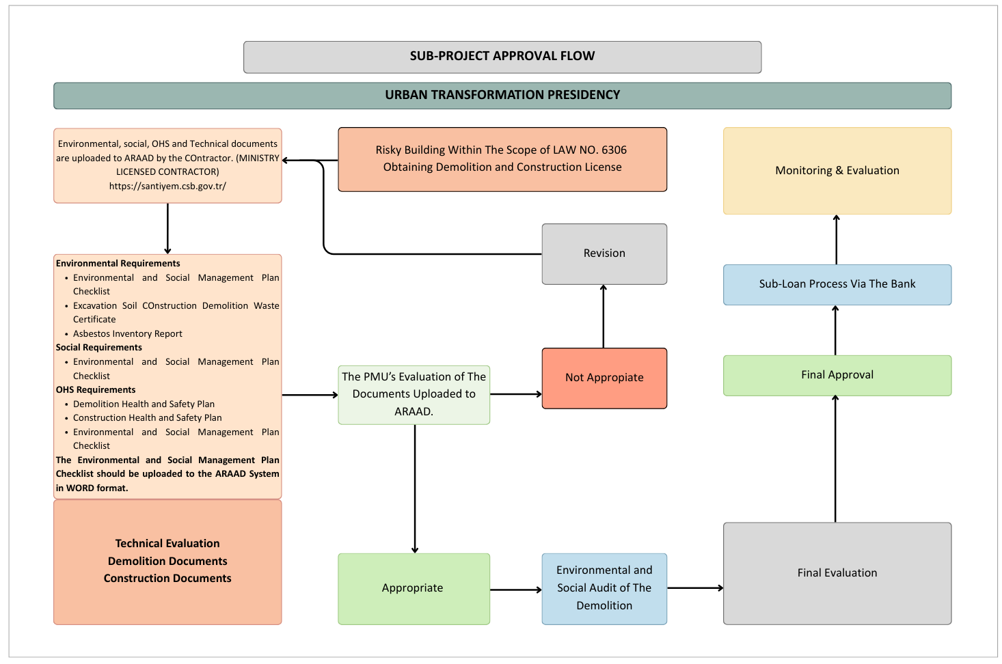

ANNEX 1- LEGAL AND REGULATORY FRAMEWORK
1.1. Legal Framework

1.1.1. Legal Framework for Environmental Protection & Conservation in Türkiye
Turkish environmental legislation has been developed in line with both nationally determined standards and international agreements, contracts, protocols and detailed standards, and has been revised especially in the recent years within the scope of pre-accession regulations under the framework of harmonization with the European Union (EU) Directives.
The Ministry of Environment, Urbanization and Climate Change (MoEUCC), with its changed name in line with the Presidential Decree No. 85 published in the Official Gazette No. 31643 of October 29, 2021, is the primary responsible organization for the protection and preservation of the environment, the development of sustainable cities and settlements and the natural environment and the implementation of the policies developed on the sustainable management of resources. The central organization of the MoEUCC is located in the capital Ankara, and there are Provincial Directorates in each province. The central organization consists of the following directorates and general directorates, with the last change in the name and structure of the MoEUCC:
- General Directorate of European Union and Foreign Relations
- Directorate General for Infrastructure and Urban Transformation Services
- General Directorate of Environmental Management
- General Directorate of Geographic Information Systems
- General Directorate of Environmental Impact Assessment, Permit and Inspection
- General Directorate of Spatial Planning
- General Directorate of Protection of Natural Assets
- General Directorate of National Real Estate
- General Directorate of Combating Desertification and Erosion
- Directorate of Turkish Environment Agency
- Directorate of Climate Change
- General Directorate of Construction Works
- General Directorate of Personnel
- Directorate of High Technics Board
- Directorate for Strategy Development
- General Directorate of Legal Services
- Department of Support Services
- General Directorate of Vocational Services
- Department of Training and Publication
- General Directorate of for Local Authorities
- Directorate of Revolving Fund Management
In line with the above-mentioned decree, the General Directorate for Combating Desertification and Erosion, which was previously affiliated to the Ministry of Agriculture and Forestry, is included among the central units of the MoEUCC and the Directorate of Climate Change was established as an affiliated institution of the MoEUCC.
The duties and responsibilities of the MoEUCC can be summarized as preparing the legislation on settlement, environment and development, carrying out urban transformation works, supervising the implementations, ensuring the development of professional services, preventing environmental pollution, protecting the environment and nature, and combating climate change.
The national Environmental Law (Law No. 2872), which first came into force in 1983, addresses environmental issues in a wide scope. Under the Environmental Law, environmental regulations have been developed in line with national and international policies and standards, and as mentioned earlier, some of these regulations have been recently revised to align with EU Directives as part of Türkiye's pre-accession efforts.
Apart from and as complementary to the Environmental Law and regulations, the laws listed below also contain provisions on the protection of the environment, the protection/management of natural resources and cultural and natural assets, the prevention & control of pollution and the implementation of measures to be taken for the prevention of pollution. The laws governing provisions relating to social impacts and provisions relating to health & safety and labor matters are also listed below:
- Expropriation Law (Law No. 2942)
- Forest Law (Law No. 6831)
- Law on Groundwaters (Law No. 167)
- Labor Law (Law No. 4857)
- Occupational Health and Safety Law (Law No. 6331)
- Law on the Protection of Cultural and Natural Assets (Law No. 2863)
- Law on Soil Preservation and Land Utilization (Law No. 5403)
- Mining Law (Law No. 3213)
- Municipality Law (Law No. 5393)
- Law on National Parks (Law No. 2873)
- Law on Pastures (Law No. 4342)
- Public Health Law (Law No. 1593)
- Settlement Law (Law No. 5543)
- Highway Traffic Law (Law No. 2918)
- Electricity Market Law (Law No. 6446)
- Energy Efficiency Law (Law No. 5627)
The Urban Transformation Presidency, established with the Presidential Decree No. 153 published in the Official Gazette No. 32341 of October 16, 2023 is affiliated to the MoEUCC. The UTP is a special budget public entity and manages the transformation of areas under disaster risk and of areas / lands where risky buildings present outside of the areas under disaster risk. UTP carries out its activities in close cooperation with Turkish Housing Development Administration (TOKİ), ILBANK and other subsidiaries of the Ministry, including local authorities. UTP is responsible for ensuring the determination of urban transformation, renewal and transfer areas, as well as the fulfilment of the determination, arrangement and valuation works & procedures on the risky structures; to carry out all kinds of maps, plans, projects, land and land arrangement processes and land consolidation regarding risky areas, reserve building areas and areas with risky structures; to carry out the determination of ownership, conciliation, expropriation, valuation of properties in the transformation practices, to come to agreement with the property owners within the framework of the procedures and projects prescribed by the Presidency, to carry out the works and procedures with regards to allocation of flat ownership, registration and transfer of development rights.
1.1.2. National Environmental, Social & Occupational Health and Safety Legislation & Regulatory Requirements
Within the framework of the laws listed above, the regulations, by laws and communiqués that have been enacted separately within the scope of environmental, social and occupational health and safety (OHS) matters are listed below:
Environmental Permits and Licenses
- Regulation on Environmental Impact Assessment
- Regulation on Environmental Permits and License
- Regulation on Environmental Audit
- Regulation on Environmental Management Services
Land Use and Soils
- Regulation on Conservation, Use and Planning of Agricultural Land
- Regulation on the Implementation of Paragraph 3 of Article 17 and Article 18 of the Forest Law
- Regulation on Land Consolidation and On-farm Development Services Implementation
- Regulation on Pastures
- Regulation on Soil Contamination Control and Point Source Land Pollution
Water
- Regulation on Surface Water Quality
- Regulation on Water Pollution Control
- Regulation on Water Intended for Human Consumption
- Regulation on Urban Wastewater Treatment
- Regulation on the Protection of Groundwater against Pollution and Deterioration
- Regulation on Control of Pollution Caused by Dangerous Substances in Water and Its Environment
- Regulation on the Protection of Drinking-Potable Water Basins
Waste
- Regulation on Waste Management
- Regulation on Control of Packaging Waste
- Regulation on Control of Excavated Soil, Construction and Demolition Wastes
- Regulation on Control of Medical Wastes
- Regulation on the Management of Waste Oils
- Regulation on the Control of Vegetable Waste Oils
- Regulation on the Control of Waste Batteries and Accumulators
- Regulation on the Control of End-of-Life Tires
- Regulation on Landfilling of Wastes
- Regulation on the Control of Waste Electrical and Electronic Equipment
- Regulation on the Control of End-of-Life Vehicles
- Zero Waste Regulation
- Communiqué on Recovery of Some Non-Hazardous Wastes
- Regulation on the Demolition of Buildings
Since the waste management would be one of the crucial issues during the activities within the scope of Component 2, brief summaries of some of the specific regulations regarding waste management are presented below:
Regulation on Waste Management: Regulation on Waste Management can be regarded as the framework regulation regarding waste management requirements and applications in Türkiye. It defines duties / authorities / responsibilities of all relevant parties, which are, the MoEUCC, Provincial Directorates, Municipalities, Waste Generators / Producers and Waste Processing Facilities. Codes of all kinds of wastes, including both hazardous and non-hazardous ones, and specific requirements are also defined in the regulation. The purpose of the regulation is determining the borders of the waste management principles and also managing the waste practices. General principles of this regulation include less uses of natural sources, development of environment-friendly technologies, minimum damage to environment, reusable and recyclable producing, minimum energy use, acceptable waste management activities such as less waste producing, proper waste collecting, separating, transporting and disposing techniques (Reduce – Reuse – Recycle). Previous regulations on waste management (solid waste, hazardous waste, etc.) have been assembled together in this regulation with the new applicable instruction and suggestions according to the international environmental standards. According to the regulation, hazardous wastes, medical wastes, used batteries & accumulators and medical wastes, as well as used tires, recyclable wastes such as packaging wastes must be disposed of separately from residential wastes. Furthermore, generators or transporters are strictly prohibited to dump wastes into recipient media such as seas, lakes and the like as well as on to streets, in forests and any other spots where they would adversely affect the environment. According to the regulation, anyone generating hazardous waste is obligated to take measures so that waste generation would be minimized, to ensure waste management in order to minimize the effects of wastes on human health and environment in compliance with the provisions of this Regulation, to prepare a 3-year waste management plan and obtain Provincial Directorates’ approval therefor, and obtain authorization from Provincial Directorates likewise in case of temporary storage of wastes in their facilities in compliance with the provisions of this Regulation.
Regulation on Control of Excavated Soil, Construction and Demolition Wastes: This is the specific regulation which defines requirements regarding excavated soil and construction & demolition wastes. According to Article 9 of the regulation, anyone generating excavated soil and construction / demolition wastes is required to ensure waste management in order to minimize the negative effects of the wastes on the environment and human health in compliance with the provisions of the regulation. Waste generators cannot dump their wastes at any spots other than such recovery or storage sites exclusively permitted by a municipality.
Regulation on the Demolition of Buildings: This Regulation is prepared based on the Environment Law No. 2872 and the Zoning Law No. 3194 and it was actually published in the Official Gazette back in October 2021 but it was stipulated come into effect as of July 1, 2022. The purpose of this regulation is “to regulate the procedures and principles pertaining to realizing the activities of building demolition in a manner that will not harm the environment, human health and safety.” This regulation does associate itself with the Law No. 6306, stating that “The provisions of the Law No. 6306 and the relevant legislation thereof shall remain reserved”. However, this regulation precludes demolitions to be performed in the scope of the Law No. 7269 on the Aids to be Given and Measures to be Taken Due to Disasters Affecting Public Life.
The aim in the enactment of this regulation is to protect and preserve human/ community health, life and property safety, as well as the environment during demolition activities. In fact, the Regulation on Control of Excavated Soil, Construction and Demolition Wastes, the Regulation on Landfilling of Wastes, the Regulation on Waste Management and also the Regulation on Occupational Health and Safety in Construction Works are all referenced as legislation to be abided by. The regulation contains provisions on noise and vibration management, and control of dust emissions.
One of the novelties in this regulation is related to the prohibition brought by stating that, the main demolition can only be commenced after asbestos and similar hazardous chemical-containing fabrications are disassembled and removed, and after “selective demolition” is made. The demolition plan needs to contain a waste management plan as an annex that indicates the waste types, codes and amounts, and all this information will be recorded on the demolition license.
Selective Demolition is defined in the regulation as follows:
“ARTICLE 15 – (1) In order to ensure high rate of recycling of demolition wastes, to ensure that the hazardous wastes are sorted and separated before the demolition, other materials are reused, and the demolition wastes are separated at the source and recycled in a controlled and phased manner, selective demolition will be applied according to the Regulation on Control of Excavated Soil, Construction and Demolition Wastes.
(2) Selective demolition covers the stages of separation/ sorting of asbestos and other hazardous wastes; doors and windows, sanitary ware such as sinks, bathtubs and similar materials, all metal-based materials, wood-based materials, gypsum-based materials, tiles, non-bearing walls (such as bricks, gas concrete, concrete) materials, glass materials, polyvinylchloride/polyurethane materials, all natural stone coatings, materials used for waterproofing that can be removed; thermal insulation materials such as glass wool, rock wool, expanded polystyrene, extruded polystyrene, polyurethane, etc.; crushed and/or sieved granular materials under in-parcel road or asphalt, concrete and wooden coating layers in other areas; scraping or separation of bitumen and derivative layers in areas covered with bitumen and derivative materials.
(3) With selective demolition, reusable materials are separated, and waste generation is prevented. During the demolition activity, the wastes are separated and collected separately. Separately gathered wastes are collected without mixing with each other, the collected wastes are subjected to recovery and the wastes that cannot be recovered are disposed of in accordance with the provisions of the relevant legislation. The wastes are sent to the recycling and/or disposal facility, which has a license certificate within the scope of the Environmental Permit and License Regulation published in the Official Gazette dated no. 29115 of 10.9.2014.”
Air
- Industrial Air Pollution Regulation
- Regulation on Air Quality Assessment and Management
- Regulation on Exhaust Gas Emission Control
- Regulation on the Control of Air Pollution Caused by Heating
Chemicals
- Regulation on Classification, Labelling and Packaging of Substances and Mixtures
- Regulation on Transport of Dangerous Goods by Rail
- Regulation on Transport of Dangerous Goods by Road
- Regulation on the Control of Polychlorinated Biphenyl and Polychlorinated Terphenyl
Health, Safety and Work/Labor
- Communiqué on Workplace Hazard Classes Related to Occupational Health and Safety
- Regulation on the Protection of Employees from Noise-Related Risks
- Regulation on Protection of Employees from Vibration-Related Risks
- Regulation on Health and Safety Requirements for the Use of Work Equipment
- Regulation on Occupational Health and Safety
- Regulation on Occupational Health and Safety in Construction Works
- Regulation on Occupational Health and Safety in Temporary or Fixed-Term Employment
- Regulations on Safety and Health in Working with Chemical Substances
- Regulation on Occupational Health and Safety Signs
- Regulation on the Fight Against Dust
- Regulation on Safety Data Sheets Regarding Harmful Substances and Mixtures
- Regulation on Occupational Health and Safety Risk Assessment
- Regulation on Personal Protective Equipment
- Regulation on the Vocational Training of Persons to be Employed in the Jobs in Dangerous and Extremely Dangerous Classes
- Regulation on Work Inspection Committee of Ministry of Labor and Social Security
- Bylaw on Work Inspections
Noise
- Regulation on Assessment and Management of Environmental Noise
- Noise Emission in the Environment by Equipment for Use Outdoors Regulations
Social
- Implementing Regulation on Settlement Law
- Regulation on the Implementation of the Law on Private Security Services
Other / General
- Road Traffic Regulation
- Railway Safety Regulation
- Regulation on Railway Safety Critical Tasks
- Regulation on Construction Managers

1.2. National Laws on Social Impacts

1.2.1. National Laws on Labor & Working Conditions
The Project is expected to employ the following type of Project workers, as per ESS 2 and described in the Labor Management Procedures (LMP) of the CDRC Project, direct workers, contracted workers, community workers, primary suppliers and migrant workers. For further details on the types of workers in the Project, the numbers and characteristics of the Project Workers and scheduling of labor requirements check Subsections 2.1 through 2.4 of the LMP.
Occupational Health and Safety
In recent years, Türkiye has carried out a reform to improve the national OHS system by adapting a number of international and regional standards within the national level requirements for the prevention of occupational risks defined in the International Labor Organization (ILO) Occupational Safety and Health Convention No. 155 of 1981. The Convention was ratified by Türkiye in 2005 together with the Occupational Health Services Convention No. 161 of 1985 and Türkiye has also been a party to the Labor Inspection Convention No. 81 of 1945 since 1951. Türkiye adopted the Occupational Health and Safety Improvement Framework No. 187 of 2006 in 2014.
In 2012, an independent OHS Law No. 6331 came into force (20 June 2012). OHS Law regulates workplace environments and sectors (both public and private) as well as all classes of workers, including part-time employees, interns and apprentices. The legislation is comprehensive and generally applies to all sectors and many industries.
Labor and Working Conditions
Türkiye is a party to numerous conventions of ILO including, but not limited to, equal treatment of employees, gender equality, child labor, forced labor, OHS, the right to organize and minimum wage. Accordingly, Labor Law No. 4857 in force in Türkiye is largely in line with the requirements of ESS2.
There is also secondary legislation that may be applicable to the Project, including regulations regarding annual leave, working hours, overtime, minimum wage, and female and child workers. The Ministry of Labor and Social Security (MoLSS) has also published various communiqués and circulars that can be applied during the Project implementation, laying the groundwork for the implementation of the Labor Law.

1.2.2. National Laws on Community Health and Safety
The main national laws covering ESS4 (Community Health and Safety) are as follows:
- General Health Protection Law No. 1593
- Law No. 5378 on the Disabled
- Law No. 5188 on Private Security Services
- Law No. 7269 on the Aids to be Given and Measures to be Taken Due to Disasters Affecting Public Life
  - Building Earthquake Regulation in Türkiye (O.G. No. 30364 of 18.03.2018)
  - Disaster Regulation for Infrastructure (O.G. No. 26435 of 15.02.2007)
- Law No. 4708 on Building Auditing (Construction and Usage Permits)
- Zoning Law No. 3194 (Construction and Usage Permits)
- Law No. 6306 on Transformation of Areas Under Disaster Risk
Turkish Earthquake Code
The purpose of this Regulation is “to identify the required rules and minimum conditions in order to design and construct, under seismic effect, official and private building and building-like structures, partly or completely, which are planned to be re-built, modified or expanded, and to assess and reinforce the performance of the existing buildings under seismic effect”. The main principle of earthquake resistant design of new buildings according to this Regulation is to limit the formation of permanent structural damage in order to ensure that the structural and non-structural system elements in the buildings are not damaged in mild earthquakes, the damage that may occur in structural and non-structural elements in moderate earthquakes is limited and repairable, and to ensure life safety in severe earthquakes. Check the Regulation in question and the ESMF subsection 2.4. for further details.
Legal Framework and Practices Regarding Risky Buildings in Türkiye
The process related to the retrofitting/demolition/reconstruction of the risky buildings against disaster risk in Türkiye is regulated by the “Law No. 6306 on Transformation of Areas Under Disaster Risk” (hereinafter referred to as the “Law No. 6306” or simply the “Law”) and the “Regulation of the Implementation of Law No. 6306” (hereinafter referred to as the "Implementing Regulation").
According to the Law, "risky area" is defined as "an area determined by the President, which carries the risk of causing loss of life and property due to the ground structure or the construction on it", and "risky building" is defined as a structure that is inside or outside the risky area, has completed its economic life, or has a risk of collapse or severe damage, which is determined based on scientific and technical data.
The Law and the Implementing Regulation are the applicable national legislation components for “risky buildings outside the areas officially defined as risky areas and/or urban transformation areas” within the scope of the Project.
Risky Building Process
Risk Identification
Identification of risky buildings is done principally by the building owners or their legal representatives, at their own expense, within the framework of the procedures and principles set forth in the Implementation Regulation.
Risky Building Identification
According to Annex-2 of the Regulation entitled Principles Regarding the Risky Building Detection, the reports regarding the buildings which are determined as risky by the Licensed Institution/Organization through application of the owners, are submitted to the relevant Governorate (Provincial Directorate of Environment, Urbanization and Climate Change) by the Licensed Institution/Organization, or to the Administration (“Municipality”) in case the MoEUCC transfers its authority.
Informing the Owners
Notifications to the owners of the buildings about the buildings that are determined as risky buildings within the scope of the Law No. 6306 are made in accordance with the Notification Law No. 7201. It notifies the owners of the building that is determined as a risky building that a "risky building annotation" has been placed in the declarations section of the land registry of the relevant land registry office.
Objection to the Risky Building Detection
An objection can be made against the risky building detection by the building owners or their legal representatives to the Directorate (Provincial Directorate of Environment, Urbanization and Climate Change) of the place where the building is located, or to the Administration (Municipality) in case of transfer of authority by the MoEUCC.
If the risky building detection decision changes as a result of the consideration of the Technical Committee, this is reported to the relevant Directorate of Land Registry.
At this point, it should be noted that in case of objection to the risky structure detection explained in the Law and Implementing Regulation, or in case it is assessed that the acts and actions taken have caused an unjust treatment or loss of right, it is also possible to seek for judicial remedies.
Demolition of Risky Buildings
In the event that a risky building is detected, the Directorate requests the relevant Municipality to send necessary notifications and demolish the risky building. The owners of the immovable properties registered in the land registry as risky buildings by the Municipality are granted a period of not exceeding ninety days to demolish the risky buildings.
Post Demolition Process and Implementation
On the parcels where risky buildings are located, without seeking the requirement of demolition of the buildings and regardless of whether they are a stakeholder of the risky building or not, the decision on their allotment, division, abandonment, creation and registration to the land registry processes, re-construction of a new building, sale of shares, re-utilization in return for flat or revenue sharing and/or other methods is taken by at least absolute majority of the stakeholders in proportion to their shares.
For further information regarding the risk generation process, refer to the relevant sections of Subsection 2.4 of the ESMF.
Specific Provisions and Practices Regarding Risky Building Process
Structures and Buildings where the Process can be Applied
There is no obligation for a building license in order to perform a risk identification for any building by following the Principles Regarding the Risky Building Detection, through application of the owners and to proceed with the relevant process.
Provisions on Blocking the Process
According to the Law, a criminal complaint can be filed with the Office of the Chief Public Prosecutor, in accordance with the relevant provisions of the Turkish Penal Code No. 5237, depending on the action and state of the situation, against those who prevent the detection, evacuation, demolition and other operations (e.g., valuation) of risky buildings.
Retrofitting Rather than Demolition of Risky Buildings
In the event that the risky building is to be retrofitting instead of demolished, within the given periods of not less than sixty days for the risky building to be demolished, it is necessary for the owners to have technical possibility of the retrofitting determined, to take a retrofitting decision as specified in the Condominium Law, to have a retrofitting Project prepared and to obtain a license within the framework of the Zoning Legislation.
Guarantees and Termination Processes
If real and private law legal entities are performing an application on the parcels where the risky building(s) are located, a guarantee of 10% of the estimated cost of the building must be submitted to the Administration before the construction license is obtained by the construction contractor who will undertake the construction work.
Rental Assistance and Other Supports
Rental assistance can be provided to the owners of the buildings evacuated by agreement. The duration of assistance is 18 months in risky buildings outside the risky area.
- Owners of structures vacated through mutual agreement may be eligible for assistance. The duration of this assistance is 18 months for structures classified as risky but located outside designated risky areas.
- According to the Decision Regarding Assistance to Those Who Use the Risky Buildings Within the Coverage of Law No. 6306 Without Being Owner, Tenant or Having Limited Real Rights, which was enacted by the Council of Ministers Decision No. 2016/8663 within the scope of the Law, rental assistance is given:
- 18 months of rental assistance for those who are entitled,
- Twice the standard monthly rental assistance amount for slum owners
Some Provisions Related to the Rights and Practices after the Demolition of Risky Buildings
After the demolition of risky buildings, the real and personal rights contained in the register of these real estates as well as any annotation restricting or prohibiting the right of alienation, remain on the shares. These rights and annotations do not hinder the execution of transactions regarding amalgamation, allotment, division, abandonment, registration, construction servitude and condominium ownership in title deed and consent is not sought for these transactions. The rights and annotations specified at the stage of new construction servitude and condominium establishment are maintained only on the independent sections that will fall to the owner who is liable for the said rights and annotations, without seeking consent.
Evaluation of Regulations Regarding the Registration of Illegal Buildings in the Scope of Preparedness for Disaster Risks
In the urbanization process in Türkiye, rapid migration from rural to urban has brought along some problems, including irregular urbanization. In this process, illegal construction, which increased in the cities, emerged as one of these problems. The buildings in slum areas contain many risks, especially in the cities that are prone to disasters and in disaster situations, due to their poor material quality and poor physical conditions.
Arrangements made in order to reduce the risks posed by these buildings, which have increased in Turkish cities until today and can become riskier by adding additional floors, to register the structures, to identify and transform unqualified and irregular housing, have come to the fore.
Slum Law No. 775
The Slum Law No. 775 is a law that has been prepared and put into effect in order to enable the transformation of slums, most of which are seen as risky structures, especially in provinces with disaster risk. In accordance with the Law No. 6306 on the Transformation of Areas Under Disaster Risk, with the decision of the Council of Ministers "on Providing Aid to Those Who Occupy Risky Buildings Without being Owners, Tenants or Limited Real Rights within the Scope of Law No. 6306", those living in slums will be able to benefit from rental assistance and will be able to benefit from the housing or property they will acquire under the law. It has become possible for businesses to benefit from low-interest loan support.

1.2.3. National Laws on Land Acquisition
Within the scope of the legal framework in Türkiye, land acquisition/expropriation issues are regulated by the Expropriation Law No. 2942.
More detailed information on National Laws on Land Acquisition can be found in the Resettlement Framework (RF) prepared for this Project.

1.2.4. Overview of Labor Legislation: Terms and Conditions
According to the Labor Law No. 4857, the main categories of employment contracts are:
- Fixed-term (fixed- duration) and Indefinite-term (undetermined duration) Employment Contracts
- Full-Time and Part-Time Employment Contracts,
- Permanent and Temporary Employment Contracts,
- Seasonal Employment Contracts (Indefinite-Definite Duration),
- Work-on-Call Contracts,
- Employment Contracts with or without Trial Periods,
- Team Employment Contracts.

1.2.4.1. Wages and Deductions
Article 32 of the Labor Law No. 4857 defines wages in general as “the amount provided to a person by the employer or third parties in exchange for a job and paid in money”. Without discrimination, every worker has the right to be paid for the work he/she conducts. A worker’s salary cannot be lower than the minimum wage set by the state. There is a national minimum wage that applies to all workers in Türkiye. According to Article 39 of the Labor Law; minimum limits of wages are determined by the relevant commission of the Ministry of Labor and Social Security no later than every two years.

1.2.4.2. Working Hours
According to the Labor Law No. 4857; in general, the working time is a maximum of forty-five hours per week. Unless otherwise agreed, this period is applied by dividing it equally into the working days of the week in workplaces.

1.2.4.3. Rest Breaks
Workers are allowed to rest for at least twenty-four hours (weekly rest day) uninterrupted in a seven-day period, provided that they have worked up to 45 hours on the days before the weekly rest day.

1.2.4.4. Leave
According to Article 53 of the Labor Law, workers who have served at least one year in the workplace, including the trial period, are granted annual paid leave. The duration of the workers' annual paid leave is;
- If the service period is between one and five years, fourteen days (including five),
- Twenty days if more than five years and less than fifteen years,
- Twenty-six days (including fifteen) if fifteen years or more.
The annual paid leave duration cannot be less than twenty days for workers who are over the age of fifty. The provisions of this Law regarding annual paid leave do not apply to workers, working in seasonal or other jobs lasting less than one year in nature.

1.2.4.5. Overtime Work
According to Article 41 of the Labor Law; overtime work is working more than forty-five hours per week limit regulated within the framework of the conditions written in the law. Worker consent is required for overtime work.
Pregnant women and breastfeeding mothers cannot be required to do overtime work.

1.2.4.6. Labor Disputes
Under the Labor Law, employers can terminate contracts in two ways: (i) to give a valid reason (Articles 18-19) or (ii) termination with a valid reason (Article 25). If the contract of a worker with at least six months of seniority in a workplace with at least 30 employees is terminated, the worker may benefit from certain protections under the Labor Law. In order to terminate the employment contract effectively, the worker must be given a written notice and the legal notice periods must be followed. However, in some cases, employers may terminate the employment relationship for a fair reason (for health reasons, immoral, dishonorable or malicious behavior or other similar behavior, force majeure). In these cases, the employer is not obliged to comply with the legal notice periods and may terminate immediately.
National labor legislation contains provisions that allow workers to resolve disputes where there is a dispute between employer and worker about the essential terms and conditions of an employment contract or other aspects of work. Such disputes will be resolved in accordance with the Law on Mediation in Civil Disputes No. 6325 and Article 20 of the Labor Law No. 4857.
For further details about the labor legislation and its implementation, check the Project’s LMP Section 4.

1.2.5. International Agreements & Conventions
Türkiye has become a party to a number of international agreements and conventions/protocols to contribute to the management of environmental resources, biodiversity, occupational health and safety (OHS) and cultural heritage on a global and regional scale. The most basic of these agreements and conventions/protocols are listed herewith below:
Environment
- Vienna Convention for the Protection of the Ozone Layer and the Montreal Protocol on Substances that Deplete the Ozone Layer, (Official Gazette [O.G.] No. 20629 of 8-9.9.1990)
- UN Framework Convention on Climate Change (O.G No. 25266 of 21.10.2003)
- Kyoto Protocol to the UN Framework Convention on Climate Change (O.G. No. 27144 of 17.02.2009)
- United Nations Convention to Combat Desertification in those Countries Experiencing Serious Drought and/or Desertification, particularly in Africa. (UNCCD) (O.G. No. 23258 of 14.2.1998)
- Convention for the Protection of the Marine Environment and the Coastal Region of the Mediterranean (Barcelona Convention) (O.G. No. 17150 of 14.11.1980)
- Protocol for the Prevention and Elimination of Pollution of the Mediterranean Sea by Dumping from Ships and Aircraft or Incineration at Sea (The Dumping Protocol) (O.G. No. 24854 of 22.8.2002).
- Protocol on the Prevention of Pollution of the Mediterranean Sea by Transboundary Movements of Hazardous Wastes and their Disposal (Hazardous wastes protocol) (O.G. No 25346 of 14.1.2002)
- Protocol for the Protection of the Mediterranean Sea against Pollution from Land-Based Sources, Athens 1980 (Türkiye: O.G. No. 19404 of 18.3.1987)
- Protocol on Specially Protected Areas in the Mediterranean, Geneva 1982, (signed on 6.11.1986) (O.G. No. 19968 of 23.10.1988)
- Convention on the Protection of the Black Sea against Pollution and other related Conventions (Bucharest Convention) (O.G. No. 21869 of 06.03.1994)
- Basel Convention on the Control of Transboundary Movements of Hazardous Wastes and Their Disposal (Basel Convention) (O.G. No. 21804 of 30.12.1993)
- Stockholm Convention on Persistent Organic Pollutants
- Convention on Long-Range Transboundary Air Pollution (CLRTAP) (Türkiye: O.G. No. 17996 of 23.3.1983)
Biodiversity
- Convention on the Conservation of European Wildlife and Natural Habitats (Bern Convention) (Türkiye: O.G. No. 18318 of 20.2.1984)
- The Convention on Wetlands of International Importance Especially as Waterfowl Habitat (Ramsar) (O.G. No. 21937 of 17.5.1994)
- Convention on Biological Diversity (O.G. No. 22860 of 27.12.1996)
- Cartagena Protocol on Biosafety to the Convention on Biological Diversity (O.G. No. 25148 of 24.06.2003)
- The Convention on International Trade in Endangered Species of Wild Fauna and Flora (CITES) (O.G. No. 22672 of 20.06.1996)
- International Convention for the Protection of Birds, Paris 1959 (Türkiye O.G. No.12480 of 17.12.1966)
Cultural Heritage
- European Convention on the Protection of the Archaeological Heritage (O.G. No. 23780 of 08.08.1999)
- Convention Concerning the Protection of the World Cultural and Natural Heritage, Paris 1972 (O.G. No. 17959 of 14.2.1983)
- European Cultural Convention on 19.12.1954 (O.G. No. 9635 of 17.6.1957)
- Convention for the Protection of the Architectural Heritage of Europe (O.G. No. 20229 of 22.07.1989)
- UNESCO Convention on the Means of Prohibiting and Preventing the Illicit Import, Export and Transfer of Ownership of Cultural Property
- UNESCO Convention for the Safeguarding of the Intangible Cultural Heritage
- UNESCO Convention on the Protection and Promotion of the Diversity of Cultural Expressions
Occupational Health and Safety
- International Labor Organization Safety and Health in Construction Convention (O.G. No. 29190 of 29.11.2014)
- International Labor Organization Occupational Health and Safety and Working Environment Convention (O.G. No. 25345 of 13.01.2004)
- ILO Convention concerning the Prohibition and Immediate Action for the Elimination of the Worst Forms of Child Labor (O.G. No. 24307 of 03.02.2001)
- International Labor Organization Forced Labor Convention (O.G. No. 23243 of 27.01.1998)
- International Labor Organization Minimum Age Convention (O.G. No. 10220 of 02.06.1959)
- International Labor Organization Freedom of Association and Protection of the Right to Organize Convention (O.G. No. 21432 of 22.12.1992)
- ILO Convention on Workers' Representatives (O.G. No. 21432 of 11.12.1992)
- International Labor Organization Human Resources Development Convention (O.G. No. 21433 of 12.12.1992)
- International Labor Organization Employment Policy Convention (O.G. No. 15769 of 20.11.1976)
- International Labor Organization Social Security (Minimum Standards) Convention (O.G. No. 13922 of 10.08.1971)
- International Labor Organization Equal Remuneration Convention (O.G. No. 12484 of 22.12.1966)
- International Labor Organization Discrimination (Employment and Occupation) Convention (O.G. No. 12484 of 22.12.1966)
- International Labor Organization Abolition of Forced Labor Convention (O.G. No. 10686 of 21.12.1960)
- International Labor Organization Right to Organize and Collective Bargaining Convention (O.G. No. 7884 of 14.08.1951)

1.2.5.1. World Bank Environmental & Social Standards
ESS1: Assessment of Environmental and Social Risks and Impacts
This Standard sets out the requirements for assessing, managing and monitoring environmental and social risks and impacts associated with each phase of World Bank sponsored Projects.
ESS1 must be addressed in the assessment process, including the environmental and social impact/risks specified in Article 26 and presented below.
- Environmental Risks and Impacts covering the following:
- Projects defined in the Environmental Health and Safety Directive
- Community safety
- Climate change and other cross-border or global risks and impacts
- Materials that threaten the conservation, maintenance and restoration of natural habitats and biodiversity
- Ecosystem services and use of living natural resources (fishing, forests, etc.)
- Social Risks and Impacts covering the following:
- Threats to human health and safety, security
- Situations where Project impacts pose a risk to individuals or groups who may be disadvantaged due to their particular circumstances,
- Impacts on the livelihoods of the households, communities or individuals,
- Impacts on the continuation and accessibility of daily life

- Cultural Heritage risks include:
- The emergence of negative effects that may prevent continuity in tangible and intangible cultural structure, heritage or forms between the past, present and future,
- Protecting the cultural heritage from the negative effects of Project activities,
- The emergence of effects that will hinder the sustainability of cultural heritage.
ESS2: Labor and Working Conditions
Environmental and Social Standard 2 emphasizes the importance of employment and income generation for comprehensive financial development and poverty reduction. Healthy working conditions must be created by treating workers fairly.
ESS3: Resource Efficiency, Pollution Prevention and Management
This standard points to the requirements of resource efficiency and pollution prevention and management with a holistic approach in practice. The aim is to minimize the pollution caused by the Project with the sustainable use of resources.
ESS4: Community Health and Safety
ESS4 highlights issues of health, safety and security risks and their impact on communities due to Project activities. Particular attention must be paid to communities and individuals who may be vulnerable due to the impacts and risks of the Project.
ESS5: Land Acquisition, Restrictions on Land Use and Involuntary Resettlement
This standard emphasizes that involuntary resettlement must be avoided. If unavoidable, necessary measures must be taken to reduce the negative impacts on displaced people.
ESS6: Biodiversity Conservation and Sustainable Management of Living Natural Resources
Biodiversity conservation and the sustainability of natural resources are the main components of sustainable development. Biodiversity, supported by all ecological functions, including forests, must be preserved.
This standard also addresses the sustainable management of primary natural production and living natural resources and recognizes the need to consider the livelihoods of Project-affected parties, including those with access to or use of biodiversity or living natural resources.
ESS7: Indigenous Peoples/Sub-Saharan African Historically Underserved Traditional Local Communities
This standard does not apply to the Project
ESS8: Cultural Heritage
This standard indicates that cultural heritage provides continuity between the past, present and future in tangible and intangible forms. Necessary measures must be taken for the protection of cultural heritage in practices.
ESS9: Financial Intermediaries
This standard does not apply to the MoEUCC but to ILBANK, acting as a Financial Intermediary, which will be implementing Component 3 and 4b of the Project. ILBANK also has prepared their Environmental and Social Commitment Plan (ESCP), ESMF, RF and SEP specific to Component 3 and 4. ILBANK also has established its Environmental and Social Management System (ESMS).
ESS10: Stakeholder Engagement and Information Disclosure
The importance of open and transparent participation among stakeholders is emphasized as it is a necessary element of good international practice. It contributes to Projects in terms of effective stakeholder engagement, improving environmental and social sustainability, increasing the acceptance of practices and successful Project design.

ANNEX 2- CODE OF CONDUCT
As the Contractor, [insert the name of the Contractor]; We have signed a contract with [Employer's name will be inserted] for [job name and description to be entered]. These works [insert the names of the construction sites and other locations where the works will be done] will also be carried out. The contract obliges us to take measures to address environmental and social risks associated with work, including the risks of sexual exploitation, abuse and gender-based discrimination.
This Code of Conduct (CoC) is part of the measures we take to fight against environmental and social risks associated with work. It applies to all our employees at the site or other places where work is executed. Besides; this contract also applies to the personnel of each subcontractor and other personnel who assist us in the execution of the works. All such personnel are called “Contractor's Personnel” and are subject to the CoC.
This CoC defines the obligated behavior of personnel identified above as "Contractor's Personnel".
Our working environment; There will be an environment where unsafe, abusive or violent behavior will not be tolerated, and where all individuals can comfortably express their problems or concerns without fear of retaliation.
REQUIRED BEHAVIOR
Contractor's Personnel:
- Perform their duties adequately and selflessly;
- Comply with this CoC and all applicable laws, regulations and other requirements, including requirements to protect the health, safety and well-being of the Contractor's other personnel and any other person;
- Organize a safe working environment within the scope listed below:
- ensuring that workplaces, machinery, equipment and processes under each person's control are safe and do not pose a health risk;
- use of necessary personal protective equipment;
- taking appropriate precautions regarding chemical, physical and biological substances and agents; and
- following appropriate emergency operations procedures
- Report working conditions that he/she believes are unsafe or unhealthy and to avoid a working condition that he/she believes poses a serious danger to his life or health;
- Not to discriminate against specific groups such as women, people with disabilities, migrant workers or children and to treat other people with respect;
- Against other personnel of the Contractor or the Employer; not engage in any form of sexual harassment, including undesirable sexual advances, sexual solicitations, or any other verbal or physical behavior of a sexual nature;
- Not to attempt Sexual Exploitation (not engaging in any act or attempting to abuse vulnerable position, power difference or trust for sexual purposes; and not sexually abusing another, including, but not limited to, benefiting financially, socially or politically)
- Not to attempt Rape. This concept means any physical or other forced (even mild) penetration with the penis or other body part into the vagina, anus, or mouth. In addition, penetration of the vagina or anus with an object is also included in this concept. Rape; includes marital rape, anal rape / anal intercourse. Attempting to those listed in this article is considered an attempted rape. Rape of a person by two or more perpetrators is called gang rape;
- Not to attempt Sexual Assault. This concept; means any form of non-consensual sexual contact that does not result in or does not involve penetration. Examples include: attempted rape as well as engaging in sexual acts such as non-consensual kissing, caressing, or touching the genitals-thighs of individuals under the age of 18, except in a pre-existing marital situation;
- Complete trainings on environmental and social aspects of the Contract, covering OHS issues along with Sexual Exploitation and Sexual Assault;
- Report any violations of this CoC; and
- Not be hostile towards any person reporting a violation of this CoC, us as the Contractor, or the Employer, or anyone using the [Project Grievance Mechanism].

REPORTING OF THE CONCERNING SITUATION
All personnel observing a behavior that they believe violates this CoC or concerns them in any other way, they should immediately report that issue. This can be accomplished through one of the following:
- Contact [insert the name of the Contractor's Social Specialist who will deal with gender-based discrimination, or, if such an employee is noncompulsory under the Contract, insert the name of another personnel designated by the Contractor] via phone number [ ] or in written form [ ] or [ ] in person; or
- To reach the Contractor's instant hotline (if applicable), call [ ] and leave a message.
The identity of the individual will be kept confidential unless reporting of allegations is required by the law of that country. Anonymous complaints or allegations will be given due and appropriate consideration. We take all reports of potential abuse seriously and will investigate appropriate action. We will provide service providers with quick directions that can help appropriately support the survivor of the alleged incident.
Hostility will not be taken against anyone who raises a good faith concern about behavior prohibited by this CoC. Such a hostile situation constitutes a violation of this CoC.
CONSEQUENCES OF VIOLATION OF CODE OF CONDUCT
Any violation of this Code of Conduct by Contractor Personnel may have serious consequences, including termination of job and possible referral to the legal authorities.
FOR CONTRACTOR PERSONNEL:
I have a written copy of this Code of Conduct in a language I understand. If I have any questions about this Code of Conduct, I understand that I can contact [insert the name of the Contractor's gender-based discrimination contact], requesting clarification.
Contractor Personnel name: [Insert name]
Signature: ______________________________________________
Date: (month/day/year): ______________________________________________
Countersignature of the authorized Contractor Representative:
Signature: ______________________________________________
Date: (month/day/year): ______________________________________________

ANNEX 3- GRIEVANCE REGISTRATION FORM (GRF)
Şikayetin Alındığı Yer/  Location of Complaints Received |  | Tarih/  Date
Alan Yetkilisinin Adı/  Name of Person in Charge |  | Şikayet Kayıt No/  Complaint Register Number
Şikayete Konu Alanın Koordinatları/
Coordinates of The Area Subject to Complaint
ŞİKAYET SAHİBİ HAKKINDA BİLGİ / COMPLAINANT INFO
Şikayet sahipleri şikayetlerini isimsiz olarak iletebilirler. Ancak kimlik veya iletişim bilgilerinin verilmemesi, başvuru sahibinin, yapılacak düzeltici faaliyetler ve talebin durumu hakkında geri bildirim almasını engelleyebilir.
Applicants can submit their requests anonymously. However, if no ID or communication details are provided, this may prevent the applicant from receiving feedback regarding the corrective actions to be taken and the status of the request.
Ad Soyad/  Name Surname |  | Şikayetin Geliş Yolu /  Form of Complaint:
TC Kimlik No/  Identification Number |  | Telefon- Ücretsiz hat /  Phone –Free phone line  Telefon - Yardım hattı/  Phone –Free phone line
Telefon/ E-Posta  Telephone/ E-mail |  | Yüz yüze /  Face to face
Mahalle-Köy-İlçe-İl/  Neighborhood-Village –District - Province |  | İstişare Toplantısı/  Consultation meeting
 |  | Dilekçe / Petition
Proje web sayfası /
Project web page
CİMER /
CİMER
(Presidential Communication Center)
ŞİKAYET DETAYLARI / DETAILS OF COMPLAINT
Şikayet Konusu /
Complaint
Şikayet sahibi tarafından talep edilen çözüm /
Solution requested by the Complainant

ANNEX 4- SAMPLE GRIEVANCE CLOSEOUT FORM
Şikayet Kapatma Numarası:
Grievance Closure No:
Alınması Gereken Acil Önlemleri Tanımlayın:
Identify the urgent actions
Alınması Gereken Uzun Vadeli Önlemleri Tanımlayın (Gerekli İse):
Identify the long term actions (if necessary)
Tazminat Talebi Bulunuyor Mu?  Is there a claim for compensation? | Evet/Yes Hayır/No
Düzeltici Faaliyetin Kontrolü ve Kararı / Control And Decısıon Of Correctıve Actıon
Düzeltici Faaliyetin Aşamaları  Stages of Corrective Action | Verilen Sürenin Sona Erdiği Tarih Ve Yetkili Kuruluşlar  Date of Expiration of the Given Period and Authorized Institutions
1.
2.
3.
4.
5.
6.
7.
8.
9.
10.

ANNEX 5- GRIEVANCE REGISTRATION LOG

Grievance Registration Log
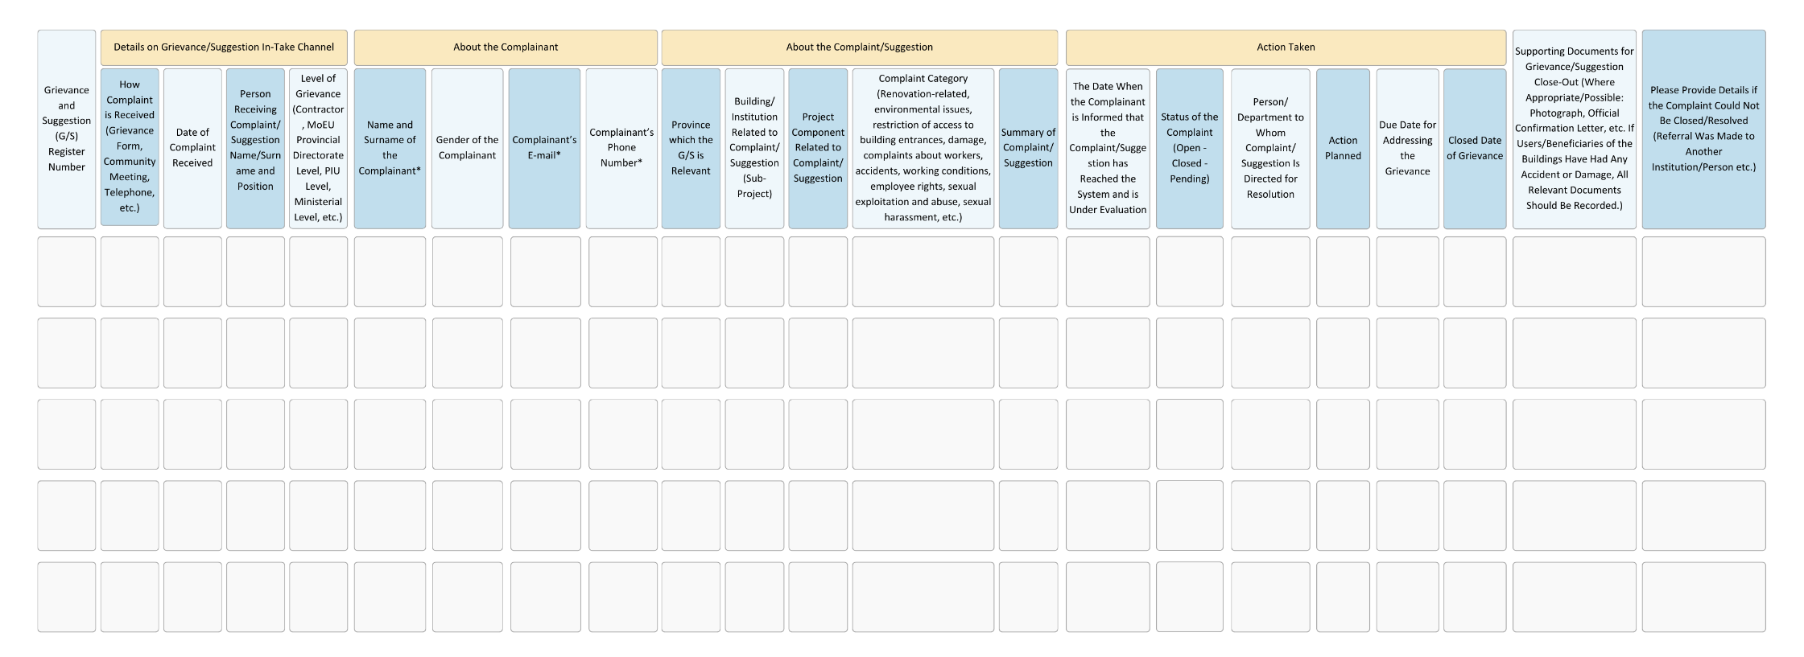

ANNEX 6- COMMUNITY SAFETY AND TRAFFIC MANAGEMENT PLAN
- Purpose and Scope
The purpose of this plan is to identify and describe various measures to reduce accidents, injuries and similar adverse situations resulting from potential traffic movements throughout the Project, as well as to minimize traffic jam and thus reduce fuel consumption, and to provide safe, fast and easy access for emergency vehicles.
The Traffic Management Plan is part of the Project's Environmental and Social Management Plan. It addresses traffic management of pedestrians, vehicles and construction equipment. This plan aims to minimize the potential impacts that may arise from the addition of vehicle movements generated by Project activities to existing roads.
The following aspects are included in the scope of this plan:
- Legal requirements and standards,
- Key tasks and responsibilities,
- Impact reducing precautions and Management Controls,
- Training, Reporting and Monitoring
This plan may be updated and revised as necessary.
- Legal Framework
2.1 National Legislation
- Transportation Law No. 4925 and Highway Transportation Regulation (Official Gazette 19/7/2003 No. 25173). During transportation, tonnage, truck sizes and load limits will be followed according to the legislation and existing roads will be arranged in accordance with Turkish standards according to the anticipated traffic type and capacity.
- Article 134 of the Road Traffic Law No. 2918 and Traffic Regulation,
- Transportation of Hazardous Material on the highway regulation (24.10.2013 Official Gazette; No. 28801)
- Prevention of Pollution Caused by Motor Vehicle Exhaust Gases Declaration (22/10/1992 Official Gazette No. 21383),
2.2 International Standards
- IFC Performance Standard 4: Community Health, Safety and Security,
- AIIB ESS 1: Environmental and Social Assessment and Management
- IFC General EHS Guidelines: World Bank Group's Community Health and Safety and EHS Guidelines
- According to -IFC PS 4; the role of Project activities in traffic, potential traffic load and road safety risks need to be identified, assessed and monitored. Implementation of the plan should include prevention of traffic accidents to protect lives of local residents and workers through transportation routes.
- Roles and Responsibilities
Roles and Responsibilities
Roles | Responsibilities
Project Management Unit (PMU). | - To ensure that adequate resources are provided to implement this procedure.  - Review and update the procedure when necessary
Contractor  Management Representative/Project Manager | - Ensuring that the management plan is implemented throughout the project.  - Provide oversight and make a routine audit to ensure that relevant activities suitable with the Management Plan.  - To Ensure that the activities are carried out in accordance with the Management Plan and relevant Procedures,  - Ensuring the necessary equipment and vehicles is in functioning.  - Supporting construction personnel in planning and coordinating traffic management in a timely and efficient manner.  - Ensuring that the OHS requirements of all personnel are met.  - Manage daily material deliveries and vehicle access to the site.  - Avoiding heavy traffic loads on frequently used roads, ensuring that access is only through designated routes, and planning the timing of deliveries and access.  - Liaise with the construction team in the planning, coordination and monitoring of traffic movements and facilitate the implementation of corrective actions.  - Prepare/ensure the preparation of necessary reports and keep accident reports and inspection reports  - To ensure that the tools and equipment used is in functioning in accordance with the manufacturer's specifications.

- Mitigation Measures and Management Controls

4.1 General Requirements
General Requirements
Project Phase | Potential Risk/Impact | Mitigation Measures | Responsibility
All Stages of the Project  (Pre-Demolition, Demolition, and Construction Phase) | Management of traffic and community safety impacts of the project | - Within the scope of the project, determining the roads and streets that can be used by heavy vehicles and those that are not suitable for use and creating a route map accordingly.  - Preventing the use of roads that would endanger public health and safety by taking the opinions of local authorities such as headman and municipality during the traffic risk analysis process  - Sharing route information, including the roads that will and cannot be used within the scope of the project, with drivers and relevant subcontractors and providing the necessary information/awareness. | Contractor

4.2 Province-Specific Requirements
Province-Specific Requirements
Project Phase | Potential Risk/Impact | Mitigation Measures | Responsibility
All Stages of the Project  (Pre-Demolition, Demolition, and Construction Phase) | Management of traffic and community safety impacts of the project | - Acting in cooperation with Sakarya Metropolitan Municipality Transportation Coordination Center Transportation Coordination Center UKOME on issues such as announcing the time intervals when heavy tonnage vehicles transport materials and equipment to/from the site, selecting alternative routes, etc. | Contractor

4.3 Sub-project Related Possible Requirements based on Types
Sub-project Related Possible Requirements Based on Types
Project Phase | Potential Risk/Impact | Mitigation Measures | Responsibility
All Stages of the Project  (Pre-Demolition, Demolition, and Construction Phase) | Management of traffic and community safety impacts of the project | - The construction site should be closed with a closure curtain (OSB, fence, etc.) in order to prevent unauthorized access to the construction site by third parties.  - Separating pedestrian roads from vehicle roads within the construction site, defining a separate transportation route for pedestrians  - The presence of blind spots outside the field of vision of machine operators during the movement of construction machinery. Use of pointers to avoid these risks.  - The tires of construction machinery and other vehicles should be selected in accordance with the land and climatic conditions, and worn tires should not be used.  - Warning the drivers and pedestrians outside the project with the necessary identification and caution plates on the roads and intersections about the construction site traffic  - Ensuring that drivers conform to legal speed limits  - Taking necessary measures to prevent the spread of dust (watering the construction site, covering the vehicles, etc) | Contractor

- Training, Reporting and Monitoring

5.1 Training
In addition to training on how to comply with environmental and social requirements for the sub-project as a whole, contractors should train their employees on how to comply with applicable mitigation requirements when performing their work. In addition to the Health and Safety training, other environmental and social training (e.g., Code of Conduct, waste management and sanitation) are described in the Sakarya ESMP. The trainings will include;
- OHS, environmental and social assessments,
- ESMP,
- Community health and safety,
- Community Safety and Traffic Management Plan
- Monitoring and reporting, and
- Other relevant topics.
Additionally, especially the contractor OHS focal point should be trained about the following subjects;
- Reporting of environmental accidents, OHS accidents and accidents that may affect public health and safety, and
- Reporting non-conformities to be identified through the implementation of C-ESMPs and ESMP Checklists.
The accident/incident reports of the OHS focal point must include, as a minimum, the following:
- The date on which the incident takes place and, the date on which it is found out if the latter is different
- Description of the incident
- The violated mitigation measures/environmental/social laws
- The parties that are present at the time of the incident
- The corrective actions taken to fix the problem and prevent its recurrence
- All necessary steps that need to be taken to remedy the situation, such as improvement
The non-conformity report must include, as a minimum, the following:
- The date on which the incident takes place and, the date on which it is found out if the latter is different
- Description of the problem
- The violated mitigation measures/environmental/social laws and the World Bank's ESF requirements
- The parties that are present at the time of the incident
- Description of the corrective steps taken
- If environmental damage occurs, a description of necessary follow-up steps or long-term improvement requirements
5.2 Reporting
Within the scope of the Project and sub-projects, reporting will be performed in line with the following responsibilities, scope, frequency and requirements:
Table of Reporting Requirements within the Scope of Implementations
Reporting Party | Reporting Requirements | Reporting Frequency | Party To Which Reports Will Be Submitted
Contractor / Contractor's OHS Focal Point | - Summary of the progress of demolition/retrofitting/construction activities schedule.  - Summary of the compliance activities according to the Sakarya ESMP, neighborhood-level ESIAs (if needed) and sub-project-specific ESMP Checklists.  - Up-to-date list of all accidents, incidents and near-misses that occur during the Project.  - Records of E&S trainings provided to personnel.  - Tracking information of all past issues still being resolved.  - Photos of the Project activities related to the implementation of the ESMP Checklist mitigation measures.  - Daily compliance checklist of the works that are performed every day on the site.  - Outputs of the performed activities in line with the - Provincial Environmental and Social Monitoring Plan presented in Section 5. | Once a month | The PMU individual specialists in the provinces.
PMU Individual Specialists in the Provinces | - Important points in the monthly reports of the Contractors / Contractor's focal points  - Outputs of the supervision, monitoring and auditing activities  - Progress of E&S Audits and ESAPs to be prepared for the Type-III sub-projects, if needed | Once A Month | The PMU Head Office
PMU Head Office | Using the reports of contractors and the PMU individual specialists in the provinces and their quarterly site monitoring outputs:  - Summary of the completed demolition/retrofitting/construction activities.  - Estimated remaining demolition/retrofitting/construction works and their schedule.  - Summary of the compliance activities.  - Outputs of the activities in line with the Sakarya Environmental and Social Monitoring Plans, whose format is presented in Section 5.  - Environmental Social, Health and Safety Key Performance Indicators (KPIs), such as:  - Statuses of grievances resolved per province,  - Properly prepared and approved ESMP Checklist per sub-project,  - Occupational accidents / incidents per province,  - Number of ESAPs (which are specific to Type-III sub-projects) whose actions are completed per Type-III sub-projects, and  - Ration of recycled construction demolition waste per province (approximately).  - Up-to-date list of Environmental, Social and Safety events.  - Up-to-date list of all accidents, incidents and near-misses that occur during the Project.  - Tracking information of all past issues still being resolved.  - Photos of Project activities.  The Project Progress Report, which will include not only the sub-project activities under Component 2, but also the activities under other components | Quarterly | WB

5.3 Monitoring
PMU has the experience and competence to oversee environmental and OHS issues associated with the implementation of the Project's construction activities, in particular in the context of field work, PMU's individual environmental and social experts in the provinces will supervise and monitor the contractors and report any issues identified in the field to the contractors and their liaison officers and agree on steps to rectify these issues. At this point, it should be noted that in an important event or accident that may affect / threaten the environment, occupational health and safety & community health and safety - fatal work accident, environmental spills and accidents that will put community and environmental health at risk, a work accident that may cause disability etc. - contractors will immediately inform the UTP and individual Environmental Specialists hired for provinces and the WB will be informed within 48 hours by the UTP. In such a case, the incident report, which includes (1) Root Cause Analysis studies, (2) measures to prevent the accident / incident from happening again, and specific compensation actions / corrective actions, will be submitted to the UTP by the contractor within 30 working days with the guidance and controls of the PMU individual specialists and the UTP will forward the incident report to the WB. The UTP will also report its findings in this context to the WB with their reporting. For the Project, the WB Project team will also visit Project sites from time to time and/or specifically as needed as part of Project supervision.
OHS Reporting Requirements Table
No | Parameter | Parameter Details / Mitigation | Monitoring Method and Location | Frequency | Responsibility
1 | Community Health and Safety / Traffic | Resolving the traffic congestion problem (if any) which were caused by the demolition activities performed. | Visual observations on and around of the sub-project site. | Daily | Contractor / Contractor’s OHS Focal Point
 |  |  |  | Weekly | PMU Individual Specialists in the provinces
2 | Community Health and Safety | Taking precautions regarding community health and safety (signing, provision of safety lines, informing locals etc.). | Visual observations on and around of the sub-project sites. | Daily | Contractor / Contractor’s OHS Focal Point
 |  |  |  | Weekly | PMU Individual Specialists in the provinces
3 | Dust and Noise | Taking compulsory measures within the scope of national legislation and to be detailed in the ESMP Checklists and Sakarya ESMP related to dust and noise. | Visual observations at sub-project sites and impact areas. | Daily | Contractor / Contractor’s OHS Focal Point
 |  |  |  | Weekly | PMU Independent Specialists of the cities
4 | Sub-project Traffic | Implementation of mitigation measures to be defined in Community Safety and Traffic Plans which will be prepared for each province. | Visual observations on and around of the sub-project sites.  Review of documentation/records such as;  - training records,  - speed limit violations,  - traffic related grievances | Daily | Contractor / Contractor’s OHS Focal Point
 |  |  |  | Weekly | Contractor / Contractor’s OHS Focal Point PMU Individual Specialists of the cities

ANNEX 7- RESOURCE EFFICIENCY AND POLLUTION PREVENTION PLAN
- PURPOSE AND SCOPE
Resource efficiency is the efficient and sustainable use of limited and exhaustible resources such as raw materials, energy and water to create more value using fewer inputs. It can also be defined as doing more with fewer resources and reducing the negative impacts of resource use.
The Resource Efficiency and Pollution Prevention Plan has been developed to identify the primary applicable requirements for waste management for the Project in accordance with relevant national legislation, the World Bank Environmental and Social Framework and relevant Environmental and Social Standards (ESSs). The Plan will be applicable to the retrofitting / demolition / reconstruction activities of the Project's subprojects, particularly under Component 2.
- STANDARDS
World Bank ESF Requirements
ESS3 recognizes that economic activity and urbanization often pollute air, water and soil and consume finite resources that can threaten people, ecosystem services and the environment at local, regional and global levels. Current and projected atmospheric concentrations of greenhouse gases (GHGs) threaten the well-being of current and future generations. At the same time, technologies and practices for more efficient and effective resource use, pollution prevention, and GHG emission avoidance and reduction have become more accessible and available.
ESS3 sets out requirements for addressing resource efficiency and pollution prevention and management throughout the life of the Project, consistent with Global International Industry International Practices (GIIP).
The objectives of the Resource Efficiency and Pollution Prevention and Management Standard are given below:
To promote the sustainable use of resources, including energy, water and raw materials
Prevent or minimize adverse impacts on human health and the environment by preventing or minimizing pollution from project activities.

Avoid or minimize project-related emissions of short- and long-lived climate pollutants
Prevent or minimize the generation of hazardous and non-hazardous waste
Minimize and manage the risks and impacts associated with pesticide use.
This plan outlines the resource efficiency and pollution prevention framework to be followed by the contractor.
This plan is prepared for implementation by the Project Management Unit (PMU), contractors and subcontractors. The roles and responsibilities for the implementation of the Plan are presented in Section 5.2.
- POSSIBLE SUB-PROJECT TYPES AND DETAILS
Potential Sub-Projects under Component 2
The rationale for Component 2 is the need for resilient housing/workplaces in the Project pilot provinces, which will greatly contribute to increased climate and disaster resilience. The Government of Türkiye faces several challenges in implementing the national regulatory framework supporting climate and disaster resilient urban transformation. Key challenges include the need for increased financing for retrofitting/reconstruction activities to meet resilience and energy efficiency standards, and the transfer of funding to municipalities to increase investments in resilient urban infrastructure. Accordingly, the sub-project types according to the activity to be realized can be listed as follows:
- Type-I: Sub-projects involving buildings that have been identified as risky structures but have not been demolished, and for which demolition and reconstruction activities will be carried out.
- Type-II: Sub-projects involving buildings that have been identified as risky structures, but have applied for loans for retrofitting instead of demolition and reconstruction, and accordingly, only retrofitting activities will be carried out.
- Type-III: Sub-projects that have been demolished after being identified as risky buildings and will apply for loans only for reconstruction activities within the scope of Component 2.

- SUMMARY OF IMPACTS
Retrofitting, demolition and reconstruction activities will cause noise and air pollution, as well as hazardous material risks such as chemical leakage risks. In addition, basic retrofitting/reconstruction requirements such as concrete, rebar, insulation material, etc., will be required as resources, as well as water for personnel use and fuels for vehicles and equipment.
Raw materials: The way materials are used is related to the production and consumption processes. Extracted natural resources are used for manufacturing purposes and then consumed as goods or services. Each process stage generates energy flows and by-products. The by-products are recovered or released into nature as waste and emissions. However, man-made materials are not easily recovered or degraded in nature due to their toxicity and non-degradable nature. Therefore, efficient use of raw materials and by-products is important to save energy and conserve natural resources.
Energy: It is accepted that a country's standard of living and energy consumption follow a parallel course. World energy consumption is constantly increasing. Unfortunately, the world's energy needs are mainly met from fossil fuels with limited reserves. Therefore, sustainable energy use should be ensured by reducing the consumption of fossil fuels, reducing greenhouse gas emissions, using energy efficiently and preferring alternative sources.
Water: Water resources are important for society and ecosystems and are required for agriculture, husbandry, energy production, navigation, recreation and manufacturing. The main issues related to water use are the abundance, availability and quality of resources in nature. While the status of water resources varies according to local conditions, climate change is also an important factor. As a result of climate change, the water demand of living things increases with increasing temperatures. On the other hand, water and energy systems are interconnected. Energy is required for water pumping, transportation and processing. Therefore, efficient use of water is necessary to improve living standards in the future.
Wastes: Project activities will result in the generation of various non-hazardous and hazardous wastes.
Non-Hazardous Wastes
Typical non-hazardous wastes are listed below;
- Household wastes,
- Recyclable waste (e.g., paper, glass, metals, wood waste, trees, cans, textiles, etc.),
- Packaging waste,
- Waste tires and
- Excavation wastes.
- Hazardous Wastes
- The different types of hazardous wastes likely to be generated as a result of the Project activities are listed below:
- Waste batteries and accumulators,
- Waste vegetable oil,
- Medical waste,
- Waste oil (from maintenance of equipment and vehicles, transformers, etc.),
- Waste paint,
- Other hazardous wastes related to operation and maintenance activities and
- Materials in contact with hazardous substances (including pesticide containers).
- Excavation, Construction and Demolition Waste
Soil and rock materials excavated during land preparation and construction will be reused on site as much as possible. Practices will be in place for the management of excess excavated material as well as other construction and demolition waste.
- MITIGATION MEASURES

Resource efficiency is the efficient and sustainable use of limited and exhaustible resources such as raw materials, energy and water to create more value using fewer inputs. It can also be defined as doing more with fewer resources and reducing the negative impacts of resource use.

Resource Efficiency and Pollution Prevention Plans
 | Mitigation Measures | Duties And Responsibilities
Air Quality | - Construction or waste materials shall not be burnt in open areas.  - Construction machinery will not be left idling for prolonged periods.  - Trucks used for material transportation will be covered, and speed limits will be enforced.  - All vehicles operating on-site will have valid exhaust emission permits and undergo regular maintenance.  - Water spraying will be conducted on transportation routes as needed to prevent dust formation.  - Regular maintenance of all vehicles will be ensured to minimize emissions.  - If dust is generated during air-powered drilling, mitigation measures such as continuous water spraying or the installation of dust barriers will be implemented. | Contractors
Soil and Groundwater | - Residual (excess) concrete from mixer trucks will not be washed on the construction site, its surroundings, or access roads.  - Concrete mixer drivers will receive appropriate training on waste management procedures.  - Hazardous chemicals and materials will be stored in a designated area to prevent leakage and spillage.  - Containers with partially used chemicals will be kept sealed when not in use. In the event of a hazardous substance or waste spillage, containment measures will be implemented to limit exposure. Workers capable of responding to such incidents will be provided with relevant leakage-spillage emergency response training.  - Proper spill containment kits will be placed at designated locations within the construction site. | Contractors
Solid Waste | - Household waste will be sorted at the source (plastic, glass, paper, etc.) and recyclable waste will be recycled.  - Non-recyclable waste will be collected in leak-proof bins and disposed of via the Sakarya Metropolitan Municipality's solid waste collection system. | Contractors
Noise level | - During the construction phase, the engine covers of generators, air compressors, and other mechanical equipment will be kept closed, and the equipment will be placed as far away as possible from residential areas.  - The noise generated during the construction phase will be limited to the time periods specified in the permits. Construction activities within or near residential areas will not be carried out during evening and nighttime hours, outside of the designated daytime working hours.  - Construction activities will be restricted to daytime hours as much as possible. In the case of activities taking place during evening or nighttime hours, the noise limits of 65 dBA for evening hours and 60 dBA for nighttime hours will be ensured. Additionally, the necessary approval from the Provincial Environmental Board will be obtained for evening and nighttime work.  - In case of increased noise levels during construction, measures such as not operating heavy machinery simultaneously or using newer model vehicles as much as possible will be taken.  - Residents living near the construction site will be informed throughout the construction period. | Contractors
Wastewater | - The wastewater generated during the construction activities will be integrated into the existing sewage system. | Contractors
Waste Oils | - Maintenance of machinery and equipment (e.g., oil change, battery replacement, etc.) will be carried out outside the Project Area by qualified service providers.  - If oil changes, battery changes, tire changes, etc. are unavoidable at the construction site, dedicated areas (with appropriate drainage) will be used for this purpose.  - An impermeable cover will be placed under the vehicles to prevent soil contamination, and this activity will be conducted away from water sources.  - In case of any oil/fuel/lubricant spillage or leakage at the construction site, pollution will be controlled using absorbent materials, and contaminated soil (if any) will be removed to a sufficient depth and stored as hazardous waste.  - All vehicles used in transportation will be equipped with absorbent material against any leakage or spillage. Workers will be instructed on the use and disposal of materials. Filters or materials saturated with petroleum products will be emptied into a suitable container to remove any free product before disposal.  - Waste oils will be temporarily stored, collected and disposed of in separate containers according to the categories specified in the Regulation on Control of Waste Oils. Waste oil will be collected in containers placed on an impermeable surface. Different containers will be used for different categories of waste oil. Waste oil temporary storage containers will be marked "Waste Oil".  - Waste vegetable oils will be temporarily collected in special containers. Waste oil will not be allowed to be discharged into receiving environments or toilets/sinks. | Contractors
Excavation, Construction and Demolition Waste | - Under no circumstances will excavation, construction, and demolition waste be disposed of on-site.  - Only the portion of cut trees and shrubs, such as small branches, leaves, etc., not collected by the relevant forestry authority will be left on site, as this material will contribute to increased growth of local flora through fertilization of the soil.  - Areas used for temporary storage of excavated waste will be reinstated as soon as the earthworks/construction activities in each relevant area are completed.  - Topsoil will be removed separately from the excavated material | Contractors

Duties and Responsibilities
Duties and Responsibilities
Project Management Unit (PMU) | - Ensure that adequate resources are provided for the implementation of this Plan.  - Review and update the Plan, as necessary  - Ensure that technical support is provided to contractors for the implementation of the Plan.  - Oversee contractor compliance with Project requirements through contractor monitoring and reports.
Contractors | - Ensure that this plan is implemented in line with Project standards  - Ensure, as its main responsibility, the implementation of the Plan (also by Subcontractors, if any) and report to the PMU on non-compliance and performance of the Plan implementation.  - Participate in the development of corrective and/or remedial actions when necessary (e.g., when non-compliances are identified, when there is a change in the relevant legislation, etc.).  - Provide relevant trainings.  - Carry out internal audits and daily audits and record non-compliances identified.  - Ensure that relevant non-compliances are recorded and responded to promptly.  - Review and update the Plan when necessary (in coordination with PMU).

ANNEX 8- WASTE MANAGEMENT PLAN
- Purpose and Scope
The Waste Management Plan was developed to identify the primary applicable waste management requirements for the Project in accordance with relevant national legislation, the World Bank Environmental and Social Framework and relevant Environmental and Social Standards (ESSs). The Plan will be implemented during retrofitting/demolition/reconstruction phases of sub-projects under Component 2.
Throughout the Project and sub-projects, different types of waste and materials will be generated from different sources and activities. The purpose of this plan is to guide and ensure the collection, separation, storage, processing, transportation, and disposal of non-hazardous and hazardous wastes resulting from Project activities in a way that minimizes impacts on human health and the environment, including minimizing the loss of valuable reusable/recyclable materials.
The plan is in line with national legislation, Resource Efficiency, Pollution Prevention and Management ESS3 requirements and other applicable Good International Industry Practices (GIIPs). The Plan will be implemented systematically throughout the Project and sub-projects along with the following relevant management plans, documents, and procedures:
- Province-based Environmental and Social Management Plan(s) (ESMP),
- Environmental and Social Management Plan Checklist
- Labor Management Procedure (LMP),
- Community Safety and Traffic Management Plan,
- Province-based Pollution Prevention Plans, and
- Stakeholder Engagement Plan (including grievance mechanism)
This Plan is a living document and responsibilities, procedures and compliance actions should be updated as appropriate.
- Legal Requirements & Standards
2.1. National Legislation
The Environmental Law No. 2872, published in the Official Gazette dated 11 August 1983 and numbered 18132, provides the legal framework for the regulation of sectors and their possible effects on the environment.
The Environmental Law has allowed the publication of various regulations. Those related to waste management and what the Project and sub-projects must comply with, are explained below.
2.1.1. Waste Management Regulation
Waste Management Regulation is the implementing regulation published with a purpose to comply with the European Union Waste Framework Directive. The Regulation was published in the Official Gazette No. 29314 and dated 2 April 2015. The Waste Management Regulation provides a single comprehensive framework for waste management. It has repealed and replaced the Solid Waste Management Regulation and the General Principles of Waste Management Regulation as of April 2015 and the Regulation on the Control of Hazardous Wastes as of April 2, 2016.
Article 9 of the Regulation regulates the obligations of waste producers and waste owners, including:
- Taking necessary measures to minimize waste production.
- Preparing and presenting the waste management plan with measures for the produced wastes and the prevention and reduction it.
- Making annual waste production notification through the internet-based system of the MoEUCC and
- When required, using the Urbanization and National Waste Transportation Form for wastes (the template is given in Annex 8-A of the Hazardous Waste Control Regulation, which was amended and repealed by the Waste Management Regulation).
2.1.2. The Regulation on Control of Excavated Soil, Construction and Demolition Wastes
The Regulation on Control of Excavated Soil, Construction and Demolition Wastes was published in the Official Gazette No. 25406 dated 18 March 2004. Articles 10, 34, 35, 36, 37, 38, 39, 40, 41 and 42 regarding the storage of wastes have been repealed by the Regulation on the Regular Storage of Wastes published in the Official Gazette dated 26 March 2010 and numbered 27533.
The purpose of this regulation; It is to determine the principles and procedures regarding the collection, temporary storage, transfer, recycling, reuse, and disposal of wastes in an environmentally friendly manner, as well as minimizing excavated soil, construction, and demolition wastes at the source of production.
Pursuant to Article 9 of the Regulation; Facilities producing excavation, construction and demolition waste are obliged to manage waste in a way that minimizes the negative impacts of waste on the environment and human health. Facilities must obtain the necessary permits for the generation, transport, and storage of waste. Facilities are not allowed to dump construction waste on places/locations and facilities other than those permitted by municipal or other authorities.
The regulation also stipulates that the Project owner is responsible for taking the necessary measures to minimize the noise and visual effects and dust emissions during the removal of the excavation material. The activity area should also be closed. In addition, planning should be done so that the amount of excavated soil is equal to the fill volume. Excavated soil should be used within the area of activity as much as possible.
2.1.3. Packaging Waste Control Regulation
Packaging Waste Control Regulation was published in the Official Gazette No. 28035 and dated 24 August 2011. The purpose of the regulation:
- To provide certain environmentally specific criteria, basic conditions, and properties for packaging production,
- To prevent the direct or indirect disposal of packaging wastes in a way that harms the environment, and
- To prevent and minimize the creation of packaging waste by using reuse, recycling, and recovery methods.
Packaging Waste Control Regulation states that packaging waste should be collected and stored separately from other wastes in order to ensure to reduce environmental pollution, make maximum use of landfills, contribute to the economy and it is disposed of without harming the environment.
The parties, which produce packaging waste within the borders of municipalities collecting wastes separately, are obliged to deliver the packaging wastes to the responsible municipalities or their contracted and licensed collection/separation organizations.
2.1.4. Waste Batteries
The Regulation on Control of Waste Batteries and Accumulators was published in the Official Gazette No. 25569 and dated 31 August 2004. The purpose of the regulation:
- To regulate the legal and technical principles for the determination of policies and programs from production to final disposal of batteries and accumulators,
- To ensure the production of batteries and accumulators with certain environmental criteria, basic conditions, and features,
- To prevent wastes from reaching to receiving environments,
- To provide the necessary technical and administrative standards in its management, and
- To establish a collection system for the recovery and final disposal of waste batteries and accumulators.
According to the regulation, battery and accumulator consumers are obliged to:
- To collect waste batteries separately from domestic waste,
- Delivering waste batteries to collection points to be established by businesses or municipalities that distribute and sell battery products,
- Delivering old accumulators to temporary storage areas created by businesses that distribute and sell accumulator products and those who operate vehicle maintenance and repair shops (accumulators cannot be delivered by waiting for more than 90 days after they become waste),
- Paying a deposit in case of purchasing a new accumulator without delivering the old ones, and
- To ensure that impermeable ground and other necessary conditions are provided in the temporary storage areas where batteries and accumulators will be stored.
2.1.5. Waste Oil Control Regulation
Waste Oil Control Regulation was published in the Official Gazette No. 26952 and dated 30 June 2008. The purpose of the regulation:
- To prevent the direct and indirect disposal of electrical waste and electronic waste oils to the environment.
- To ensure its temporary storage, transportation, and disposal without harming the environment and human health.
- To establish the necessary technical and administrative standards in the management of waste oils.
- To determine the necessary principles and programs for the establishment of temporary storage, collection, and disposal facilities, and
- To manage these facilities in an environmentally friendly way.
According to Article 9 of the Waste Oil Control Regulation, waste oil producers are obliged to take the necessary measures to minimize the creation of waste oils, including waste motor oils and residues from the processing of waste oils. Waste oil producers must make waste oil analyzes and report the production amounts to the MoEUCC. Waste oils of different categories should not be mixed with each other or with other hazardous wastes.
Waste oil producers must comply with the provisions of the Hazardous Waste Control Regulation for disposal. All records, including waste oil declaration forms and analysis reports, must be kept for at least five years. Regulations prepared by the MoEUCC should be followed for the transportation of waste oils.
Waste oil must be collected in red colored tanks/barrels, labeled as "Waste Oil". The barrels are placed in the warehouse with provisions for a sealed floor (at least 25 cm thick and lined with epoxy, geo membrane and similar insulating materials) as well as protection from rain.
2.1.6. Electrical and Electronic Equipment Waste Control Regulation
One of the main purposes of the Regulation, published in the Official Gazette No. 28300 and dated 22 May 2008, is to determine the methods and targets for minimizing the generation of electrical and electronic waste through reuse, recycling, and recovery.
2.1.7. Communiqué on Recovery of Certain Non-Hazardous Wastes
The Communiqué on Recovery of Certain Non-Hazardous Wastes was published in the Official Gazette No. 27967 and dated 17 June 2011. According to this communiqué, non-hazardous waste producers are obliged to prepare and implement a waste management plan for the recovery of these wastes, as well as minimizing their production.
Waste should be stored in sealed (or similar) containers in an impermeable floor and roof area. Non-hazardous wastes can be temporarily stored at the construction site until they are recovered, up to one year. Producers are also obliged to send their non-hazardous waste to licensed collection and separation or licensed recycling facilities. In addition, a three-year waste management plan must be prepared and submitted to the Provincial Directorate of Environment and Urbanization.
In addition, it is obligatory to fill in the non-hazardous waste declaration form every year with the information of the previous year and to submit these forms digitally to the MoEUCC. It was also stated that copies of the forms should be kept for 5 years.
2.2. World Bank ESF Requirements
2.2.1. Resource Efficiency, Pollution Prevention and Management - ESS3
ESS3 recognizes that economic activity and urbanization often pollute the air, water and soil and consume limited resources and can threaten people, ecosystem services and the environment at local, regional, and global levels. The current and projected atmospheric concentration of greenhouse gases (GHG) threatens the well-being of present and future generations. At the same time, more efficient and effective resource use, pollution prevention and greenhouse gas emission avoidance and reduction technologies and practices have become more accessible.
Throughout the Project lifecycle, the ESS3 determines the requirements regarding to resource efficiency and pollution prevention and management consistent with Global International Industry Practices (GIIP).
The objectives of the Resource Efficiency and Pollution Prevention and Management Standard are given below:
- To promote sustainable use of resources, including energy, water, and raw materials
- To prevent or minimize adverse impacts on human health and the environment by preventing or minimizing pollution from Project activities
- To prevent or minimize Project-related emissions of short- and long-lived climate pollutants
- To prevent or minimize the generation of hazardous and non-hazardous waste
- Minimizing and managing the risks and impacts associated with pesticide use.
2.3. European Union (EU) Legislation
European Union Directive 2000/532/EC2008/98/EC (Waste Framework Directive) predicts the general provisions regarding waste management and determines the basic waste management definitions. It requires the management of wastes without endangering human health and harming the environment, and without posing a risk to water, air, soil, plants, or animals, and without causing disturbance due to noise or odors, and without adversely affecting rural areas or areas of special interest. Directive replaced the old EU directive on waste, hazardous waste and waste oils and now covers all wastes defined by Decision 2000/532/EC (i.e., European Waste Codes).
In an effort to adjustment of Turkish environmental protection standards with the EU's Waste Framework Directive (2008/98/EC) and the European Commission Decision (2000/532/EC), which creates a waste list, the Republic of Türkiye the MoEUCC adopted a new waste management regulation that will affect the important waste generating companies in Türkiye. The waste management implementation regulation, published to comply with the Waste Framework Directive, was adopted in 2015. Currently, the waste codes given in Annex 3 of the Turkish Waste Management Regulation are exactly the same as the European Waste Codes.
- Roles and Responsibilities
Roles and responsibilities for the Environmental and Social (E&S) management of the Project are detailed in the Project ESMF. In this context, roles and responsibilities related to asbestos management are given in the table below:
Roles and Responsibilities
Roles | Responsibilities
Project Management Unit  (PMU) | - Ensure adequate resources are provided for the implementation of this Plan.  - Review and update the Plan as needed  - Ensure that technical support is provided to contractors for the implementation of the plan.  - Ensure that relevant training is provided by contractors through review of training records and relevant training documentation.  - Supervising the contractor's compliance with Project requirements through contractor monitoring and reports.
Contractors | - Ensure that this plan is implemented in line with Project standards  - As its main responsibility, to ensure the implementation of the Plan (also by the Subcontractors, if any) and to report the non-compliances and implementation performance of the Plan to the PMU.  - Participate in the development of corrective and/or remedial actions when necessary (for example, when non-compliances are detected or there is a change in relevant legislation, etc.).  - Provide relevant training.  - Performing internal and daily inspections and recording any detected non-compliances.  - Ensuring that relevant non-compliances are recorded and promptly responded.  - Review and update the Plan as needed (in coordination with the PMU).  - Ensure that asbestos management considerations are added in the daily checklist, which will be included in the monthly report to the PMU.
All Personnel | - Participating in training required for asbestos management.  - Provide self-competence for the implementation of this plan.

4. Waste Management
4.1. Waste Management Approach
The Waste Framework Directive (Directive 2008/98/EC) provides a waste hierarchy that sets priorities for the best overall environmental option in current waste legislation and policy. In this context, the EU waste hierarchy will also be the hierarchical approach of the Project and the waste management will be based on the following in descending order of preference:
EU Waste Hierarchy

No waste production if possible

Reducing waste generation at source

Reuse of waste/excess materials if possible

Recovery/recycling of waste materials, if possible

Disposal of waste off-site by a licensed waste company/municipality

The following good management practices will be used to minimize and appropriately manage site waste:
- Reducing waste generation (through management practices, avoiding or reducing material use, etc.) is the primary objective of this plan.
- Non-hazardous wastes will be separated from hazardous wastes.
- Waste recycling will be mandatory throughout all Project activities and relevant training will be provided.
- Wastes to be sent to licensed recycling/recovery companies will be separated according to their types.
- Efforts will be made to minimize the amount of hazardous materials used.
- Personnel working with hazardous materials and waste will be trained in proper use and management.
- Hazardous material leaks will be prevented through careful and logical management of materials.
- Where possible, non-hazardous alternatives will be used instead of hazardous materials.
- Regular inspections of storage areas will be made. Damaged or leaking containers will be replaced when detected.
- Corrective/Preventive maintenance will be performed on the equipment to prevent possible leaks.
- Waste storage areas will have secondary safety barriers or overflow containers.
- Under no circumstances, wastes will be disposed of at the construction site.

4.1. Classification of Waste
Project activities will result in the generation of various non-hazardous and hazardous wastes.
4.2.1. Non-Hazardous Wastes
Typical non-hazardous wastes are listed below.
- Domestic waste,
- Recyclable waste (e.g., paper, glass, metals, wood waste, trees, tin cans, textiles, etc.),
- Packaging waste,
- Waste tires and
- Excavation waste.
4.2.2. Hazardous Wastes
Different types of hazardous wastes possibly to be generated as a result of Project activities are listed below:
- Waste batteries and accumulators,
- Waste vegetable oil,
- Medical waste,
- Waste oil (from the maintenance of equipment and vehicles, transformers, etc.),
- Waste paint,
- Other hazardous wastes related to operation and maintenance activities and
- Materials that come into contact with hazardous materials (including pesticide boxes).
4.3. Implementation
4.3.1. Waste Collection, Storage, Transportation and Disposal
An industrial (hazardous and non-hazardous) waste management plan will be prepared in line with legal requirements and submitted to the Provincial Directorate of Environment and Urbanization. In addition, it is obligatory to fill in the waste declaration form every year in March, with the information of the previous year and to submit these forms digitally to the MoEUCC.
4.3.2. Collection, Separation and Storage
Wastes will be separated and temporarily stored in safe storage areas that are defined separately for hazardous and non-hazardous wastes. Transportation and final disposal activities are explained in Part 4.3.3.
Non-Hazardous Wastes
The management of non-hazardous wastes will be as follows:
- Domestic wastes will be collected in special bins in accordance with the Waste Management Regulation and will be temporarily stored at the construction site.
- Recyclable wastes will be separated and temporarily stored on site in designated areas.
- Packaging wastes will be collected separately and temporarily stored in the areas reserved for them at the construction site in accordance with the Packaging Waste Control Regulation.
- Appropriate waste containers will be provided at waste generation sites to facilitate safe and environmentally sound temporary storage. All containers will be clearly marked according to their contents.
Hazardous Wastes
The management of hazardous wastes will be as follows:
- In accordance with international standards and international common practice, hazardous wastes will be stored in undamaged, leak-proof, safe and suitable containers. In line with the relevant legislation, a specific area with a concrete floor will be used for storage.
- All waste containers to be used, will have a clear label and an accurate description of the waste type. This will inform site and external personnel for the safe collection and transport of waste. All unidentified waste will be considered hazardous waste. Waste labels will include information such as waste classification/category, waste volume, MSDS and required PPE. All old labels on containers will be removed or sealed to avoid confusion.
- Hazardous waste containers will be inspected regularly to determine if they are damaged or has any leaks.
- Hazardous waste containers will be kept closed and wastes will be stored in a way that no chemical reaction occurs.
- Vehicles and construction machinery will be used in the land preparation, construction, and closure phases of the Project. Maintenance of machinery and equipment (e.g., oil change, battery change, etc.) is planned to be done by qualified service providers outside the Project Area. If it is necessary to perform such activities (oil change, battery change, tire change etc.) at the construction site, areas reserved for this work (with appropriate drainage) will be used. In order to prevent soil contamination, a sealed cover will be placed under the vehicles and this activity will be performed away from water sources. If any oil/fuel/lubricant spills or leaks occur at the construction site, the pollution will be controlled by using absorbent materials and the contaminated soil (if any) will be taken to a sufficient depth and stored as hazardous waste.
- All vehicles used for transportation will have absorbent material against any leakage or spillage. Workers will be informed about the use and disposal of materials. Filters or materials saturated with petroleum products will be discharged into a suitable container to remove any free products prior to disposal.
- Waste oils will be temporarily stored, collected, and disposed of in separate containers according to the categories specified in the Waste Oil Control Regulation. Waste oil will be collected in containers placed on an impermeable surface. Different containers will be used for different categories of waste oils. There will be a "Waste Oil" sign on the waste oil temporary storage containers.
- Waste vegetable oils will be temporarily collected in special containers.
- Bulbs containing mercury
- Waste oils will not be allowed to be discharged into receiving environments or toilets/sinks.
- Waste batteries and accumulators will be collected and stored separately in accordance with the Regulation on Control of Waste Batteries and Accumulators.
- Vehicle maintenance in the Project will be done outside the construction site. However, when it is necessary to change the tires of vehicles and construction machines, the changed tires will be kept in the places reserved for them in accordance with the Waste Tire Control Regulation.
- Medical wastes will be collected separately from other wastes in accordance with the Regulation on Control of Medical Wastes.
- Project activities do not require the use of explosives. However, if necessary, waste explosives will be stored in containers of the same type as the original but marked as explosive waste and transported by licensed companies.
Excavation, Construction and Demolition Wastes
Soil and rock materials excavated during the land preparation and construction phase will be reused on site as much as possible. In addition to the excess excavation material to be generated, the following practices will be conducted for the management of other construction and demolition wastes:
- Excavation, construction, and demolition wastes will not be disposed of at the construction site, under any circumstances.
- Only the part of cut trees and shrubs such as small branches, leaves that is not collected by the relevant forestry authority will be left on the site, as this material will contribute to increased local flora growth through soil fertilization.
- Areas used for temporary storage of excavation waste will be restored as soon as the excavation works/construction activities in each relevant area are concluded.
- Topsoil will be taken separately from the excavation material.

4.3.3. Transportation and Disposal
Non-Hazardous Wastes
The following management controls will be implemented for the transport and recycling, recovery, and disposal of non-hazardous wastes:
- A protocol will be signed with the relevant municipality for the transportation of domestic wastes to the sanitary landfill.
- Agreements will be signed with licensed companies for the transport of separated recyclable waste and packaging waste.
- The part of the excavation waste that cannot be reused at the construction site will be transported to the excavation, construction, and demolition waste disposal areas, which are approved by the relevant municipality. This process must comply with the Regulation on Control of Excavation, Construction and Demolition Wastes.
- The company's agreements with licensed waste facilities will be added to this plan.
Hazardous Waste
The following management controls will be implemented for the transport and reuse, recovery, recycling, and disposal of hazardous waste:
- Hazardous wastes will be transported out of the construction site when the storage at the construction site approaches the maximum storage capacity levels. Hazardous wastes will be securely packaged and labeled before they are removed from the site to ensure they are transported safely to an approved landfill without harming the collectors or the environment.
- Waste batteries and accumulators collected separately; will be delivered to collection points established by municipalities or businesses engaged in the recovery, distribution, and sale of battery products.
- Waste tires; will be handed over to licensed transport, recycling or (as fuel) reuse companies.
- Medical wastes will be sent to a nearby health facility or medical waste disposal company under the supervision of the workplace physician.
- Waste oils will be transported to licensed processing and disposal facilities by licensed carriers. Before the transportation, the National Transportation Form will be filled, and the annual waste oil declaration form will be submitted to the relevant authorities.
- Waste vegetable oils collected in special containers will be sent to licensed companies for reuse/recovery.
- Licensed disposal facilities will be used for the transportation and disposal of other hazardous wastes.
- The company's agreements with licensed waste facilities will be added to this plan.
5. Monitoring and Reporting
Waste types, amount of collected waste of each type and waste classifications will be recorded monthly. Records of generated waste, from the time of production to the destination, will be kept. A sample waste registration form for this purpose is presented in Annex-1.
Annual waste declaration forms (online internet-based system of the MoEUCC, http://online.cevre.gov.tr) and National Waste Transport Forms (template, given in Hazardous Waste Control Regulation – Annex 8-A, which was repealed on April 2, 2016) will be stored at the construction site for 5 years.
During the construction and operation phase, daily inspections will be conducted regarding the management of waste at the construction site.
A sample checklist of issues to be addressed during inspections is provided in Annex-2. In addition to these inspections, quarterly internal inspections will be conducted during the construction phase. Inspection and monitoring results will be presented to the PMU and the World Bank as part of the biennial report.
Based on monitoring and inspection results, corrective and/or remedial actions will be determined and implemented. The performance of these activities will also be monitored and reported.
- Trainings
The contractors will ensure that adequate training is provided to all personnel (including those of subcontractors, if any). The scope of the training covers the waste management duties and functions of workers; and ensures them to be aware of relevant aspects of this plan, relevant legislation and standards, and general waste management practices (e.g., tidiness, waste separation).
Details of the training (e.g., participants, topics, training hours provided) will be recorded and records kept on site. Personnel who routinely work with hazardous wastes and materials; will receive additional specialization training in which special handling, separation, labeling, storage, spill response and disposal requirements are explained in detail.
- Review & Update
This Plan is a 'living' document and responsibilities, procedures and compliance actions should be updated if needed (for example, following a change in legislation). It is the responsibility of PMU and contractors to be fully aware of its contents. Contractors will provide relevant training to personnel and ensure that measures/commitments are implemented to ensure compliance with this Plan.
Date (Month/Year): Waste Registration Form No:
No | Date | Waste Type (Hazardous/Non-Hazardous) | Subtype | Waste Amount (ton/m³) | Transporter | Disposal | Disposal Method
1
2
3
4
5

ANNEX 9- ASBESTOS MANAGEMENT PLAN
- Purpose and Scope
This Asbestos Management Plan (AMP) explains how the risks arising from asbestos-containing materials should be managed in all subprojects. This AMP also specifies asbestos-related procedures within line the Climate and Disaster Resilient Cities Project (Project) and is designed to effectively manage and minimize asbestos-related health risks to those working on the Project.
This plan is applied to the employees of the Urban Transformation Presidency of the Ministry of Environment, Urbanization and Climate Change, and all contractors who will work in deconstruction and construction works to be assigned within the Project.
This Plan is a 'living' document and responsibilities, procedures and compliance actions should be updated as appropriate.
- Legal Requirements & Standards
  - National Legislation
The rules regarding the use of asbestos in Türkiye are regulated by the regulations, communiqués, and standards of different ministries.
In this context, the most important legislation is the Regulation on Health and Safety Precautions in Working with Asbestos, prepared by the Ministry of Labor and Social Security (MoLSS) and published in the Official Gazette (OG) dated 25/01/2013 and numbered 28539. With this legislation, regulations were made on the prevention of exposure of employees to asbestos dust in asbestos removal, deconstruction, repair, maintenance, and removal works, and protection from health risks arising from this exposure, and also on determination of limit values and other special precautions.
With the Dust Fighting Regulation (Date of OG: 02/04/2015, No:29314), prepared by the MoLSS and published in the OG dated 05/11/2013 and numbered 28812; the procedures and principles regarding the necessary precautions to be taken in order to combat dust in terms of occupational health and safety and to protect the workers from the effects of dust and prevent the risks that may arise from dust in the workplaces, were determined.
The most up-to-date regulation regarding asbestos safety in national legislation is the "TS 13633 Practice Rules for Complete and Partial Demolition of Buildings" standard, published by the Turkish Standards Institute. In the aforementioned standard, the basic principles of the operations regarding asbestos, which may cause significant health and safety risks, during the office work and field research to be performed before the complete and partial (restoration, deconstruction, etc.) demolition operations for the buildings are specified, and a special title is given on the subject of asbestos.
With the Communiqué on Asbestos Removal Training Programs, prepared by the MoLSS and published in the OG dated 29/06/2015 and numbered 28692; procedures and principles regarding the qualifications, training, training programs and exams to be held at the end of the asbestos removal training of the specialists and the training, training programs and their certification of the asbestos removal workers who will take part in asbestos removal, deconstruction, repair, maintenance and removal works, were determined.
Issues related to the management of asbestos wastes in Türkiye are regulated by the Environmental Legislation. In accordance with this legislation, asbestos-containing waste is considered as “hazardous waste” and its packaging, transportation and disposal by storage should be conducted within this framework. The relevant legislation is presented below;
- Waste Management Regulation (Date of OG: 02/04/2015, No:29314)
- Regulation on Regular Storage of Wastes (Date of OG: 26/03/2010, No: 27533)
  - World Bank ESF Requirements
    - Resource Efficiency, Pollution Prevention and Management - ESS3
ESS3 recognizes that economic activity and urbanization often pollute the air, water and soil and consume limited resources that can threaten people, ecosystem services and the environment at local, regional, and global levels.
Hazardous wastes pose risks to human health, property, ecosystem services and the environment due to their physical or chemical properties. Wastes containing asbestos should be classified as hazardous waste.
If the waste generated is considered hazardous, the Project is expected to comply with current requirements, national legislation, and applicable international conventions, including those related to cross-border movement, for the management of hazardous waste (including storage, transportation, and disposal). In the absence of such requirements, Good International Industrial Practice (GIIP) alternatives will be adopted for an environmentally valid and safe waste management and disposal. If hazardous waste management is conducted by third parties, they will use reputable and legitimate contractors that are licensed by the relevant governmental institutions and obtain chain of custody documentation regarding transportation and disposal to the final destination.
Within the scope of the Project, licensed waste sites, which are operated at acceptable standards will be determined and these sites will be used. Where licensed sites are not operated to acceptable standards, waste sent to these sites will be minimized and alternative disposal options will be considered, including the possibility of developing recovery or disposal facilities at the Project site or elsewhere.
    - Community Health and Safety – ESS4
ESS4 recognizes that Project activities, equipment and infrastructure can increase community exposure to risks and impacts. The ESS4 defines requirements for the management and safety of hazardous materials.
The Project will prevent or minimize the possibility of community exposure to hazardous substances that may occur due to the Project. Where there is potential for the public (including workers and their families) to be exposed to hazards, particularly life-threatening hazards, the Project will take exceptional care to avoid or minimize exposure by modifying or removing the situation or substances that cause potential hazards. Where hazardous materials are part of existing Project infrastructure or components, the Project will use due diligence to eliminate exposure during construction and Project implementation, including abandoning.
The Project will implement measures and actions to control the safety of the transfer of hazardous materials and the storage, transportation and disposal of hazardous materials and waste, and will implement measures to prevent or control community exposure to such hazardous materials.
- Roles and Responsibilities
Roles and responsibilities for the Environmental and Social (E&S) management of the Project are detailed in the main body of the Project ESMF. In this context, roles and responsibilities related to asbestos management are given in the table below:
Roles and Responsibilities
Roles | Responsibilities
Project Management Unit  (PMU) | - Ensure adequate resources are provided for the implementation of this Plan.  - Review and update the Plan as needed  - Ensure that technical support is provided to contractors for the implementation of the plan.  - Ensure that relevant training is provided by contractors through review of training records and relevant training documentation.  - Supervise the contractor's compliance with Project requirements through contractor monitoring and reports.
Contractors | - Ensure that this plan is implemented in line with Project standards  - As its main responsibility, to ensure the implementation of the Plan (also by the Subcontractors, if any) and to report the non-compliances and implementation performance of the Plan to the PMU.  - Participate in the development of corrective and/or remedial actions when necessary (for example, when non-compliances are detected or there is a change in relevant legislation, etc.).  - Provide relevant training.  - Performing internal and daily inspections and recording any detected non-compliances.  - Ensuring that relevant non-compliances are recorded and promptly responded.  - Review and update the Plan as needed (in coordination with the PMU).  - Ensure that asbestos management considerations are added in the daily checklist, which will be included in the monthly report to the PMU.  - Negative health effects on workers, service providers and society due to accidents and incidents that may occur during the asbestos inventory, removal, transportation and disposal process.  - General occupational health and safety risks that may apply to any demolition activity.  - Demolished material is harmful to environment if it is not disposed of adequately. Especially if the material or waste is dangerous or might be dangerous.  - Check out the Mitigation Plan in Section 5.1 and the measures presented in Section 3.1.
All Personnel | - Participating in training required for asbestos management.  - Provide self-competence for the implementation of this plan.

- Asbestos Management
The General Directorate of Occupational Health and Safety of the MoLSS explained the steps to be followed in asbestos work with a workflow chart. The aforementioned workflow chart is presented in Annex -1 (Workflow in Asbestos Studies). Within the scope of the Project, the steps given in Annex-1 will be followed in the works with asbestos in the demolition, maintenance and repair activities that will be performed in the buildings.
  - Course of Action Before Starting Deconstruction
Although it is not a requirement in terms of legislation within the scope of urban transformation practices, during the issuance of the demolition license before the demolition of the buildings, the relevant municipalities require the contractors to conduct an asbestos inventory study and prepare an asbestos inventory report in order to determine whether there is asbestos in the building to be demolished. The diagram describing the asbestos detection process in question is given below. Definition of the relevant steps are also provided below.
Identification of parts of buildings, containing asbestos
- Identification of Asbestos-Containing Components in Buildings
- Determining the type of asbestos
- Preparation of business plan and institution structure
- Assignment of Occupational Safety Specialist (construction sites are classified in very hazardous class according to NACE code)
- Preparation of a risk assessment
- Preparation of asbestos risk analysis
- Photographing the current condition of the construction site
- Determination of the required number of employees with Asbestos Removal Certificate and their duties
- Assignment of Asbestos Removal Specialist
- Completion of Social Security Institution (SGK) entrances, health checks (including working at height and respiratory system examinations), occupational safety trainings and certification of these trainings or checking related documents.
- The Asbestos Removal Specialist will prepare and review documents and files.
- Notification of the Provincial Directorate of the Turkish Employment Agency and the MoLSS
Asbestos Identification and Management Flowchart
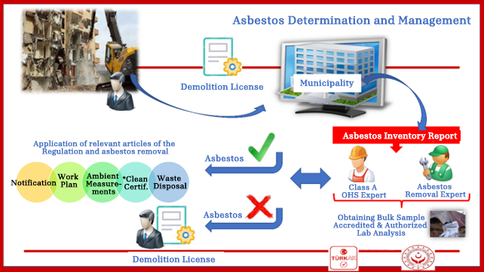
Within the scope of the Regulation on Health and Safety Measures in Working with Asbestos; the analysis of solid samples, taken to investigate the presence of asbestos before deconstruction, demolition, maintenance, and reconstruction works, is considered as occupational hygiene measurement test and analysis. Laboratories authorized by the MoLSS; may perform sampling and analysis and are allowed to accept samples from outside for analysis. Samples coming from outside can be accepted to the laboratory, provided that they are taken by an Asbestos Removal Specialist (Samples from urban transformation areas are considered within this scope). For the acceptance of samples coming from workplaces where no Asbestos Removal Specialist is employed (for example, samples taken during maintenance, repair works related to a part of the process or for the control of raw material content, etc.); the samples are required to be taken by an A Class Occupational Safety Specialist. If asbestos is detected as a result of the inventory study, a risk analysis should be performed.
  - Preparation of the Site Before Asbestos Removal
    - Informing the Employees
- Before asbestos removal works, employees will be informed about the following issues.
- Health risks arising from asbestos and/or dust emitted from asbestos-containing materials
- Limit values specified in the regulation and measurements that must be made continuously in ambient air
- Hygiene rules to be followed, including not smoking
- Use of PPE and precautions to be taken
- Special precautions designed to minimize asbestos exposure
- The sites where asbestos waste will be stored and how the waste will be transported to these sites
    - Marking
The necessary signs should be placed on the work areas where asbestos containing materials are used and the packages used for the transportation of asbestos waste after dismantling. In order to create a safe working area, while marking with “Stop, No Unauthorized Access” signs, there should be a label in accordance with the sample provided in Annex 17 of the Regulation on Registration, Evaluation, Authorization and Restriction of Chemicals.
Warning Signs (Work Area Warning Boards and Asbestos-Containing Package Labels)
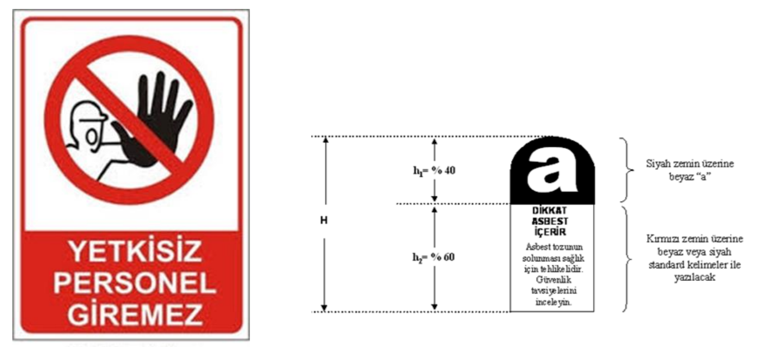
White “a” on black background
UNAUTHORIZED PERSONEL NOT ALLOWED
ATTENTION
CONTAINS ASBESTOS
It is harmful to health to inhale asbestos powder. Review the safety recommendations
To be written with standard wording in white or black font on red background
    - Creating the Quarantine Area
In working areas where high fiber concentrations are likely (black area), a quarantine area must be established in order for asbestos removal to be performed in a controlled manner. This quarantine area prevents the exposure of asbestos fibers to other people and workers in the environment by hindering the spread of asbestos fibers during asbestos removal works, waste packaging and cleaning of the deconstruction site.
Quarantines should be designed in such a way that deconstruction works can be done easily in the area where asbestos is to be removed. In determining the dimensions, the number of workers and the size of the equipment to be used should be considered. For example, if a scissor lift or a scaffold will be used, they should be large enough to provide comfortable equipment use. If the quarantine area is larger than necessary, it increases the spreading area of asbestos, therefore the size of the quarantine area should be kept at an optimum level.
The most commonly used material for quarantines is polyethylene coating. This material is highly preferred because of its flexible and impermeable structure. This coating should be thick enough to withstand the erosion and corrosion of quarantine. In most cases, a 1000-gauge (250 micron) coating is sufficient. In exposed areas, the polyethylene coating may not have sufficient strength due to external factors such as wind, so alternative materials such as polyvinyl chloride (PVC) sheet reinforced with woven nylon mesh can be considered.
The most common means of supporting the coating material are timber frames. Specially designed frames such as metal or plastic tubes can also be used. Some wood with a width of 50 mm x 50 mm is sufficient for the wooden sticks used. The coating must be fixed to the bars using staples, tape, and spray adhesive.
The quarantine area must be airtight. All leaks must be detected and sealed. All places where air escape may occur, such as corners, window ledges, doors or area around the negative pressure unit should be properly taped or sealed with suitable foam material.
In very confined and hot areas, the use of certain foams and adhesives close to pipelines or breathing space can cause harmful if they were used in high concentrations. This situation should be avoided.
If the breaches of sealing cannot be prevented with these precautions, additional measures should be taken. These can be as follows;
- The performance of the negative pressure unit may be increased,
- Glove bag may be used,
- Mini-quarantine areas can be set up inside the quarantine area.
Quarantines must be established before any work is done, including inserting injection needles into the asbestos including materials, and the covering material must be disposable.
    - Negative Pressure Unit (NPU)
No matter how well designed, the quarantine cannot be guaranteed to be airtight and there may be some degree of leakage. Therefore, it should be ensured that the air pressure inside the quarantine is slightly below atmospheric pressure. With that inequality, any leaking airflow inside the quarantine moves inwards, not outwards, so the asbestos dust stays in the quarantine area. However, sufficient fresh air should be provided to replace the exhausted air. This air must enter quarantined area in a controlled manner with shower enclosures or airlocks. In this way, the ventilation of the quarantine is regulated, and fresh air is provided to the asbestos workers. In principle, the NPU should be located opposite the airlocks. However, the optimal location for the NPU depends on several factors, including the shape of the quarantine area, accessibility of the walls or suitability of walls to accommodate the unit. The airlock alone can provide enough fresh air for a small or simple quarantine; however, additional air intakes may be required for larger or complex facilities. These air inlets should have filtration (pre-filter) and should be sealed by taping around. The NPU should normally be located outside the quarantine and only the prefilter should be seen from inside. This depends on access and available space. A flexible piping may be required between the main HEPA filter and the pre-filter in quarantine, in which case this flexible pipe should be maintained and inspected regularly.
Sufficient negative pressure should be created inside the quarantine area and this pressure should be distributed as evenly as possible in the quarantine area. The location of the negative pressure unit should provide effective airflow in the quarantine and airlocks. Air locks and waste cabinets should not be seen as an alternative to negative pressure.
    - Entering Quarantine (Air Lock)
The most important feature for quarantine is shower cabins or air locks. Thanks to the air locks, the entrance and exit of the personnel, equipment and wastes are kept under control. Airlocks and waste cabinets must be at least 1m x 1m x 2m (height) and they should be larger where larger wastes such as pipelines or wood chips are disposed of. Where confined in one direction (i.e., along a corridor), airlocks and waste cabinets should extend in the other direction (i.e., 0.8m x 2m x 2m). If enough space is available, separate airlock and waste cabinet should be used. Air locks should be designed in a way to prevent the leakage of asbestos dust from the passages between the cabinets. This is usually achieved by vertically shearing of the coating between the cabinets. These openings prevent the outside air from entering and the inside air from flowing out. In order to control the air flow, the bottom of the inner slit should be weighted with plastic or wooden sticks. It is essential to provide sufficient reserve air into the quarantine.
    - Hygiene Unit
The hygiene unit (the system designed for personnel cleaning) should be adjacent to the quarantine area, and if this is not possible, airlocks should be used. Airlocks should be designed in such a way that they do not spread asbestos dust into the environment. The use of the transition system is undesirable and should be avoided as much as possible. Connecting shower units directly to quarantine or to air locks is preferred. The purpose of airlock and waste cabinets is to provide additional control over spreads, and they should be installed adjacent to the quarantine to control air movement during accidental leaks, personnel movement, and waste transfers.
    - Waste Cabinet
Waste cabins are used for the waste transfer and their design is shown in the figure below:
Waste Cabinet Design
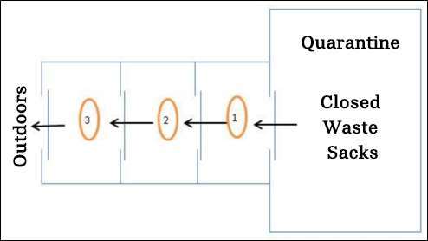
Waste Cabinet Design
In cabin number one, the outside of the waste bags is cleaned by wiping. In cabin number two, the waste bag is transferred into the second waste bag. In cabin number three, the waste is stored temporarily and an outsider personnel member takes the waste bag from there and carries it to the temporary waste storage facility. Waste should never be discharged directly from the hygiene unit.
    - Observation Panel
Observation panels (camera system, etc.) should be attached to the walls of the quarantine so that the Asbestos Removal Specialist can see what is happening inside without having to go inside. The number and location of these panels depend on the location, size, and complexity of the quarantine. Transparent plastic observation panels should be placed over the coating during the construction of the quarantine. Panels should be taped on both sides have the minimum dimensions of 60cm x 30cm and must be placed at a height of 1.5 m from the floor. Observation panels should also be in the airlock and waste cabinets. Where viewing from panels is impractical, the camera system can be used as an alternative for specialists to observe and monitor developments in the quarantine. The camera system should be protected for ease of cleaning.
    - Site Preparation
Before starting work in the building, a hygiene unit, including the quarantine, should be purchased, and installed. PPE to be used during the initial setup of the quarantine should be determined. The deconstruction area should be examined. The purpose of this operation is to determine the items to be removed and to cover the items that cannot be taken out in order not to have difficulty during the cleaning. The work area should be as free from plants, equipment, and furniture as possible. All remaining equipment, such as electrical equipment, must be pre-cleaned and then covered with a polyethylene coating and tightly taped to prevent contamination. If there are boilers or chimneys in quarantine are, they must be closed to prevent the spread of asbestos due to fumes.
If there is any asbestos material in the dismantling area, a preliminary cleaning should be done. For this, all loose materials must be removed before the quarantine is established. Pre-cleaning should be performed using appropriate dust prevention and control measures, including vacuuming with an H-type vacuum cleaner, surface wiping, temporary encapsulation with polyvinyl acetate (PVA), tape or adhesive film, spray wetting, and bagging. In addition, if there is asbestos-free dust and waste, pre-cleaning should be done for this as well. These wastes can be considered as normal waste. Otherwise, after the work starts, this waste will be considered as asbestos waste and must be disposed of as hazardous waste.
    - Smoke Test
Before deconstruction begins in the quarantine, the tightness of the quarantine should be tested by pumping smoke from the smoke generator while the negative pressure unit is not operating. Large leaks will be readily apparent; but small leaks will show themselves after a little wait. These small leaks can cause asbestos to be released into the environment during removal. The easiest way to examine fugitive smoke is to shine light over it with a flashlight. If any leakage is encountered, that area should be re-examined, and the leaking part should be taped.
  - Necessary Materials and Personal Protective Equipment
Before starting the deconstruction work, the materials listed below, and personal protective equipment must be provided.
    - H Type Vacuum Cleaner
Industrial vacuum cleaners in H dust class and suitable for asbestos-containing dust removal should be used in accordance with EN 6035-2-69 in order to clean the small parts spread around during asbestos removal and to remove the fibers stuck to the clothes by vacuuming.
During the works in buildings, low pressure must be maintained in the working area with help of suction devices. In this way, in case of leakage, it is ensured that fresh air from outside enters the work area, and that asbestos air does not flow out of the work area.
    - Binding Agent
During the deconstruction of asbestos-containing structures, there is a risk that the fibers attached to the components will fly off and mix with the breathing air. For this reason, surfaces must be coated with fiber-binding agents (e.g., plaster fixer) and pressure less spraying method should be used. This ensures that the fibers adhere well to the component.
    - Hygienic Devices
Washing facilities should be available in all asbestos work areas so that workers can wash their faces and hands before eating or smoking. During extensive work on asbestos-containing structures, a transition area separated by showers and allowing for separate storage of casual and work clothes is required.
    - Personal Protective Equipment
Protective Clothing
- For protective clothing, disposable body protective coveralls that have anti-static properties should be taken.
- A new protective clothing must be used for each entry into the contaminated area.
- Coveralls used should be appropriate to the Type 5 airborne solid particles standard according to TS EN ISO 13982-1 and Type 6: Limited protection standard against splashing liquid particles according to TS EN 13034.
- Protective clothing and the personal clothing of the employees are kept in separate places.
Respiratory Protective Mask
- The full-face shield must be equipped with a hazard-appropriate filter.
- The suitability of the respiratory protection must be tested before use and its physical dimensions must be the suitable for the user.
- Improper respiratory protection will provide little to no protection.
- A suitable respiratory protection should have a minimum specified protection factor of 20 or more, but 50 or more is recommended.
Disposable respirators:
- Disposable Respirators with FFP3 protection level 50 or more protection factor and compatible with TS EN 149+A1 harmonized standard and EN149:2001+A1:2009 standard, can be used.
Full Face Mask:
- A full-face mask can be used with a particle filter with P3 protection level according to TS EN 143 harmonized standard and EN143+A1/AC standard.
Motorized Respiratory Protection:
- For the motor parts, like battery, a combined shield with EN 12941 standard can be used. It also should comply with every standard suitable for the selected respiratory, head, eye, hearing, and face protection class.
Other Personal Protective Equipment:
- Occupational safety shoes that can be put directly on the feet without laces or buckles should be worn. Boots should be preferred over shoe covers, as they involve the risk of slipping. Washable boots can be preferred.
- Disposable work gloves should be used. If a glove with high mechanical resistance, high electrical resistance or chemical resistance is to be used depending on the job, thin hygiene gloves with high gripping ability can be used inside these gloves. After each asbestos removal operation, the glove should be placed in properly sealed asbestos waste bags after the worker has left the contaminated area. A new pair of safety gloves should be worn each time you enter the contaminated area.
  - Removal of Asbestos Containing Materials by Boxing and Separation
It is necessary to properly separate termites and/or contaminated materials without creating dust and breaking parts as much as possible. In addition, before starting the cutting, chemical adhesive liquid should be sprayed on the relevant area in order to suppress the dust spread. It is ensured that after squeezing the adhesive liquid, the cut and disassembled parts are put into special sealed foil and/or asbestos sacks (big bags), packaged and labeled and placed in the waste cabinet, which is determined by the contractors, before disposal.
  - Course of Action After Deconstruction
After the Deconstruction process is completed, the following operations should be performed;
- If necessary, cleaning all areas indoors with a filtered industrial type vacuum cleaner, and if not, simply humidifying,
- Wet cleaning with chemicals and/or non-chemical materials,
- Spraying a special liquid material containing fiber adhesive, on all surfaces
  - Management and Disposal of Asbestos Waste
The asbestos waste management should not be considered as an issue that will be dealt with only after the deconstruction and demolition works are completed. Asbestos-containing waste should be collected at the end of every working day, placed in bags bearing the asbestos sign, and stored regularly at the workplace. Necessary warnings and guards should be placed to prevent personnel unrelated to waste procedures from accessing waste, and all employees should be informed that asbestos storage locations should not be entered. Double bags should be used if there is a possibility that the stored material will break holes in the bags (e.g., sharp, hard waste). Wetting the waste bags with a fiber binder solution is also recommended. When the deconstruction and demolition works are over or the wastes accumulate in such an amount that it is economical to transport, the waste should be transported and disposed of in accordance with the legislation and by signing a contract with the waste transport company licensed by the MoEUCC and with the authorized waste disposal organization.
Asbestos, which is revealed as a result of deconstruction from the building, is in the nature of "waste" and must be transported and disposed of in accordance with the provisions of "waste legislation". According to Article 11 of the Environmental Law; facilities, businesses, and settlements that are not deemed appropriate to directly or indirectly deliver their wastes generated as a result of production, consumption and service activities to the receiving environment are obliged to treat and dispose of their wastes in accordance with the standards and methods determined in the regulations and to obtain the prescribed permits. This provision, which applies to all wastes, also applies to the disposal of asbestos waste.
Within the scope of the Annex-4 waste list of the Waste Management Regulation (WMR) published in the Official Gazette dated 02/04/2015 and numbered 29314 by the MoEUCC, asbestos-containing wastes that will be generated as a result of the Project activities should be considered as "insulation materials and asbestos-containing construction materials”.
Waste Codes for Insulation Materials and Construction Materials Containing Asbestos
Waste Codes | Waste Code Definition | Explanation
17 06 | Insulating materials and building materials containing asbestos
17 06 01 | Insulating materials and building materials containing asbestos | M*
17 06 05 | Insulating materials and building materials containing asbestos | M
* M mark: The sign in the "Description" column at the level of the six-digit waste code indicates that the waste is a possible hazardous waste. In order to determine whether the wastes marked in this way are hazardous or not, a study should be performed to determine the hazardous properties of the waste as stipulated in Article 11 of the Waste Management Regulation.
The hazardous properties of the wastes marked with (M) in the waste list, must be determined. In these studies, evaluations regarding H3-H8, H10 and H11, which are among the features listed in Annex-3/A of the same regulation, are made on the basis of the concentration values ​​in Annex-3/B. Analysis studies are carried out by laboratories that have been qualified for Annex-3/B from the MoEUCC.
According to the Waste Management Regulation, the implementation of the disposal process should be controlled. Asbestos-containing materials will be appropriately labeled and stacked. In the online programs of the MoEUCC, it will be ensured that hazardous materials containing asbestos are sent to licensed disposal facilities by using the waste management application over the Integrated Environmental Information System.
During the disposal of asbestos waste, the following will be considered,
- Asbestos waste should be wrapped and packaged without breaking.
- Asbestos waste should be labeled after packaging without breaking.
- Asbestos waste must be sent to a licensed disposal facility upon completion of online registration.
- Asbestos waste should be sent to the disposal facility by licensed vehicles.
- Asbestos wastes may not be discharged into unloading areas or designated areas for excavation materials.
- Asbestos wastes cannot be discharged along streams.
- Asbestos waste cannot be incinerated.
Aforementioned asbestos wastes, within the framework of the provisions specified in Article 30 (titled "Wastes requiring consideration of special circumstances) of the Regulation on the Regular Storage of Wastes, published in the Official Gazette dated 26/03/2010 and numbered 27533, can be stored in class II storage facilities, without testing.
- Review & Update
This AMP is a 'living' document and responsibilities, procedures and compliance actions should be updated if needed (for example, following a change in legislation). It is the responsibility of PMU and contractors to be fully aware of its contents. Contractors will provide relevant training to personnel and ensure that measures/commitments are implemented to ensure compliance with this AMP.
The standards presented in this annex are minimum compliance standards which can and should be supported with additional measures as required by the conditions of the project sites.
Workflow in Asbestos Studies
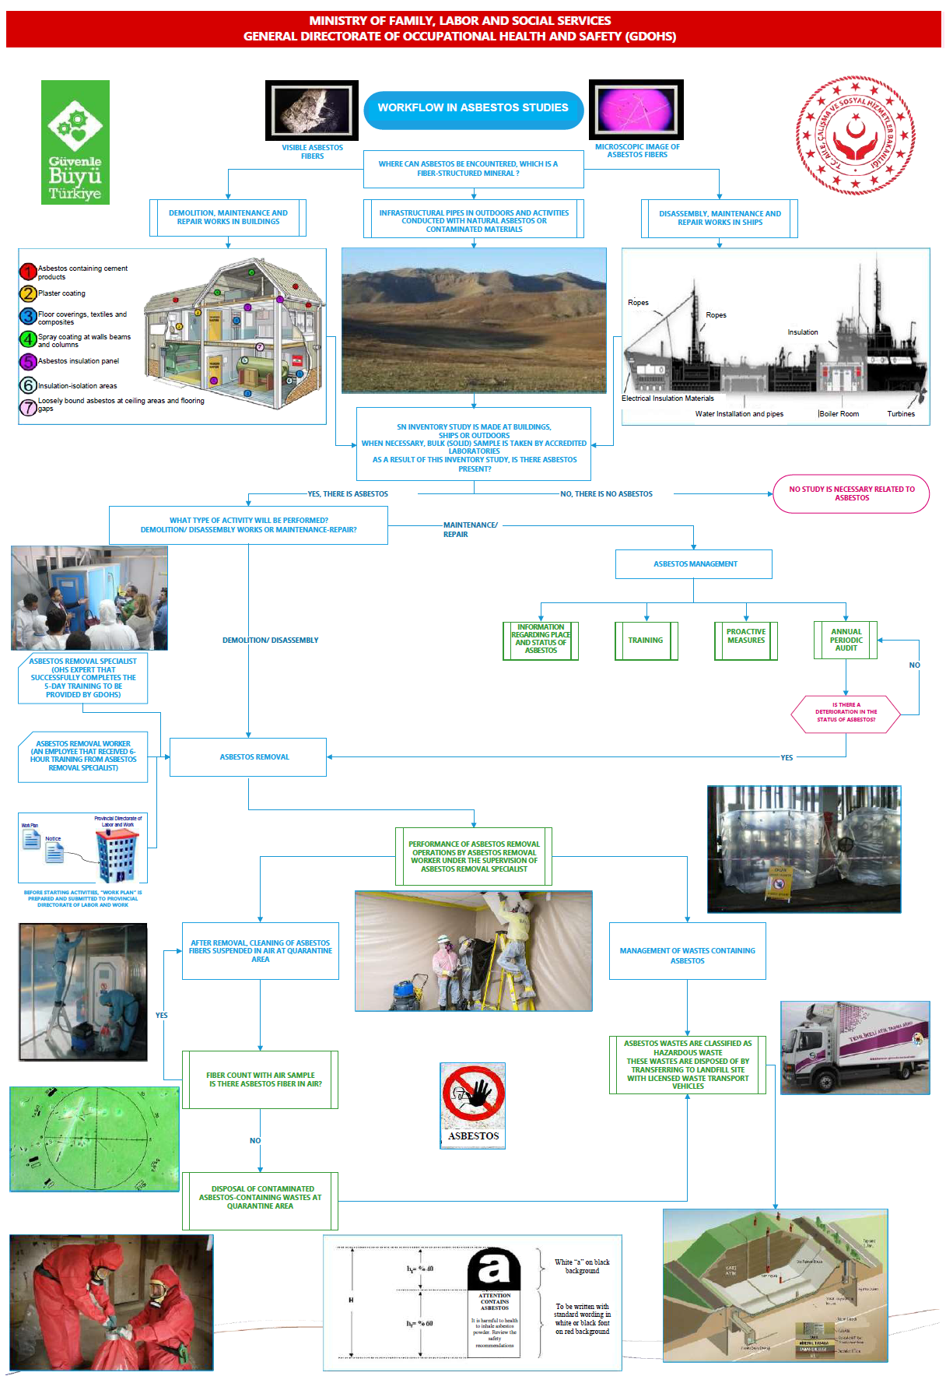

ANNEX 10- CHANCE FIND PROCEDURE
- Introduction
Urban Transformation Presidency (UTP) of the Ministry of Environment, Urbanization and Climate Change (the MoEUCC) is responsible for the sub-project activities to be carried out within the scope of the Project and the management and protection of archaeological and cultural heritage sites/resources in the areas affected by these activities. Natural and Archaeological Sites, Cultural and Historical Buildings will not be included in the Project. However, it is still possible to encounter some unknown archaeological sites and cultural heritage assets as “Chance Finds” during the Project activities.
  - Purpose
The purpose of this document is to outline the procedure and related responsibilities required in relation to managing the Chance Finds process during the works to be carried out within the sub-project.
  - Definitions
Definitions
Change Find | Any potential objects, features or areas of cultural inheritance that have been defined as a result of regular monitoring of Project-related construction works but extrinsically to an official site survey.
Museum Directorates
Regional Conservation Boards
Project | Climate and Disaster Resilient Cities Project
Work to be Done or Mandatory Actions | Represents mandatory conditions
Compulsory Work | Indicates that a provision is not mandatory but recommended as good practice

- Roles and Responsibilities
The Project Management Unit (PMU), which will be established under The Urban Transformation Presidency, is obliged to comply with this procedure along with all its affiliated units and subcontractors throughout all activities for all sub-projects under Component 2. All workers involved in sub-projects’ activities will receive training on the implementation of this procedure.
Roles and responsibilities for the Environmental and Social (E&S) management of the Project are detailed in the Project ESMF. In this context, roles and responsibilities regarding the chance find process are given in the table below:
Roles and Responsibilities
Roles | Responsibilities
Project Management Unit (PMU) | - Ensure adequate resources are available to implement this procedure.  - Reviewing and updating the procedure as needed  - Ensure that technical support is provided to contractors to implement the procedure.  - Ensure that relevant training is provided by contractors through review of training records and relevant training documentation.  - Supervising the contractor's compliance with Project requirements through contractor monitoring and reports.
Contractor  Project/Site Manager | - Ensure that this procedure is implemented in line with Project standards  - As its main responsibility, to ensure the implementation of the procedure (also by the Subcontractors, if any) and to report the non-compliances and the implementation performance of the procedure to the PMU.  - Participating in the development of corrective and/or remedial actions when necessary (e.g., when non-compliances are detected, when there is a change in the relevant legislation, etc.).  - Providing relevant training.  - Performing internal and daily audits and recording any observed non-compliances.  - Ensuring that relevant non-compliances are recorded and promptly responded to.  - Reviewing and updating the procedure as necessary (in coordination with the PMU).  - Ensure that chance finds are included in the daily checklist to be included in the monthly report to the PMU.
All employees | - Participating in training required for chance finds.  - Providing provides self-competence for the implementation of this procedure.

- Chance Find Process
The step-by-step process to follow any chance finds in the Project site and its area of impact is given in the table below.

Chance Find Process
STEP 1– Following a chance find:
- All works in the survey area will cease.
- A transitional buffer zones will be established around the chance find area.
- Site management and the museum archaeologist will be contacted immediately.
- The area of the finding will be adequately secured by markings, signposts and banners, etc.
- Protection of the site the chance finding will not be transported lifted or damaged further.
STEP 2 – Registration
Chance Find Notification Form Section A will be filled in and a copy will be forwarded to the Project/Site Manager in 24 hours.
STEP 3 – Communication with local authorities
The director of the related museum will be notified regarding the chance find.
STEP 4 – Museum Decision
The archaeologist of the related museum will decide actions to follow in the chance find site.
STEP 4 A – Site or the find is of no significance  - Museum archaeologist declares that the site/find is of no significance.  - Project/Site Manager notifies respective authorities.  - The Project/Site Manager keeps a copy of the chance finds record for his/her own records.  - No further action is required.  - The chance find procedure ends.  - Construction activities can continue. |  | STEP 4 B – Site is significant  - Museum archaeologist declares that the site/find is significant.  - The archaeologist of the museum directorate decides on the next steps and informs the Project/Site Manager.  - Project/Site Manager notifies respective authorities.  - Go to Step 5.
STEP 5 – Site survey
Project staff follows the instructions of the archaeologist of the related Museum.
- Following the site survey, the museum archaeologist declares that the site is of minor significance.  - Project/Site Manager informs the PMU.  - Project/Site Manager records Part C of the Chance Find Form.  - No further action is required.  - The chance finds procedure ends.  - Construction activities can resume. | - Following the site survey, the museum archaeologist declares that the site is moderately significant.  - More advanced works such as the test pit/recovery excavation or remote sensory surveys will be completed.  - Museum archaeologist will instruct and/or supervise works.  - Project/Site Manager informs the PMU.  - Project management will provide an archaeological task force under the lead of the museum archaeologist. The task force will be composed of qualified archaeologists as well as other specialists and workers.  - Upon completion of excavation, the team will report to the museum.  - Museum forwards the findings of the survey to the Regional Cultural Asset Conservation Board.  - The Regional Cultural Asset Conservation Board will officially approve such recovery and notifies the Project management.  - Project/Site Manager records Part C of the Chance Find Form.  - No further action is required.  - The chance finds procedure ends.  - Construction activities can resume. |  | - Following the site survey, the museum archaeologist declares that the site/find is highly significant.  - Recovery excavation will be completed.  - The site will be handled in observance of the provisions of the Law No.2863 on the Protection of Cultural and Natural Assets dated 21.07.1983.  - Museum Archaeologist provides instructions and/or supervision for the test pit/archaeological recovery excavation.  - Project/Site Manager informs the PMU.  - Project management will provide an archaeological task force under the lead of the museum archaeologist. The task force will be composed of qualified archaeologists as well as other specialists and workers.  - Upon completion of excavation, the team will report to the museum.  - The Regional Cultural Asset Conservation Board will officially approve such recovery and notifies the Project management.  - The site will be registered and placed under protection as per the Turkish legislation.  - Project/Site Manager informs the PMU.  - Project/Site Manager records Part C of the Chance Find Form.  - No further action is required.  - The chance find procedure ends.  - Construction activities may resume in accordance with the Board's decision or additional preventive studies may be required.

- Monitoring and Reporting
Project/Site Manager will visually monitor any and all construction and other activities as proof of presence of cultural inheritance assets.
Chance Finds will be recorded in the Chance Finds Notification Form. Print copies of Chance Find Notification Forms will be available on site, which will be always scanned once filled in and registered and saved.
Chance Find Notification Forms will be updated by the Project/Site Manager, which be recorded in the Chance Finds Log. This document will be regularly checked.

CHANCE FIND REPORT FORM/ RASTLANTISAL BULUNTU RAPOR FORMU
Chance Find Report Form
PART A
BÖLÜM A
Project Location:  Proje Sahası | District (İlçe):  Village (Köy): |  | Date:  Tarih |  | Form No:
Name of person reporting chance find:
Rastlantısal buluntuyu rapor eden kişinin ismi
Was work stopped in the immediate vicinity of the chance find? ☐ Yes ☐ No
Rastlantısal buluntunun tam çevresinde iş durduruldu mu? Evet Hayır
Was a buffer zone created to protect the chance find? ☐ Yes ☐ No
Rastlantısal buluntuyu korumak için tampon bölge oluşturuldu mu? Evet Hayır
NOTIFICATION
BİLDİRİM
Project/Site manager contacted ☐ Yes ☐ No
Proje/Şantiye Müdürü ile irtibata geçildi Evet Hayır

CHANCE FIND DETAILS
RASTLANTISAL BULUNTU AYRINTILARI
GPS coordinates  GPS koordinatları |  |  | Photo record ☐ Yes ☐ No  (HD quality – no cell phone photos)  Fotoğraf kaydı Evet Hayır  (HD kalitesinde – cep telefonu fotoğrafı değil)  If not, explain why:  Yok ise nedenini açıklayınız  Other records ☐ Yes ☐ No  Specify (drawings, HD quality videos, etc.):  Diğer kayıtlar Evet Hayır  Belirtin (çizimler, HD kalite videolar, vb.)
Description of chance find:
Rastlantısal buluntunun tanımı

Description of site and vegetation: (e.g. surface sediment type, ground surface visibility, distance to closest watercourse, etc.)
Sahanın ve bitki örtüsünün tanımı: (örn. Yüzey sediman türü, yüzey zemin görünürlüğü, en yakın su yoluna olan mesafe, vb.)

PART B
BÖLÜM B
NOTIFICATION OF MUSEUM DIRECTORATE ARCHAEOLOGIST
MÜZE MÜDÜRLÜĞÜ ARKEOLOĞUNA BİLDİRİ
Monitoring archaeologist contacted museum directorate archaeologist ☐ Yes ☐ No
Arkeolog müze müdürlüğü arkeoloğu ile irtibata geçti. Evet Hayır

Date of notification:
Bildirim tarihi

Name of museum directorate and Name of museum archaeologist:
Müze müdürlüğü ve Müze müdürlüğü arkeoloğunun ismi

Contact number of museum directorate archaeologist:
Müze müdürlüğü arkeoloğunun iletişim numarası
DECISION OF MUSEUM DIRECTORATE ARCHAEOLOGIST
MÜZE MÜDÜRLÜĞÜ KARARI
Date of site visit:
İlk saha ziyaret tarihi:
☐ Site of no significance - Construction to proceed with no further action – End of chance find procedure  Önemsiz saha – İnşaat daha fazla araştırma yapılmadan devam edilebilir – rastlantısal buluntu prosedürün sonu.  Date of notice to resume work:  İşe başlama tarihi bildirisi |  |  | ☐ Site of significance - Further actions required  Önemli saha – Ek araştırma gerekmektedir  Please Fill out Part C  Lütfen Bölüm C’yi doldurun.
Name of museum directorate archaeologist:
Müze müdürlüğü arkeoloğunun ismi
Contact information:
İletişim numarası
Project/Site manager contacted ☐ Yes ☐ No
Proje/Şantiye Müdürü ile irtibata geçildi Evet Hayır

PART C
BÖLÜM C
FURTHER FIELD INVESTIGATION
EK SAHA ARAŞTIRMASI
☐ Site of minor significance  Önemsiz saha |  | ☐ Site of moderate significance  Az önemli saha |  | ☐ Site of major significance  Çok önemli saha
Describe additional work to be conducted:
Yapılması gereken ek işlerin tanımları

Date started:  Başlangıç tarihi |  |  | Date completed:  Bitiş tarihi
Date of notice to resume work:
İşe başlama tarihi bildirisi
Name of museum directorate archaeologist:
Müze müdürlüğü arkeoloğunun ismi:
Contact information:
İletişim numarası
Construction manager contacted ☐ Yes ☐ No
Proje/Şantiye müdürü ile irtibata geçildi Evet Hayır

Chance Find Form

DATE OF FIND | BRIEF DESCRIPTION OF THE CHANCE FIND |  | NAME OF AUTHORIZED STAFF HAS BEEN NOTIFIED |  | ACTION TAKEN |  | NAME OF AUTHORIZED STAFF FILLED THE CHANCE FIND FORM |  | STATUS (OPEN/CLOSED) |  | OTHER CONSIDERATIONS

Contact Information
MUSEUM | ADDRESS | TELEPHONE | FAX |  | E-MAIL

CONSERVATION  BOARD | AREAS OF  RESPONSIBILITY | ADDRESS | TELEPHONE | FAX | E-MAIL

ANNEX 11- ENVIRONMENTAL & SOCIAL SCREENING CHECKLIST FOR SUBPROJECTS
The sub-projects to be proposed within the scope of Component 2 can be divided into three types as per the activity to be performed as below:
- Type-I: The sub-projects with demolition and reconstruction - buildings were registered as risky building, however, no demolition activity has been performed at the time of loan application
- Type-II: The sub-projects with retrofitting - buildings were registered as risky building, however, loan application is made for only retrofitting rather than demolition and reconstruction
- Type-III: The sub-projects with only reconstruction - buildings were registered as risky building and demolished before loan application, and the application is only made for reconstruction.
ENVIRONMENTAL AND SOCIAL SCREENING CHECKLIST
PART-I
Sub Project Type | Type III
Name of Subproject | Reconstruction within the Scope of Climate and Disaster Resilient Cities Project:
Projected Start Date
Address
Prepared by

PART-II: Environmental and Social Risks - Current Situation

Environmental and Social Considerations | Projected Risk According to the Current Situation (provide as much detail as possible in the columns)
Risk Level | No Risk |  | Low Risk | Moderate  Risk |  |  | Substantial Risk |  |  |  |  |  |  | High Risk
What is the level of the risk of the subproject to damage a known cultural heritage in terms of sub-project area’s proximity?
 | Explanation:
What is the level of the risk of the subproject to pollute a water body in terms of sub-project area’s proximity?
 | Explanation:
What is the risk regarding impacts related with dust generation in terms of the sensitivity level of the receptors?
 | Explanation:
What is the risk level regarding impacts related with noise generation in terms of the sensitivity level of the receptors?
 | Explanation:
What is the risk level regarding vulnerability status of the population of the building to be demolished/reconstructed/ retrofitted (the vulnerable group population of the building to be demolished can be assessed)?
 | Explanation:
What is the risk level regarding livelihood impact for any worker working in the building (e.g., supers and other workers population)? (This section should be completed if there are personnel (eg. super) or commercial enterprises in the building, providing brief information about their status following the building’s risk assessment. If neither applies to the sub-project, please clearly indicate this.)
 | Explanation:
What is the risk of in-adequate waste management in terms of the waste management capacity of the region where the sub-project will be realized?
 | Explanation:

PART-III: Environmental and Social Risks - Anticipated risks of sub-project activities
Environmental and Social Considerations | Anticipated Risk (provide as much detail as possible in the columns)
Risk Level | No Risk | Low  Risk | Moderate  Risk | Substantial  Risk | High  Risk
What is the risk of presence of asbestos material at the building to be demolished/retrofitted in terms of the building’s age? (As a pre visual observation assessment)?
 | Explanation:
What is the risk regarding impacts related with dust generation in terms of the volume of building to be demolished and/or reconstructed?
 | Explanation:
What is the level of risk of the subproject in terms of possible increase on the traffic load, given the duration (depending on the size of the work, e.g., the size of the new building) and intensity of the activities.

 | Explanation:
What is the risk regarding impacts related with construction & demolition waste generation of the sub-project (for instance, such criteria can be assessed: volume of the building to be demolished, nature of the activity to be performed (much less construction & demolition waste will be generated during retrofitting when compared to demolishing) etc.)?
 | Explanation:
What will be the extent of occupational exposure and other OHS risks of the subproject, other than asbestos (e.g., will there be work at height during retrofitting activities, or how much will the risk of working at height be when performing reconstruction activities, depending on the design of the new structure, etc.)?
 | Explanation:
What will be the level of the risk of the subproject within the scope of RF?
This section will be filled out by taking into consideration the following:
- Identification of vulnerable groups (if any) affected by the building to be transformed under the Project and determination of their entitlement (tenant/homeowner) status.
This is an indicative piece of information. Please adjust it according to the information you have.
Please provide details with about the potential vulnerable groups in the building with reference to their rights within the scope of the CDRC project. (i.e. additional interest deduction, rental support, etc.).
Vulnerable groups: Female-headed households, elderly, persons with disabilities, poor households (including those with many children) and persons without social security insurance (including unemployed youth and households with child laborers), migrants / Syrians under temporary protection / Ethnic groups, persons and groups whose livelihoods depend on the structures covered by the Project and who will be permanently displaced economically and physically (e.g.supers)

Explanation:

Within the scope of the Climate and Disaster Resilient Cities Project, beneficiaries who have not previously benefited from rental assistance or interest support have been informed that they can apply for and benefit from rental assistance in accordance with Article 16 of the Implementing Regulation of Law No. 6306 and the conditions specified in the Rental Assistance Guide, even if the one-year application period has passed.
Accordingly, the project will ensure that all eligible PAPs (homeowners, renters, business owners, etc.) receive compensation in accordance with the Project’s RF.
Other environmental and social risks (if any, please identify nature and level)

 | Explanation:
PART-IV: Environmental and Social Risks - Current Status (For Type-III subprojects only)
Environmental and Social Considerations | Risk According to Predicted / Observed Conditions
Risk Level | No Risk | Low  Risk | Moderate  Risk | Substantial  Risk | High  Risk
What is the risk in terms of presence of unmanageable amount of demolition waste, if they are still present at the site or areas close to the site, if any?
 | Explanation:
What is the risk of future grievance regarding dust generation, due to evidence of such grievance during demolition? (Was there a significant complaint(s) about dust during the demolition?)
 | Explanation:
What is the risk of future grievance regarding noise generation, due to evidence of such grievance during demolition? (Was there a complaint about noise during the demolition?)
 | Explanation:
What is the risk of meeting with nuisance with neighbors due to a damage to other buildings during the demolition process?
 | Explanation:
What is the risk of future issues due to lack of demolition plan during the demolition or insufficiency of it in terms of quality?
 | Explanation:
What is the risk in terms of asbestos presence at the demolition site as a pre visual observation assessment)

 | Explanation:
What is the risk in terms of legal / reputational / public discomfort due to any fatal accident or accident caused disability during the demolition process?
 | Explanation:
As a preliminary observation, are there any property owners who will benefit from the additional interest rate discount specified in the sub-project?

(This is an indicative piece of information. Please adjust it according to the information you have.
﻿
(Within the scope of the Project, four categories determined by the Presidency for annual interest rate reduction on loans are presented below):
Category I: Citizens who do not own any other independent unit registered in the land registry besides the risky building in which they reside, and are homeowners residing in the same property with their household.
Category II: Households with low and middle income (Income threshold for Category II additional interest rate discount).
Category III: Families of martyrs, veterans, war and duty disabled individuals, widows and orphans, retirees, citizens with at least 40% disability, and households where the main income earner is a woman or where there is a high level of social vulnerability.
Category IV: For projects where an A or B type social vulnerability ID card is presented, an annual interest rate reduction of 0.50 or 0.25, respectively, is applied.

(For additional interest rate reduction categories, please visit the link below:
https://kentseldirenclilik.csb.gov.tr/proje-kapsaminda-verilecek-kredilerin-yillik-faiz-oranina-baskanligimizca-belirlenmis-olan-4-kategoriden-her-bir-kategori-icin-yillik-bazda-faiz-indirimi-uygulanacaktir-haber-286788)

Explanation:
Within the scope of the Climate and Disaster Resilient Cities Project, beneficiaries who have not previously benefited from rental assistance or interest support have been informed that they can apply for and benefit from rental assistance in accordance with Article 16 of the Implementing Regulation of Law No. 6306 and the conditions specified in the Rental Assistance Guide, even if the one-year application period has passed.
Accordingly, the project will ensure that all eligible PAPs (homeowners, renters, business owners, etc.) receive compensation in accordance with the Project’s RF.

PART-V: Screening Summary
Designated Category | Environmental |  |  |  |  | Social
Designated Category | High* | Substantial* | Moderate* |  | Low* | High* | Substantial* |  | Moderate* | Low*
Reasons for Determining the Category and Related Details
Required Tools | Neighborhood Level ESIA** |  |  | ESMP Checklist*** |  |  |  | E&S Audit / Environmental and Social Action Plan****
Required Tools |  |  |  | REQUIRED.

* Note to User: If one or more of the questions asked in the screening list on environmental issues are answered as "high risk", the relevant sub-project will be identified as "high risk" in environmental terms.
** Note to User: Neighborhood level / based ESIAs will not be sub-project specific. In case more than 10 sub-projects with a social risk classification of "high" and environmental risk classification of "substantial" are implemented in the same neighborhood within a one-month period, this box will be filled in the screening checklist of each sub-project and sent to the PMU head office for their review.
*** Note to User: It will in all probability be required for each proposed sub-project, however, its scope will be determined based on the assessments in this screening list.
**** Note to User: E&S Audit will be required for each Type-III subproject. The requirement for an Environmental and Social Action Plan will be determined based on the results of the audit but is highly likely to be required. The ESAP will include relevant environmental and social corrective measures based on the findings of the E&S Audit.
Within the scope of the “Climate and Disaster Resilient Cities Project”, the undersigned hereby declare, accept, and undertake that all environmental, social, and other issues detailed in this Environmental and Social Management Plan Checklist for the Reconstruction Work Titled: ......................................................................................Project,
constitute binding commitments. In the event of any action contrary to the provisions set forth in this checklist or any breach of these commitments, the undersigned acknowledge that they shall be subject to all sanctions stipulated under the Environmental Law No. 2872 and all related legislation — including suspension of works — as well as all sanctions prescribed under the World Bank Environmental and Social Standards.

Contractor (Name–Surname) Site Supervisor (Name–Surname)
Signature Signature

ANNEX 12- LIST OF NON-ELIGIBLE TYPES OF SUB-PROJECTS
The list of non-eligible types of sub-projects are presented below:
- Any sub-project that is included in the World Bank Group/International Finance Corporation Exclusion List
- Any sub-project that includes the buildings registered as Cultural Heritage.
- Any sub-project that will have impacts on Natural Habitats/Critical Habitats and trigger an overall ESS6 such as alteration of environmentally important areas, including wetlands, native forests, grasslands, and other “critical” natural habitats and ecosystem services.
- Any sub-projects where in-situ transformation is not possible.
- The buildings which are not registered as risky building within the scope of Law and Implementation Regulation.
- Risky buildings within designated Disaster Exposed Areas.
- Any sub-project that would affect the quality and/or quantity of international waterways as defined in WB OP 7.50 and that would benefit from existing hydroelectric dams in a way, triggering any dam safety issues under the scope of ESS4.
- Any Type-III sub-Project, whose demolishing works had been completed before October 1, 2020.
- Any sub-project which would be classified as “High Risk” in terms of environmental risks.

ANNEX 13- OCCUPATIONAL HEALTH AND SAFETY MANAGEMENT PLAN
- Purpose and Scope
This plan presents the Occupational Health and Safety (OHS) management principles for the subproject activities within the scope of Component 2 of the Project. Prior to construction activities, the Contractor will also develop its own Occupational Health and Safety Management Plan (OHSMP) in line with national legislation to address OHS issues.
This plan outlines the framework of the OHS system to be followed by the Contractor during the land preparation and construction phase.
This plan has been prepared to be implemented by the Project Management Unit (PMU), Contractors and Subcontractors. In addition, Contractors are required to adopt plan requirements within their management plans. The roles and responsibilities for the implementation of the Plan are presented in Annex 1.
This Plan is a living document and responsibilities, procedures and compliance actions should be updated as appropriate.
- Legal Framework
  - National Legislation
The main national legislation that the Project is subject to on occupational health and safety is as follows:
  - Occupational Health and Safety Law No. 6331
  - Health and Safety Signs Regulation
  - Implementing Regulation on the Duties, Authorities, Responsibilities and Training of Workplace Physicians and Other Health Personnel
  - Regulation on Emergency Situations in Workplaces
  - Implementing Regulation on the Procedures and Principles of Employee Occupational Health and Safety Training
  - Communiqué on Workplace Hazard Classes Regarding Occupational Health and Safety
  - Regulation on the Duties, Authorities, Responsibilities and Training of Occupational Safety Specialists
  - Occupational Health and Safety Services Regulation
  - Occupational Health and Safety Risk Assessment Regulation
  - Regulation on Occupational Health and Safety Boards
  - Regulation on Health and Safety Measures in Asbestos Work
  - National Occupational Health and Safety Council Regulation
  - Regulation on Stopping Work at Workplaces
  - Regulation on Health and Safety Conditions in the Use of Work Equipment
  - Regulation on the Protection of Employees from the Hazards of Explosive Environments
  - Implementing Regulation on the Use of Personal Protective Equipment in Workplaces
  - Implementing Regulation on the Vocational Training of Those Who Will Work in Dangerous and Very Dangerous Class Jobs
  - Regulation on the Protection of Employees from Risks Related to Noise
  - Regulation on Health and Safety Precautions in Working with Chemicals
  - Regulation on Laboratories Performing Occupational Hygiene Measurement, Testing and Analysis
  - Regulation on Health and Safety Precautions in Working with Screened Vehicles
  - Regulation on the Protection of Employees from Vibration Related Risks
  - Regulation on Occupational Health and Safety in Temporary or Fixed Term Jobs
  - Communiqué on the Qualifications and Selection Procedures and Principles of the Employee Representative on Occupational Health and Safety
  - Regulation on Combating Dust
  - Regulation on Support of Occupational Health and Safety Services
  - Implementing Regulation on the Prevention and Mitigation of Major Industrial Accidents
  - Regulation on Occupational Health and Safety in Construction Works
  - Regulation on the Procedures and Principles of Employment of Children and Young Workers
  - Communiqué on Supporting Occupational Health and Safety Services
  - Regulation on Protection of Buildings from Fire
  - Communiqué on Categorization Guide of Personal Protective Equipment
  - World Bank ESF Requirements
    - Labor and Working Conditions - ESS2
ESS2 emphasizes measures relating to occupational health and safety that should be applied to the Projects and sets the requirements that should be fulfilled by financed Projects.

    - Environmental Health and Safety Guidelines
The World Bank Group Environmental, Health and Safety Guidelines (EHS Guideline) are technical reference documents with general and industry-specific examples of GIIP. EHS Guideline is used as a technical source of information during Project appraisal. The EHS Guideline contains the performance levels and measures that are generally considered to be achievable in new facilities at reasonable costs by existing technology. Occupational Health and Safety is addressed in the General EHS Guideline document under Section 2. In addition, in Section 4.2, risks and measures related to occupational health and safety are specified in construction and demolition activities.
- Roles and Responsibilities
Involvement of all in implementing, maintaining and continually improving OHS processes is the key to successful completion and achievement of quality objectives set by the management. All Project personnel will therefore be required to be familiar with the content of this plan and will participate in implementing, maintaining and improving the management system. It is the responsibility of the PMU and all key personnel to ensure that the requirements for quality are fulfilled for works under their responsibility.
All new staff and staff who are given new responsibilities are to be inducted into the requirements set out in this plan in general and into their function and responsibilities in particular. In this context, roles and responsibilities related to occupational health and safety management are given in the table below:
Roles and Responsibilities
Roles | Responsibilities
Project Management Unit (PMU) | - Ensure adequate resources are provided for the implementation of this Plan.  - Review and update the Plan as needed  - Ensuring that technical support is provided to contractors to implement the plan.  - Ensure that relevant training is provided by contractors through review of training records and relevant training documentation.  - Supervising the contractor's compliance with Project requirements through contractor monitoring and reports.
Contractor  Management Representative / Project Manager | - Demonstrates the values through H&S Leadership outlined within this H&S plan.  - Provides suitable and sufficient resources (e.g., people, equipment and budget) to ensure H&S department can fully function.  - Reviews H&S performance to provide support and commitment and to ensure that areas of concern are recognized and effectively managed.  - Provides active participation in the implementation of the safety program (e.g., audits, safety committees, training etc.).  - Recognizes personnel who continuously demonstrate commitment and proactive leadership qualities with regard to H&S.  - Ensures that H&S will be the first specific topic, at all Project related meetings.  - Reviews the H&S performance on an ongoing basis, provide support and commitment to ensure that areas of H&S concern are recognized and managed.  - Establishes coordination to resolve the non-compliance issues that cannot be addressed / resolved by the line organization.  - Participates actively in the implementation of the safety program (e.g., audits, safety committees, training etc.).  - Approves specific work method statements and risk assessments for work being carried out, where applicable.  - Will co-ordinate with the H&S Expert and facilitate the weekly H&S meetings.  - Will set a personal example and assist in the proactive promotion of safety as a personal objective.  - Ensures that all sub-contractors at the site are aware and trained in the H&S requirements of the Project.  - Actively participates in construction site/ camps and office inspections.  - Ensures that this plan is implemented in line with Project standards  - As his/her main responsibility, ensures the implementation of the Plan (also by the Subcontractors, if any) and reports the non-compliances and the implementation performance of the Plan to the PMU.  - Participates in the development of corrective and/or remedial actions when necessary (e.g., when non-compliances are detected, when there is a change in the relevant legislation, etc.).  - Provides relevant training.  - Performs internal and daily audits and recording any non-compliances detected.  - Ensures that relevant non-compliances are recorded and promptly responded to.  - Reviews and updates the Plan as needed (in coordination with the PMU).  - Develops and implements a program for monitoring and analysis of all environmental incidents and contingencies  - Ensures that OHS considerations are included in the daily checklist to be included in the monthly report to the PMU
Contractor  OHS Focal Point | - Provides office H&S support and assistance as required.  - Evaluates and monitors the safety performance on a weekly and monthly basis.  - Develops all necessary ISO 45001:2018 Systems Documents  - Develops core H&S Strategies, Procedures, Instructions etc.  - Effectively manages the safety personnel under his control and provide appropriate direction and training as required optimizing their effectiveness on site  - Establishes an inspection scheme and schedule that involves all levels of site supervision, office personnel and other exposed to the define stage of the Project  - Implements an H&S training program  - Reviews the results of inspections of PMU to identify safety issues and deficiencies, and to advise PMU on findings  - Co-ordinates the investigation of any incident (LTI, near miss, property damage etc. as necessary)  - Identifies any trends relevant to incident investigations that become apparent and to ensure that remedial actions have been agreed and corrective action performed and recorded  - Reviews, compiles, analyses, and interprets contractor Key Performance Indicator data to determine causes, trends, and relationships of injury/illness, major severity potential Incidents and all other unplanned events  - Inspects the place of employment, by visual observation and mechanical testing equipment, to observe and report on potential violations of any of the above H&S standards  - Gathers evidence and prepares reports on safety violation complaints and occupational accidents and fatalities  - Reviews accident, injury, and illness reports to detect problem areas related to employee / contractor safety  - Act as a team member of all Incident Investigation committees where required
All Staff | - Learning, understanding and complying with all Health & Safety procedures, rules and practice which are applicable to their conduct at all times whether at or away from the workplace  - Employees are responsible for their personal safety and the safety of their co-workers, through both their acts or their omissions  - Be constantly aware of their work situation and report hazardous situations to their supervisors, stopping work and informing their immediate supervisor if there is a potential for any harm  - Comply with all health and safety requirements, practices and other initiatives at all times  - Use and maintain the appropriate supplied Personal Protective Equipment (PPE), reporting all deficiencies and replacing as necessary  - Reporting substandard procedures or conditions to their immediate supervisor  - Understand that any employee who jeopardizes their safety and health and /or the safety and health of others will be subject to disciplinary action (including immediate termination of employment)  - Working in a safe manner at all times.  - Stopping their immediate or impending work where they consider the work being performed is ‘at risk’ or unsafe

- Mitigation Measures and Management Controls
  - Risk Assessment and Management
Risk assessment and the management of risks is a key process for the management of H&S and is central to meeting the expectations of the Project’s H&S goals. The approach focuses on identifying, assessing and managing H&S related risks in all Project activities.
The approach is one of systematic identification of hazards, recording of hazards, performing risk assessments, and devising risk controls to eliminate or reduce risk to at least tolerable level that is “As Low as Reasonably Practicable (ALARP)”.
The main categories of activity for which risk assessments are required on a case-by-case basis are:
  - Hazard Identification (HAZID);
  - Hazard and Operability Study (HAZOP);
  - Quantitative Risk Assessment (QRA);
  - Layout reviews;
  - Design and engineering reviews;
  - Utilization of an Action Tracking Register.
The Contractor will implement a number of risk assessment and risk management activities prior to the commencement of construction activities.
Actions will be taken to resolve potential problems prior to beginning work or mobilization to site, underlining the need to determine levels of risk for all activities to impose appropriate management controls.
The Contractor is required to continue the development of these assessments to ensure that risks are mitigated prior to execution of the work. The Contractor will develop a comprehensive training program that will be in compliance with Turkish H&S Legislation and the requirements of the World Bank.
  - Hazard Identification
Identification of hazards is the responsibility of all personnel who access all Project areas. The Contractor must ensure that hazards with potential to harm personnel are identified, assessed (in terms of risk) and controlled to reduce the risk.
The Contractor will provide a range of tools to assist in the identification, assessment and control of hazards and risks pertaining to activities within the Project area.
Risk assessment framework should be in place to provide for the efficient assessment of risks, and allow for the implementation of controls commensurate with the level of risk identified.
Hazards and risks are identified through other means such as:
- throughout the course of a work activity;
- during workplace inspections;
- during pre-start inspections of equipment;
- through Incident Analyses;
- during auditing activities; and
- via a range of other methods.
  - Incident Management
The Contractor must ensure immediate response to and timely reporting, analysis and communication of all incidents to PMU.
All personnel have a responsibility to report all incidents regardless of severity, to their supervisor as soon as practicable.
All incidents will be recorded in the approved incident reporting system, and be analyzed to a level commensurate with the actual consequence or potential risk rating, whichever is higher.
  - Injury Management
The Contractor is committed to return workers to meaningful and productive employment at the earliest possible time.
  - Fitness for Duty
The Contractor employees will undergo a medical assessment to ensure they are medically fit to perform their role before commencing the works and these controls will be repeated annually.
Employees must make their supervisor informed of any pre-existing injury or illness which may affect their performance or has the potential to impact safety and health in the workplace. A medical assessment may also be required to determine associated risks or limitations.
The Contractor will ensure that work activities do not aggravate a disclosed injury or illness, or impact the safety and health of the workplace.
    - Health Surveillance
The Contractor must ensure that health assessments are carried out in respect of all personnel who engage in specific tasks with the potential for occupational exposure, if:
  - an identifiable disease or other adverse effect on the health of the employee may be related to the exposure;
  - there is a reasonable likelihood that the disease or adverse effect may occur under the particular conditions of work; and
  - there are recognized techniques for detecting indications of the disease or adverse effect.
Health Surveillance is carried out to monitor for possible health effects that may arise following occupational exposures at concentrations above accepted exposure standards. Where a risk assessment determines there is a reasonable likelihood that employees may be exposed to an occupational hazard at levels exceeding accepted values, management will conduct specific health monitoring to assess actual exposures and the effects of these exposures on personnel.
    - Fatigue Management
Fatigue is defined as an impaired physical and/or mental condition that arises from an individual’s exposure to physical and mental exertion and inadequate or disturbed sleep.
The Contractor recognizes that fatigue may arise from hours and patterns of work and activities, and travel/commute time. As it is also influenced by factors outside of work, such as family responsibilities, stress, lifestyle, personal health etc., the management of fatigue is a shared responsibility between management and the individual.
  - General Hazard Prevention
The Contractor acknowledges the risk associated with Project area operations, and provides for the reporting and rectification of hazards.
    - Working Alone
Where personnel are required to work alone, the activities and conditions should be subjected to risk assessment and a safe system of work should be developed.
    - Manual Handling
Where a manual handling task is required, a risk assessment will be completed to identify the hazards. The risk of injury should be assessed for each hazard, and appropriate controls implemented, including manual handling training as appropriate.
The Contractor must ensure suitable powered mechanical plant or equipment and lifting aids are provided to enable personnel to avoid heavy manual tasks.
    - Hygiene and Sanitation
The Contractor must supply suitable facilities for personnel including:
  - toilet facilities within a reasonable distance from each workspace;
  - sanitation and hygiene facilities that are properly maintained;
  - eating places that are dry, clean, well-ventilated and have adequate seating, tables, hand washing and waste disposal facilities; and
  - potable water supplies available to all personnel.
Personnel must not intentionally pollute work areas or misuse or damage any sanitation or hygiene facilities provided.

    - Occupational Hygiene
The Contractor must ensure commitment to monitoring and reporting of occupational health hazards and hazardous occupational environments, and implement controls to reduce risk in accordance with all applicable regulations and, wherever practicable, with regard to accepted best practices.
Specific occupational hygiene assessments will be conducted with reference to approved methodologies and applicable standards. Ongoing assessments will be conducted and, as required, controls implemented for the following occupational health hazards:
  - airborne contaminants such as metal dusts, respirable silica and asbestos fibers; and
  - occupational noise exposure.
Risk assessment, evaluation and control of occupational hazards may be undertaken in consideration of the following broad hazard categories:
  - chemical hazards - such as fumes and vapors;
  - physical hazards - those related to heat, cold, noise, vibration, ionizing radiation, ultra-violet light and workplace lighting;
  - biological hazards - including mosquito-borne viruses, potable water contaminants and other water-borne hazards such as legionella; and
  - ergonomic hazards - including manual handling hazards.
    - Hazardous Substances
The Contractor must ensure the safe control of hazardous substances and reduce the level of exposure to personnel, property and the environment in accordance with the ESIA Requirements.
A risk assessment will be undertaken to assess the health risks to personnel. Health Surveillance may be required to monitor the health of personnel who are at significant risk of exposure to hazardous substances. Material Safety Data Sheet Forms will be present near each chemical and hazardous substance.
    - Personal Protective Equipment (PPE)
The Contractor must ensure that all personnel and visitors wear or use personal protective equipment provided if it is necessary to protect them from harm. Personal protective equipment will be properly fitted, and users instructed in their use.
All personal protective equipment supplied must conform to an applicable be properly maintained and, if it becomes defective, replaced.
    - Safety Signs
The Contractor must ensure that sufficient Safety Signs are posted in workplaces and travel ways to prevent incidents, identify hazards, indicate the location of safety and fire protection equipment, and provide guidance and instruction in emergency procedures.
    - Fall Prevention
The Contractor must ensure that all personnel undertaking activities where there is a risk of a person falling from one level to another do so in a controlled manner to reduce the risk of personal injury.
  - Task Specific Hazard Prevention
    - High Risk Work
The Contractor must identify High Risk Work, as detailed in the Danger Classes List Communique Related to Occupational Health and Safety (O.G. 25.11.2009/ 27417), and implement a procedure or risk assessment specific to that task to ensure adequate controls are in place to eliminate, prevent or control possible risks.
The Contractor must ensure that personnel performing High Risk Work having relative training with respect to Regulation on The Procedures and Principles Of Employee Health And Safety Trainings (O.G. 15.03.2013 / 28648).
    - Electrical Work
An electrical log book will be kept at each operational site to record plans, work carried out and other relevant information.
Electrical equipment will be provided with full current isolating devices capable of being secured in the isolating position wherever practicable. Where such features are not practicable, a risk assessment will be conducted to establish suitable alternative controls, and outcomes communicated to impacted personnel.
    - Scaffolding
Scaffolding may be used for the purpose of supporting access or working platforms, personnel, plant or other material.
Personnel erecting scaffold must ensure that an area where scaffold is to be erected is clear of rubbish and material or equipment not required for immediate use.
The Contractor must ensure personnel are not required to use incomplete scaffold. Where incomplete scaffold is to be left unattended, danger tags, warning signs or other appropriate measures will be used to alert personnel and deter them from unauthorized access.
    - Driving Safety
The Contractor must ensure that personnel permitted to drive either a vehicle in Contractor controlled areas or a Contractor owned vehicle on public roads, hold a current driver’s license and comply with the relevant road rules for that class of vehicle.
All personnel driving vehicles on Contractor land must obey all traffic directions, traffic rules and the relevant Traffic Management Plan.
  - Access and Site Security
Access to the Project area will be restricted by the Contractor and necessary precautions will be taken such as fencing the area and placing relevant signs, etc.
It is the Contractor’s responsibility to ensure that all site security requirements identified in the Risk Assessment for this activity are fully implemented.
  - Site Induction and Site Safety Rules
Site inductions will be carried out by the Contractor. Arrangements for site inductions for this Project will be:
  - Any new worker coming to the work site will be briefed on the site safety rules including the site logistics plan, hazards, evacuation procedures, emergency and first aid procedures, and the duties and responsibilities of all persons on site.
  - A Site Induction briefing and Site Safety Rules will be developed in Turkish and in English.
  - All attendees of the Site Induction briefing will be recorded.
  - Visitors will be given a brief site induction (either orally or in writing) and will be accompanied at all times during their visit to the site.
  - Workplace Inspections
Inspections of the Project site should be carried out weekly. Contractor will undertake weekly inspections of the whole work site, and specifically of:
  - Equipment
  - Scaffolds
  - Small tools
  - Lifting devices
  - Electrical cables
  - Fire extinguishers
  - First aid kits
Records of the inspections will be kept by H&S Expert.
- Training, Reporting and Monitoring
  - Training
The Contractor will be committed to providing employees with the necessary training to perform their work safely and effectively.
Refer to the Employment and Training Plan (ETP) for further information about the identification, coordination and management of training.
All personnel are required to complete the induction training. This induction informs participants of the minimum safety, environmental and security requirements to gain access to the Project area.
On completion of the Induction Training, personnel will be suitably inducted to their work area. They will be informed of the hazards and controls, the location of firefighting and first aid equipment, and emergency response and evacuation procedures as a minimum.
It will be the responsibility of the H&S Expert to control and determine the training needs of the personnel, prepare the training programme and have it approved by the Project manager. Trainings may be renewed or additional trainings may be provided if it is seen necessary by H&S expert or Project Manager in case of a significant incident etc.
  - Reporting
Daily inspections will be carried out under the coordination of the H&S Expert. All serious incidents including near misses will be reported, investigated, and documented immediately to PMU and WB. In this scope, the World Bank and PMU will be promptly notified of any incident or accident related to the Project which has, or is likely to have, a significant adverse effect on the environment, the affected communities, the public or workers including but not limited to; incidents and accidents encountered during construction works, environmental spills, etc. Sufficient detail will be provided regarding the incident or accident, findings of the Root Cause Analysis (RCA), indicating immediate measures or corrective actions taken or that are planned to be taken to address it, compensation paid, and any information provided by any contractor and supervision consultant, as appropriate. It will be ensured that the incident report is in line with the World Bank’s Environment and Social Incidence Response Toolkit (ESIRT). Subsequently, as per the Bank’s request, a report on the incident or accident and propose any measures to prevent its recurrence will be prepared.
All contact with and reporting to government officials is to be done by the H&S Expert in consultation with the Project Manager. In regard to injuries, all compensation carriers have specific legislative reporting requirements for the employer, worker, and attending physician(s).
All incidents will be reported to the H&S Expert immediately. All incidents that require medical attention or have the potential for medical attention require immediate notification to the Project Manager. All serious incidents will be reported to the Project Manager immediately – the notification of any government agencies will be coordinated by the Project Manager.
The H&S Expert and the Project Manager will be promptly notified of equipment or property damage. The Incident Report Form will be completed for all incidents and forwarded to the district office for administrative processing.
  - Monitoring
Key monitoring activities outlined in the ESMF will focus on ensuring compliance with the mitigation measures and management controls described in this plan, using key performance indicators.
Monitoring activities for each Occupational Health and Safety issue will be detailed in the management / implementation plans and procedures to be prepared by the Contractor prior to the start of the land preparation and construction phase. Monitoring activities will be designed to target specific issues to meet site-specific requirements, in line with the plan framework presented in the ESMF and taking into account key performance indicators.
Performance indicators for the implementation of the Plan are provided below and relevant indicators will also be included in the Project's Environmental, Health and Safety (EHS) procedures and plans:
OHS Management
Key Performance Indicator | Target | Records | Responsibility
H&S Audit and Review Schedule | At least once a week | H&S Records  Audit Reports | HS Expert
H&S Policies communicated to all Project personnel | At least once a month | Minutes of Meetings  Training Records | HS Expert
Management engagement in H&S Meetings/ Reviews to demonstrate visible leadership | At least once a month | Minutes of Meetings | Project Manager
Weekly H&S Meetings | At least once a week | Minutes of Meetings | HS Expert
H&S Walkdowns | At least once a week | H&S Records  Audit Reports | HS Expert
H&S Induction - All Project site personnel receives before commencing the work at site | Before starting the works | Training Records | HS Expert
Emergency Drills | Twice a year | H&S Records  Audit Reports | Project Manager
H&S Reporting | Quarterly | Quarterly Monitoring Reports | Project Manager

Lagging Indicators
Key Performance Indicator | Target | Record | Responsibility
Number of fatalities | 0 in a year | H&S Records  Incident Reports | Project Manager
Lost Time Incident | 0 hours in a year | H&S Records  Incident Reports | Project Manager
Total Recordable Injury | 0 hours in a year | H&S Records  Incident Reports | HS Expert
Incidents reported and investigated | After each incident | H&S Records  Incident Reports | HS Expert

- Review & Update
This Plan is a living document and will be updated as responsibilities, procedures and compliance actions are needed (for example, following a change in legislation). It is the responsibility of PMU and contractors to be fully aware of its contents. The Contractors will provide relevant training to staff and ensure that measures/commitments are implemented to ensure compliance with this Plan.

ANNEX 14- CONTRACTOR ENVIRONMENTAL AND SOCIAL MANAGEMENT PLAN CHECKLIST TEMPLATE
Contractor Environmental and Social Management Plan (C-ESMP) Checklist has been prepared for the purpose of identifying and implementing measures to sustain and/or eliminate potential environmental and social risks and impacts that may arise from the project activities to be carried out in the sub-projects of the Climate and Disaster Resilient Cities (CDRC) Project.
C-ESMP Checklist clearly states who will take action, when and how, during the construction phase of the project to manage, monitor and keep potential environmental and social risks and impacts at an acceptable level. C-ESMP has been prepared in accordance with the CDRC Project's ESMF, SEP, LMP, which have been prepared primarily in accordance with Turkish laws and regulations, but also in accordance with World Bank policies and the ESF.
C-ESMP Checklist refers to relevant legal and regulatory framework, assesses the environmental and social risks and impacts that will occur during the subproject, identifies guidelines and procedures to ensure that social and environmental issues are systematically addressed during the subproject phase, and discusses measures and plans to reduce, mitigate and offset adverse risks and impacts.
C-ESMP Checklist provides an environmental and social baseline for the sub-project and project site in question and a detailed list of mitigation measures to encounter the environmental and social risks. The document also clearly explains responsibilities of the parties about environmental and social monitoring.
The C-ESMP Checklist includes also the following annexes and sub-management plans:
Annex 1 – Sample Grievance Register Form
Annex 2 – Sample Grievance Closure Form
Annex 3 – General Project and Site Information (Maps, Drawings and Photographs)
Annex 4 – Resource Efficiency and Pollution Prevention Plan
Annex 5 – Community Safety and Traffic Management Plan
Annex 6 – Code of Conduct
Annex 7 – Waste Management Plan
Annex 8 – Environmental and Social Screening Checklist

ANNEX 15 - E&S AUDIT REPORT TEMPLATE
The E&S Audit Report for demolition works under the CDRC Project is a key safeguard instrument designed to assess whether demolition activities carried out by beneficiaries (contractors and right holders) align with the Project’s environmental and social standards. It’s a crucial part of the Project's E&S management and is required prior to the issuance of financial support for reconstruction works.
Purpose of the Audit
The demolition phase of urban transformation projects presents significant environmental, occupational health and safety, and social risks—including noise, dust, waste management, traffic congestion, and safety hazards. The E&S Audit serves to:
- Assess compliance with national laws and the Project’s ESMF and other relevant E&S instruments.
- Identify existing gaps in environmental protection and occupational health and safety (OHS) measures.
- Ensure that no irreversible harm is caused to people or the environment during demolition activities.
Scope of the Audit
The audit evaluates the demolition site with regard to:
- waste handling and disposal procedures,
- dust and noise generation and related mitigation measures,
- worker safety protocols and OHS practices,
- traffic and pedestrian safety around the site,
- community health and safety concerns,
- social impacts/risks, such as impacts on neighboring properties or vulnerable groups.
The audit process includes visual observations, interviews, review of documentation, and incorporation of site photos and checklists to support findings.

Requirements for Beneficiaries
To successfully pass the E&S Audit and proceed with the next phase of the CDRC Project, potential beneficiaries must
- comply with legal demolition procedures, including permits and proper documentation,
- ensure contractors implement basic OHS measures (e.g., proper fencing, warning signs, use of PPE, and first aid availability),
- manage debris and waste in an environmentally sound manner, with records of legal disposal,
- minimize disturbances to neighbors through dust suppression, noise control, and traffic safety measures,
- cooperate fully with E&S specialists conducting the audit by providing site access, records, and relevant personnel.
Consequences of Non-Compliance
Failure to meet these requirements may result in delays in the disbursement of project funds or the imposition of mandatory corrective actions.

ANNEX 16 – MINUTES OF THE MEETING FOR SAKARYA ESMP
A consultation meeting was held to present and discuss the Sakarya draft Province Environmental and Social Management Plan (ESMP) of the Climate and Disaster Resilience (CDRC) Project, which was disclosed on the Project website in Turkish and English. During the meeting, stakeholders were informed about the potential environmental and social risks and impacts of the Project activities to be implemented in Sakarya province. The Grievance Mechanism (GM) was explained, and the roles and responsibilities of different parties involved in Project implementation were outlined, in addition to receiving feedback and responding to questions related to the Project. The meeting was held on 16 January, 2026 at Sakarya Social Development Center of Sakarya Metropolitan Municipality.
On behalf of Urban Transformation Presidency (UTP), the Head of the Department of External Finance, Environmental and Social (E&S) Team’s coordinator, Environmental Specialist and the Social Specialist (Resettlement) participated in the meeting to convey the required technical and procedural details and to respond to questions and feedback from the participants.
The detailed list of participants has been recorded by UTP for project implementation purposes; however, in accordance with the requirements of the Law on the Protection of Personal Data (Law No 6698-KVKK), it has not been made publicly available.
Participant groups included rights holders, representatives of contractor firms and the neighborhood muhtars, and representatives of district municipalities.
A total of 163 individuals attended the consultation meeting. Of these attendees, 41 were female and 122 were male.
At the beginning of the meeting, attendees were informed that photographs and a video would be taken during the meeting. This information was also included in the attendance sheet signed by participants. No objections were raised regarding the recording or visuals.
Participants were informed that the main purpose of the meeting was to present the Sakarya Province Draft ESMP, which was accessible on the project website. The participants were briefed on the goals and objectives of the province-level ESMP, its intended use and implications for sub-projects, and the ways in which citizens could provide feedback, submit requests, and express their opinions on the document.
The meeting continued with presentations by the E&S Coordinator and her team. Topics covered included general information about the Environmental and Social Framework, CDRC Project’s Sakarya ESMP and stakeholder engagement, resettlement, and occupational health and safety. In addition, experiences and lessons learned from the pilot implementation of the CDRC Project in Izmir were to help accelerate and facilitate the upcoming implementation in Sakarya.
Following the presentation, written questions from the participants were collected. Approximately, 40 questions were submitted, a selection of which was addressed during the “Questions & Answers” session. Some of the questions were not about the Project and did not fall under the jurisdiction of the UTP PMU. Thus, they were not addressed. Below is the full list of Questions and Answers from the meeting.
Q&A
1. What safeguards are in place for rights holders once urban transformation starts under the Project (in relation to the contractor or during the construction period)?
The contractor acknowledges and undertakes that the construction contract executed with the rights holders may be terminated, following a decision taken by the simple majority of co-owners in proportion to their shares, in the event that: (i) construction of the new building does not commence within two months for reasons attributable to the contractor; (ii) construction activities are suspended at any stage; or (iii) construction activities are not carried out for at least three consecutive months with adequate personnel and equipment sufficient to ensure completion of the Project. The contractor further acknowledges that the contract may be terminated pursuant to Article 13, paragraph eleven of the Implementing Regulation of Law No. 6306 on the Transformation of Areas Under Disaster Risk. In addition, the Contractor acknowledges and undertakes that the contract may also be terminated in the event of non-compliance with the ESMP prepared for Sakarya province, which is the main subject to this meeting, as well as with the Project’s Labor Management Procedures, Stakeholder Engagement Plan, and Resettlement Framework, all of which are mandatory under the Project, and with Law No. 6331 on Occupational Health and Safety and its secondary legislation. Furthermore, the contractor is obliged to complete the works and deliver the building to the property owner in a condition ready for obtaining the occupancy permit. The contractor irrevocably undertakes to compensate any and all material losses incurred by the contracting parties arising from the failure to obtain the occupancy permit.
2. How can shareholders benefit from the loan if the building has a land title deed?
In buildings registered under a land title deed, shareholders may benefit from the loan after the independent units of the rights holders in the risky structure have been identified.
3. Where should applications be submitted?
Applications can be submitted through the ARAAD system, interlinked with the e-Government Gateway. Loan and support applications are carried out under the AFDİS module in ARAAD, and the application and evaluation processes are conducted in accordance with the procedures and principles set forth in the relevant legislation and implementation guidelines.
4. Sakarya Metropolitan Municipality has suspended parcel-based urban transformation practices. How will the process proceed?
As a result of the meeting with the municipality, the municipality stated that all types of on-site transformation would be permitted within the scope of the project. However, it was noted that there were reservations regarding on-site transformation in areas declared as reserve areas. In this context, the process will be carried out in coordination with the municipality.
5. Do banks impose restrictions on providing loans for construction activities?
The eligibility for the urban transformation loan under the CDRC is evaluated by the UTP in accordance with the guidelines of the CDRC Project and is ultimately approved and disbursed by the UTP.
6. The land was inherited from my grandfather. After his death, my father and uncles became heirs, and now my siblings and I are heirs. We have a total of five independent units. How can we benefit from the loan?
Heirs may benefit from the loan in proportion to their shares in the risky structure, provided that they can prove their legal status as heirs via certificate of inheritance.
Check out FAQs for more details: https://kentseldirenclilik.csb.gov.tr/sikca-sorulan-sorular-i-112335
7. I had a risk assessment conducted previously and the building was demolished. Can I benefit from this Project?
Buildings that were demolished after October 2020 and for which a valid risky building determination exists are eligible to benefit from the Project, subject to the fulfillment of the application requirements. For Type III applications to be approved, construction must not have progressed beyond the blinding concrete stage. Please refer to the implementation manuals for further information.
8. Do I need to resubmit demolition-related documents for the application?
Yes. The list of required documents can be accessed at the following address: https://kentseldirenclilik.csb.gov.tr/muteahhit-tarafindan-araad-uygulamasina-yuklenecek-evraklar-i-112282
9. My building company is a legal entity registered solely under my name. Can I act as the contractor for my own building?
If the name of the rights holder appears among the contractor qualification documents submitted for the application, the rights holder may not be designated as the contractor for the construction of the new building.
The rental subsidy amounts are typically updated annually. You can search for update on www.csb.gov.tr.

10. What type of support is provided for tenants within the scope of the urban transformation process?
Within the scope of the Project, rental assistance is provided to rights holders, while tenants are entitled to relocation assistance. For Sakarya Province, rights holders are eligible for rental assistance of TRY 5,500 (2025) per month for a period of 18 months. Tenants proving their eligibility in line with the Rental Assistance Manual of the MoEUCC are also entitled to two-months of rental assistance.
11. If the entire building with multiple independent units is owned by an individual, how is the loan utilized?
Each rights holder may benefit from the loan for only one independent unit.
12. Are there differences in implementation between the city center and districts?
Implementation principles are the same for both city centers, districts as well as the rural areas.
13. Will there be any loss in terms of square meters for the rights holder?
The existing land share of the rights holder is preserved. Changes in square meters are determined in accordance with zoning regulations and project specifications.
14. Is there a faster solution to reduce the extensive documentation required for loan applications?
Some of the required documents are obtained through e-Government and integrated systems, thereby accelerating the process. The bank also provides assistance to those who need it.
15. In a large, older housing complex with 500 independent units, what percentage of majority is required for collective applications?
Within the scope of Law No. 6306, it is required to obtain the simple majority (%50 + 1) of the owners based on their land share ratios. This requirement is applicable to all types of housing and residential complexes.
16. Who will pay the fee of the building inspection firm responsible for supervising progress payments after the construction permit is issued?
Under the Building Inspection Law No. 4708, building inspection companies are responsible for the inspection of the building permit application process and subsequent construction processes. As stated in paragraph 6 of Article 5 of the aforementioned law, the building inspection service fee shall be deposited by the building owner into an escrow account to be opened at the provincial accounting unit for the payment of the service fees of the building inspection organizations.
On the other hand, UTP appoints a Legal and Technical Consultant Team to oversee adherence to project standards and validate progress payments of contractors. This service is provided at no additional expense.
17. Are there any criteria for social assistance? Can a rights holder benefit from both the loan and rental assistance stipulated by law?
Rights holders may benefit from both the loan and rental assistance simultaneously. Also the right holders can apply and benefit from programs of other government and municipal bodies that they may be eligible for. The UTP’s project offices can provide guidance and pointers about the programs available.
18. What are the permitted working hours for construction activities carried out in residential areas?
Construction activities are carried out within the working hours determined by the relevant local authorities. However, the citizens living nearby the project sites would be free to use the Grievance Mechanism when they are disturbed by noise or dust.
19. Is the Project applicable for the newly constructed buildings or just demolished buildings?
The Project is implemented within the scope of the transformation of risky buildings.
20. If the building is very old and derelict, is it possible to avoid conducting a risk assessment?
The fact that a building is derelict does not eliminate the obligation to carry out a risk assessment.
21. For which types of buildings can a risk assessment be conducted?
Under the Principles on the Identification of Risky Buildings, except for timber buildings designed in accordance with a national standard or regulation, a reasoned report issued by a licensed entity stating that a timber, adobe, or non-structural-material building is risky is deemed sufficient for the building to be treated as a “risky building” under Law No. 6306. Also as stated in the first paragraph of Article 7 of the implementation regulation of Law No. 6306: Risky structure identification is carried out for structures that can be used independently, are covered, and can be entered by people, and are used for people to sit, work, have fun, or relax or worship, as well as structures used to protect animals and goods. Structures under construction that are not inhabited, as well as structures whose structural integrity has been compromised due to abandonment or other reasons, are not subject to hazardous structure identification. However, eligibility for sub-loan under the project requires that residents own an independent unit within a residential property officially designated as a risky structure. Furthermore, business owners seeking to apply for sub-loan for risky buildings must operate as sole proprietorships.
. .
22. I live in a 30-year-old, four-storey building with 48 residential units. Both the cost and feasibility of this Project seem unrealistic for us. Will there be alternative solutions for those with limited financial capacity?
Additional interest rate discounts have been defined to enable rights holders with limited financial capacity to participate in the process. The households with income below the designated level for Category II are eligible for an additional annual interest rate discount of 0.25.
These benefits are available to rights holders who do not own any other residential unit besides the one in the risky building (Category I), retirees, the families of martyrs, the households with disabled members and female-headed households under Category III. Also, an interest rate discount of 0.5% annually for buildings with a Class A Energy Performance Certificate (EKB), 0.25% annually for buildings with a Class B Energy Performance Certificate will be provided in scope of the CDRC Project. Benefiting from one category of interest rate discount does not affect eligibility for other categories. For instance, a rights holder with Class A energy-efficient sub-project can also be entitled to interest rate discount to all other three categories in which case that person will receive a per annum interest rate discount of 1,25%.
23. Can I benefit from this loan if there is no building on my land?
No. Only real property owners with a building identified as a risky structure under Law No. 6306 are eligible for this loan.
24. Will an office be opened in Sakarya under this Project?
Yes, there will be an office under the CDRC Project in Sakarya. Information regarding the project’s implementation and office locations will be shared with the public through official announcements by the UTP.
25. Can only one block of a site consisting of 8 blocks on a single parcel undergo urban transformation?
This is possible. In a site located on a single parcel, if the blocks are licensed as separate structures and each has its own Building Identification Number (BIN), only the blocks for which risk assessments have been conducted can be included in the Project.
26. My land is located within a 2-hectare area and includes one residence and one barn. We are five siblings as shareholders. At what rate can we benefit from the loan?
The loan utilization rate is determined based on the number of independent units belonging to the residential building identified as a risky structure and the land share (ownership share) of the rights holders; structures that do not qualify as independent units are not included in the loan calculation.
27. How will inspections be carried out during the construction process?
The construction process is subject to the standard building inspection system as required by legislation. In addition, construction activities are monitored by the UTP PMU and the Legal and Technical Consultant Team is assigned for compliance.
28. Are the mentioned projects applicable in urban neighborhoods, and will there also be activities in rural areas?
Buildings that meet the conditions specified in the Guidelines and are identified as risky under Law No. 6306 can be considered within the scope of the Project, regardless of the type of settlement.
29. Is it mandatory for all rights holders in a building to be transformed under the CDRC Project to use the loan?
It is not mandatory for all rights holders to utilize the loan.
30. I own more than one independent unit. Can I use a separate loan for each unit?
Each rights holder may benefit from the Project for one risky unit.
31. Is the risky building assessment carried out by the rights holders?
Risk assessment is to be carried out by the beneficiaries through institutions licensed by the Ministry, and all procedures related to the assessment and its outcomes should be conducted in accordance with the provisions of Law No. 6306. Risk assessment has to be conducted line with the principles laid out in ‘Principles Regarding the Identification of Risky Structures’ dated 02.07.2013 and numbered 28695.
32. In a building with multiple rights holders, is the consent of all rights holders required for transformation?
As per Law No. 6306, urban transformation decision can be taken by simple majority (50% + 1) of the shares in property. Once the required majority is achieved, the transformation process is carried out in accordance with the procedures stipulated in the Law.
33. Can I obtain detailed information about contractor license classes?
Contractors holding H or G1 class contractor certificates who have completed works previously may apply for buildings consisting of ground floor + three storeys and one basement. For buildings exceeding three storeys, at least a G class contractor certificate is required.
In cases where the contractor establishes an ordinary partnership, at least a D class contractor certificate for the partnership is required and the partnership cannot include more than two partners. In addition, the contractor shall submit a letter of undertaking confirming acceptance of and compliance with the conditions required under the Project, in addition to the contract to be executed with the property owners.
34. Will a contractor be recommended to us?
The UTP cannot recommend a contractor due to the scope of the project, its jurisdiction, and the principles of the free market. However, rights holders can check and make their research about via the platform: https://www.turkiye.gov.tr/csb-muteahhit-bilgileri-sorgulama
35. My current apartment is 140 m². We were informed by the municipality that the new apartment would be reduced to 70 m². Will there be a solution regarding this issue?
The size of the new independent unit is determined in accordance with the applicable zoning regulations and project principles.
36. Neighboring parcels outside my own parcel are willing to participate in transformation. Can these parcels be combined to benefit from a joint project?
Parcel consolidation is possible within the framework of zoning legislation. However, if the rights holder chooses to unite parcels, they must do so by applying to the municipality and completing this process before applying for the CDRC Project.

Photographs from the Meeting
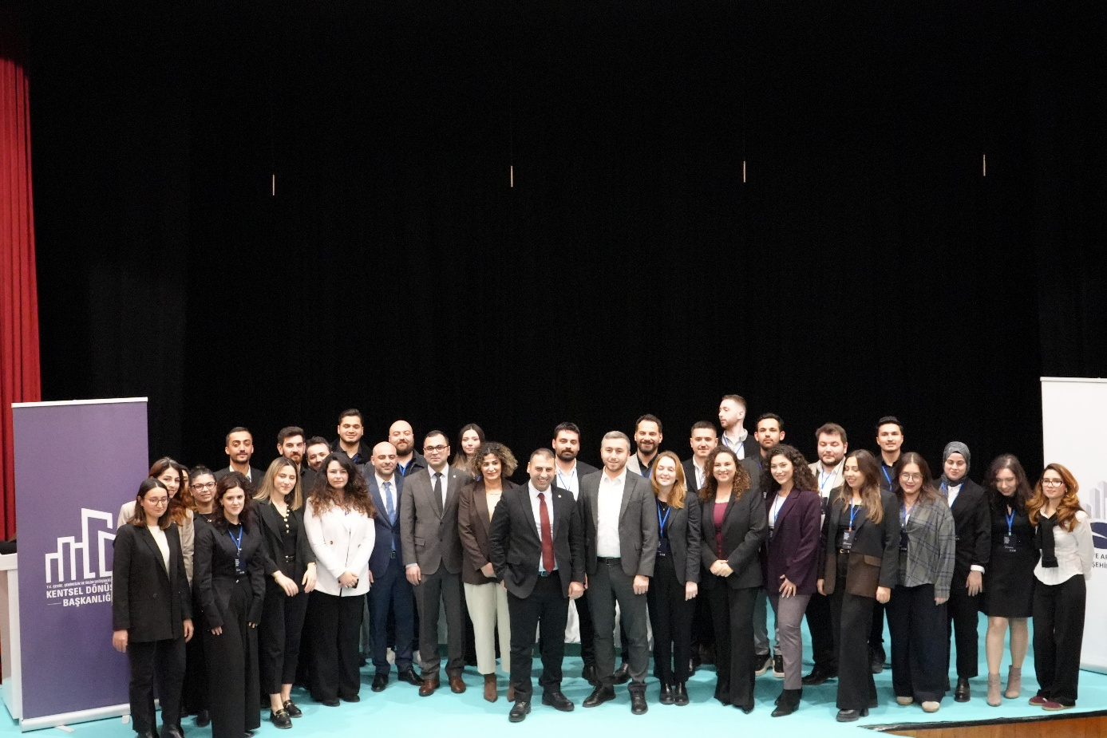
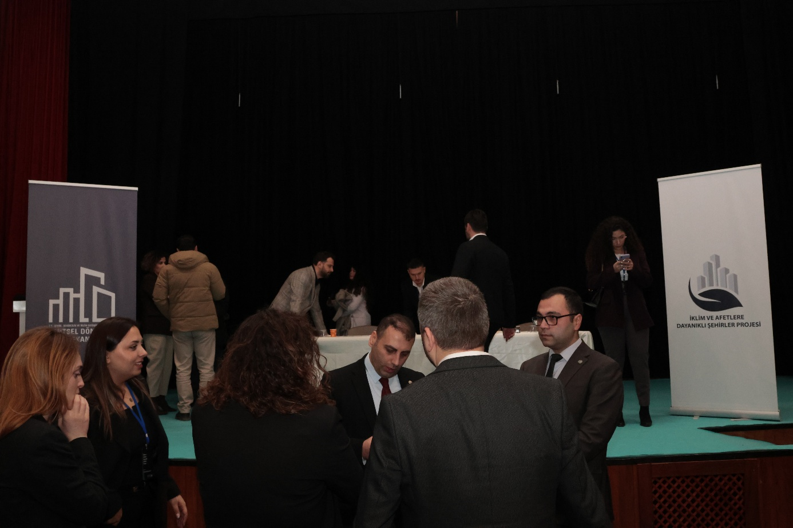
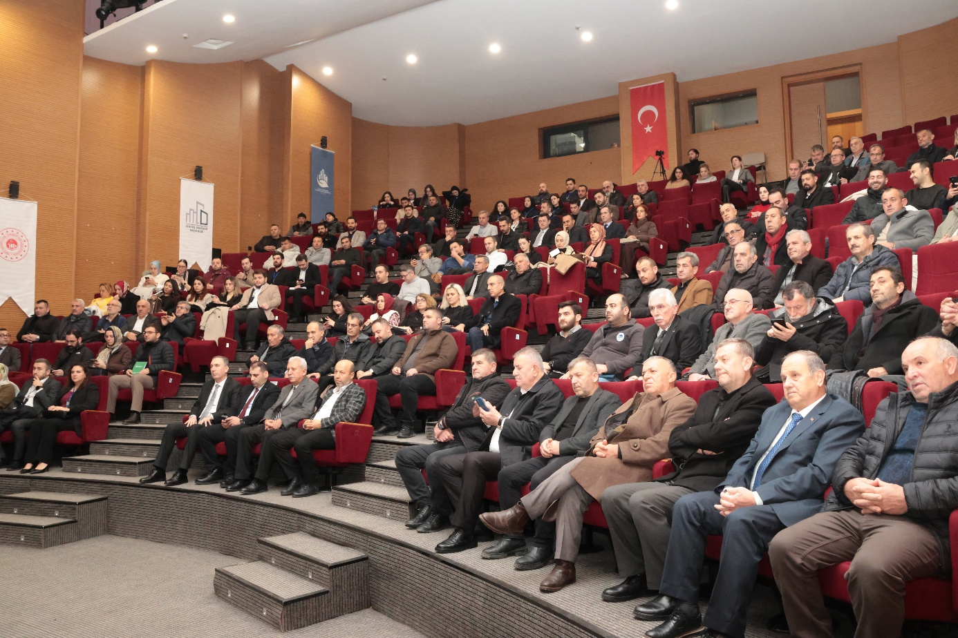

For details please see the Project Appraisal Document (PAD): https://documents1.worldbank.org/curated/en/099955009082212553/pdf/BOSIB09755adcf0b60b1370d3698b9987d0.pdf
The Project Management Unit (PMU) is established under a UTP department at the MoEUCC.
The ESMF is available at: https://kentseldirenclilik.csb.gov.tr/ingilizce-dokumanlar-i-108261
SEP is available at: https://kentseldirenclilik.csb.gov.tr/ingilizce-dokumanlar-i-108261
The LMP is available at: https://kentseldirenclilik.csb.gov.tr/ingilizce-dokumanlar-i-108261
⁶ Republic of Türkiye, Governorship of Sakarya, Provincial Directorate of Environment, Urbanization and Climate Change, Sakarya Province 2023 Environmental Status Report, 2024.
⁷ Republic of Türkiye, Governorship of Sakarya, Provincial Directorate of Environment, Urbanization and Climate Change, Sakarya Province 2023 Environmental Status Report, 2024.
Republic of Türkiye, Governorship of Sakarya, Provincial Directorate of Environment, Urbanization and Climate Change, Sakarya Province 2023 Environmental Status Report, 2024.
Citing the SASKİ 2024 Report: Republic of Türkiye, Sakarya Governorship, Provincial Directorate of Environment, Urbanization, and Climate Change, 2024. Sakarya Province 2023 Environmental Status Report.
Republic of Türkiye, Governorship of Sakarya, Provincial Directorate of Environment, Urbanization and Climate Change, Sakarya Province 2023 Environmental Status Report, 2024.
Republic of Türkiye, Governorship of Sakarya, Provincial Directorate of Environment, Urbanization and Climate Change, Sakarya Province 2023 Environmental Status Report, 2024.
Republic of Türkiye, Governorship of Sakarya, Provincial Directorate of Environment, Urbanization and Climate Change, Sakarya Province 2023 Environmental Status Report, 2024.
2021 Sakarya Governorship Provincial Disaster Risk Reduction Plan (PDRRP). Sakarya Governorship Provincial Directorate of Disaster and Emergency Management. AFAD (Disaster and Emergency Management Presidency).
Republic of Türkiye Ministry of Industry and Technology, General Directorate of Development Agencies. SEGE Studies, 2025.
The Socio-Economic Development Index (SEDI or SEGE) is a study carried out periodically by the General Directorate of Development Agencies of the Ministry of Industry and Technology at the regional (NUTS-2), provincial and district levels. Demographics are based on a wide range of variables, including employment, health, education, finance, competitiveness, innovation, and quality of life. SEGEA defines six development levels for provinces and districts, with the first level being the most developed and the sixth level being the least developed.
T.C. Sanayi ve Teknoloji Bakanlığı, İlçelerin ve Bölgelerin Sosyo-Ekonomik Gelişmişlik Sıralaması Araştırması, 2022.
Definitions of migrants and Syrians under temporary protection are given in Section 2.2.4 "Vulnerable Groups".
Ministry of Family and Social Policies, General Directorate of Family and Community Services. Strategy Paper for Roma Population (2016-2021). April 2016. Ankara Access Address: http://www.sp.gov.tr/upload/xSPTemelBelge/files/wZYtU+Roman_Vatandaslara_Yonelik_Strateji_Belgesi_2016-2021_.pdf
IMM Department of Cultural Heritage and Istanbul Planning Agency. 2020. Istanbul Roma Workshop 2019. Istanbul: Istanbul Metropolitan Municipality.
IMM Department of Cultural Heritage and Istanbul Planning Agency. 2020. Istanbul Roma Workshop 2019. Istanbul: Istanbul Metropolitan Municipality.
Republic of Türkiye Ministry of Culture and Tourism
Sakarya University, 2018. Sakarya's Physical and Human Report.
Ministry of Health of the Republic of Turkey, 2023, Health Statistics Yearbook.
Sakarya Provincial Directorate of Agriculture and Forestry
Sakarya Province Environmental Status Report
TurkStat, 2024
Sakarya Governorship. (2015, February 24). Briefing
Sakarya Metropolitan Municipality, 2024.
Sakarya Environmental Status Report, 2023.
A “High Risk” environmental rating generally would entail the following impacts (a) significantly impact on human populations, including settlements and local communities (b) alteration of environmentally important areas, including wetlands, native forests, grasslands, and other “critical” natural habitats and ecosystem services; (c) direct pollutant discharges that are large enough to cause degradation of air, water or soil, endangered species and “critical” habitats; (d) largescale physical disturbances of the site and/or surroundings; (e) extraction, consumption or conversion of substantial amounts of forest and other important natural habitats, including above and below ground and water-based ecosystems; (f) measurable modification of hydrologic cycle; and (g) hazardous materials in more than incidental quantities. It should be noted here that, as the whole Project is rated as “High Risk” in terms of social risks, subprojects with “high risk” in terms of social risks will not be non-eligible. Therefore, professional judgement will be used to identify “high risk” categorization in terms of environmental aspects during screening phase.
SEP Available at: https://kentseldirenclilik.csb.gov.tr/ingilizce-dokumanlar-i-108261
You can access the web page at the following address: https://kentseldirencligi.csb.gov.tr/
https://kentseldirenclilik.csb.gov.tr/sikca-sorulan-sorular-i-112335
The Labor Management Procedures (LMP) is available at: https://webdosya.csb.gov.tr/db/altyapi/icerikler/moeucc_lmp-20220705095035.pdf
In the Law and the Implementing Regulation, the Administration refers to “Municipalities within the boundaries of municipalities and adjacent areas, special provincial administrations outside these boundaries, metropolitan municipalities in metropolitan provinces and, if authorized by the MoEUCC, district municipalities within the boundaries of metropolitan municipalities”. Since all of the provinces within the scope of the Project are metropolitan cities, the “Administration” will be used as the Municipality within the scope of the Project.
The RF is available at: https://webdosya.csb.gov.tr/db/altyapi/icerikler/moeucc_rf-20220601190650.pdf
The term "Pollution" is used to refer to both hazardous and non-hazardous chemical pollutants in solid, liquid, or gaseous form and includes thermal discharge into water, emissions of short and long-lived climate pollutants, offensive odors, noise, vibration, radiation, electromagnetic energy and contains other components, such as the creation of potential visual impacts, including light
Considering that measures to promote reductions in the use of energy and raw materials, as well as local pollutant emissions, also generally promote the reduction of emissions of short- and long-lived climate pollutants, "pollution management" is defined as short- and long-lived climate pollutant emissions, unless otherwise specified in this ESS. It includes measures designed to prevent or minimize emissions of pollutants, including climate pollutants.
A “High Risk” rating generally would entail the following impacts (a) significantly impact on human populations, including settlements and local communities (b) alteration of environmentally important areas, including wetlands, native forests, grasslands, and other “critical” natural habitats and ecosystem services; (c) direct pollutant discharges that are large enough to cause degradation of air, water or soil, endangered species and “critical” habitats; (d) largescale physical disturbances of the site and/or surroundings; (e) extraction, consumption or conversion of substantial amounts of forest and other important natural habitats, including above and below ground and water-based ecosystems; (f) measurable modification of hydrologic cycle; (g) hazardous materials in more than incidental quantities; and (h) involuntary displacement of people and other significant social disturbances. It should be noted here that, as the whole Project is rated as “High Risk” in terms of social risks, sub-projects with “high risk” in terms of social risks will not be non-eligible. Therefore, professional judgement will be used to identify “high risk” categorization in terms of environmental aspects during screening phase.
To access the C-ESMP Checklist template: https://webdosya.csb.gov.tr/db/kentseldirenclilik/icerikler/c-esmp-checkl-st-10.06.2025_clean-20250610130041.docx
To access the E&S Audit Report Template: https://webdosya.csb.gov.tr/db/kentseldirenclilik/icerikler/e-s-aud-t-report-1-20250819085458.docx
https://kentseldirenclilik.csb.gov.tr/uygulama-kilavuzlari-i-112364
https://www.mevzuat.gov.tr/mevzuat?MevzuatNo=6306&MevzuatTur=1&MevzuatTertip=5
https://webdosya.csb.gov.tr/db/altyapi/icerikler/r-skl--yapilarin-tesp-t-ed-lmes-ne-il-sk-n-esaslar-20190218134628.pdf

