CLIMATE AND DISASTER RESILIENT CITIES PROJECT
Stakeholder Engagement Plan
DocID: | REP-URP-2
Revision: | 02

Revision History

Rev | Date of Issue | Prepared by | Checked by | Approved by | Description of Change
01 | 06.12.2021 |  |  |  | First submission
02 | 29.04.2022 |  |  |  | Second submission

Table of Contents
List of Tables 5
List of Figures 6
Definitions, Abbreviations & Acronyms 7
Executive Summary 8
1 Introduction 9
1.1 Project Overview 9
1.2 Purpose and objectives of SEP 14
2 Regulations & Requirements 15
2.1 Turkish Requirements 15
2.2 World Bank Requirements 15
3 Summary of Previous Stakeholder Engagement Activities 18
3.1 Consultations Conducted Prior to SEP 18
3.2 Communications with NGOs 19
3.3 Consultation Meetings on Final Drafts of Environmental and Social Documents 19
4 Stakeholder Identification and Analysis 21
4.1 Project-affected Parties 21
4.2 Other Interested Parties 21
4.3 Vulnerable Individuals or Groups 21
4.4 Summary of Stakeholder Interest in and Influence over the Project 23
5 Stakeholder Engagement Program and Methods 31
6 Roles & Responsibilities for Stakeholder Engagement Implementation 34
6.1 Implementation Arrangements 34
6.2 Timeframe 34
6.3 Roles and Responsibilities 34
6.4 Estimated Budget 36
7 Grievance Mechanism 37
7.1 Receiving & Registering Grievance 37
7.2 Assessment of the Grievance 38
7.3 Resolving the Grievance 38
7.4 Close out of the Grievance 38
7.5 GM contact information 39
8 Monitoring and Reporting 40
8.1 Monitoring Reports in the Course of the Project 40
8.2 Involvement of Stakeholders in Monitoring Activities 40
8.3 Reporting Back to Stakeholder Groups 40
Annex-1. Records of Meetings and Consultations 41
Annex-2. Minutes of meetings in Istanbul 49
Annex-3. Minutes of meetings in Izmir 58
Annex-4. Minutes of meetings in Kahramanmaras 63
Annex-5. Minutes of meetings in Manisa 66
Annex-6 Consultations of Final Drafts of Environmental and Social Documents (Istanbul) 68
Annex-7 Consultations of Final Drafts of Environmental and Social Documents (Izmir) 72
Annex-8 Consultations of Final Drafts of Environmental and Social Documents (Manisa) 75
Annex-9 Consultations of Final Drafts of Environmental and Social Documents (Tekirdag) 78
Annex-10. Grievance Register Form 85
Annex-11. Grievance Closure Form 86

List of Tables
Table 1. Gross Domestic Product per Capita by Provinces, 2018-2020 13
Table 2 Stakeholder Matrix 24
Table 3 Analysis of the Affected Stakeholders in Istanbul 25
Table 4 Analysis of the Interested Stakeholders in Istanbul 25
Table 5 Analysis of the Affected Stakeholders in Izmir 26
Table 6 Analysis of the Interested Stakeholders in Izmir 26
Table 7 Analysis of the Affected Stakeholders in Manisa 27
Table 8 Analysis of the Interested Stakeholders in Manisa 27
Table 9 Analysis of the Affected Stakeholders in Tekirdag 28
Table 10 Analysis of the Interested Stakeholders in Tekirdag 28
Table 11 Analysis of the Affected Stakeholders in Kahramanmaras 29
Table 12 Analysis of the Interested Stakeholders in Kahramanmaras 29
Table 13 Stakeholder Engagement in Transforming Risky Structures 32
Table 14 Roles and Responsibilities 35
Table 15 Budget Items and Estimated Costs 36
Table 16 Workflow of the GM 37

List of Figures
Figure 1 Stakeholder Impact/Interest Matrix 30

Definitions, Abbreviations & Acronyms

Definition, Abbreviation or Acronym | Description
ASAM | Association for Solidarity with Asylum Seekers and Immigrants
CERC | Contingent Emergency Response Component
CIMER | Cumhurbaskanligi Iletisim Merkezi [Presidential Communications Center]
ESHS | Environment, Social, Health and Safety
ESMF | Environmental and Social Management Framework
ESS | Environmental and Social Standard
FGD | Focus Group Discussions
GDIUTS | General Directorate of Infrastructure and Urban Transformation Services
GDP | Gross Domestic Product
GM | Grievance Mechanism
GRF | Grievance Register Form
GRS | Grievance Redress Service
GT | Government of Turkiye
KADEM | Kadin ve Demokrasi Dernegi [Women and Democracy Association]
MoEUCC | Ministry of Environment, Urbanization and Climate Change
NGO | Non-governmental Organization
OHS | Occupational Health and Safety
PAP | Project Affected People
PMU | Project Management Unit
PPM | Public Participation Meeting
Project | Climate and Disaster Resilient Cities Project
SEA/SH | Sexual Exploitation and Abuse / Sexual Harassment
SEP | Stakeholder Engagement Plan
SILC | Statistics on Income and Living Conditions
WB | World Bank

Executive Summary
The Climate and Disaster Resilient Cities Project, which is planned to be implemented through World Bank funding, aims to increase access to seismic and climate resilient housing, urban infrastructure and services in selected provinces in Turkiye (Istanbul, Izmir, Kahramanmaras, Manisa and Tekirdag), and to respond promptly and effectively in the event of an Eligible Crisis or Emergency. It will support the development of a pilot program in order to develop a multiple hazard risk assessment methodology and disseminate an inclusive and participatory urban transformation strategy that promotes the needs of vulnerable groups while addressing key policy and sectoral bottlenecks.
One of the mandatory documents to be prepared for the Climate and Disaster Resilient Cities Project is the Stakeholder Engagement Plan (SEP). The main objective of the Stakeholder Engagement Plan is to ensure that all relevant stakeholders (individuals, groups and organizations) affected by and/or interested in the Project are involved in the Project activities and that the flow of information to/from these stakeholders is continuous throughout the Project.
Stakeholder engagement is an important activity within the Project process because it enables the stakeholders to be informed at every stage of the Project, to express their expectations and concerns, and to establish an open communication channel with the Ministry of Environment, Urbanization and Climate Change (MoEUCC) as it implements its commitments under the project. In this regard, in this SEP document, necessary consultations, meetings, communication tools and awareness raising needs were defined and "Stakeholder Engagement in Transforming Risky Structures", “Stakeholder Defining Process” and "Stakeholder Matrix" were developed.

Introduction

Project Overview
The Climate and Disaster Resilient Cities Project (Project) serves as a pilot to show how the urban resilience policies of the Government of Turkiye (GT) can be implemented in selected provinces and expanded over time. Within the scope of the Project, a pilot program will be developed to support the implementation of the urban transformation strategy, which also addresses key policy and sector bottlenecks through technical assistance and capacity building. In addition, it is aimed to develop a financing framework to support the retrofitting/reconstruction of risky structures and large-scale urban resilience investments.

Project Components
The Project includes five components.
Component 1 - Institutional strengthening to enable conditions for urban resilience (MoEUCC)
Component 1 will provide technical assistance to the MoEUCC and selected local government institutions, including the metropolitan municipalities at the Project pilot provinces as well as additional municipalities vulnerable to disaster risks, to strengthen their capacity to develop, implement, and monitor green and resilient urban transformation programs.
It will finance consulting and non-consulting services, training, and goods for, inter alia:
(i) the preparation of municipal urban transformation strategies for selected pilot provinces vulnerable to climate and disaster hazards, jointly with local government officials, including city-wide climate and disaster risk assessments to inform on structural plans and investment prioritization, definition of financing modalities, implementation plans, and citizen engagement strategies for green and resilient urban transformation;
(ii) the improvement of systems and procedures for managing, monitoring, and evaluating urban transformation programs with the involvement of relevant stakeholders at national and local levels, including structural hazard and climate risk datasets;
(iii) the preparation and execution of targeted capacity building programs (including training, knowledge exchange study tours, etc.) for MoEUCC and municipal staff on relevant topics such as conducting disaster and climate risk assessments, integration of energy efficiency measures into resilient housing design, and use of green and nature-based solutions to mitigate climate and disaster risks in the urban environment; and
(iv) the strengthening of MoEUCC’s capacity, especially at its Provincial Directorates in the Project provinces, to provide technical support to homeowners interested in applying for the resilient housing loans provided under Component 2 during all stages of the loan application and subsequent housing retrofitting or reconstruction process, especially on technical, contractual, and legal matters with particular attention paid to lower-income and women-headed households, and to carry out technical verification and inspections during housing reconstruction or retrofitting.
Component 2 – Expanding Access to Resilient Housing (MoEUCC)
Component 2 will provide demand-side support for resilient housing in the Project provinces by financing loans (in Turkish lira) at below-market conditions for eligible homeowners to retrofit or reconstruct their housing or commercial units in risky residential or mixed-use buildings to meet the regulation for resilient buildings and energy efficiency standards. The objective of this new financial product is to address the issue of limited affordability and access to finance for a specific niche market segment that is not served through the existing mortgage market (i.e., owners of risky housing units who cannot afford seismic retrofitting or reconstruction of their property) with the aim to save lives. As such, it is not intended to be rolled out to a wider market segment nor to become an integral part of the mortgage industry in Turkiye. In addition, the World Bank financing will not be made available directly to developers or for the direct construction of buildings. The loans funded by the International Bank for Reconstruction and Development (IBRD) under this Component will be channeled through participating commercial banks and will be paired with the government’s existing rental subsidies (which will continue to be financed by MoEUCC with their own funds) to support families to relocate temporarily during the retrofitting or reconstruction process.
Eligibility and targeting: Owners of units in residential or mixed-use buildings located in urban areas of the Project provinces that are assessed as “risky” according to the provisions of Law No. 6306 will be eligible to apply for the loans financed under this component. This includes owners of units in multi-family buildings (who are expected to be the majority) as well as owners of single-family houses. Owners of risky housing units are eligible to apply for the loans regardless of their income level; however, financial terms will be differentiated to provide incentives and ensure affordability of the loans for the vulnerable groups. In particular, middle to lower-income households (those whose household income are below a certain threshold, e.g., 4th or 3rd income quintile), those that only own one unit, and households that are women-headed or include persons with disabilities, deceased military/public servants, or retirees/elderly will be eligible for more favorable loan terms.
A multidimensional vulnerability analysis using Statistics on Income and Living Conditions (SILC) 2019 cross-sectional data showed that in general, households in these target categories are relatively more vulnerable compared to the regional averages in the Project provinces.
In addition, within the scope of the Regulation on Energy Performance for Buildings, more favorable loan terms will be provided for upgrading to a higher energy efficiency standard (Class A or B Energy Performance Certificates) than required by the 2019 Building Earthquake Regulation (Class C Energy Performance Certificate) to incentivize climate change mitigation and help reduce household energy bills.
Communications and outreach activities, which will be financed under Component 4 to make potential beneficiaries in the Project provinces aware of and elicit demand for the new loans, will have a particular focus on more vulnerable groups, including lower income and women-headed households, and highlight the benefits of resilient housing retrofitting and reconstruction including energy efficiency measures.
MoEUCC’s Project Operations Manual (POM) will detail the methodology for the targeting of beneficiaries, including communication and outreach activities provided under Component 4, use of differentiated loan terms, and targeted technical support to be provided under Component 1 to ensure that middle to lower income households and women-headed households benefit from the loans provided under this component. MoEUCC will also conduct annual assessments to review the performance of the new resilient housing loan mechanism supported under this component, including demand and targeting, effectiveness of communication and support provided to homeowners, the quality of housing construction, and environmental and social aspects, in order to identify and timely implement any necessary adjustments and course-corrections during Project implementation, as needed.
Loan terms: A fixed, below-market interest rate (not tied to IBRD terms), determined based on affordability criteria, will be charged for the loans. There will be further (cumulative) interest rate deductions for eligible owners falling in the categories listed above and for upgrading to higher energy efficiency standards.
The interest rates, maximum loan maturity, and maximum principal amounts will be agreed between the MoEUCC and the participating commercial banks considering affordability while at the same time ensuring that payment capacity of households is leveraged. All such loan terms shall be reasonable and acceptable to the WB and will be specified in the POM, in addition to eligibility criteria and the application forms.
Eligible expenditures: The loan proceeds can only be used for civil works and consulting services required for the seismic and climate-resilient retrofitting or reconstruction of risky housing units, including energy efficiency measures. MoEUCC will continue to finance existing rental subsidies with their own funds.
Component 3 – Investments in Climate and Disaster Resilient Municipal Infrastructure (ILBANK)
Component 3 will support ILBANK to on-lend loans (in Euro) with longer maturities and lower interest rates than the comparable domestic market to Project metropolitan municipalities and their affiliated utilities to undertake infrastructure investments that increase resilience against the impacts of climate-related and/or other disaster hazards. ILBANK will be the Financial Intermediary (FI) for this Component and Project metropolitan municipalities and affiliated utilities will be sub-borrowers. ILBANK will ensure the financial viability and creditworthiness of the sub-borrowers per standard practice. The Component will finance works, goods, non-consulting and consultant services for: (i) demand-driven resilient and green municipal infrastructure investments in Project provinces, and (ii) technical assistance to sub-borrowers to strengthen their capacity to plan, prepare, and implement infrastructure investments that mainstream climate and disaster risk considerations.
Sub-project eligibility and prioritization. Sub-projects eligible for financing under this Component include, the construction or rehabilitation of, inter alia: (i) stormwater, drainage, and flood management systems, (ii) water and wastewater systems and treatment plants, and (iii) bridges roads, and junctions to climate and disaster-resilient standards; as well as the creation of complementary permeable public and/or green spaces and other nature-based solutions alongside these investments. Additionally, sub-projects will need to fulfill the following eligibility criteria: (i) be in areas designated as hazard risk prone in the Project provinces or require improvements for climate and disaster resilience as per existing risk assessment studies , (ii) be aligned with existing municipal plans and policy documents (such as city development plans, climate action plans, transport master plans, disaster risk reduction plans, etc.); and (iii) be complementary to other investments being financed in the Project provinces. Any municipal investment with high environmental or social risks will not be eligible for financing. Prioritization among eligible sub-projects will consider how sub-projects contribute to climate mitigation and/or adaptation, adopt innovative and integrated approaches to resilience (e.g., incorporation of complementary permeable public and/or green spaces and other nature-based solutions), and have a high degree of readiness for implementation. The eligibility and prioritization approach for sub-projects will be elaborated in the POM prepared by ILBANK, including a borrowing cap for each sub-borrower (metropolitan municipalities and affiliated utilities) based on a transparent methodology considering city size, investment needs, and equity (e.g., access to other financing sources), as well as their municipal borrowing history limits and creditworthiness. The careful creditworthiness assessments and prudent financing allocations are expected to help manage the foreign exchange risks associated with the loans at the municipal level.
Technical assistance to sub-borrowers. Technical assistance will focus on sub-project management and implementation support, including sub-project design, procurement, contract management, construction supervision, environmental and social management, monitoring and evaluation, as well as outreach and citizen engagement by the municipal sub-borrowers.
As mentioned before, this Component will be implemented by ILBANK and is not covered by this ESMF. ILBANK has prepared a separate ESMF for this component.
Component 4: Project Management, Monitoring and Evaluation
(4a) For Component 1, 2 and 5 (MoEUCC)
(4b) For Component 3 (ILBANK)
Component 4 will have two sub-components that finance consulting and non-consulting services, goods, training, and operating costs as required by ILBANK and MoEUCC to implement the Project as per the WB policies and guidelines, including but not limited to monitoring and evaluation, reporting, procurement, financial management, and disbursement, environmental and social management, grievance mechanisms, as well as communication and outreach activities especially for Component 2 to ensure potential beneficiaries, in particular women and lower-income households, are aware of the resilient housing program and its benefits. This Component will also support MoEUCC’s annual assessments of how the new mechanism to support resilient housing retrofitting or reconstruction under Component 2 is performing to identify adjustments and course-correction during implementation as needed.
Component 5 – Contingent Emergency Response Component (CERC)
This Component is included in accordance with World Bank Operational Policy/Bank Procedure 10.00 (Investment Project Financing), paragraphs 12 and 13, for contingent emergency response through the provision of immediate response to an Eligible Crisis or Emergency, as needed. It will allow the Government of Turkiye (GT) to respond promptly and effectively to an eligible emergency or crisis, that is a natural or human-made disaster or crisis that has caused or is likely to imminently cause a major adverse economic and/or social impact by requesting a rapid reallocation of Project funds. An Operations Manual for this Component will be prepared by the MoEUCC.

Project Locations
The Project will focus on building urban resilience in the provinces of Istanbul, Izmir, Kahramanmaras, Manisa and Tekirdag. These provinces are highly vulnerable to disasters and climate change and have a large number of vulnerable areas that require urgent urban resilience investments. The selection of these municipalities is based on their socio-economic profiles, poverty, population, migrant population (if any) and GDP per capita figures, different geographic areas, municipal capacities, different types of natural disasters (e.g., earthquakes) and on-site redevelopment potential. All five provinces are exposed to a range of natural hazards with high exposure to earthquakes and river flooding. In addition, the selected five provinces are geographically dispersed all over Turkiye, have migrants and Syrians under temporary protection and have different socio-economic development levels.
Istanbul is the most populated city in Turkiye, serving as the country's economic, cultural and historic hub. The city straddles the Bosporus strait, lying on both Europe and Asia. Its total area is 5,461 km² and this metropolitan city has a population of over 15.8 million residents as per 2021 data, comprising nearly 19% of the population of Turkiye. Istanbul is the most populous city in Europe and the world's 13th largest city. The per capita GDP of Istanbul was 97,950 ₺, taking first place in the country.
Izmir is located in the west of Turkiye and in the middle of the Aegean Region's coastline, with a total area of 11,891 km² and a population of approximately 4.4 million in 2021 and per capita GDP of Izmir was 70.010 ₺ in 2020.
Kahramanmaras is located in the Mediterranean region with a total area of 14,520 km² and a population of 1.2 million. Kahramanmaras ranks 48th among 81 provinces in Turkiye in terms of general welfare and ranks 63rd in terms of income and welfare. Per capita GDP of Kahramanmaras is below national average with 39,416 ₺.
Manisa located in the Aegean region, has an area of 13,339 km² and a population of 1.5 million in 2021. Per capita GDP of Manisa was 59,442 ₺ in 2020, which was below the national average.
Tekirdag is located in the West Marmara region of Turkiye and has a total area of 6,190 km² and a population of 1.1 million in 2021. Tekirdag ranks 30th among 81 provinces in terms of general welfare. Per capita GDP of Tekirdag was 84,522 ₺ in 2020, which was above the national average of 60.525 ₺.

Table 1. Gross Domestic Product per Capita by Provinces, 2018-2020
Provinces | Per capita GDP (TRY) |  |  | Per capita GDP ($)
 | 2018^{(r)} | 2019^{(r)} | 2020 | 2018^{(r)} | 2019^{(r)} | 2020
Turkiye | 46,172 | 52,286 | 60,525 | 9,793 | 9 208 | 8,598
Istanbul | 76,932 | 86,723 | 97,950 | 16,317 | 15,272 | 13,914
Izmir | 54,905 | 60,505 | 70,010 | 11,645 | 10,655 | 9,945
Kahramanmaras | 28,718 | 33,977 | 39,416 | 6,091 | 5,983 | 5,599
Manisa | 44,458 | 49,407 | 59,442 | 9,429 | 8,700 | 8,444
Tekirdag | 63,077 | 70,801 | 84,522 | 13,378 | 12,468 | 12,006
Source: TurkStat, Gross Domestic Product by Provinces, 2018-2020
Note: (r) Figures were revised for the years.
All five Project provinces are vulnerable to both disasters and climate change. However, since this RF is prepared for Component 2 and the activities under Component 2 consists of retrofitting/reconstruction of risky buildings which are defined according to Law no. 6306, this RF specifically focuses on the impacts of earthquakes. The most destructive earthquakes in the project provinces are summarized below.
Istanbul: In the earthquake of magnitude Mw 7.4 that took place on August 17, 1999, 1.823 residences and 326 workplaces were severely damaged in the Avcılar district alone, and approximately 4,000 buildings throughout Istanbul were severely damaged, and a total of 981 people lost their lives in the Avcılar and Bağcılar districts.
Izmir: In the earthquake with a magnitude of Mw 6.6 that occurred on October 30, 2020, 8 buildings collapsed in Bayraklı district, and 752 collapsed / heavily damaged buildings were detected in 27 districts in total. 117 people died in the earthquake.
Kahramanmaras: On February 6, 2023, two very large earthquakes of magnitude (Mw) 7.8 and 7.5, occurred nine hours apart on different fault lines in the southern region of Türkiye and northern Syria, which are referred to as the “Kahramanmaraş earthquakes”. 11,020 aftershocks, including fourteen over magnitude 5.5 have occurred. The earthquakes affected 11 provinces, where around 14.01 million (16.5 percent) of Türkiye’s population live, including Adana, Adıyaman, Diyarbakır, Elazığ, Gaziantep, Hatay, Kahramanmaraş, Kilis, Malatya, Osmaniye and Şanlıurfa. As of March 1, 2023, 45,089 fatalities have been reported and 1,971,589 people displaced.
Manisa: In the earthquake with a magnitude of Mw 5.4 that occurred on January 22, 2020, although there were no deaths or injuries, minor damages occurred in 1,729 buildings, moderate damage in 159 buildings, and severe damage in 761 buildings.
Tekirdag: In the earthquake with a magnitude of Ms 7.4 that occurred in 1912, 24,980 buildings were collapsed and 2,836 people lost their lives.

Implementing Institutions
The responsibility for the overall project management and coordination will belong to the General Directorate of Infrastructure and Urban Transformation Services (GDIUTS) under the Ministry of Environment, Urbanization and Climate Change (MoEUCC). Established in 2011 to manage the transformation of areas under disaster risk, GDIUTS carries out its activities in close cooperation with other subsidiaries of the Ministry, including TOKI (Turkish Mass Housing Administration), ILBANK and local authorities. GDIUTS is also defined as the main institution responsible for the implementation of the Law on Transformation of Areas Under Disaster Risk (Law No. 6306).

Purpose and objectives of SEP
The main objective of the Stakeholder Engagement Plan is to ensure that all relevant stakeholders (individuals, groups and organizations) affected by and/or interested in the Project are involved in the Project activities and that the flow of information with these stakeholders is continuous throughout the Project. Stakeholder engagement is an important activity for such projects because it enables the stakeholders to be informed at every stage of the Project, to express their expectations and concerns, and to establish an open communication channel with the MoEUCC as it implements its commitments in the Project. The objectives of the SEP are generally as follows:
- Identifying stakeholders directly or indirectly affected by the Project and/or interested in the Project.
- Identifying and planning stakeholder engagement activities that will begin during Project preparation and continue with the implementation of the Project.
- Setting out the frequency, content, information sharing and level of participation of consultation activities
- Establishing a Grievance Mechanism that will create an open communication channel for stakeholders to raise concerns/complaints at every stage of the Project.
- Ensuring that concerns and expectations expressed by stakeholders are addressed during the decision-making and planning stages of the Project.
The SEP has been prepared to meet the requirements set forth in the World Bank's Environmental and Social Standard (ESS) 10 on Stakeholder Engagement and Information Disclosure.

Regulations & Requirements

Turkish Requirements
Law on Transformation of Areas Under Disaster Risk: The Law on Transformation of Areas Under Disaster Risk, dated 16.05.2012 and numbered 6306, constitutes the procedures and principles regarding improvement, demobilization and reconstruction of the areas under disaster risk, as well land with risky structures inside and outside the disaster risk areas, in order to provide healthy and safe living environments in accordance with scientific and cultural norms and standards.
Environmental Law: The Environmental Impact Assessment Regulation dated 25.11.2014 and numbered 29186 requires stakeholder participation and informing. The 1st clause of the 9th article of the regulation is as follows:
- To inform the public, to get their opinions and suggestions about the Project: A Public Participation Meeting (PPM) will be held on a date given by the Ministry and it is expected that the participants of the Project-affected community, as well as the institutions / organizations and Project owners who are stakeholders in the Project will participate in the meeting, to be located at a central location determined by the Governor.
  - Institutions/organizations that are stakeholders in the Project will publish the meeting day, time and place through a widely known newspaper, at least ten (10) calendar days before the date determined for PPM.
  - The public participation meeting will be held under the control of the Provincial Directorate of the MoEUCC or the authorized presidency. At the meeting, the public will be informed about the Project and the opinions, questions and suggestions of the public will be taken. The Director may request written comments from the participants. Minutes of the meeting will be sent to the Ministry, and one copy will be kept for the records of the Governorship.
- The Governor's Office will announce the program and contact information for public opinion and suggestions. Comments received from the public will be submitted to the Commission in accordance with the schedule.
- Commission members can examine the Project implementation area before the scoping process, and they can also attend the public consultation meeting on the announced date.
- Institutions/organizations that are stakeholders in the Project may provide brochures, surveys and seminars or online studies to inform the public before the public participation meeting.
In order to inform the public, brochures, surveys, etc., before the public participation meeting, are prepared by the institutions / organizations that have been qualified by the Ministry in the 4th paragraph of the same article of the EIA Regulation. It is stated that it can be distributed and published by making seminars.
Right to Information Law: The Right to Information Law No. 4982 (published in the Official Gazette dated 24.10.2003 and numbered 25269) regulates the procedures and principles of the right of access to information in accordance with the principles of equality, impartiality and openness, which are the requirements of a democratic and transparent government. Everyone has the right to obtain information about the activities of public institutions and professional organizations that qualify as public institutions.
Expropriation Law: The expropriation process is carried out in accordance with the Expropriation Law No. 2942 (published in the Official Gazette dated 08.11.1983 and numbered 18215) in accordance with its purpose, authority, procedure, reason and field of activity.

World Bank Requirements
World Bank Environmental and Social Standard 1 (ESS1)
The World Bank requires that the environmental and social risks and impacts of projects supported by the Bank be assessed, managed and monitored to ensure that projects are environmentally and socially sound and sustainable.
The objectives of ESS1 are;
(i) identify, assess and manage the environmental and social risks and impacts of the Project in a manner consistent with ESSs;
(ii) adopt the mitigation hierarchy approach described below;
a) Anticipating and avoiding risks and impacts,
b) To minimize the risks and impacts or to reduce them to acceptable levels where avoidance is not possible,
c) after risks and impacts are minimized or mitigated, mitigate and (iv) compensate or offset where significant residual impacts remain, where technically and financially feasible
(iii) take differentiated measures to avoid adverse impacts being disproportionately disadvantageous or those who are vulnerable and are not disadvantaged in sharing the development benefits and opportunities arising from the Project,
(iv) when appropriate to utilize national environmental and social institutions, systems, laws, regulations and procedures in the evaluation, development and implementation of projects, and
(v) improved in ways that recognize and enhance the Borrower's capacity promoting environmental and social performance.
In accordance with the requirements of ESS1, the Borrower will: (i) undertake an environmental and social assessment of proposed sub-projects; (ii) undertake stakeholder engagement and disclose appropriate information in accordance with ESS10; (iii) develop an Environmental and Social Commitment Plan (ESCP) and implement all measures and actions outlined in legislation, including the ESCP; and (iv) monitor and report the environmental and social performance of the Project against ESSs.
World Bank Environmental and Social Standard 5 (ESS5)
The objectives of ESS5 are:
          - to avoid involuntary resettlement or, when unavoidable, to minimize involuntary resettlement by exploring Project design alternatives;
          - avoid forced eviction;
          - mitigate the unavoidable negative social and economic impacts of land acquisition or restrictions on land use by: (a) providing timely compensation for loss of assets with replacement costs, and (b) assisting displaced persons in their recovery or at least restoration efforts, and livelihoods; and living standards, in real terms, to pre-displacement levels or levels prior to the start of Project implementation, whichever is higher;
          - improve the living conditions of the physically displaced poor or vulnerable by ensuring adequate shelter, access and use of services and facilities;
          - design and conduct resettlement activities as sustainable development programs by providing adequate investment resources to enable IDPs, due to the nature of the Project, to directly benefit from the Project; and
          - ensure that resettlement activities are planned and implemented with appropriate information disclosure, meaningful consultation and informed participation of those affected.
The applicability of ESS5 is dependent on the environmental and social assessment described in ESS1 and applies to permanent or temporary physical and economic displacement resulting from land acquisition or land use restrictions undertaken or implemented in connection with Project implementation described in ESS5.
ESS5 requirements cover the preparation and implementation of a resettlement framework or plan that will form the basis for: (i) general requirements such as suitability classification, Project design, compensation and benefits for affected persons, community engagement, grievance mechanism, planning and implementation; (ii) physical and economic displacement; (iii) cooperation with other responsible bodies or sub-national jurisdictions; and (iv) technical and financial assistance.
World Bank Environmental and Social Standard 10 (ESS10)
This ESS recognizes the importance of open and transparent engagement between the Borrower and Project stakeholders as an essential element of good international practice. Effective stakeholder engagement can improve the environmental and social sustainability of projects, enhance Project acceptance, and make a significant contribution to successful Project design and implementation.
ESS requires borrowers to engage with stakeholders throughout the Project life cycle, commencing such engagement as early as possible in the Project development process and in a timeframe that enables meaningful consultations with stakeholders on Project design. The nature, scope and frequency of stakeholder engagement will be proportionate to the nature and scale of the Project and its potential risks and impacts. According to ESS10, Borrowers shall engage in meaningful consultations with all stakeholders, provide them with timely, relevant, understandable and accessible information, and consult with them in a culturally appropriate manner, which is free of manipulation, interference, coercion, discrimination and intimidation.
The process of stakeholder engagement will involve the following, (i) stakeholder identification and analysis; (ii) planning how the engagement with stakeholders will take place; (iii) disclosure of information; (iv) consultation with stakeholders; (v) addressing and responding to grievances; and (vi) reporting to stakeholders.
As set out in detail in the ESS10, the Borrower is required to maintain, and disclose as part of the environmental and social assessment, a documented record of stakeholder engagement, including a description of the stakeholders consulted, a summary of the feedback received and a brief explanation of how the feedback was taken into account, or the reasons why it was not.
The Borrower shall identify the different stakeholders, both Project-affected parties and other interested parties. Individuals or groups that are affected or likely to be affected by the Project will be identified as ‘Project affected parties’ and other individuals or groups that may have an interest in the Project will be identified as ‘other interested parties’.
The Borrower shall also identify those Project-affected parties (individuals or groups) who, because of their particular circumstances, may be disadvantaged or vulnerable. Based on this identification, the Borrower shall further identify individuals or groups who may have different concerns and priorities about Project impacts, mitigation mechanisms and benefits, and who may require different, or separate, forms of engagement. An adequate level of detail shall be included in the stakeholder identification and analysis so as to determine the level of communication that is appropriate for the Project.
Depending on the potential significance of environmental and social risks and impacts, the Borrower may be required to retain independent third party specialists to assist in the stakeholder identification and analysis to support a comprehensive analysis and the design of an inclusive engagement process.
In consultation with the Bank, the Borrower is required to develop and implement a Stakeholder Engagement Plan (SEP) proportionate to the nature and scale of the Project and its potential risks and impacts. A draft of the SEP shall be disclosed as early as possible, and before Project appraisal, and the Borrower shall seek the views of stakeholders on the SEP, including on the identification of stakeholders and the proposals for future engagement. If significant changes are made to the SEP, the Borrower shall disclose the updated SEP.
As detailed in ESS10, the Borrower is required to respond to concerns and grievances of Project-affected parties related to the environmental and social performance of the Project in a timely manner. For this purpose, the Borrower shall propose and implement a grievance mechanism to receive and facilitate resolution of such concerns and grievances.
The grievance mechanism shall be proportionate to the potential risks and impacts of the Project and shall be accessible and inclusive. Where feasible and suitable for the Project, the grievance mechanism shall utilize existing formal or informal grievance mechanisms, supplemented as needed with Project-specific arrangements.

Summary of Previous Stakeholder Engagement Activities

Consultations Conducted Prior to SEP
Within the scope of the plans prepared as of 2021 of the Climate and Disaster Resilient Cities Project, the stakeholders affected by the Project and related to the Project were identified and engagements commenced. Opinions and suggestions were received from public institutions and organizations, municipalities, mukhtars, NGOs representing vulnerable groups living in risky structures and Project-specific NGOs on the transformation of risky structures.
Information meetings held by the Ministry of Environment, Urbanization and Climate Change (MoEUCC):
A face-to-face information meeting was held by the MoEUCC on 9 December 2021. This information meeting was held with the participation of the municipalities, provincial directorates, water and sewerage administrations representatives of the Project cities, ILBANK and the World Bank for the purpose of promoting the Project. At this meeting, presentations regarding the Project were made by the MoEUCC, General Directorate of Infrastructure and Urban Transformation Services and ILBANK.
An online information meeting was held on 24 November 2021 and the participants are given below.
- MOEUCC
- World Bank
- ILBANK
- Istanbul Directorate of Infrastructure and Urban Transformation
- Izmir Provincial Directorate of Environment, Urbanization and Climate Change
- Tekirdag Provincial Directorate of Environment, Urbanization and Climate Change
- Manisa Provincial Directorate of Environment, Urbanization and Climate Change
- Kahramanmaras Metropolitan Municipality
- Manisa Metropolitan Municipality
- Tekirdag Metropolitan Municipality
In this information meeting, general information about the Project was given and the evaluations of the participants about the Project were received.
Field works were carried out on the following dates:
- Istanbul: 19-21 July 2022
- Izmir: 9-11 November 2021
- Manisa: 11-12 November 2021
- Tekirdag: 18-19 November 2021
- Kahramanmaras: 18-19 November 2021
In field studies, detailed information was obtained on the below listed subjects from the relevant institutions such as Provincial Directorates of Environment, Urbanization and Climate Change, Development Agencies, AFAD, relevant departments and directorates of municipalities, and Mukhtars:
- Specific practices in the provinces related to the transformation of risky structures;
- Responsibilities of different parties within the scope of Law No. 6306 and related Implementation Regulation;
- The way the Law and Implementation Regulation is implemented in the field, positive and negative situations encountered;
- Ways in which districts and neighborhoods in the provinces, the owners of the buildings can respond to the loan;
- Districts and neighborhoods with more risky buildings;
- Regions where vulnerable groups live in provinces;
- Building stock of the provinces;
- Waste storage capacity of provinces; and
- The current situation, which can be evaluated within the scope of the Project, both environmental and social, in particular the environmental risks that have occurred or may occur in the risky building transformation, occupational health and safety (OHS) risks and how these risks are managed and audited.
Records of stakeholder meetings are given in Annex-1, Annex-2, Annex-3, Annex-4 and Annex-5.

Communications with NGOs
During the field studies, a number of NGOs – such as the Association for Solidarity with Asylum Seekers and Immigrants (ASAM), Women and Democracy Association (KADEM), Roman Neighborhood Associations, Chamber of Geological Engineers, Chamber of City Planners, Chamber of Civil Engineers, and Earthquake Reinforcement Association – provided suggestions and opinions on areas where vulnerable groups live, the situation of the Syrian population, the participation of women in social and economic life, the distribution of ethnic and marginal groups in the city and their housing ownership, local geology, construction challenges, planning, risky areas in provinces and districts and risky structures. All of these issues were discussed in consultations and smaller meetings.
Before meeting with NGOs and trade associations, information was given about the Project and meetings were held by making appointments.
Suggestions and opinions of NGOs on socio-economic issues within the scope of the Project and their fields of expertise guided the development of framework documents prepared within the scope of the Project, within the framework of the stakeholder engagement plan and complaint. In the identification of vulnerable persons and groups, in the planning of Stakeholder Engagement activities, in the definition of communication tools, the information obtained from stakeholders were taken into consideration.
Key points from discussions and consultations with NGOs were as follows;
- The distribution of vulnerable groups in each province within the city,
- Excluded and marginalized groups in the provinces and their socio-economic position in the city,
- The characteristics of the residential areas of vulnerable groups,
- Their potential in the urban transformation process within the scope of the Project and their participation in the Project process,
- Socio-economic potential impacts of the Project,
- The need for information and awareness levels of the potential beneficiaries of the Project, especially the vulnerable groups,
- Suggestions.
These basic issues are defined and included in the actions in both the Resettlement Framework document and the Environmental and Social Framework document. In addition, the necessary consultations, meetings, communication tools and awareness raising needs were defined in the SEP document and included in the "Stakeholder Engagement in Transforming Risky Structures", Stakeholder defining process and "Stakeholder Matrix" development process.

Consultation Meetings on Final Drafts of Environmental and Social Documents
Final drafts of environmental and social documents were presented on:
- April 03, 2023, on the Anatolian side and April 04, 2023, on the European side of Istanbul province,
- April 10, 2023, in Izmir province,
- April 11, 2023, in Manisa province and
- April 5, 2023, in Tekirdag province
to stakeholders through consultation meetings. Consultation meetings on environmental and social documents could not be held in Kahramanmaras, as the province of Kahramanmaraş was greatly affected by the earthquake that occurred on February 6, 2023, and public institutions and non-governmental organizations were still working to eliminate the effects of the, and these institutions did not have suitable working conditions.
Before the meetings, the final drafts of the environmental and social documents were published on the Project website (kentseldirenclilik.csb.gov.tr/) on March 18, 2023. Meetings are scheduled to be online or face-to-face. Representatives of public institutions in the provinces, municipalities, mukhtars, professional chambers and non-governmental organizations were invited to the meetings with an official letter, stating that the documents were published on the website ready to be read before the meetings.
During the meetings, Ms. Banu Behram Kuran, the Head of the 4th Department of the Transformation Areas of the Directorate General of Infrastructure and Urban Transformation Services, made a presentation about the scope and components of the project, and then Candan Sağıroğlu on behalf of Çınar Mühendislik explained the possible environmental and social impacts and risks of the Project, the measures to be taken to eliminate or reduce these impacts and risks, the roles and responsibilities of the parties to be involved in the project implementation, and described the procedures to be followed for monitoring. A question-answer session after the presentation was held and in addition, participants were also notified that they can convey their questions or suggestions and complaints through writing e-mail to donusumpyb@csb.gov.tr within a week after the meeting. However, no grievance or concern received through donusumpyb@csb.gov.tr within the one week after the meetings.
In the meetings, generally, questions and comments regarding the scope of the Project and how it will be implemented, rather than the potential environmental and social risks and impacts of the Project, were conveyed.
Detailed information about the consultation meetings held in İstanbul, İzmir, Manisa and Tekirdağ provinces are given in Annex-6, Annex-7, Annex-8 and Annex-9, respectively.

Stakeholder Identification and Analysis
Identifying stakeholders is an important step in the stakeholder engagement process. Stakeholders are divided into two categories in the World Bank's Environmental Social Framework, which are given below.
- Individuals or groups affected by the Project or potentially affected (Project affected parties); and
- Individuals or groups who may be interested in the Project (other interested parties).
With this determination, it will be ensured that an effective SEP will be created that will enable all stakeholders of the Project to be analyzed correctly.
Stakeholder Identification is an important step in managing the overall stakeholder engagement process. It reduces the risk of a narrow stakeholder group dominating the consultation process.
Within the scope of the Project stakeholder mapping and participation studies, the stakeholders have been classified according to stakeholder groups under two categories, 'Project-affected parties' and 'Other interested parties', in accordance with the categories given in the World Bank Environmental and Social Framework, and the stakeholders are given under the relevant sections below.

Project-affected Parties
In line with the potential environmental and social risks of the Project and according to the stakeholder mapping diagram, the individuals, groups and communities identified as key affected stakeholders to be cooperated and consulted are:
- House owners, tenants, vulnerable people or groups living in risky buildings
- Business owners and tenants in risky structures
- Public institutions and organizations affected at the national level
- Locally affected public institutions and organizations

Other Interested Parties
It represents individuals, groups, communities, institutions and organizations interested in Project activities. These stakeholders are listed below.
- Public institutions and organizations affected at national and local level
- Local and community NGOs
- Trade Associations
- Media and Press
- News Agencies
- Local Newspapers
- Academic institutions

Vulnerable Individuals or Groups
Vulnerable people or groups living in risky structures will be the affected stakeholders of the Project. Vulnerable persons or groups are those who are more likely to be subject to temporary or permanent forced displacement than other stakeholders within the scope of the Project. They are those who may have limitations in the process of raising concerns about the transformation of risky structures or understanding their impact.
Vulnerable persons or groups may include women-headed households, the disabled, the elderly, poor households, migrants, Syrians under temporary protection and ethnic groups. Within the scope of the Project, if this population is subjected to forced displacement, taking necessary measures to eliminate the impacts of the Project that will cause them to stay away from social life, health and education opportunities, solidarity or social support networks, increase their expenses, reveal risks in the process of participating in urban life, and decrease their quality of life is important.
Vulnerable individuals or groups are expected to participate in stakeholder engagement activities on an equal basis with other stakeholders. In addition, the Project will endeavor to ensure that the potential grievances are minimized.
Detailed information on the disadvantaged and vulnerable people or groups identified within the scope of the Project is given below.
Women-headed households
Women-headed households can be considered as a vulnerable group disadvantaged by the impacts of the Project. One of the primary reasons for this is the negative impact on livelihoods.
Considering that women's participation in employment is lower than men, based on the socioeconomic status of the provinces, it can be said that women headed households are more disadvantaged. Such disadvantages are exacerbated by the fact that the urban transformation process could result in women and their families being displaced from social life, the workplace, and the institutions where their children or themselves are educated. This could cause them to be separated from social support networks, increase their expenses, and decrease their quality of life.
Therefore, the Project will encourage their meaningful participation in the Project, to identify and operate appropriate tools to maintain information exchange and stakeholder relationship during the Project process, and to provide appropriate support defined within the scope of the Project.
Disabled people
The Project will ensure the full participation of disabled people in the Project. Disabled residents are considered as PAPs affected by Project as well as being shareholders, tenants or informal users.
Persons with disabilities are considered as vulnerable, both as persons affected by the Project and as beneficiaries of the Project. Alternative accessible tools will be defined to support the meaningful participation of disabled people in the Project process to establish information exchange mechanisms that will enable them to be one of the main decision makers in the process of being involved in urban transformation, and to directly inform disabled persons about stakeholder meetings to be made within the scope of the Project. The grievance mechanism and stakeholder participation process to be established within the scope of the Project will be planned to include the disabled population.
If a disabled individual is the owner or tenant of the building subject to the Project, he or she will be subject to temporary or permanent displacement. In this case, the participation of disabled right holders in social life and employment could be difficult -- their expenses may increase, they may stay away from social life, they may be disconnected from social support networks or economic areas. Thus, their quality of life could decrease. Necessary measures will be taken and implemented to prevent such impacts.
Elderly persons
Although old age is not considered as a vulnerable condition in itself, there are people who need care, are ill, etc. Elderly people are considered as a vulnerable group within the scope of the Project.
The elderly population has been evaluated both as a retired population with limited livelihoods and in the middle and lower-middle income group, and as a disadvantaged group that will be subject to temporary or permanent forced displacement within the scope of the Project when they live alone.
During stakeholder meetings and visits to the office of the mukhtars and neighborhood in Izmir, it was revealed that the majority of the elderly population who retired from a job bought their houses with their retirement savings and paid additional rent, travel expenses, etc. within the scope of the Project. It was stated that they would not have sufficient funds for extra expenses.
For this reason, the prevention of the impacts of the Project that will make it difficult for the right holders to participate in social life and employment or increase their expenses will cause them to stay away from social life, social support networks or economic area during the urban transformation process. This could increase their expenses, expose risks in the process of participating in urban life, and decrease the quality of life. Necessary measures will be taken and implemented to mitigate Project impacts.
Poor households (including those with many children) & people without any social security insurance (including unemployed young population, households with child workers)
When the poor and people without any social security insurance are subject to temporary or permanent forced displacement as a property owner, shareholder, tenant or informal user, they are considered as a disadvantaged group as they would not have sufficient funds for extra expenses such as additional rent payment, travel expenses etc.
For this reason, poor rights holders' participation in social life and employment becomes more difficult or their expenses increase, they can be separated from social and support networks or economic areas, education and health opportunities during the urban transformation process. Their expenses could increase, and other risks could arise in the process of participating in urban life. Necessary measures will be taken and implemented to prevent Project-related impacts such as decreased quality of life.
Migrants/Syrians under temporary protection /Ethnic groups
Migrants and Syrians under temporary protection were evaluated as both a Project-affected group and a beneficiary population that will be subject to forced resettlement within the scope of the Project in the five Project provinces. They are vulnerable tenants who would be entitled to Project support measures, as is the case with other vulnerable groups.
They live in low-quality residences located in urban areas with low land value or outdated areas. These groups, which are the poor and marginalized population in the cities, work predominantly in temporary and precarious informal business areas, and continue their social and economic lives in social networks in certain areas of the cities.
However, within the scope of the Project, in case of forced displacement, there is a need to eliminate the impacts of the Project that will cause them to stay away from social life, health and education opportunities, social support networks. Without support, they could face increased risks in participating in urban life, and a decreased quality of life. Necessary measures will be taken and implemented.
Persons and groups whose livelihoods are dependent on the structure subject to the Project who will be permanently displaced, economically and physically (e.g., supers)
Regardless of whether the property is registered or not, supers make up a significant proportion of those whose livelihood depends on the properties subject to the Project and are considered as the vulnerable group that is disadvantaged by the Project.
This group works in different ways. Supers, who live in the common areas of the apartments with their families and provide the maintenance, cleaning and daily shopping of the apartment residents, mostly by using domestic labor, are not defined as the right holders in the transformation process of the residences subject to the Project. This group should be considered as PAPs who will be subject to permanent forced displacement, as these individuals or households are not guaranteed to continue working as a janitor in the new building to be rebuilt.
Supers are also considered to be people or households that are negatively affected economically by the Project and lose their livelihoods, although they are under similar conditions with the unofficial tenants/users of the houses that will be included in the urban transformation in the Project regarding the right to housing.

Summary of Stakeholder Interest in and Influence over the Project
All of the identified stakeholders may be in numbers that make effective communication impossible. For this reason, it is important to communicate with, record and prioritize the stakeholders ensure stakeholder views are reflected in the Project. Issues to be considered include the power of the stakeholder to influence the Project activities, the degree of being affected by the Project activities and the level of interest of the Project.
The values, perceptions, concerns of the stakeholders, their power to direct, support or adversely affect the Project activities and services, the possibility of being affected by these activities and services and the degree of this impact and the level of interest of the stakeholder in the Project have been assessed at this stage.
Within the scope of the Project, the stakeholders' interest in the Project and its impact on the Project are given below.
Table 2 Stakeholder Matrix
Stakeholder Group | Project-affected or Other Interested Party | Information to be Shared | Engagement Method
National and local state institutions and organizations | Project-affected | - Non-technical summary of the Project and Stakeholder Engagement Plan  - Current developments related to the Project | - Consultation Meetings  - In-depth interviews  - Project Brochures  - Presentations  - Grievance Mechanism
National and local state institutions and organizations | Other Interested Party | - Non-technical summary of the Project and Stakeholder Engagement Plan  - Current developments related to the Project | - Consultation Meetings  - In-depth interviews  - Project Brochures  - Presentations  Grievance Mechanism
House owners, tenants, vulnerable people or groups living in risky buildings | Project-affected | - Non-technical summary of the Project and Stakeholder Engagement Plan  - • Information about the land acquisition process  - Current developments related to the Project  - Grievance Mechanism Procedure | - Consultation Meetings  - Socio-economic researches  - Brochures and posters to be hung in public places (cafe, office of the mukhtar)
NGOs  Trade Organizations  Media and Press  News Agencies  Local Newspapers  Academic institutions | Other Interested Party | - Non-technical summary of the Project and Stakeholder Engagement Plan  - Current developments related to the Project | - Consultation meetings  - In-depth interviews  - Project Brochures  - Presentations  Grievance Mechanism

In order for stakeholder engagement to be efficient and solution-oriented, the priorities and objectives of the Project are understood, and the needs and expectations of stakeholders for participation are evaluated during the rating. This information is then used to determine the engagement pattern of each stakeholder group or stakeholder. The forms of participation are determined during the evaluation process of the stakeholders.
The stakeholder impact-interest rating study forms the basis for the Impact/Relevance Matrix to be used in the assessment of stakeholders. The Impact/Relevance Matrix is used to determine the quality of communication with stakeholders. This matrix provides information about the level of participation, how to establish a relationship with the stakeholders, how they will be informed, and the continuity and level of the established communication, in line with the needs of the stakeholders, depending on their sensitivity related to their impact-interest level.
The above-mentioned stakeholder matrix is detailed in the provinces within the scope of the Project, and the analyzes of stakeholder groups on the level of impact and interest are given below.

Table 3 Analysis of the Affected Stakeholders in Istanbul
Affected Stakeholders | Interest Level | Impact Level
Affected Communities
House Owners Living in Risky Buildings in Istanbul | High | High
Tenants Living in Risky Buildings in Istanbul | High | Low
Vulnerable Individuals or Groups Living in Risky Buildings in Istanbul | High | Medium
Business Owners Living in Risky Buildings in Istanbul | High | High
Workplace Tenants Living in Risky Buildings in Istanbul | High | Low
Public Institutions and Organizations at the National Level
Ministry of Environment, Urbanization and Climate Change | Medium | High
General Directorate of Infrastructure and Urban Transformation Services | High | High
General Directorate of Environment Management | Medium | Medium
General Directorate of Construction Works | High | High
General Directorate of Strategy Development | Medium | High
Public Institutions and Organizations at the Local Level
Istanbul Provincial Directorate of Environment, Urbanization and Climate Change | High | High
Istanbul Directorate of Infrastructure and Urban Transformation Services | High | High
Istanbul Metropolitan Municipality | Medium | Medium
District Municipalities of Istanbul | Medium | Medium
Table 4 Analysis of the Interested Stakeholders in Istanbul
Interested Stakeholders | Interest Level | Impact Level
Public Institutions and Organizations at the National Level
Ministry of Interior | Medium | Low
Disaster and Emergency Management Presidency | High | Medium
Ministry of Culture and Tourism | Low | Low
General Directorate of Cultural Heritage and Museums, Department of Boards | Medium | Medium
Public Institutions and Organizations at the Local Level
Istanbul Governorate | Medium | Medium
Istanbul Provincial Directorate of Health | Medium | Low
Istanbul Provincial Directorate of Disaster and Emergency | Medium | Medium
Istanbul Development Agency | Medium | Low
District Governorates of Istanbul | Medium | Medium
Non-Governmental Organizations
Local and Regional Non-Governmental Organizations | High | Medium
National Non-Governmental Organizations | Low | Low
Trade Organizations
TMMOB Chamber of Geological Engineers Representative | High | Medium
TMMOB City Planners Chamber Representative | High | Medium
TMMOB Chamber of Civil Engineers Representative | High | Medium
Media and Press
News Agencies | Low | Low
Local Newspapers | High | Low
Academic Institutions
Universities | Low | Low

Table 5 Analysis of the Affected Stakeholders in Izmir
Affected Stakeholders | Interest Level | Impact Level
Affected Communities
House Owners Living in Risky Buildings in Izmir Province | High | High
Tenants Living in Risky Buildings in Izmir Province | High | Low
Vulnerable Individuals or Groups Living in Risky Buildings in Izmir Province | High | Medium
Business Owners Living in Risky Buildings in Izmir Province | High | High
Workplace Tenants Living in Risky Buildings in Izmir Province | High | Low
Public Institutions and Organizations at the National Level
Ministry of Environment, Urbanization and Climate Change | Medium | High
General Directorate of Infrastructure and Urban Transformation Services | High | High
General Directorate of Environment Management | Medium | Medium
General Directorate of Construction Works | High | High
General Directorate of Strategy Development | Medium | High
Public Institutions and Organizations at the Local Level
Izmir Provincial Directorate of Environment, Urbanization and Climate Change | High | High
Izmir Metropolitan Municipality | Medium | Medium
Izmir Province, District Municipalities | Medium | Medium
Table 6 Analysis of the Interested Stakeholders in Izmir
Interested Stakeholders | Interest Level | Impact Level
Public Institutions and Organizations at the National Level
Ministry of Interior | Medium | Low
Disaster and Emergency Management Presidency | High | Medium
Ministry of Culture and Tourism | Low | Low
General Directorate of Cultural Heritage and Museums, Department of Boards | Medium | Medium
Public Institutions and Organizations at the Local Level
Izmir Governorate | Medium | Medium
Izmir Provincial Directorate of Health | Medium | Low
Izmir Provincial Directorate of Disaster and Emergency | Medium | Medium
Izmir Development Agency | Medium | Low
Izmir Province District Governorates | Medium | Medium
Non-Governmental Organizations
Local and Regional Non-Governmental Organizations | High | Medium
National Non-Governmental Organizations | Low | Low
Trade Organizations
TMMOB Chamber of Geological Engineers Representative | High | Medium
TMMOB City Planners Chamber Representative | High | Medium
TMMOB Chamber of Civil Engineers Representative | High | Medium
Media and Press
News Agencies | Low | Low
Local Newspapers | High | Low
Academic Institutions
Universities | Low | Low

Table 7 Analysis of the Affected Stakeholders in Manisa
Affected Stakeholders | Interest Level | Impact Level
Affected Communities
House Owners Living in Risky Buildings in Manisa Province | High | High
Tenants Living in Risky Buildings in Manisa Province | High | Low
Vulnerable Individuals or Groups Living in Risky Buildings in Manisa Province | High | Medium
Business Owners Living in Risky Buildings in Manisa Province | High | High
Workplace Tenants Living in Risky Buildings in Manisa Province | High | Low
Public Institutions and Organizations at the National Level
Ministry of Environment, Urbanization and Climate Change | Medium | High
General Directorate of Infrastructure and Urban Transformation Services | High | High
General Directorate of Environment Management | Medium | Medium
General Directorate of Construction Works | High | High
General Directorate of Strategy Development | Medium | High
Public Institutions and Organizations at the Local Level
Manisa Provincial Directorate of Environment, Urbanization and Climate Change | High | High
Manisa Metropolitan Municipality | Medium | Medium
Manisa Province, District Municipalities | Medium | Medium
Table 8 Analysis of the Interested Stakeholders in Manisa
Interested Stakeholders | Interest Level | Impact Level
Public Institutions and Organizations at the National Level
Ministry of Interior | Medium | Low
Disaster and Emergency Management Presidency | High | Medium
Ministry of Culture and Tourism | Low | Low
General Directorate of Cultural Heritage and Museums, Department of Boards | Medium | Medium
Public Institutions and Organizations at the Local Level
Manisa Governorate | Medium | Medium
Manisa Provincial Directorate of Health | Medium | Low
Manisa Provincial Directorate of Disaster and Emergency | Medium | Medium
Zafer Development Agency | Medium | Low
Manisa Province District Governorates | Medium | Medium
Non-Governmental Organizations
Local and Regional Non-Governmental Organizations | High | Medium
National Non-Governmental Organizations | Low | Low
Trade Organizations
TMMOB Chamber of Geological Engineers Representative | High | Medium
TMMOB City Planners Chamber Representative | High | Medium
TMMOB Chamber of Civil Engineers Representative | High | Medium
Media and Press
News Agencies | Low | Low
Local Newspapers | High | Low
Academic Institutions
Universities | Low | Low

Table 9 Analysis of the Affected Stakeholders in Tekirdag
Affected Stakeholders | Interest Level | Impact Level
Affected Communities
House Owners Living in Risky Buildings in Tekirdag Province | High | High
Tenants Living in Risky Buildings in Tekirdag Province | High | Low
Vulnerable Individuals or Groups Living in Risky Buildings in Tekirdag Province | High | Medium
Business Owners Living in Risky Buildings in Tekirdag Province | High | High
Workplace Tenants Living in Risky Buildings in Tekirdag Province | High | Low
Public Institutions and Organizations at the National Level
Ministry of Environment, Urbanization and Climate Change | Medium | High
General Directorate of Infrastructure and Urban Transformation Services | High | High
General Directorate of Environment Management | Medium | Medium
General Directorate of Construction Works | High | High
General Directorate of Strategy Development | Medium | High
Public Institutions and Organizations at the Local Level
Tekirdag Provincial Directorate of Environment, Urbanization and Climate Change | High | High
Tekirdag Metropolitan Municipality | Medium | Medium
Tekirdag Province, District Municipalities | Medium | Medium
Table 10 Analysis of the Interested Stakeholders in Tekirdag
Interested Stakeholders | Interest Level | Impact Level
Public Institutions and Organizations at the National Level
Ministry of Interior | Medium | Low
Disaster and Emergency Management Presidency | High | Medium
Ministry of Culture and Tourism | Low | Low
General Directorate of Cultural Heritage and Museums, Department of Boards | Medium | Medium
Public Institutions and Organizations at the Local Level
Tekirdag Governorate | Medium | Medium
Tekirdag Provincial Directorate of Health | Medium | Low
Tekirdag Provincial Directorate of Disaster and Emergency | Medium | Medium
Trakya Development Agency | Medium | Low
Tekirdag Province District Governorates | Medium | Medium
Non-Governmental Organizations
Local and Regional Non-Governmental Organizations | High | Medium
National Non-Governmental Organizations | Low | Low
Trade Organizations
TMMOB Chamber of Geological Engineers Representative | High | Medium
TMMOB City Planners Chamber Representative | High | Medium
TMMOB Chamber of Civil Engineers Representative | High | Medium
Media and Press
News Agencies | Low | Low
Local Newspapers | High | Low
Academic Institutions
Universities | Low | Low

Table 11 Analysis of the Affected Stakeholders in Kahramanmaras
Affected Stakeholders | Interest Level | Impact Level
Affected Communities
House Owners Living in Risky Buildings in Kahramanmaras Province | High | High
Tenants Living in Risky Buildings in Kahramanmaras Province | High | Low
Vulnerable Individuals or Groups Living in Risky Buildings in Kahramanmaras Province | High | Medium
Business Owners Living in Risky Buildings in Kahramanmaras Province | High | High
Workplace Tenants Living in Risky Buildings in Kahramanmaras Province | High | Low
Public Institutions and Organizations at the National Level
Ministry of Environment, Urbanization and Climate Change | Medium | High
General Directorate of Infrastructure and Urban Transformation Services | High | High
General Directorate of Environment Management | Medium | Medium
General Directorate of Construction Works | High | High
General Directorate of Strategy Development | Medium | High
Public Institutions and Organizations at the Local Level
Kahramanmaras Provincial Directorate of Environment, Urbanization and Climate Change | High | High
Kahramanmaras Metropolitan Municipality | Medium | Medium
Kahramanmaras Province, District Municipalities | Medium | Medium
Table 12 Analysis of the Interested Stakeholders in Kahramanmaras
Interested Stakeholders | Interest Level | Impact Level
Public Institutions and Organizations at the National Level
Ministry of Interior | Medium | Low
Disaster and Emergency Management Presidency | High | Medium
Ministry of Culture and Tourism | Low | Low
General Directorate of Cultural Heritage and Museums, Department of Boards | Medium | Medium
Public Institutions and Organizations at the Local Level
Kahramanmaras Governorate | Medium | Medium
Kahramanmaras Provincial Directorate of Health | Medium | Low
Kahramanmaras Provincial Directorate of Disaster and Emergency | Medium | Medium
DOGAKA Development Agency | Medium | Low
Kahramanmaras Province District Governorates | Medium | Medium
Non-Governmental Organizations
Local and Regional Non-Governmental Organizations | High | Medium
National Non-Governmental Organizations | Low | Low
Trade Organizations
TMMOB Chamber of Geological Engineers Representative | High | Medium
TMMOB City Planners Chamber Representative | High | Medium
TMMOB Chamber of Civil Engineers Representative | High | Medium
Media and Press
News Agencies | Low | Low
Local Newspapers | High | Low
Academic Institutions
Universities | Low | Low
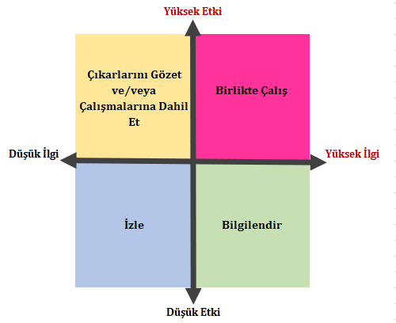
Work together
Inform
Monitor
High Impact
High Interest
Low Interest
Low Impact
Seek interests and/or invite to activities
Figure 1 Stakeholder Impact/Interest Matrix

- Stakeholders marked in pink have a high level of impact and interest, and working together with these stakeholders should be supported by being in constant communication.
- The level of impact of the stakeholders marked with yellow color is medium and high, and the level of interest is low. These stakeholders can be included in the studies by considering their interests.
- The level of interest of the stakeholders marked with green color is medium and high, and the level of impact is low. These stakeholders need to be informed regularly.
- Stakeholders marked in blue have low impact and interest and will be monitored with minimal effort for these stakeholders.

Stakeholder Engagement Program and Methods
Stakeholder engagement is an ongoing process that begins before the development of this SEP and will continue throughout the life of the Project. MoEUCC will be in active communication with the identified stakeholders throughout the life of the Project.
Tools and methods defined for stakeholder engagement; it has been diversified and expanded in order to enable all Stakeholders to access the Project by means of their own preference and most convenient access.
Covid-19, which started in the first months of 2020 and whose effects are still ongoing, necessitated a planning that prioritizes safety and health in the stakeholder engagement process. For this reason, stakeholder engagement activities will be carried out using appropriate methods in line with Covid-19 measures and restrictions.
The methods and tools of stakeholder engagement of the Project are described below. First of all, the methods and tools that are suitable for the restrictions and measures in the Covid-19 process are explained, then the methods and tools that are recommended to be used when the new normalization process is started and when the conditions are suitable, are defined.
The following methods and materials will be used within the scope of engagement from the scoping phase of the Project to the completion of the transformation of risky structures.
Consultation Meetings: Consultation meetings will be held as needed throughout the Project process. Detailed information about the Project will be given and questions and opinions of stakeholders will be evaluated. Consultation meetings will be held as needed during periods or issues that require the Project's consultation with stakeholders. In cases where consultation is required, consultations will be carried out using online tools during the Covid-19 process, and stakeholder consultations can be made face-to-face with the conditions after the new normalization process. In these meetings, the current developments of the Project will be explained, information will be given about the resettlement / relocation process, and ideas and expectations will be discussed during these processes.
In-Depth Interviewing: In-depth interviewing is a qualitative research technique that involves intensive individual interviews with a small number of participants to examine their perspectives on a particular idea, program or situation. In this case, in-depth interviews will be conducted with stakeholders such as national and local government agencies/organizations, cooperatives etc. to analyze the potential impacts of the Project on management and businesses and to evaluate their expectations/advice through planning. In-depth interview interviews are planned to be held online through online tools during the Covid-19 process instead of face-to-face meetings.
Focus Group Discussion (FGD): Focus group interviews can be conducted when there is a need for data collection and qualitative fieldwork during the monitoring process. Focus group studies, which are held in the form of face-to-face meetings, can be carried out online during the Covid-19 process or face-to-face if conditions allow after the new normalization process. FGD is an effective way to bring together people from similar experiences to discuss a specific topic related to the Project.
Socio-Economic Research: Economic and social conditions affect each other positively or negatively. There is a direct connection between economic factors such as livelihoods of the society, income level, job and unemployment and social life. Therefore, economic parameters determine social standards.
Within the scope of the Project, research will be carried out in order to reveal the socio-economic status of stakeholder groups.
Surveys: Survey studies will be used when data collection is required during the Project process, and it is planned to be carried out online through online tools during the Covid-19 process.
Presentations: Visual material will also be used during the informing phase of the stakeholders. Presentations containing summaries of written documents will be made.
Project Brochure: At the first stage, brochures/flyers with communication channels, announcements and information about the Project will be left in the common public areas in the surrounding settlements, in the offices of the mukhtars, in the municipalities, in the provincial directorates, and in the professional chambers.
Grievance Mechanism: The Grievance Mechanism will be open to all stakeholders throughout the duration of the Project, including recording grievances, taking action for resolution, and closing grievances by proving necessary information.
Letter/mail: Project brochures, postings, reports or announcements can be sent by mail, courier or letter when necessary so that stakeholder groups or individuals who do not have access to the Internet, smart phones, social media or e-mail so that they can access Project information.
Hotline: There will be a hotline that all stakeholders can use to voice their concerns and complaints. This method is important in terms of solving the urgent problems of the stakeholders and being fast.
Corporate Website: The corporate website provides announcements, Project documents, reports and contact information for further information requests.
Social Media: Within the scope of social media tools, the Ministry's website (https://csb.gov.tr/), the ministry's social media accounts (https://twitter.com/csbgovtr) will be used as tools to disseminate the announcements and announcements of the Project. In addition, following the initiation of the Project, if needed, social media accounts can be created to convey announcements and developments specific to the Project.
COVID-19 Conditions: The COVID-19 epidemic has affected the whole world and measures such as wearing masks and maintaining social distance in society have become the new normal of our daily lives. If the COVID-19 pandemic conditions continue during the operation phase of the Project and the implementation of this SEP, the activities of SEP will be aligned and implemented in accordance with the guidelines of relevant and responsible national and international organizations such as World Health Organization (WHO), Ministry of Health (MoH) and MoEUCC.
Within the scope of SEP, face-to-face meetings will be held in accordance with mask and social distance rules of MoH and WHO. In cases where face-to-face meetings are not possible due to the COVID-19 conditions, online interview methods can also be used. In addition, it will be ensured that the meetings to be held will be organized in open areas, in accordance with social distance and other regulations of MoH and WHO.
Apart from these measures, other practices outlined in the “Interim Advice for IFC Clients on Safe Stakeholder Engagement in the Context of COVID-19” and the World Bank ESF/Safeguards Interim Note: COVID-19 Considerations In Construction/Civil Works Projects note will also be used on planning stakeholder engagement activities.
In the tables below, which stakeholder engagement activity will be carried out at which stage of the Project and which methods will be used are detailed.
Table 13 Stakeholder Engagement in Transforming Risky Structures
Timing of Stakeholder Engagement Activity | Activity | Engagement Method | Location | Stakeholder Group | Practitioner / Individual Responsible
Within the first month of the launch of the Project | Project kick-off meeting and Grievance Mechanism Central stakeholder institutions introduction meeting | Online / Face-to-face meetings | Ankara / Online | • National and local government institutions and organizations,  • NGO and other interest groups | GDIUTS  PMU head office
Within the first month of the launch of the Project | Project kick-off meeting and Grievance Mechanism Central stakeholder institutions introduction meeting | Online / Face-to-face meetings | Istanbul, Izmir, Kahramanmaras, Manisa and Tekirdag / Online | • Provincial level representations of national institutions,  • Professional chambers,  • Local government institutions and organizations,  • NGOs and other interest groups,  • Mukhtars | MoEUCC Provincial Directorates  PMU
Within the first month of the mobilization of the site staff | Preparing of the "Stakeholder Engagement in Transforming Risky Structures in the Province Level" with local NGOs and key stakeholders. | Online / Face-to-face meetings | Istanbul, Izmir, Kahramanmaras, Manisa and Tekirdag / Online | • Provincial level representations of national institutions,  • Professional chambers,  • Local government institutions and organizations,  • NGOs and other interest groups,  • Mukhtars | Province level social experts (site social experts)
Within the first month of starting the Sub-project | Stakeholder Engagement and Grievance Mechanism Disclosure  Delivery of Project Disclosure notes via e-mail (information by phone when necessary) | Delivery of project information brochures by e-mail or mail | Neighborhoods where subprojects are implemented | • Mukhtars of the affected neighborhoods,  • Mukhtars of the adjacent neighborhoods (if necessary)  • Educational institution management in the impact area (if necessary) | MoEUCC Provincial Directorates  PMU
Within the first month of starting the Sub-project | Stakeholder Engagement and Grievance Mechanism Disclosure  Delivery of Project Disclosure notes via e-mail (information by phone when necessary) | Distribution of project information brochures  Mukhtar information visit  Phone/ e-mail | Living in the neighborhood/near residential area affected by the Project | • Mukhtars of the affected neighborhoods,  • Business and residential managers in the impact area  • Owners, tenants, business owners living in risky buildings,  • Vulnerable people or groups | Contractor
During the Sub-Projects, when necessary (annual monitoring, intensity of complaints, etc.) | Project grievance mechanism register follow-up | In-depth interviews | Izmir, Manisa, Tekirdag and Kahramanmaras Provinces | Vulnerable people or groups living in risky buildings | MoEUCC Provincial Directorates  PMU Social Expert
During the Sub-Projects, when necessary (annual monitoring, intensity of complaints, etc.) | Project grievance mechanism register follow-up | Socio-Economic Researches | Izmir, Manisa, Tekirdag and Kahramanmaras Provinces | Owners, tenants, business owners, Vulnerable people or groups living in risky buildings | MoEUCC Provincial Directorates  PMU Social Expert
During the Sub-Projects, when necessary (annual monitoring, intensity of complaints, etc.) | Project grievance mechanism register follow-up | Focus group discussions | Izmir, Manisa, Tekirdag and Kahramanmaras Provinces | National and local government institutions and organizations, NGOs and other interest groups | MoEUCC Provincial Directorates  PMU Social Expert

Roles & Responsibilities for Stakeholder Engagement Implementation

Implementation Arrangements
Responsibility for the overall Project management and coordination will belong to the General Directorate of Infrastructure and Urban Transformation Services (GDIUTS) within the Ministry of Environment, Urbanization and Climate Change. SEP and GM activities will be carried out by the PMU.
The PMU will be the main responsible for coordinating the stakeholder engagement activities outlined in this plan with the Contractors. The collection of complaints, questions and feedback will be the direct responsibility of the PMU and the Contractors' Social Teams. Detailed roles and responsibilities of the team for the social management of the Project are given in Chapter 6.3.

Timeframe
With the approval of the Project and its entry into force, this SEP and GM will be implemented.

Roles and Responsibilities
The PMU, established under the General Directorate, will be responsible for procurement, financial management, urban development, disaster risk management, environmental and social issues, communication, monitoring and evaluation. The PMU will also be the supervisor of the fund flow within the scope of the Project and will be responsible for carrying out the activities defined in the Stakeholder Engagement Plan.
The PMU structure is planned as follows:
The central staff of the PMU, which was established within GDIUTS, will consist of the following personnel:
- PMU Manager (Project Director),
- Application Regulations Specialist,
- Procurement Specialist,
- Social Expert,
- Environmental Specialist,
- Financial Management Specialist
- Financial Instruments Specialist
Along with the management of the environmental and social subjects of the Project, it will also be responsible for the activities defined within the scope of resettlement and will employ the independent expert personnel defined below to carry out all these studies.
- Four (4) personnel, i.e. one environmental specialist, one OHS specialist and two social specialists (one for community engagement and other for relocation related issues) to work in the head office of GDIUTS,
- Two (2) personnel, i.e. one environmental specialist and one social specialist (community / stakeholder engagement specialized), to work continuously in the office to be established only for the Project in Izmir Provincial Directorate of Environment, Urbanization and Climate Change,
- Two (2) personnel, i.e. one environmental specialist and one social specialist (community / stakeholder engagement specialized), to work continuously in the office to be established only for the Project in Manisa Provincial Directorate of Environment, Urbanization and Climate Change,
- Two (2) personnel, i.e. one environmental specialist and one social specialist (community / stakeholder engagement specialized), to work continuously in the office to be established only for the Project in Tekirdag Provincial Directorate of Environment, Urbanization and Climate Change, and
- Two (2) personnel, i.e. one environmental specialist and one social specialist (community / stakeholder engagement specialized), to work continuously in the office to be established only for the Project in Kahramanmaras Provincial Directorate of Environment, Urbanization and Climate Change.
- Two (2) personnel, i.e. one environmental specialist one social specialist (community / stakeholder engagement specialized), to work continuously in the office to be established only for the Project in Istanbul Provincial Directorate of Environment, Urbanization and Climate Change at Asian side.
- Two (2) personnel, i.e. one environmental specialist and one social specialist (community / stakeholder engagement specialized), to work continuously in the office to be established only for the Project in Istanbul Provincial Directorate of Environment, Urbanization and Climate Change at European side.
The detailed roles and responsibilities of the team for the social management of the Project are given in the table below.
Table 14 Roles and Responsibilities
Roles |  | Responsibility
GDIUTS PMU | Social Expert | - Oversees the social risk management of the Project, including social assessment and resettlement  - Implements and improves grievance mechanism and stakeholder engagement/citizen engagement processes  - Accelerates and monitors the social team for the proper implementation of processes related to grievance mechanism and stakeholder engagement/citizen engagement.  - Coordinates with parties for the appropriate implementation of grievance mechanism and stakeholder engagement/citizen engagement processes.
 | Project Director | - Producing all work in accordance with quality, safety, budget and timing requirements and procedures and contract terms  - Ensuring successful delivery of all identified documents  - Receiving and recording the complaints/demands from authorized persons within the scope of the grievance mechanism regarding social issues and reports them to the relevant units. It helps the relevant units to take the necessary actions.  - Coordinating the interface and reporting to the World Bank regarding the implementation of the SEP, getting reports from the World Bank  - Meets Lenders' Project standards and meets with audit teams, answering their questions as needed  - Performs other activities necessary to achieve the objectives of the SEP implementation.
Site (Environmental and Social Experts | Environmental & OHS Expert / Social Expert | - Identifying incidents or problems arising from the transformation process of risky structures and developing appropriate corrective actions or directing them to the PMU when necessary  - Providing appropriate approach and tools to be used by relevant parties to carry out field activities in accordance with SEP and other Project requirements,
 | Social Expert | - Ensure that the Contractor informs affected communities about Project construction activities and other Project issues.  - Implements the Environmental and Social Plan and, where applicable the Resettlement Plan  - Province level social experts will prepare the "Stakeholder Engagement in Transforming Risky Structures in the Province Level" with actual local NGOs and key stakeholders.  - Implements processes related to Grievance Mechanism and stakeholder engagement. Receives and records the applications / complaints / requests from the right holders within the scope of the Grievance Mechanism regarding social issues. Provides GDIUTS with reports on community-related issues on daily basis.  - Helps to fill in the grievance register forms created in cases where the stakeholders want to apply.  - Acts as a key point of contact with affected communities and other stakeholders  - Keeps records of complaints and participation activities  - Reports grievances and engagement activities to PMU.  - Oversees design and implementation of citizen engagement measures

Estimated Budget
Details of the budget required to carry out all stakeholder engagement activities described in this SEP are presented below. The budget presented below represents social aspects of the budget, which is separated from the budget provided in Chapter 9 of the ESMF prepared within the scope of the Project.
Table 15 Budget Items and Estimated Costs
Budget Items | Estimated Costs
Employment of Social Experts | 750,000 $
PMU Monitoring Activities regarding social aspects (for 72 months) | 150,000 $
Public disclosure activities such as awareness campaigns and information disseminations.
Trainings to be provided for PMU, other staff, and Contractor’s ESHS Specialists within the scope of social aspects | 100,000 $
Total | 1,000,000 $

Grievance Mechanism
The grievance mechanism (GM) is an arrangement that provides channels for Project stakeholders to provide feedback and/or voice their concerns and grievances about Project activities.
In accordance with the international requirements, a grievance mechanism has been established to receive, resolve and follow up the concerns and complaints of the Project-affected and relevant stakeholders within the scope of the Project.
The PMU, which will be established under the Ministry of Environment, Urbanization and Climate Change (MoEUCC), will be accessible to stakeholders and will respond to all complaints as soon as possible.
Stakeholders will be able to use ALO 181, CIMER, hotline, face-to-face meetings, grievance registration forms and the website contact form to voice their grievances.
The steps to be followed during the grievance management will be as follows;

Receiving & Registering Grievance
- All complaints received by the relevant administration through the telephone line, contact form or other channels are recorded using the Grievance Registration Form (GRF) (Annex 10) and a hard copy of the form is given to the Complainant. The completed form is entered into the PMU grievance registration system of the MOEUCC within the same business day.
- If the GRF cannot be filled, the following basic information is recorded:
  - Complainant's first and last name (complainants also have the right to register an anonymous complaint);
  - The subject of the grievance;
  - Place of Grievance;
  - Contact information (phone / mobile number, address, e-mail, etc.);
  - Organization name (if relevant)
  - Date and time
- Project teams complete the GRF according to the information provided and register the grievance.
- All corrective actions suggested by the complainant are recorded through the GRF.
Table 16 Workflow of the GM
Workflow steps | Name of Step in Data File System: “Status of Notification” | Principles and Standards
Receiving the complaint | Notification has been received. | Complaints can be made verbally or in writing using any of the tools described in section 5 Stakeholder Engagement Program and Methods
Registering the complaint | The notification has been saved. | Incoming complaint is recorded within 2 days at the latest to the GM database system. System will automatically define the complaints to the site experts according to Provinces.
Evaluation | It is under evaluation. | Site Social Experts will conduct the initial complaint assessment immediately after the complaint is registered to define the subject of the complaint and convey it to the relevant unit-authority for investigation.
Confirmation notification of receipt of complaint | The relevant stakeholder was informed that the notification was received. | The stakeholder will be notified that the grievance has been received and recorded. Feedback will be sent based on the transmission method of the complaint (mail, telephone, etc.).
Assign/ take action | The action is assigned. | Site Social Expert will assign the complaint to the relevant unit or person who needs to develop a solution according to the complaint, and define his or her task.
Research / Review | It is in the research/review phase. | The relevant unit will develop a solution and corrective action within 15 days, obtain the necessary approvals, and report the result to the Site social expert.
Communicating feedback to the stakeholder | Final feedback was given to the stakeholder. | Corrective action will be explained to the complainant, consulted and agreed.
Implementation of corrective action | The action has been taken. | The existing complaint will be eliminated by applying a solution / corrective action.
Closing the complaint | Actions regarding notification are closed. | It will be determined that the existing problem or complaint has been resolved / approval of the complainant will be obtained, and then the complaint will be closed within 30 days at the latest from the date of registration.

Assessment of the Grievance
- All grievances are reviewed to be classified according to whether they are genuine or not related to Project activities. If the issues/disputes raised are not related to the Project activities, guidance is provided to the Complainant to contact the relevant person. Eligible Complaints will be answered in accordance with the Project's social and environmental standards.
- All Grievances received via hotline, email, face-to-face meetings/communications are recorded and Project teams contact the Grievance owner to explain the response process within two (2) Business Days after registration.
- The GM will include a channel to receive and address confidential complaints related with Sexual Exploitation and Abuse/Sexual Harassment (SEA/SH) with special measures in place to ensure confidentiality and sensitive treatment of such complaints, as well as measures to ensure such complaints are handled in accordance with national or local laws.
- The PMU has ten (15) Business Days to investigate and respond to grievances. If the situation requires a more complex investigation, the Complainant will be provided with updated information describing the necessary actions and possible timeline for resolving the Grievance.

Resolving the Grievance
- Necessary corrective actions will satisfy the complainant.
- All parties agree on corrective actions throughout the resolution process.
- The PMU aims to resolve each complaint within thirty (30) Business Days after responding, which may be extended by written order of the Ministry.
- Complainants may appeal the decision of the GM. The processing, hearing and report on the appeal’s outcome shall be concluded within 30 Business Days of the receipt of the appeal.
- Complainants can apply to the court when they are not satisfied with the decision of the PMU or the Ministry regarding their complaints.

Close out of the Grievance
Evidence of the corrective actions taken (photographs or other evidence documents on the Site, pertaining to the subject) is collected and a “Grievance Closure Form” (Annex 11) is signed between the PMU and the Complainant.

Registration and Evaluation of Anonymous Complaints
When both external and internal stakeholders have issues, concerns or difficulties in providing their contact information and identity information, the complaints submitted by the stakeholders will be first evaluated and recorded as anonymous complaint or anonymous suggestion. Stakeholders can submit all their wishes and complaints to the request – complaint hotlines without specifying their names.
As another method, they can convey their complaints about the Project by any other defined communication tool they prefer, without giving their name and contact address.
Complaints received anonymously will be evaluated by implementing the steps defined in the workflow. Within the scope of the complaint, it will be evaluated by going through the investigation / examination processes and each stage will be processed into the complaint mechanism system. Third parties will not be informed about complaints that should be kept confidential, and no official notification/return will be made.
Although there will be no official feedback on the solution to be applied when the complaint is finalized, if it is a matter that needs to be informed to the public and if deemed necessary, it can be announced to the stakeholders via joint boards/public and general communication tools.

GM contact information
Channels to be used by stakeholders to formally voice their grievances are as follows:
ALO 181: The MoEUCC examines complaints, notices and information requests from 81 provinces of Turkiye, intervenes and carries out inspections. Citizens can send their complaints and notices about environmental problems, air, water, soil, radioactive pollution, urban transformation, noise and waste by calling Alo 181. The notifications recorded from the call center are transferred to the relevant General Directorates regarding the legislation area of the MoEUCC and their answers are received through the system. The information received from the relevant units on the subject is transferred to the applicant via telephone by the authorized person in the call center. In this way, citizens are given feedback as soon as possible about the records they leave. Stakeholders can also contact GDIUTS for any complaints, notices and information requests by calling this number.
CIMER will be able to make all kinds of requests, complaints, notices, opinions and suggestions of the stakeholders within the scope of the Project, as well as their applications regarding their right to information, by using all communication channels through CIMER.
Hotline: Stakeholders can call the phone number 0 (312) 410 10 00 and request a contact with a contact person.
Face to face: Stakeholders can convey their complaints to the relevant staff of the PMU face to face.
Web page contact form: a Project specific website will be established.
It should be noted here that as a final note, the stakeholders and affected parties will be made aware from the GM through the web page to be established and especially through awareness campaigns and information disseminations -such as advertisements, brochures, posters etc. to be prepared and disseminated-.
World Bank Grievance Redress System:
Communities and individuals who believe that they are adversely affected by a World Bank (WB) supported Project may submit complaints to existing Project-level grievance mechanisms or the WB’s Grievance Redress Service (GRS). The GRS ensures that complaints received are promptly reviewed in order to address Project-related concerns. Project affected communities and individuals may submit their complaint to the WB’s independent Inspection Panel which determines whether harm occurred, or could occur, as a result of WB non-compliance with its policies and procedures. Complaints may be submitted at any time after concerns have been brought directly to the World Bank’s attention, and Bank Management has been given an opportunity to respond. For information on how to submit complaints to the World Bank’s corporate Grievance Redress Service (GRS), please visit http://www.worldbank.org/en/projects-operations/products-and-services/grievance-redress-service. For information on how to submit complaints to the World Bank Inspection Panel, please visit www.inspectionpanel.org

Monitoring and Reporting

Monitoring Reports in the Course of the Project
By monitoring the environmental and social impacts of the Project, it is aimed to prevent and reduce the negative impacts. Both environmental and social issues within the scope of mitigation measures will be monitored and overseen by experts appointed through the Ministry of Environment, Urbanization and Climate Change.
Along with the monitoring, it is aimed to provide technical assistance and inspection, mitigation measures and early detection of related conditions, follow-up of mitigation results and information on the progress of the Project.
Social experts will be responsible for monitoring and reporting consultation meetings with Project-affected stakeholders, complaints received and closed.
Experts in the provinces will submit monthly monitoring reports to the PMU in Ankara, and PMU will submit quarterly monitoring reports to the World Bank.
The monitoring and follow-up phase will cover the following indicators.
- Grievances received / resolved
- Consultation meetings held
- Number of attendees etc.
- The source of the complaint
- The result of corrective action,
- The effectiveness of the corrective action,
- Evaluation of residual risks or impacts,
- Complainant satisfaction will be recorded, and the process will be monitored.
- If it could not be closed or an agreement could not be reached, the evaluation and additional studies planning report will be prepared and submitted to the management.
- Lessons learned

Involvement of Stakeholders in Monitoring Activities
GDIUTS will maintain communication channels with relevant stakeholders as determined. Additional identified stakeholders will be added to the stakeholder list and communications will be initiated with them. In the event of significant changes or updates to the Project, environmental and social issues will continue to be addressed and communicated to stakeholders. Improvements, upgrades and all environmental and social issues will be communicated in a timely manner through the methods outlined in Chapter 5 of this SEP.
The SEP will be updated periodically and whenever major Project changes occur. Updates will provide brief summaries of issues, concerns, and questions raised during the previous year, as well as information on any changes between planned activities and actually held activities and events.

Reporting Back to Stakeholder Groups
The PMU of GDIUTS will report to stakeholder groups through consultation meetings, specifically to Project-affected stakeholders. Meeting minutes will be shared at the next consultation meetings. Feedback received through GM will be responded to verbally and in writing. Important Project updates will be published on the Project-specific website.

Annex-1. Records of Meetings and Consultations
Date | Location | Stakeholders | Notes
24.11.2021 | Ankara  (Online) | - Ministry of Environment, Urbanization and Climate Change  - World Bank  - ILBANK  - Istanbul Provincial Directorate of Infrastructure and Urban Transformation  - Izmir Provincial Directorate of Environment, Urbanization and Climate Change  - Tekirdag Provincial Directorate of Environment, Urbanization and Climate Change  - Manisa Provincial Directorate of Environment, Urbanization and Climate Change  - Kahramanmaras Metropolitan Municipality  - Manisa Metropolitan Municipality  - Tekirdag Metropolitan Municipality | In order to promote the Project, presentations regarding the Project were made to the stakeholders.
09.12.2021 | Ankara  (Face to face) | Municipalities, provincial directorates, water and sewerage administrations representatives of the cities within the scope of the Project, ILBANK and World Bank | General information about the Project was given and the opinions and suggestions of the stakeholders were received.  The following issues were raised by stakeholders:  - Their role in the Project related to Component 2  - The possibility of including retrofitting into the scope of the Project
26.11.2021 | Ankara  (Face to face) | Ministry of Culture and Tourism, General Directorate of Cultural Heritage and Museums, Department of Boards | The following issues were consulted with stakeholders:  - The goal of the Project  - Characteristics of urban protected areas  - What kind of way is followed in case of risky structures in urban protected areas?  - Opinions and suggestions were received about what should be considered in the transformation of the risky building in case there is a risky building next to the registered building.  In general evaluations, it is stated that the owners of the buildings do not look forward to the transformation because the transformation of risky buildings in urban protected areas depends on the degree of protection of the area.
26.11.2021 | Ankara  (Face to face) | AFAD - Disaster and Emergency Management Presidency Planning and Risk Reduction Department | The following issues were consulted with stakeholders:  - The goal of the Project  - Ground condition in risky buildings  - Areas where settlement is risky  - Opinions and suggestions were received on how to transform risky structures in disaster-prone areas.  In general evaluations, warnings are made when disaster-sensitive areas are opened to settlement, transformation can be made, but precautions must be taken. A report on risk reduction should be prepared
27.11.2021 | Ankara  (Face to face) | TMMOB Chamber of City Planners | The following issues were consulted with stakeholders:  - The goal of the Project  - Neighborhoods with high risk structures in the city  - Social and economic risks  - Opinions and suggestions were received on the Project risks and mitigation measures that may arise during the on-site transformation process.  In general evaluations, they stated that while the risky structures are being transformed, the beneficiaries should be affected at the minimum level and joint studies should be carried out with the relevant institutions.
09.11.2021-11.11.2021 | Izmir  (Face to face) | Izmir Development Agency | The following issues were consulted with stakeholders:  - The goal of the Project  - Neighborhoods with high risk structures in Izmir province  - Socio-economic and demographic structure  - Distribution of the general population and the vulnerable population within the city  - Social and economic risks  - Causes of risks  - Urban transformation projects currently being carried out  - Opinions and suggestions were received on the Project risks and mitigation measures that may arise during the on-site transformation process.  In general evaluations, they stated that while the risky structures are being transformed, the beneficiaries should be affected at the minimum level and joint studies should be carried out with the relevant institutions.
09.11.2021-11.11.2021 | Izmir  (Face to face) | Provincial Directorate of Environment, Urbanization and Climate Change | The following issues were consulted with stakeholders:  - The goal of the Project  - Neighborhoods with high risk structures in Izmir province  - Socio-economic and demographic structure  - Distribution of the general population and the vulnerable population within the city  - Social and economic risks  - Causes of risks  - Urban transformation Projects currently being carried out  - Opinions and suggestions were received on the Project risks and mitigation measures that may arise during the on-site transformation process.  In general evaluations, they stated that while the risky structures are being transformed, the beneficiaries should be affected at the minimum level and joint studies should be carried out with the relevant institutions.
09.11.2021-11.11.2021 | Izmir  (Face to face) | Izmir Provincial Directorate of Disaster and Emergency | - The goal of the Project  - Districts and neighborhoods where risky buildings are concentrated in Izmir province  - Social and economic risks  - Causes of risks  - Urban transformation projects currently being carried out  - Opinions and suggestions were received on Project risks and mitigation measures that may arise during the on-site transformation process.  In general evaluations, they stated that while the risky structures are being transformed, the beneficiaries should be affected at the minimum level and joint studies should be carried out with the relevant institutions.
09.11.2021-11.11.2021 | Izmir  (Face to face) | Izmir Metropolitan Municipality Urban Transformation Directorate | - The goal of the Project  - Districts and neighborhoods where risky buildings are concentrated in Izmir province  - Social and economic risks  - Causes of risks  - Urban transformation projects currently being carried out  - Opinions and suggestions were received on the Project risks and mitigation measures that may arise during the on-site transformation process.  In general evaluations, they stated that while the risky structures are being transformed, the beneficiaries should be affected at the minimum level and joint studies should be carried out with the relevant institutions.
09.11.2021-11.11.2021 | Izmir  (Face to face) | Kemalpasa Municipality License and Inspection Directorate | - The goal of the Project  - places where risky structures are concentrated in the district  - characteristics of risky structures  - what kind of process the municipality followed during the demolition and construction phases  - Opinions and suggestions were received on the Project risks and mitigation measures that may arise during the on-site transformation process.  In general evaluations, they stated that while the risky structures are being transformed, the beneficiaries should be affected at the minimum level and joint studies should be carried out with the relevant institutions.
09.11.2021-11.11.2021 | Izmir  (Face to face) | Bayrakli Municipality Building Control Directorate-Bayrakli Municipality Plan Project Directorate | - The goal of the Project  - places where risky structures are concentrated in the district  - characteristics of risky structures  - what kind of process the municipality followed during the demolition and construction phases  - Opinions and suggestions were received on the Project risks and mitigation measures that may arise during the on-site transformation process.  In general evaluations, they stated that while the risky structures are being transformed, the beneficiaries should be affected at the minimum level and joint studies should be carried out with the relevant institutions.
09.11.2021-11.11.2021 | Izmir  (Face to face) | Menemen Municipality Urban Transformation Directorate | - The goal of the Project  - places where risky structures are concentrated in the district  - characteristics of risky structures  - what kind of process the municipality followed during the demolition and construction phases  - Opinions and suggestions were received on the Project risks and mitigation measures that may arise during the on-site transformation process.  In general evaluations, they stated that while the risky structures are being transformed, the beneficiaries should be affected at the minimum level and joint studies should be carried out with the relevant institutions.
09.11.2021-11.11.2021 | Izmir  (Face to face) | Karabaglar Municipality | - The goal of the Project  - places where risky structures are concentrated in the district  - characteristics of risky structures  - what kind of process the municipality followed during the demolition and construction phases  - Opinions and suggestions were received on the Project risks and mitigation measures that may arise during the on-site transformation process.  In general evaluations, they stated that while the risky structures are being transformed, the beneficiaries should be affected at the minimum level and joint studies should be carried out with the relevant institutions.
09.11.2021-11.11.2021 | Izmir  (Face to face) | Rafet Pasa Neighborhood Mukhtar | - The goal of the Project  - Socio-economic and demographic characteristics of the neighborhood  - Social and economic conditions and risks  - Distribution of the general population and the vulnerable population in the neighborhood  - The situation of risky buildings in the neighborhood  - Opinions and suggestions were received on the transformation of risky structures.  In general evaluations, it was explained as to how stakeholder consultation meetings should be conducted during the transformation of risky structures and how they should be informed about the Project. Moreover, Project risks and what should be done to reduce these risks should be explained.
09.11.2021-11.11.2021 | Izmir  (Face to face) | Ornekkoy Neighborhood Mukhtar | - The goal of the Project  - Socio-economic and demographic characteristics of the neighborhood  - Social and economic conditions and risks  - Distribution of the general population and the vulnerable population in the neighborhood  - The situation of risky buildings in the neighborhood  - Opinions and suggestions were received on the transformation of risky structures.  In general evaluations, it was explained as to how stakeholder consultation meetings should be conducted during the transformation of risky structures and how they should be informed about the Project. Moreover, Project risks and what should be done to reduce these risks should be explained.
09.11.2021-11.11.2021 | Izmir  (Face to face) | Semikli Neighborhood Mukhtar | - The goal of the Project  - Socio-economic and demographic characteristics of the neighborhood  - Social and economic conditions and risks  - Distribution of the general population and the vulnerable population in the neighborhood  - The situation of risky buildings in the neighborhood  - Opinions and suggestions were received on the transformation of risky structures.  In general evaluations, it was explained as to how stakeholder consultation meetings should be conducted during the transformation of risky structures and how they should be informed about the Project. Moreover, Project risks and what should be done to reduce these risks should be explained.
09.11.2021-11.11.2021 | Izmir  (Face to face) | TMMOB Chamber of Geological Engineers | - The goal of the Project  - Risks in Izmir Province,  - the nature of risky structures,  - structural and disaster-related risks,  - vulnerable groups and  - Opinions and suggestions were received about the priority areas throughout the province, and the situation was evaluated.  In general evaluations, they stated that while the risky structures are being transformed, the beneficiaries should be affected at the minimum level and joint studies should be carried out with the relevant institutions.
11.11.2021-12.11.2021 | Manisa  (Face to face) | Provincial Directorate of Environment, Urbanization and Climate Change - Infrastructure and Urban Transformation Branch Directorate | - The goal of the Project  - Neighborhoods where risky buildings are concentrated in Manisa province  - Socio-economic and demographic structure  - Distribution of the general population and the vulnerable population within the city  - Social and economic risks  - Causes of risks  - Urban transformation projects currently being carried out  - Opinions and suggestions were received on the Project risks and mitigation measures that may arise during the on-site transformation process.  In general evaluations, they stated that while the risky structures are being transformed, the beneficiaries should be affected at the minimum level and joint studies should be carried out with the relevant institutions.
11.11.2021-12.11.2021 | Manisa/Yunus Emre District  (Face to face) | Yeni Mahalle Neighborhood Mukhtar | - The goal of the Project  - Socio-economic and demographic characteristics of the neighborhood  - Social and economic conditions and risks  - Distribution of the general population and the vulnerable population in the neighborhood  - The situation of risky buildings in the neighborhood  - Opinions and suggestions were received on the transformation of risky structures.  In general evaluations, it was explained as to how stakeholder consultation meetings should be conducted during the transformation of risky structures and how they should be informed about the Project. Moreover, Project risks and what should be done to reduce these risks should be explained.
11.11.2021-12.11.2021 | Manisa/Salihli District  (Face to face) | Kocacesme Neighborhood Mukhtar | - The goal of the Project  - Socio-economic and demographic characteristics of the neighborhood  - Social and economic conditions and risks  - Distribution of the general population and the vulnerable population in the neighborhood  - The situation of risky buildings in the neighborhood  - Opinions and suggestions were received on the transformation of risky structures.  In general evaluations, it was explained as to how stakeholder consultation meetings should be conducted during the transformation of risky structures and how they should be informed about the Project. Moreover, Project risks and what should be done to reduce these risks should be explained.
11.11.2021-12.11.2021 | Manisa  (Face to face) | KADEM Manisa Representative Office | - The goal of the Project  - KADEM's founding purpose  - Problems faced by families, especially women, living in risky structures  - Social and economic conditions and risks  - Opinions and suggestions were received on the ongoing urban transformation issues in the neighborhood.  In general evaluations, it was explained as to how stakeholder consultation meetings should be conducted during the transformation of risky structures and how they should be informed about the Project. Moreover, Project risks and what should be done to reduce these risks should be explained.
18.11.2021-19.11.2021 | Kahramanmaras | Kahramanmaras Metropolitan Municipality, Department of Reconstruction and Urbanization, Reconstruction and Urban Transformation-Planning Branch Offices | - The goal of the Project  - Places where risky structures outside the risky area are concentrated  - Regions and neighborhoods with high population of vulnerable groups  - existence of urban sites and urban transformation areas  - risky area or urban transformation areas that are planned for the future  - Building stock situation in the province  - Advantages and disadvantages of transforming risky structures  - Social and environmental risks that may arise with the transformation of risky structures and measures to be taken  - Opinions and suggestions were received about the transformation of risky buildings.  In general evaluations, it was explained as to how stakeholder consultation meetings should be conducted during the transformation of risky structures and how they should be informed about the Project. Moreover, Project risks and what should be done to reduce these risks should be explained.
18.11.2021-19.11.2021 | Kahramanmaras  (Face to face) | ASAM (Association of Solidarity with Asylum Seekers and Migrants) | - The goal of the Project  - What the Association for Solidarity with Asylum Seekers and Migrants does  - Regions and neighborhoods with high population of vulnerable groups  - How vulnerable groups take part in social and economic life, their livelihoods  - Whether vulnerable groups experience problems such as exclusion  - Whether there are vulnerable groups living in risky structures  - Whether the building stock is sufficient throughout the province.  - Advantages and disadvantages of transforming risky structures  - Social and environmental risks that may arise with the transformation of risky structures and measures to be taken  - Opinions and suggestions were received about the transformation of risky buildings.  In general evaluations, it was explained as to how stakeholder consultation meetings should be conducted during the transformation of risky structures and how they should be informed about the Project. Moreover, Project risks and what should be done to reduce these risks should be explained.
18.11.2021-19.11.2021 | Kahramanmaras  (Face to face) | TMMOB Chamber of Civil Engineers | - The goal of the Project  - Places where risky structures outside the risky area are concentrated  - Regions and neighborhoods with high population of vulnerable groups  - existence of urban sites and urban transformation areas  - risky area or urban transformation areas that are planned for the future  - Building stock situation in the province  - Advantages and disadvantages of transforming risky structures  - Social and environmental risks that may arise with the transformation of risky structures and measures to be taken  - Opinions and suggestions were received about the transformation of risky buildings.  In general evaluations, it was explained as to how stakeholder consultation meetings should be conducted during the transformation of risky structures and how they should be informed about the Project. Moreover, Project risks and what should be done to reduce these risks should be explained.
18.11.2021-19.11.2021 | Kahramanmaras  (Face to face) | TMMOB Chamber of Geological Engineers | - The goal of the Project  - Places where risky structures outside the risky area are concentrated  - Regions and neighborhoods with high population of vulnerable groups  - existence of urban sites and urban transformation areas  - risky area or urban transformation areas that are planned for the future  - Building stock situation in the province  - Advantages and disadvantages of transforming risky structures  - Social and environmental risks that may arise with the transformation of risky structures and measures to be taken  - Opinions and suggestions were received about the transformation of risky buildings.  In general evaluations, it was explained as to how stakeholder consultation meetings should be conducted during the transformation of risky structures and how they should be informed about the Project. Moreover, Project risks and what should be done to reduce these risks should be explained.
18.11.2021-19.11.2021 | Tekirdag  (Face to face) | Tekirdag Metropolitan Municipality Infrastructure Coordination Branch Office | - The goal of the Project  - Risky building detection studies,  - areas open to risk  - social and economic risks,  - priority areas,  - beneficiaries,  - Project risks that may arise during the urban transformation process  - Approaches and projects that will ensure the inclusion of vulnerable groups in urban transformation have been evaluated.  In general evaluations, it was explained as to how stakeholder consultation meetings should be conducted during the transformation of risky structures and how they should be informed about the Project. Moreover, Project risks and what should be done to reduce these risks should be explained.
18.11.2021-19.11.2021 | Tekirdag  (Face to face) | Suleymanpasa Municipality Urban Transformation Branch, Infrastructure Branch Directorate | - The goal of the Project  - Risky building detection studies,  - areas open to risk  - social and economic risks,  - priority areas,  - beneficiaries,  - Project risks that may arise during the urban transformation process  - Approaches and projects that will ensure the inclusion of vulnerable groups in urban transformation have been evaluated.  In general evaluations, it was explained as to how stakeholder consultation meetings should be conducted during the transformation of risky structures and how they should be informed about the Project. Moreover, Project risks and what should be done to reduce these risks should be explained.
18.11.2021-19.11.2021 | Tekirdag  (Face to face) | Aydogdu Neighborhood Mukhtar | - The goal of the Project  - Socio-economic and demographic characteristics of the neighborhood  - Social and economic conditions and risks  - Distribution of the general population and the vulnerable population in the neighborhood  - The situation of risky buildings in the neighborhood  - Opinions and suggestions were received about the transformation of risky buildings  In general evaluations, it was explained as to how stakeholder consultation meetings should be conducted during the transformation of risky structures and how they should be informed about the Project. Moreover, Project risks and what should be done to reduce these risks should be explained.
18.11.2021-19.11.2021 | Tekirdag  (Face to face) | Corlu Municipality Directorate of Reconstruction and Urbanization, Directorate of Plans and Projects, Directorate of Building Control | - The goal of the Project  - Risky building detection studies,  - areas open to risk  - social and economic risks,  - priority areas,  - beneficiaries,  - Project risks that may arise during the urban transformation process  - Approaches and projects that will ensure the inclusion of vulnerable groups in urban transformation have been evaluated.  In general evaluations, it was explained as to how stakeholder consultation meetings should be conducted during the transformation of risky structures and how they should be informed about the Project. Moreover, Project risks and what should be done to reduce these risks should be explained.

Annex-2. Minutes of meetings in Istanbul
Records of Meetings held in Istanbul between 19.07.2022 and 21.07.2022
Location | Institution
İstanbul | İstanbul Directorate of Infrastructure and Urban Transformation Services
İstanbul | Kadıköy Municipality
İstanbul | Üsküdar Municipality
İstanbul / Kağıthane District | Hamidiye Neighborhood, Office of the Mukhtar
İstanbul | İstanbul Provincial Directorate of Environment, Urbanization and Climate Change
İstanbul | İstanbul Metropolitan Municipality, Earthquake Risk Management and Urban Improvement Department
İstanbul | Esenler Municipality
İstanbul / Zeytinburnu District | Sümer Neighborhood, Office of the Mukhtar
İstanbul | Kadıköy Roman Community Coordinator
İstanbul | Earthquake Strengthening Association
İstanbul / Çekmeköy District | Çamlık Neighborhood, Office of the Mukhtar
İstanbul / Kartal District | Orhantepe Neighborhood, Office of the Mukhtar
Minutes of Meetings in Istanbul
İstanbul Directorate of Infrastructure and Urban Transformation Services
Although the risky structure is determined separately for each building, in general, buildings built before 2000—because they do not comply with earthquake regulations—and that have completed their economic life are considered risky structures. Risky structures in İstanbul are mainly located in Üsküdar, Esenler, Avcılar, Ataşehir, Beyoğlu, Şişli, Maltepe, Kadıköy and Küçükçekmece districts. Especially in the districts of Şişli, where buildings are mostly built adjacent to each other, it is very difficult to demolish and reconstruct risky buildings due to the common walls. In districts such as Beyoğlu, where protected areas are concentrated, the buildings are included in the transformation after obtaining permission from the Regional Board. Since it is generally not possible to demolish and reconstruct the structures in the protected area, strengthening works are preferred in these areas.
In the province of İstanbul, the authorities related to urban transformation were transferred to local governments in 2014. In this regard, İstanbul Metropolitan Municipality works in partnership with district municipalities. District municipalities make evacuations according to Law No. 6306 after the risky structure report regarding the building is finalized. When evacuations are sometimes not possible according to this Law, they manage the evacuation process according to Article 39 of the Zoning Law No. 3194.
In order to make the urban transformation process attractive, some facilities are provided to the building owners. For example, if the number of floors of a building that is licensed and occupied but determined as a risky building has been reduced in the zoning plans made later, the floor permit is given according to the number of floors in the license, not according to the existing zoning during the reconstruction of the building.
Problems related to urban transformation are mainly caused by finance. The owners want to have their buildings built by agreeing with the contractor in exchange for flat, not for a price. In addition, since the rent assistance has not been updated according to inflation for the last 3 years, the owners of the buildings have economic difficulties when they rent out. Some citizens even think that because of the cost, "I have a place to put my head for now, if it will be destroyed, let it collapse on my own head". Other problems related to urban transformation are:
- The emergence of dissatisfaction in the citizens due to the fact that the projects related to urban transformation are not explained well to the citizens.
- Inability of the tenants to rent a house in the same neighborhood again due to the recently increased rents.
- Since it is sufficient for a single person to request a determination for the detection of a risky building, if the owners of the building do not agree with each other beforehand and the building is determined as a risky structure, there will be trouble in the evacuation of the building.
- Illegal construction. For example, if 3 floors of a 7-storey building are illegal and there are 2 apartments on each floor, when this building is rebuilt with the same floor right, 8 apartments will remain in the building, since the owners of the illegal floors do not have condominium or floor servitude even though they are shareholders of the land, this means 6 owners will have to abandon the building and go.
- Illegal structures built on treasury, foundation or municipal lands. Although the owners of the buildings here are in the position of occupiers, although they are evaluated as the owner of the building within the framework of the social state understanding and even though they are paid pro rata the debris share and the land price, sometimes an agreement cannot be reached.
- Archeological/ Protected Sites. Sometimes even strengthening is not allowed.
- Construction in undeveloped (un-zoned) areas.
Kadikoy Municipality
The number of buildings in Kadıköy that received a risky structure report is 4,223, and only 5 or 6 buildings have been strengthened since 2012. Others were demolished and rebuilt.
The income level of Kadıköy district varies from region to region. For example, the income level of Caferağa, Osmanağa, Hasanpaşa and Rasimpaşa neighborhoods located in the center is lower than Bağdat Caddesi.
The average age of the people living in Kadıköy is high, and the household generally consists of retirees. Households consisting of elderly and single women are quite high. These people do not want to have their houses demolished and rebuilt by taking a loan/credit because their income is stable and they cannot afford the payments. In addition, since the rents are around 12 thousand TL in the places where they currently live, accustomed to their location and social environment, and the rental assistance provided by the state is insufficient, the owners also experience loss of rights. For this reason, they do not want to move from their homes and transform their homes. Although the state's rental assistance was sufficient until 2018, the rental assistance did not increase after 2018 despite the changes in inflation and economic conditions.
In the first years of the urban transformation, the contractors were working in places with a high land share or where the floor right in the zoning was higher than the current number of floors. Therefore, in addition to the rent subsidy provided by the state, the contractors themselves used to give rent aid to the landlords. Since there are no such advantageous places anymore, contractors do not provide rent assistance. Housing owners are not willing to transform their buildings, as the government's rental assistance is also not sufficient. Again in the first years, since the lands with more square meters and the buildings with more floor right in the zoning than the current floor right were transformed, while agreements could be made with the contractors in return for the floor, now the owners make agreements with the contractors for a price, since these advantageous locations are no longer existent. Therefore, the owners see it as a disadvantage to be involved in the transformation at the point where the development/zoning does not increase.
After the risky structure is determined, the municipality sends a letter to the land registry office to annotate the title deed. Afterwards, the owners are notified and the 15-day objection period of the owners starts from the date of the last notification. After the appeal process is over, the building must be evacuated within 60+30 days. After these periods end, problems are encountered with the owners who do not vacate their buildings. Sometimes a third additional period is requested, but municipalities do not have the authority to grant this third additional period. In addition, since the municipalities are legally responsible for any negative situation that may occur, these structures are obligated to absolutely evacuate the premises. If there are owners who do not vacate their buildings on time, first of all, electricity, water and natural gas utility connections of the houses where these owners live are cut off. However, there are still owners who continue to line in the buildings. In fact, if there are bedridden patients in the residence, the risky building evacuation becomes even more complicated. As a last resort, we remove the owners who do not want to leave their homes or shops despite all offers of reconciliation, with the intervention of law enforcement. In this case, the items in the house or in the shop are counted with camera recording and they are placed in escrow warehouses.
It is an important problem that the application of a single person for the determination of risky buildings is sufficient in the detection of risky buildings, as it causes economic difficulties for other owners living in the building.
In some parts of the urban transformation, infrastructure and transportation problems arise due to the increase in the floors of the buildings. For example, as 5-storey buildings were replaced by 15-storey buildings on Bağdat Street, the population in this region and consequently the traffic increased.
Another group that has problems in the urban transformation process is the owners who own a business. Even though the notification period has expired, the businesses sometimes do not want to leave the building because they are worried about the change in their social environment and the rents of new places. Therefore, there are businesses that are currently in court with the municipality.
Individuals living in the janitor’s flat are also among the people affected by the transformation of risky buildings. With the urban transformation, they have to leave their current place of residence and therefore their jobs, and some of the newly built buildings do not have a janitor’s flat. However, while most of the old janitor's apartments are in damp, sun-drenched basements, the living conditions of these janitors are getting better in the redesigned buildings. Occupational programs can be made for janitors who have lost their jobs permanently, and replacement housing can be provided for those who have lost their homes permanently.
Other problems related to urban transformation are the difficult demolition processes in adjacent buildings.
As a result, although the urban transformation process has some disadvantages, it also provides solutions to problems such as earthquakes, floods and parking lots.
Uskudar Municipality
District municipalities carry out the process in İstanbul. 336 residences in Üsküdar were built with the urban transformation area application. There are approximately 2500 risky structures.
In general, municipalities are left in the middle between the side that wants urban transformation and the side that does not.
The primary problems related to risky structures are those arising from the legislation. In line with the Law No. 6036, it is seen as a problem that one of the owners is sufficient to identify risky structures. The owner, who has good financial power or has problems with other apartment owners in the apartment, can apply and put the building status in a risky structure, but problems arise since there was no agreement between the owners beforehand. Sometimes, some owners prevent the detection of risky structures. In this case, a petition is written to the security forces to open the locked doors based on Article 6/A of the Law No. 6306. However, since the police are not willing to apply this article of the Law, the process can generally go to the court.
The second problem experienced within the scope of the legislation is that the notifications are made from the land registry in accordance with the Law No. 7201 in order to finalize the risky structure report. Although the title deed notification period is normally 15 days, there are owners who have not been notified for 2 years. In addition, due to the difficulty of notifying the owners living abroad, the transformation period of the buildings is prolonged. As a result, if the notification cannot be made, the Üsküdar Municipality Urban Transformation Directorate, in correspondence with the Zoning Directorate, is requested to take action in accordance with Article 39 of the Zoning Law. At the end of this process, the building is demolished within 30 days. Generalizing this practice, making changes in the current legislation and in case the building is determined to be risky, instead of not delivering the notification to the owners, notification of the notification according to the 32nd and 39th articles of the Zoning Law and taking action according to these articles will accelerate the urban transformation process and will prevent the wronged status of other owners due to never served notifications. After the risky building report is finalized, the owners are given time to evacuate the building, provided that it is at least 30 and at most 60 days. If the risky buildings are not evacuated within this period, the owners are evacuated from the buildings through the hand of security forces and municipal police.
Another problem with notifications is related to the notifications that is required to be made to the tenants. Article 8 of the Implementation Regulation of the Law No. 6306 states that, in the notification to be made to the owners, the tenant or those who use the risky building with limited rights in rem must be notified by the owner for the evacuation and if it is determined that this notification is not made, the notification has to be made by the Administration. However, it is not possible for the Administration to learn whether a notification has been served to the tenants and limited real rights holders by the owner. In fact, there are tenants who learn that the building is a risky structure and that it will be demolished when the municipality personnel go to the building for evacuation.
A third problem is the owners being unable to reach an agreement. If two-thirds of the owners cannot agree among themselves, the building is left in its demolished state. If all the owners cannot agree, but at least two-thirds of them agree, the property of the remaining owners is put up for sale by auction. However, this process sometimes takes longer due to court processes. Currently, there are owners who have been waiting for the sale of shares to be completed by auction for 4-5 years. The inability of the owners to agree with each other is usually due to the lack of a culture of consensus or false information from hearsay.
Including the buildings in the transformation has its advantages, as well as disadvantages, due to the loss of rights of the owners in various ways. In a recent case study, there are two buildings on a parcel, one owner is persuaded by someone regarding urban transformation. The owner of the building arranges a risky structure determination for the building, and as a result, the building is demolished because the building is risky. Since most of the building appears to be abandoned on the road in the zoning development, and the owners of the other building in the parcel do not approach urban transformation, the building remains as it was demolished, and a new building cannot be built in its place.
Economic factors are also effective on urban transformation. Shared areas and structures are difficult to transform. In addition, island and building sizes also affect whether the transformation is easy or difficult. For example, if the owner has a land and does not have a building, the transformation is easier. In case the owner has both the land and the building, the square meters of the building and the land are important. If the land is large and the building is small, the transformation is easier, if the land is small and the building is large, the transformation is more difficult. Because in the first option, it is possible to agree with the contractor in return for flat, while in the second option, an agreement with the contractor in return for a price comes to the fore. Although the square meters of the apartments are reduced in the agreements made in return for the flat, their value increases compared to the past.
If the building has a license and the existing area is small, the owners prefer strengthening works instead of demolishing the risky structures and constructing a new building.
Since the elderly and retired people with a fixed income usually live in Üsküdar city center, these people want to make an agreement for flat instead of for a price. However, the size of the land or building is not always suitable for making an agreement in return for flat. In this case, the owners of the buildings here want an additional floor increase. However, this causes both infrastructure problems and raises questions such as whether an additional floor increase will be allowed when these buildings are transformed again in the following years, and to what extent this will be sustainable.
The Ministry provides urban transformation loan or rental support to the flat owners in order to support them economically. Although banks to apply for urban transformation loan are published on the website of the Ministry, banks say that they are not aware of this loan. Therefore, urban transformation loans cannot be given to those in need at the moment. Rental support has not changed since 2019, and the current amount of 1150 TL for İstanbul is quite insufficient. Since the owners cannot leave the house with the help of this rent, they approach transformation process coldly. Rental support given by the contractors in the first years of the transformation is also not given today, since almost all of the conversion of advantageous parcels and buildings have been completed. As a result, the Ministry must either abolish the rental assistance completely or adapt it to current conditions.
In addition to the economic conditions, it has become very difficult to find rental flats in the market recently due to the large difference between the housing supply and demand in İstanbul. This is an important obstacle facing the owners to abandon their risky structures.
The impact of the protected areas in Üsküdar on urban transformation should also be taken into account. There is a construction ban in the Bosphorus front view and rear view areas. In addition, if the historical buildings in the district are destroyed, they cannot be rebuilt.
Finally, there are Romans and refugees in the district. These people are not affected more than other citizens with the same socio-economic conditions in the urban transformation processes, and they do not benefit less.
Hamidiye Neighborhood, Office of the Mukhtar
The population of the neighborhood is approximately 40 thousand and there are 10 thousand households. It is one of the last developing neighborhoods of Kağıthane district. 30% of the neighborhood has been transformed. Especially in the last 5 years, its population has increased due to its location, ease of transportation and connection roads. The population is young and the working segment is large. The number of households receiving regular assistance is 500. There are around 40-50 disabled people in the neighborhood.
After the transformations in the neighborhood, 3 types of flats were formed. The rents of the 1+1 residence flats are 7 thousand TL, the rents of the 3+1 flats on a housing estate are 7-8 thousand TL, and the rents of the 3+1 apartment flats are around 3.500 TL. In the region where the slums are located, the rents are around 1500 TL.
The biggest problem experienced during the conversion of risky buildings is the disagreements between the building owners and the contractors, due to the contractors leaving the building unfinished or demanding extra fees. More owners would participate in the transformation if state assurance is provided for the transformation of risky structures.
Since the buildings in the neighborhood are family buildings, the building owners prefer to negotiate with the contractors in return for a price rather than for flat. Urban transformation will accelerate considerably with state assurance and favorable credit/loan conditions.
Immigrants living in the neighborhood are not adversely affected by the urban transformation process.
Istanbul Provincial Directorate of Environment, Urbanization and Climate Change
Excavation and demolition wastes are the responsibility of Istanbul Metropolitan Municipality (IMM).
The most important environmental impact of urban transformation is the dust generated during demolition and subsequent construction. Dust generated during demolition can be largely prevented if the demolition is made by watering. However, it should be noted that the dust generated during the construction phase is more than the dust generated during the demolition phase.
Istanbul Metropolitan Municipality
Building owners who want to transform their risky buildings through the istanbulyenileniyor.com website are transformed with the assurance of Kiptaş. It should be essential to prioritize risky structures. First of all, buildings that need to be demolished urgently should be identified and these buildings should be demolished. Economic conditions should be considered in the transformation of risky structures. In addition, instead of demolishing and reconstructing risky structures, reinforcement works should be preferred in some houses.

Esenler Municipality
There are 2018 risky buildings in the district, only 10-20% of them have been transformed. The biggest reason for this is that since the socio-economic profile of the district is low, the size of the areas owned by the owners is quite small, such as 100m 2 -150 m². Since the buildings in the district are generally adjacent, reinforcement works cannot be done. In recent years, the number of applicants for risky building detection has also decreased due to economic reasons.
Rents in the district vary between 3-4 thousand TL and 7-8 thousand TL. Since the housing production in İstanbul has slowed down, it is very difficult to find a rental house. However, at the end of the 60+30-day period given for evacuation, a rental house can be found.
Due to the fact that citizens do not want to lose floors in the urban transformation process, there are problems in the zoning legislation. Citizens want their number of floors to increase.
One of the biggest problems is that the owners cannot agree among themselves. The reasons for these disagreements are usually social and cultural factors. In order to encourage the owners to agree among themselves, plan note amendment was made. Accordingly, if the owners come together and combine their parcels and the size of the area exceeds 500 m², an increase of 15% is given to the building to be built here. Despite this, there are lands that remain uninhabited for 2-3 years after the building on it is demolished due to the fact that the owners cannot come to an agreement among themselves. Therefore, it is necessary to amend the legislation so that the owners agree among themselves and apply for the risky structure determination with this agreement protocol before the procedures related to the risky structure determination are commenced.
The urban transformation process is especially challenging for groups with low socio-economic status. Although temporary rental assistance is given for 18 months, it takes approximately 2-3 years for the building to be demolished and then rebuilt.
After the transformation, some social problems such as gentrification and social separation arise. In addition, building owners face problems such as high building dues in new buildings. However, building owners always want more, even though they get high rents/ income.
Other groups negatively affected by urban transformation are:
- Romans. Due to their low-income level, they cannot find new housing areas where they can live together.
- Refugees.
- Tenants. Some building owners fail to notify the tenants.
- Business owners. Business owners have to leave their workplaces for 30-50 years. Even if the owners of these workplaces are the owners, the contractors want to give flats in the newly built building instead of a store place.
Sumer Neighborhood, Office of the Mukhtar
There are 50 thousand immigrants in Zeytinburnu district and most of these immigrants reside or work in Sümer district. Mostly the owners themselves live in the houses in the neighborhood.
The first urban transformation project in the neighborhood was made 10 years ago on the basis of area. 75 m² flats were given free of charge to each 100 m² flat of the homeowners. It has been sold to those who want to buy a larger flat, with price difference. However, the values of these newly built houses have been quite high compared to the old ones. After this project, not only did the neighborhood culture end in that area, but some of the owners sold their houses because the building dues for the new houses were too high. Nevertheless, they obtained a lot of profit from it. Another recently completed urban transformation area project in the neighborhood is Loca Mahal. Those who were able to own houses from this project have also become owners of houses that are very valuable compared to the shares they have given. For example, an owner borrowed 50,000 TL and became the owner of a flat amounting to 4-5 million TL. Currently, rents in old buildings are between 4-5 thousand TL, while house rents in Loca Mahal are around 10 thousand TL.
After a building collapsed in 2021 in the Sümer neighborhood, an area of 5 acres was declared an urban transformation area by the İstanbul Metropolitan Municipality.
The owners of the slums in this region in the 90s agreed with the contractor in exchange for a flat and had a new building built instead of the slums. Now, if he transforms that building again, the owners of the building do not transform their buildings within the scope of risky construction, since he will have fewer apartments than he owns. They are expecting an increase in precedent.
The agreements of risky building owners in the region with the contractor in return for a price start from at least 750-800 thousand TL. Although the size and quality of the apartments in the building to be reconstructed are the same as the apartments in Loca Mahal, but since these buildings are not located inside housing estates as in Loca Mahal, rather located between streets, their values are well below the apartments in Loca Mahal. While an apartment in Loca Mahal is sold for 4-5 million, this new apartment on the street with the same features is sold for 1.5 million. Therefore, for the residents of the neighborhood, the transformation on the basis of building rather than area does not make much sense.
Refugees residing in the Sümer neighborhood still work in the garment workshops here. Urban transformation does not have any disadvantages for them. In fact, the rent increases in this region are also because of them. It will be better for the local people if the garment workshops here go elsewhere as a result of urban transformation.
Kadikoy Roman Community Coordinator
As A Roman living in this region, we were included in the urban transformation project in Fikirtepe, thanks to the Minister Murat Kurum. Currently, we continue to live right next to the constructions in Fikirtepe. Some of our houses on the road were demolished, but container houses were built instead. The biggest problem we have experienced in this process is the dust and noise caused by the construction activities.
In general, the Roman community face economic problems related to urban transformation, as their income level is low. There are households with only elderly or widowed women who continue their lives with financial aid. It is not possible for these people to participate in urban transformation on the basis of risky buildings. Although it is a good development that they are included in projects such as Fikirtepe on a field basis, it is not possible for these people to make repayments within the scope of these projects. There will also be problems with the payment of building dues after the buildings are completed.
Camlik Neighborhood, Office of the Mukhtar
The population of the neighborhood is approximately 25 thousand and the number of immigrants in the neighborhood is between 50-100. The rents of the newly built 2+1 flats in the neighborhood are 4 thousand TL, the rents of the 3+1 flats are 6 thousand TL, and the rents in the old buildings are around 3 thousand TL.
There is no area-based urban transformation in the neighborhood. In the transformations on the basis of buildings, the owners prefer the transformation in return for a price, not for the flat, when they have the opportunity. 90% of the requests are in this direction. Considering the increase in state support and especially the abundance of unlicensed buildings in the neighborhood, it is important for the support to be provided to include unlicensed buildings as well in order to accelerate the transformation process.
Earthquake Strengthening Association
The current urban transformation is aimed at erecting buildings made of better-quality concrete and more iron. However, attention should be paid to the construction of new buildings suitable for the climate and environment. 2 million of the 20 million buildings in Türkiye are located in İstanbul, and 70% of these buildings are problematic. There is a risk of collapse of 50 thousand buildings at any time.
There are various problems related to urban transformation. The first of these arises from residing in the same building and trying to bring together people who cannot get along with each other or who do not want to agree or compromise, and thus wait for them to reach a joint decision.
The second problem stems from the legislation and the municipalities' lack of sufficient knowledge about retrofitting (strengthening). Since most municipalities do not know about retrofitting or are against retrofitting, they direct risky structures to be demolished and rebuilt rather than retrofitting. At this point, the legislation also hampers the route to retrofitting of buildings. For retrofitting licenses, municipalities first check whether the building has a license and whether it is built in accordance with the zoning legislation. For example, even if the building has a license, municipalities do not give a license for retrofitting if the balcony of the building is covered with Pimapen afterwards, or if the column is 5 cm outside the building or if the building is just 7 cm larger. Considering that there are hundreds of thousands of houses in İstanbul and 80% of the buildings are without housing permit, it becomes clear that the legislation needs to be updated according to the cost-benefit calculation.
Another misconception in the legislation on retrofitting is related to the economic life of the buildings. The strength of a building whose concrete is correctly formulated increases for 30 years. If we set out to rebuild even such buildings every 30 years, this build-demolish process will never end. It is necessary to strike a balance between retrofitting and demolishing & rebuilding. Although every building can be retrofitted, this may not always be economical. Although there is no published standard on this subject, the general opinion is that if the cost of retrofitting the building exceeds 40% of the cost of demolition and reconstruction of that building, it is more appropriate to demolish and reconstruct the building.
It is also necessary to make changes in the legislation regarding the determination of the risky structure. Currently, the report only states whether the structure is risky. However, sometimes buildings fall into the risky category due to problems that can be corrected with very small costs. For example, if the building has not been compacted, this building is in the risky category, but in a 10-storey building, this is a problem that can be easily solved for 500 thousand TL. However in the current situation, the building must be demolished according to the current legislation and a new one is built in its place. If the risk is stratified in the report, the building will not necessarily have to be demolished, and the building owners will be able to live in more disaster-resistant houses at more affordable costs. In fact, energy savings will be achieved with insulation and elevator changes to be made in these buildings.
The demolition of all risky structures has negative effects on natural resources as well as economic effects. The gravel beds in the immediate vicinity of İstanbul will be insufficient if all risky buildings in İstanbul are demolished and rebuilt. Stone chips from more distant places will also increase the carbon footprint due to transportation. Although it is possible to use the rubbles that emerged after the demolition of the risky buildings in the new buildings to be built by recycling, the question arises at this point whether the capacities of the recycling facilities are sufficient or not.
Building owners should also be informed about retrofitting. With the other renovation and decoration works to be done in the building within the scope of the strengthening, the value of the flats increases similarly to the new buildings. For example, the value of a flat that was 600 thousand TL before retrofitting increases to 1.5 million TL after retrofitting.
The third important point regarding urban transformation is the financial difficulties experienced by the building owners. Even though people's houses are on the verge of becoming a wreck, they cannot strengthen their buildings or demolish them and rebuild them because they do not have money. At this point, it is of great importance to provide loans with favorable conditions. For example, options with a 2-year grace period and a 10-year maturity would be appropriate. This loan should not be given to homeowners or contractors. Giving the loan directly to the homeowners may result in the use of this loan in areas that are not suitable for its purpose. Therefore, it would be more appropriate to deposit the loan in the bank and to pay the progress payments to the contractor directly from the bank, within the framework of the agreements made, by placing a deadline on it.
Another financial difficulty faced by the homeowners arises from the fact that the contractor leaves the house unfinished in case of bankruptcy or asks for a price increase during the work due to the change in economic conditions in the agreements made with the contractor. Although Article 8 of Law No. 6306 obliges the building contractor to have issued a “building completion insurance”, this insurance is not active for the time being. Activating this insurance will prevent building owners from falling into difficulties due to their buildings being left unfinished.
At the moment, the high prices of houses for sale and rent in İstanbul and the problem of finding a house for rent in the market are based on the sales of houses to foreigners. In addition, the lack of new housing supply for the last 3 years also triggers this problem. Generally, tenants can find suitable rental homes in their socio-economic situation. In particular, there is no problem faced by refugees in finding a home.
Orhantepe Neighborhood, Office of the Mukhtar
After a building collapsed in the Orhantepe neighborhood in 2019, TOKİ built 2300 residences on 14 islands in the neighborhood in the scope of the urban transformation area.
In the neighborhood, the owners generally agree with the contractors in return for a price, not for flat. Since the banks do not give enough loans to the owners for urban transformation, the owners face economic difficulties. In addition, illegal buildings are in the majority in the neighborhood.

Annex-3. Minutes of meetings in Izmir
Records of Meetings held in Izmir between 09.11.2021 and 11.11.2021
Location | Institution
Izmir | Izmir Development Agency
Izmir | Izmir Provincial Directorate of Environment, Urbanization and Climate Change
Izmir | Izmir Provincial Directorate of Disaster and Emergency
Izmir | Izmir Metropolitan Municipality Urban Transformation Directorate
Izmir | Kemalpaşa Municipality License and Inspection Directorate
Izmir | Bayraklı Municipality Building Control Directorate-Bayraklı Municipality Plan Project Directorate
Izmir | Menemen Municipality Urban Transformation Directorate
Izmir | Karabağlar Municipality
Izmir / Bornova District | Rafet Paşa Neighborhood, Office of the Mukhtar
Izmir / Karşıyaka District | Örnekkoy Neighborhood, Office of the Mukhtar
Izmir / Karşıyaka District | Semikler Neighborhood, Office of the Mukhtar
Izmir | TMMOB Chamber of Geological Engineers
Minutes of Meetings in Izmir
Development Agency
All districts of İzmir are heterogeneous. In each district, there are both quality residences and risky residences, and similarly, there are socially risky or regular areas in each district. The neighborhood in Bayraklı district, where the Roma population working predominantly in the informal sector, lives, is in the middle of the newly built high business centers. The food market, which is right next to it and which is the food distribution center of İzmir, is also located in this area. Regarding the surrounding counties:
- Torbalı district is a region where industry is concentrated, and especially the organized industry and furniture sector have developed in the district. Therefore, the district receives intense immigration from less developed provinces, especially from the eastern regions of Turkey. The rate of tenants is high. The Ayrancılar neighborhood in the district stands out as a region where large residences were built and the center shifted towards here.
- In Çiğli district, both agricultural activities and industry etc. economic activities exist. It is a transition zone in terms of population movements. The number of housing projects is high.
- The district of Menemen receives immigration because it is close to the province of Manisa and universities and is on the transit road. Due to the constant immigration and high number of workers, the number of tenants in the district is high.
- There are many protected areas in Selçuk district.
- Ödemiş is a rural district with a high population. Therefore, mainly agriculture and animal husbandry activities and especially cattle breeding are carried out. It is mostly inhabited by the local population. It is at a high socio-economic level. There are places suitable for transformation in the center.
- There are mostly old buildings in Tire district. Since it is a region where both agriculture and animal husbandry and industry are intense, it receives migration. It has a high socio-economic structure.
- Kemalpaşa district receives immigrants mostly from Erzurum province. Industry and agriculture are intertwined and cherry production is intense.
- İkiçeşmelik neighborhood, close to Kadifekale neighborhood in Konak district, is a place where spotters are concentrated, and it is recommended to remove these areas since it is a region where tourists go.
- Historical buildings are in majority in Urla district. After COVID 19, the number of permanent residents, especially from Istanbul, has increased. Since it is the center of gravity, it transforms by itself.
- Upper districts of Seferihisar district such as Tepecik and Çolak İbrahim neighborhoods are suitable for transformation.
- has been united with the center of İzmir with the urban sprawl. In the last 10 years, there has been a significant increase in housing prices, especially. Transformation takes place within itself.
- Site areas are dense in Karaburun district.
- The district of Çeşme and the surrounding Gümüldür, Ürkmez, Özdere neighborhoods are the neighborhoods where the middle class resides, and there are old buildings.
Semikler Neighborhood, Office of the Mukhtar
The population of Şemikler neighborhood is approximately 30,000 and there are 7,000 households. 60% of the population is Macedonian immigrants, 70% are retired and 70% are homeowners. It is a middle class neighborhood socio-economically. Two buildings damaged after the 2020 Izmir earthquake were demolished, but no new buildings were built in their place. Moreover, other buildings were damaged during the demolition. There are around 30% of unlicensed buildings in the neighborhood. The Roma living in the neighborhood mostly make a living by scrapping and stay in tents. If this area is transformed, it is very difficult for the Roma to find a new place to live. The roads of the neighborhood are narrow and the infrastructure is insufficient, and there is no building stock.
Ornekkoy Neighborhood, Office of the Mukhtar
The population of Ornekkoy neighborhood is approximately 24,000, and workers, civil servants and retired people are concentrated. The socio-economic level of the neighborhood is middle-low. Women living in the neighborhood mostly work in daily cleaning jobs. The number of those receiving social assistance is 1,270. 55% of the residents of the neighborhood are homeowners. The Roma population are in the majority and they do not seem to be able to apply for loans as they mostly make their living by knitting baskets and scrapping. There is a high incidence of drug use and violence in the neighborhood. Urban transformation in the neighborhood started in 2010. Since 2014, Izmir Metropolitan Municipality has been continuing the transformation. A total area of 18 hectares has been converted. Before the transformation, there were houses with a maximum of 4 floors, usually 2 floors. A preliminary contract was made by the municipality for urban transformation. Nearly 98% agreement was reached. The neighborhood is divided into 9 districts. Four regions were given to the contractor, but 5 regions remain. After the agreement was reached, the tender was launched. However, due to the lack of space, the contractors did not enter the tender because they could not make much profit. Until now, a building has been completed and the construction of a building is still ongoing. Generally, there are problems with contractors. It is expected 4-5 months for rent assistance.
Rafet Pasa Neighborhood, Office of the Mukhtar
It is a neighborhood that was formed in the 1980s by immigration mostly from the provinces in the northeast of Turkey. Population density is high. The houses are usually 4 floors and very old and rotten. There are stray floors. The ground is soft and rough. Applications for risky building determination are not made due to the fear of loss of area and floor. After the 2020 İzmir earthquake, the residents of the neighborhood did not want samples to be taken from the buildings because they thought that if samples were taken, their buildings would be unstable to earthquakes and the houses would be demolished. Since the roads are very narrow, it is very difficult for earthmoving trucks to enter the streets. Since the public in general has little knowledge of the transformation, they need to be accepted and informed as stakeholders within the scope of the Project.
Karabaglar Municipality
In order to prevent unplanned urbanization, it would be healthier to make island-based transformation instead of building-based transformation. In addition to earthquake protection, regulations for road and front garden distance should also be considered while transforming. As of 2014, the responsibility for whether the buildings constructed in accordance with the legislation has passed to the building inspection companies. However, since the building inspection firms receive their wages from the contractor, it cannot be said that these firms are completely independent. Sometimes they make wrong decisions to get their wages. Since the site inspection belongs to the building inspection company, what the municipality can do is only on paper. The municipality cannot control the environmental and social impacts.
Menemen Municipality Urban Transformation Directorate
Since the buildings in Menemen district were mostly built between 1985-2000, 60% of the district should be converted. Applications are made frequently from all over Menemen within the scope of Law No. 6306, and more applications are made from İsmet İnönü, Camikebir, Tülbentli, Esatpaşa, Kazımpaşa and Seydinnasrullah neighborhoods, which are the central neighborhoods where trade and rent are high .
It is close to the Bird Sanctuary, on the way to the Menemen district, and the district has easy access and clean air. In addition, the station is planned to be built here as part of the High Speed Train Project. The construction industry is dominant. The district has a heterogeneous structure. There are cotton and corn warehouses. The textile industry has developed. That's why it migrates. More migration is done from the city. A project is being prepared within the scope of the urban site study.
Roma mostly reside in Ağadır and Kazımpaşa neighborhoods. While 60% of the Roma are property owners, 40% of them live in barracks on treasury lands.
The Asarlık region in the district is mostly formed by immigrants from the provinces in Southern and Eastern Anatolia. Its population is approximately 45,000 and 70% of the buildings in the region are illegal and unlicensed. While the people in this region mostly work as construction workers or craftsmen, women work in daily jobs such as picking spinach and cotton.
Bayraklı Municipality Building Control Directorate and Plan Project Directorate
90% of the buildings in Bayraklı district are risky, illegal and unlicensed. Since the socio-economic level of the district is low, applications for risky buildings are not made much. Infrastructure is insufficient. Island-based transformation is more welcome. Young population is high. Fuat Edip Baksi and Emek neighborhoods are being transformed. It is important to consider the urban transformation financially, as the repayments of the loans create grievances.
İzmir Provincial Directorate of Disaster and Emergency
In Bostanlı district, applications on the basis of risky structures are in the majority. Since there is no building stock information, urban decay areas cannot be determined. It may take years to reveal building stock data due to the high level of construction, area and population density. The areas around the İzmir and Seferihisar fault lines are risky areas. There are problems with citizens in urban transformations at the area level. These problems prevent personal submissions. At the beginning of this problem, we come across as financial difficulties, too much shareholding and sending the family to a different place. These reasons, problems that will arise during the on-site transformation process, such as the problem of rent assistance, population mobility, transportation problems, both work and education-based problems, and the problem of moving should be addressed in more detail.
Urban transformation contractors need to be filtered.
In the districts of Karşıyaka, Alsancak and Güzelyalı, where adjacent structures are concentrated, the buildings that have undergone transformation pose a risk to the surrounding structures.
İzmir Metropolitan Municipality Urban Transformation Directorate
- Retirees mostly reside in the lower quarters of the Narlıdere district, in the Hatay- Üçyol region and on Karşıyaka-Girne Street.
- İzmir is not a city where it is possible to produce new land.
- In the 2020 Izmir earthquake, planned and converted buildings were damaged or destroyed rather than slums.
- The Municipality and the World Bank are negotiating the conversion of moderately and slightly damaged buildings.
- Urban transformation is being carried out in almost all of Karabağlar district. In the remaining areas, revision determination studies have been completed.
- In the long term, urban transformation is not planned except for 6 regions.
- More island-based conversions are made in adjacent areas.
İzmir Provincial Directorate of Environment and Urbanization
One of the most risky neighborhoods is Fuat Edip Baksır neighborhood.
With the 16th article of the Law No. 7143, which was published in the Official Gazette on May 11, 2018, regarding the zoning peace, many illegal structures, including risky structures, were licensed. Applications for urban transformation have decreased due to both the reduced interest in urban transformation due to the rights granted by this law and the increase in costs.
2000 earthquake regulations and 2012 building inspection were enacted. For this reason, all buildings built before 2000 should be looked at. Since the buildings built before these dates have not undergone technical inspection and their projects are made and implemented without building inspections, they are defined as buildings with a high probability of being risky.
than 60% of İzmir can be defined as a slum area. These areas are not only the single-storey detached buildings, but also the densely populated areas of apartment-like buildings built with illegal floors. These areas are considered to be areas where risky buildings are concentrated, since the building quality is low and the number of floors is higher than the precedent defined in the zoning plans.
- The Aegean quarter is a settled neighborhood mostly populated by Roma.
- The socio-economic level of Karşıyaka, Buca, Bornova and Konak districts is high. In these districts, there may be areas that may be suitable for conversion on the basis of parcels and that there may be a demand for this.
- Gultepe Neighborhood; Suitable for large family sample. There is a lot of leakage.
- Sarniclar neighborhood; Treasury lands are in the majority.
- Camdibi Neighborhood; The municipality does not currently operate in this neighborhood. The houses are very old and risky structures. The roads are very narrow. There is a residential texture in the neighborhood where ambulances and firefighters cannot enter the side streets.
- Bayrakli District; Illegal structuring is intense.
- Naldoken District; Industry and houses are intertwined.
- Çaldıran and Gürçeşme Neighborhoods; Conversion of the rear is being considered.
- Provincial Director's recommendation; It should be done on a parcel basis. Because there are so many places that have been decided to be transformed and not converted.
- Branch Manager's opinion; Due to the illegal floor situation, the citizen does not make an individual application with the thought that he will receive less money.
- Manavkuyu District, Adalet District, Mansuroğulları District; The risk zone will not be declared.
- Two areas are urban renewal areas in Karabağlar. The district is an area where furniture, shoes and small manufacturing are concentrated, and low-income households live predominantly.
- Kemeraltı 1st and 2nd site old city area. Here, an allusion plan was made for protection purposes.
- Leather factories in Yeşilyurt Gülbahçe were moved to Menemen OSB. No project could be produced for this region, which has a shanty house behind it.
An area of 43 hectares in Narlıdere, where treasury lands and private lands coexist, has been determined as an urban transformation area. 600+600 objections were received regarding the urban transformation plan in the area, which was suspended twice. With 1.7 precedent, the large number of objections in the area to be transformed slows down the process. This situation works the same in almost all urban transformation projects. For this reason, transformation studies at the field level can become slow and long-lasting projects.
The answers to the following questions regarding transformation at the structure level are important:
- Will structures on treasury lands be included for conversion with personal loan use? Illegal residential buildings in these areas have been granted a building registration certificate and have become legal and able to purchase electricity, water and natural gas.
- Is the transformation in Roma neighborhoods or neighborhoods populated by marginalized ethnic groups appropriate to be structure-based?
- What will be the path to be followed in the transformation of shared residences? Bayraklı is one of the areas where the need for transformation is highest, but multi-ownership structure is very common in small parcels. This makes it difficult to reconcile between shareholders. There are those who are left out in terms of rent assistance. Underneath this, some of the shareholders living in the buildings that have received the building registration certificate with the zoning peace stay outside.
Çamdibi, as an area within the city, close to the garage and close to the business centers, can be evaluated as an area that is suitable for zoning and can respond to transformation on a parcel basis.
In order to accelerate the transformation on parcel basis in İzmir, it is expected that the precedent/floor will be increased. Since the shareholders who own the condominium can rent their houses instead of giving them for conversion after the zoning peace, they do not want to go through the transformation without an increase in the precedent/floor.
Consultants learn about the precedent and easement rights because they can get information about the parcel to be transformed without reflecting on the official process, and if it is a highly profitable parcel, they enter. Since the costs are high, they do not want to enter every parcel, even if it is a risky structure.
Zoning notes are important in transformation.
- transforming it together with the surrounding structures,
- floor or precedent
- Decisions regarding the road and the street should be evaluated.
As a result of these decisions, if the square meter of the parcel decreases and the floor / precedent decreases, the demand for urban transformation also decreases.

Annex-4. Minutes of meetings in Kahramanmaras
Records of Meetings held in Kahramanmaras between 18.11.2021 and 19.11.2021
Location | Institution
Kahramanmaras | Kahramanmaras Metropolitan Municipality, Department of Reconstruction and Urbanization, Section of Reconstruction and Urban Transformation-Planning
Kahramanmaras | ASAM- (Association of Solidarity with Asylum Seekers and Migrants)
Kahramanmaras | TMMOB Chamber of Civil Engineers
Kahramanmaras | TMMOB Chamber of Geological Engineers
Minutes of Meetings in Kahramanmaras
Association for Solidarity with Asylum Seekers and Migrants (ASAM)
- ASAM carries out social, legal and psychological support/counseling activities. In this context, asylum seekers and immigrants are guided so that they can integrate into social life or, for example, they are supported on where to go and how to act when they have a legal question or problem.
- Refugee groups generally live in Dulkadiroğlu district. The neighborhoods where refugees live the most are Yusuflar neighborhood in Onikisubat district and Ekmekçi, Menderes and Yavuz Selim neighborhoods in Dulkadiroğlu district.
- The majority of asylum seekers and immigrants work without insurance. This is preferred because it is advantageous for both employers and themselves. Because when the insured works, the aid they receive from the Red Crescent is cut off. They generally work in daily jobs.
- Children of asylum seekers and immigrants face serious pressure/humiliation/bullying from the children of local families.
- The places where immigrants and asylum seekers mostly live and the places where risky structures are concentrated coincide. According to ASAM's hearing, there was a project/decision regarding the living of immigrants and asylum seekers living in areas designated as risky areas or urban transformation areas in the residences built by TOKİ in Saçaklızade. If this is true, the same practice can be applied to risky structures. Because if they leave the flat they are in due to the renovation or demolition of the risky building, it is not easy for them to find a rental house in the same region for the same price. In addition, they may be in a difficult situation as it is forbidden to return to the camp after leaving the camp. (The ASAM does not contain information on the criteria by which those staying in the camps are selected. Although it is not thought to be a written criterion, information on this subject can be obtained from the Special Provincial Administration.)
- Since there are neighborhoods where immigrants and asylum seekers live—where risky buildings are concentrated—as well as neighborhoods with poor economic conditions, they may not be able to use credit because they do not have the economic situation to pay the loan.
- It is not considered that there is sufficient building stock in the province.
- Although the transformation of buildings is necessary in terms of life health, economic grievances should also be taken into account.
- Although the number of immigrants in Kahramanmaraş is approximately 98,000 according to official figures, the actual number is thought to be around 100,000. There is no clear information on how many of them stay in the camps, but it is thought that most of them live in the city. There is information that those staying in the camps are more disadvantaged groups, but there is no information on the exact criteria for this.
- Since the number of unidentified immigrants in Kahramanmaraş is very low, there is no problem in this sense.
- Since immigrants and asylum seekers can make a rental agreement, they will also benefit from rental assistance.
- Generally, rents are low. Rents in Dulkadiroğlu district start from 350 TL. Average rents are between 500 TL and 700 TL. Rents in Onikisubat district are in the band of 1400 TL and 1500 TL, and there are also houses with rents of more than 2000 TL.
- It was stated that since the Red Crescent was able to carry out the detailed fieldwork and ASAM did not have such authority, they learned from the people who applied to them and were able to give clear non-numeric answers in line with their general experience.
Kahramanmaraş Metropolitan Municipality, Department of Zoning Affairs
- Risky structures are mostly located in Dulkadiroğlu district and Namık Kemal neighborhood.
- Applications for the detection of risky buildings mostly come from the west of the city center. Although it is said that the most important reason for not receiving applications from the east of the city center is economic, if sufficient information and awareness studies are carried out, applications from that side will also increase. Likewise, the only reason for the applications coming from the west is not economic, but also due to the high level of education.
- Refugee groups generally live in Dulkadiroğlu district. The neighborhoods where refugees live the most are Yusuflar neighborhood in Onikisubat district and Ekmekçi, Menderes and Yavuz Selim neighborhoods in Dulkadiroğlu district.
- The proposed urban area transformation in Kahramanmaraş is located in Sanem Ayşe, Dereli and Arslanbey neighborhoods. In addition, a reserve area proposal was made for the Dereli neighborhood.
- Since social areas cannot be determined in a common way in transformations based on risky structures, such transformations do not have much benefit for qualified urbanism. For example, roads have narrowed due to single risky building transformations in the west.
- Although the amount of rent support determined for Kahramanmaraş is appropriate, its duration can be extended. In addition, tenants cannot benefit from the support until the demolition permit is obtained. Therefore, additional support packages may be given until they are officially eligible for support.
- During the implementation of the law and implementing regulation, problems of agreement among shareholders are frequently encountered, especially within the scope of risky structures.
- The eastern side of the center of Maraş, in which the construction dates of the buildings dates back to before 1980, can respond more to the loan.
Provincial Directorate of Environment, Urbanization and Climate Change / Infrastructure
- Applications for risky structures have started to come from distant districts more in recent years. The most important reason for this is that there are smaller buildings in distant districts and it is easier to reach an agreement with the contractor. The reason why fewer applications are received from the city center is the obligation of collateral for the contractor in the implementation regulation.
- Risky structures are now mostly located in remote districts. The problem with risky buildings in the city center has been partially resolved. The building stock is numerically sufficient.
- Refugees are less in Kahramanmaraş as there is a camp in the city. The neighborhood where refugees live the most is Yusuflar neighborhood in Dulkadiroğlu district.
- In general, citizens have recently seen the risky area more advantageous. In addition, since an owner with 4 houses in the same building can receive only one rent assistance, s/he prefers island-based risky building conversion or risky area conversion.
- Although the rental assistance given during the risky building transformations in the central districts is not sufficient, it is sufficient because the rents in the far districts are low.
- It may be more beneficial to turn to individual transformation projects such as village type, with barns and gardens etc. In addition, applications such as rent assistance / interest support are too bureaucratic for citizens.
- Neighborhoods in distant districts such as Pazarcık, Çağlayancerit, Elbistan and Göksun, and especially Fatih, İstiklal and Küçükcerit neighborhoods in Çağlayancerit district are more suitable for the Project.
- The lawsuits filed against the risky structure transformation are mostly the lawsuits filed in order to get what the parties who are not happy with the agreements want. Almost all of the pending applications are stopped by the decision of stay of execution taken as a result of the lawsuit filed, not by objection to the determination or the decision of the technical committee.
- Rental assistance for tenants is provided within 3 months after the demolition permit is issued.
Chamber of Civil Engineers
- Risky structures are mostly located in Dulkadiroğlu District – Namık Kemal Neighborhood.
- Applications for risky buildings come more from the west (Onikisubat) of the city center than to the east (Dulkadiroğlu).
- Disadvantaged groups such as refugees, etc. generally live in Dulkadiroğlu district.
- It should be taken into account that not only buildings built before 2000 but also buildings built between 2000 and 2011 may be risky in Kahramanmaraş since they were not built in accordance with the legislation. If a turning point is considered for Kahramanmaraş, it should be 2011.
- Transformation on the basis of area, predetermining social areas/services, being more prepared for natural disasters as a whole, etc. It is superior to transformation in terms of structure.
- In the current situation, there is not much that attracts the contractor in the Law No. 6306 and the relevant Implementation Regulation. As advantages such as tax reductions and insurance premiums have been removed, the interest of the contractors in the transformation of single-risk structures has decreased. In addition, in some previous applications, contractors left the work unfinished, etc. Due to such situations, the enthusiasm of the citizens for this work has decreased.
- Neighborhoods in distant districts such as Elbistan and Göksun, and especially the Harbiye district in Göksun district, are regions that can possibly respond to the loan.
Kahramanmaraş Metropolitan Municipality, Department of Environmental Protection, Waste Management Branch Office
- Risky buildings outside the risky area are mostly located in Dulkadiroğlu district.
- Applications for risky buildings mostly come from neighborhoods in Onikisubat district and recently from neighborhoods in distant districts.
- After leaving the risky structure, it is not possible for the tenants to find rent at the same or similar rate.
- There will be no capacity problem in terms of excavation storage in the central districts. Similarly, since it will not be difficult to find singular areas in distant districts, there will be no problems in this sense.
- Provincial Zero Waste Management system is ready.
- During the conversion of individual buildings, the most complaints are about noise and dust.
Chamber of Geology Engineers
- Despite the presence of risky structures in distant districts, the problem of risky structures in the center has not been resolved yet. Bahçelievler District from Dulkadiroğlu District or Gayberli District from Onikisubat District together are the regions where risky structures are in the majority.
- Applications for risky buildings mostly come from the west in the center, more than the district of Onikisubat. However, due to the decrease in the contractors' appetite for building-based transformation in the center, the application weight shifts to distant districts.
- Since the ground and seismic structures of neighborhoods such as Üngüt, Avşar and Boğaziçi neighborhoods are quite problematic, they should be evaluated and evacuated as a disaster-prone area rather than declaring them as a risky area or an urban transformation area. Neighborhoods such as Kuyucak, Kümbet, Mağaralıand Namık Kemal can be identified as risky areas.
- There are over 200,000 buildings in the province. Qualitatively, the buildings in general have risks.
- Although the transformation of risky buildings is advantageous in terms of life health, it may cause unplanned zoning.
- Conversion of buildings that are very close to each other within the scope of risky structures, especially if they are adjacent or not adjacent to each other, may pose a problem if there is an untransformed and risky structure next to the transformed building. In this case, in case of an earthquake, a new and technically unproblematic transformed building may also be damaged by the risky building next to it. For this reason, transformation should be preferred on a field basis.
- Citizens should be guided, special attention should be given to reserve areas, and all work should be done with state aid and support in urban transformation works on the basis of buildings or areas.
- As of 2018, construction inspection firms have been able to report non-compliances and deficiencies in both technical and OHS terms more freely, thanks to the change in the assignment of construction inspection firms. However, the criminal liability on the construction inspection firms is too high, and the construction inspection firms are penalized due to the contractor's mistakes. In addition, it is thought that institutions also evade responsibility in this context.
- Settlements in areas where fault lines cross, even if they are not disaster-exposed areas, should be considered as disaster-exposed areas or a similar application should be considered. Although the buildings built according to the rules are built according to the highest earthquake risk, risk should be avoided in places where there is excessive risk, if possible.

Annex-5. Minutes of meetings in Manisa
Records of Meetings held in Manisa between 11.11.2021 and 12.11.2021
Location | Institution
Manisa | Manisa Provincial Directorate of Environment, Urbanization and Climate Change – Section of Infrastructure and Urban Transformation
Manisa / Yunus Emre District | Yeni Neighborhood, Office of the Mukhtar
Manisa / Salihli District | Kocaçeşme Neighborhood, Office of the Mukhtar
Manisa | KADEM Manisa Representative Office
Minutes of Meetings in Manisa
Yeni Neighborhood, Office of the Mukhtar
Between 2014 and 2021, an average of 500 buildings were converted on an island basis. But island-based transformation has created a problem. When the decision to stay the execution was taken and the rental period ended, people became victims. The biggest problem created by urban transformation is that it is an island-based transformation.
In the on-site transformation, the buildings are renewed, but the streets remain old, since they cannot be expanded, firefighters etc. cannot pass. It is a problem that the transition is difficult.
The population of the new neighborhood consists mostly of young population. The nuclear family structure is more dominant. There are 50 disabled people and 150 elderly people in need of help in the neighborhood. In the neighborhood, the households of refugees such as Afghan, Syrian and Iraqi are located outside the neighborhood. There are about 100 households. They generally work in factories, animal husbandry, scrap and paper business. These refugees mostly stay in risky structures and cannot receive rental assistance. There are also registered and unregistered employees. In addition, since there was not enough building stock in the neighborhood, the refugees who came later went to other neighborhoods because they could not find a place.
There is a general housing shortage in Manisa. There is a distribution of approximately 40% tenants and 60% landlords. Looking at the distribution of employees, 30% are civil servants, 50% OIZ workers, 10% are retired and the remaining 10% are unemployed. The majority of OIZ workers work at Vestel. Farmers, on the other hand, are mostly producing olives and grapes for export.
KADEM Manisa Office
Approximately 30% of women participate. 10% of this participation only comes back to life economically. The pandemic process has been effective in the decrease in participation activities.
None of the women who are members of KADEM or participate in activities without being a member live in risky buildings.
Although families living in risky structures do not feel safe, they cannot get better conditions because they cannot receive financial support.
Kocacesme Neighborhood, Office of the Mukhtar
Urban transformation started after 2009. People suffered because of the court processe and the rental support is only 18 months. While the rents used to be 600-700 TL, they now vary between 1000-1500 TL. The distribution of tenants and landlords is almost the same.
Since Celal Bayar is a Vocational School, university students predominate, and they play an active role in the predominance of the young population in the neighborhood. University students mostly stay in 1+1 houses.
Syrians mostly work in construction works informally. In addition, for the last 3 years, they have gone to work in various jobs on farms in villages.
Looking at the distribution of employees, they are civil servants, OIZ workers and retired. The majority of OIZ workers, on the other hand, work at Vestel. Farmers, on the other hand, are mostly producing olives and grapes for export. Some of the workers work in chicken farms and Alaşehir district.
When we look at the number of female employees in the neighborhood, they mostly go to young and middle-aged women to work in the vineyard or garden. They mostly go to the Alaşehir district for the grape harvest.
The most important problems experienced during the urban transformation are that there is a lot of dust because there is not enough irrigation during the demolition phase of the buildings.
Damages occurred in buildings that were not demolished in adjacent buildings.
Manisa Provincial Directorate of Environment, Urbanization and Climate Change – Section of Infrastructure and Urban Transformation
Authorities within the scope of Law No. 6306 in Manisa are still in the provincial directorate. It is not transferred to municipalities.
Although the condition of the structure and the risk of the ground are evaluated together in the determination of a risky structure, the subject of ground and seismic risk is evaluated more superficially in practice.
It is necessary to increase the awareness of the citizens in order to take into account the life health of the risky building more.
Rental assistance is not sufficient.
Single risk building conversions are sometimes used to evade disputing tenants by landlords.
Manisa Provincial Directorate of Environment, Urbanization and Climate Change – Section Responsible for Environmental Management and Inspection
Complaints are more frequent in 2-3 days within the scope of noise while pouring concrete. Irrigation service is provided for dusting complaints, and it is not expected that there will be a specific problem in the transformation of individual buildings in terms of waste capacity.

Annex-6 Consultations of Final Drafts of Environmental and Social Documents (Istanbul)
Consultations of the final drafts of the environmental and social documents in the province of Istanbul were planned separately for the Anatolian and European sides on 3 and 4 April 2023, respectively, and took place online.
Questions and Comments Submitted at the Meeting:
- Prioritization should be made while implementing the Project, as some regions are more risky than other regions.
- Will there be attractive loan advantages for buildings with green building certificate?
- Will there be an upper limit on loans?
- How much of a loan will the World Bank distribute under the Project?
- Currently, housing finance products are provided with interest rates starting from 0.69% per month in first-hand houses for middle-income citizens. The loan to be given within the scope of the project should have more favorable conditions than this. In addition, banks' current lending criteria are quite strict. For example, it does not give loans to a 67-year-old person. What will be done within the scope of the project?
- How will the risky structure be determined?
- From what date can the loan be applied for?
- There may be different standards between the flat built by the contractor for himself and the flat built for the owner. What can be done about it?
- If the structure of the citizen turns out to be "risky" within the scope of Law No. 6306 and then the loan application is not accepted, he will be a victim as his house will be demolished within the scope of Law No. 6306. Therefore, the citizen will be relieved to be able to get a preliminary acceptance for the loan before applying for the risky structure determination.
- Some of the risky buildings are located in areas such as park areas according to the zoning plans that are in force, so that the building cannot be rebuilt in the same place after it is demolished. In fact, their title deeds may be given 2-3 streets away so that the owners of such buildings do not lose their rights. However, since they cannot build on the same place of the demolished building within the scope of the Project, they will not be able to use the advantages of the Project and will have to continue to live in the “risky” structure. Solutions must also be found for people living in such buildings.
- Approximately 60% of the building stock in Istanbul is illegal or unlicensed. While the building owners demolish and rebuild their own risky buildings, they have to move to another risky building, albeit temporarily, because the number of buildings constructed in line with the earthquake regulation in the Province is quite low. In this case, the loss of life could not be prevented 100%. Therefore, areas such as reserve housing areas or social housing areas should also be considered within the scope of the Project.
- Can the project loan be used for site or parcel consolidation?
Responses to Submitted Questions and Comments:
- Since every building whose building is determined as risky within the scope of Law No. 6306 is already “risky”, no prioritization will be made on the basis of these buildings or quota will not be applied on the basis of province/district. In order to benefit from the project, the order of application will be taken as a basis.
- According to the energy class of the buildings to be strengthened or rebuilt within the scope of the project, a discount will be made from the base point of the loans.
- There will be an upper limit on loans.
- The total loan amount to be distributed within the scope of the Project is 317 million Euros. If the demand is too high, additional loan negotiations with the WB can be made.
- The application conditions of the loan to be given within the scope of this project will be more suitable than the existing loans and the interest rate will be lower. In addition, this low interest rate is offered to certain groups with an additional discount, so that the Project can appeal to wider audiences. While giving a loan, the creditworthiness of the person will not be considered too high. However, the loan will be given by making a mortgage on the house to be loaned.
- Whether the building is a risky structure or not will be determined according to the processes determined in Law No. 6306 and related regulations.
- The loan can be applied from 1 May 2023.
- The project will also provide legal consultancy to the citizen regarding the contract that the citizen will make with the contractor. The contractor will construct the building in accordance with the commitments made in the contract. In addition, the contractors who will carry out the work within the scope of the Project must have the qualifications that will be specified on the project's website. Project credit will not be given directly to the citizen or to the contractor. After the loan is approved, the loan will be transferred to the blocked account of the citizen and the progress payments will be paid to the contractors piecemeal according to the predetermined completion levels. However, the citizens’ repayments will start immediately.
- • Municipalities will also have duties during the implementation of the project. For example, during the demolition of “risky” buildings, certain standards must be followed in order for them to benefit from the Project later on. Municipalities should be aware of these standards and should be able to guide citizens in this regard.
- The project loan can be used for site or parcel merging, not exceeding 10 buildings.
Meeting Photos:
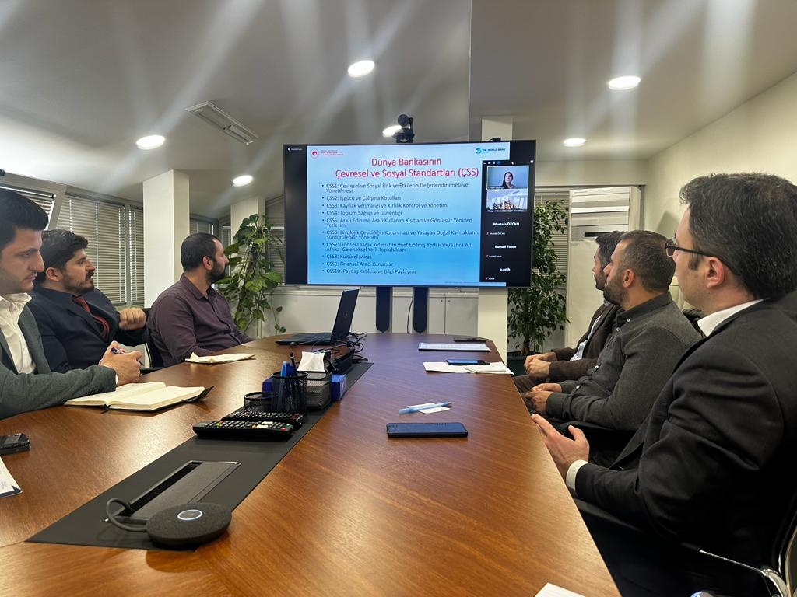
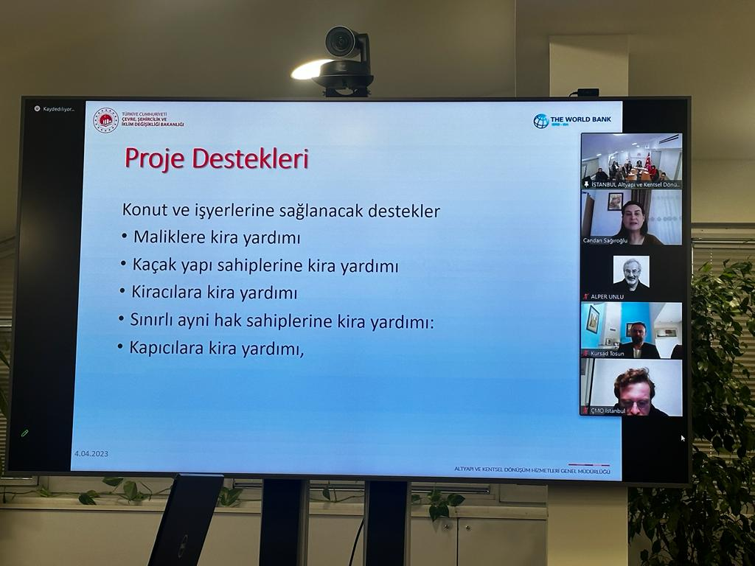
Participant list:
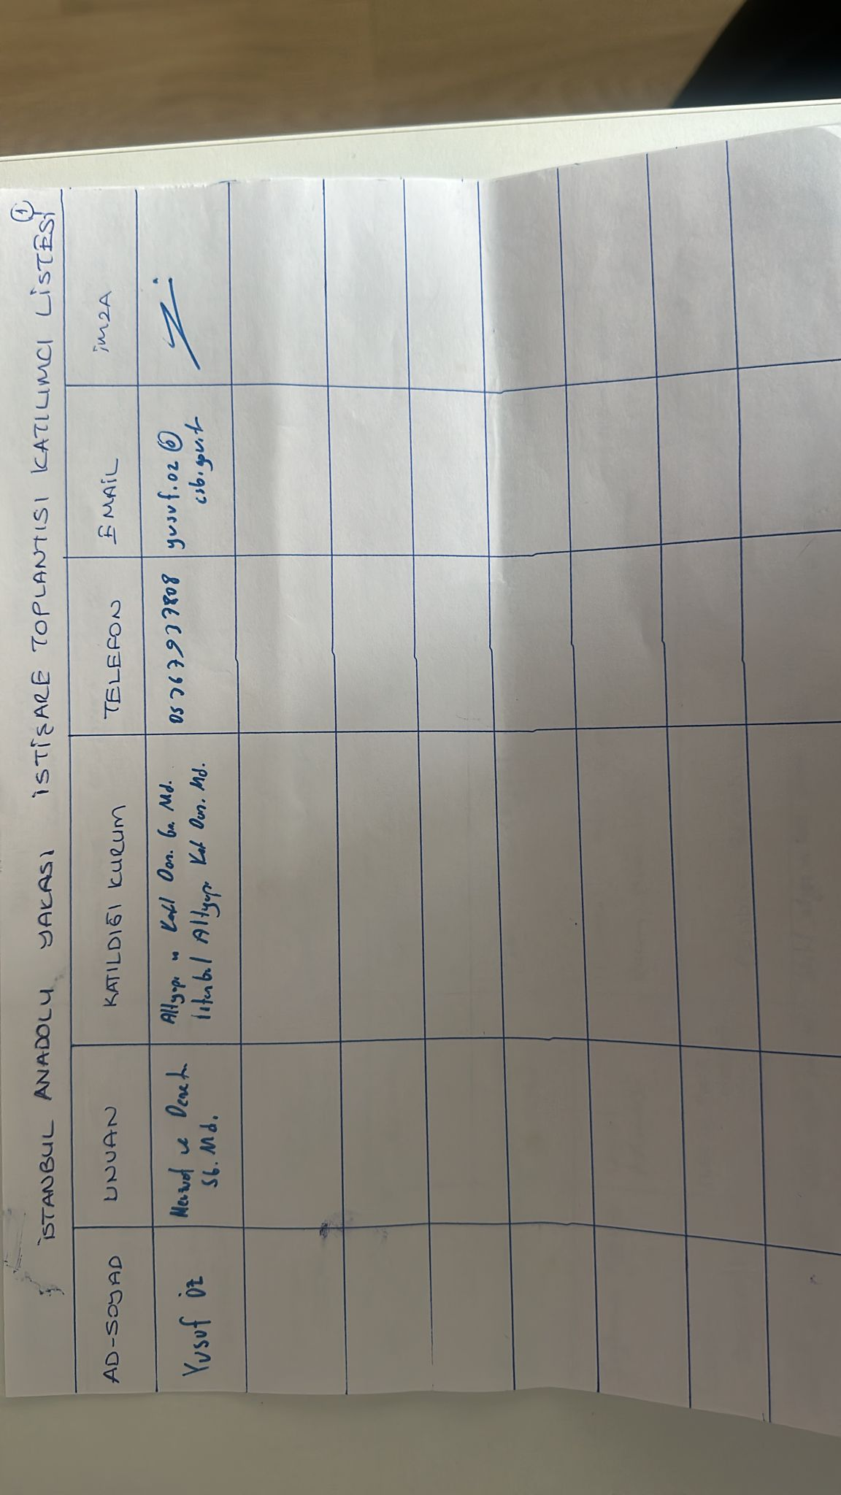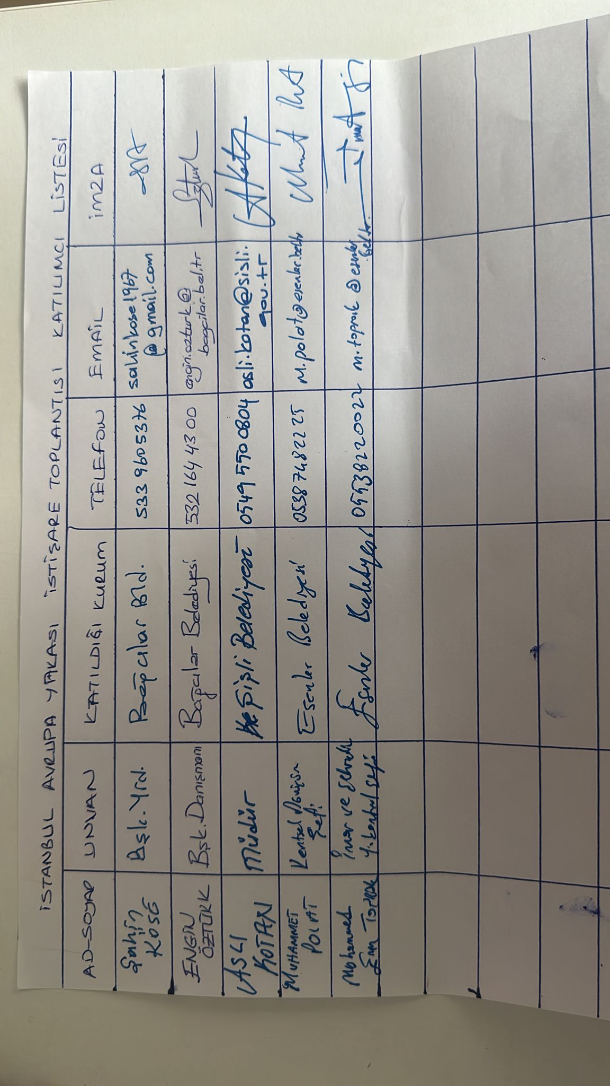
Signature
e-mail
Phone
Institution
Title
Name
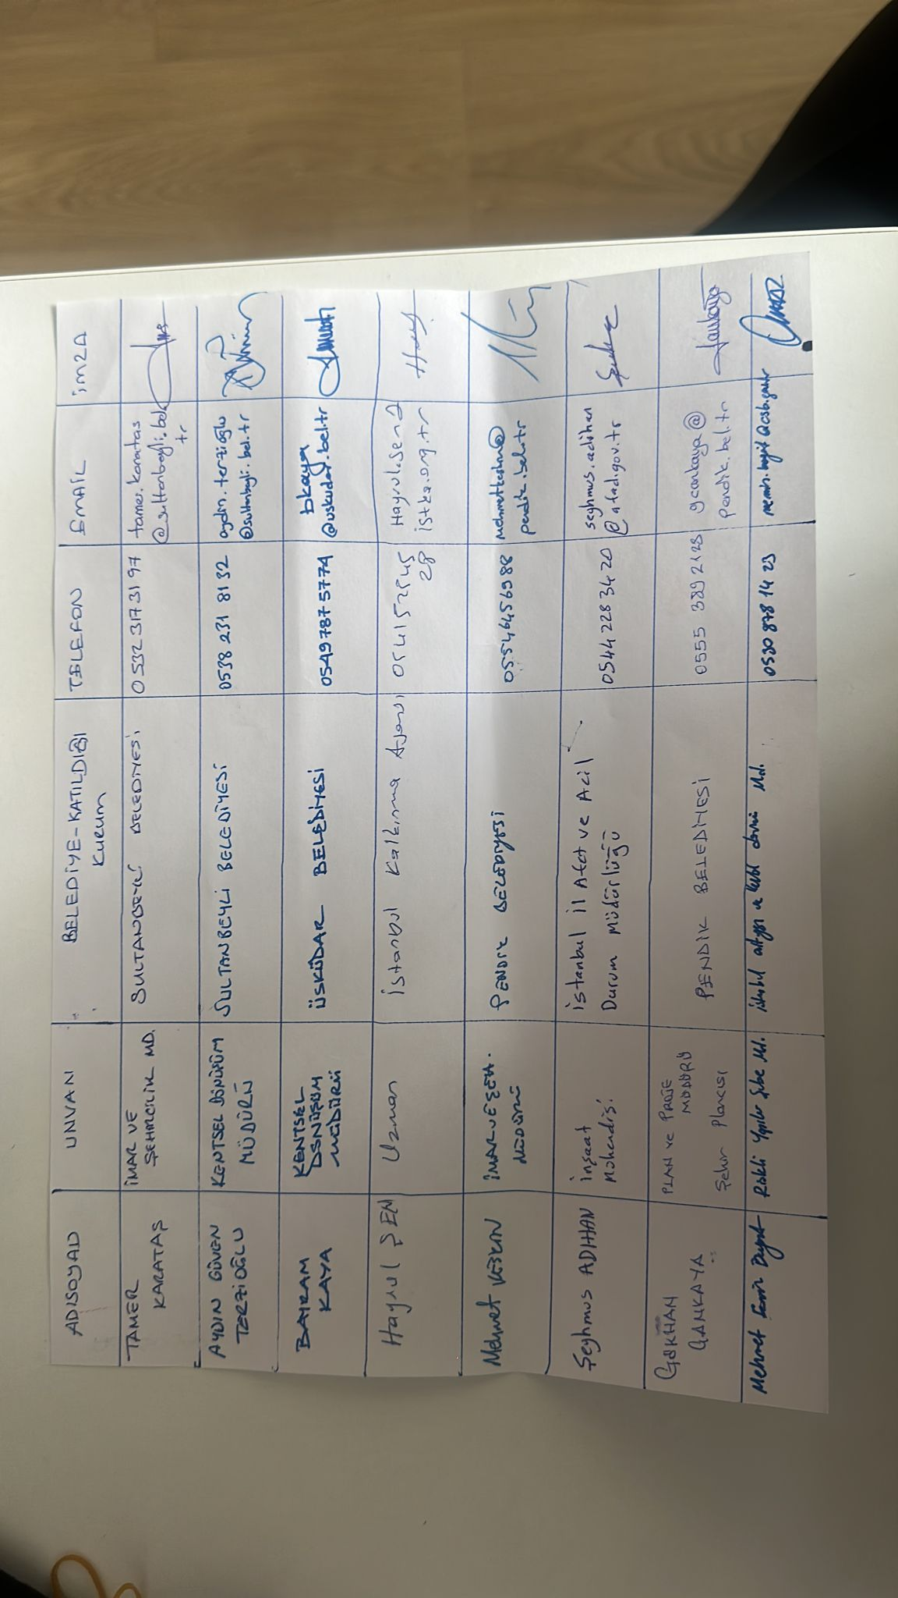
e-mail
Signature
Phone
Title
Name
Institution

Annex-7 Consultations of Final Drafts of Environmental and Social Documents (Izmir)
The consultation of the final drafts of the environmental and social documents in Izmir was held on April 10, 2023. 47 people from public institutions, mukhtars and non-governmental organizations attended the consultation meeting. The opinions conveyed at the meeting, the meeting photo and the list of participants are presented below, respectively.
Questions and Comments Submitted at the Meeting:
- Cooperatives also need to be involved in the Project.
- Regarding tax and duty exemptions, payments such as "floor servitude" that do not contain the phrase "duty" in its name are made to municipalities. Exemptions to be made for “duty” payments within the scope of the project should also include these payments.
- The definition of “female-headed households” in the definition of vulnerable group should be explained more clearly since there is no such definition in the legislation.
- Can building block-based application be made without being in the definition of a risky area?
- Will parking be made compulsory in the buildings?
- Precautions should be taken against noise during the demolition of buildings.
- What kind of work will municipalities do on waste management?
- Newly constructed buildings should be constructed in accordance with urban aesthetics.
- Will there be renewable energy use in newly constructed buildings?
Responses to Submitted Questions and Comments:
- Within the scope of the project, the construction of more than 10 buildings in the same region will not be allowed. For this reason, if there are more than 10 buildings in a building-block based works, they will not be able to benefit from the loan given by the Project.
- Parking lots regulations will be complied with in buildings that have been identified as risky structures, demolished and reconstructed.
- Municipalities are obliged to fulfill their duties and responsibilities in the Waste Regulation.
- Renewable energy will be used in newly constructed buildings. Moreover, in addition to the loan interest to be given within the scope of the project, an extra discount will be applied according to the energy class of the building.
Meeting Photo:
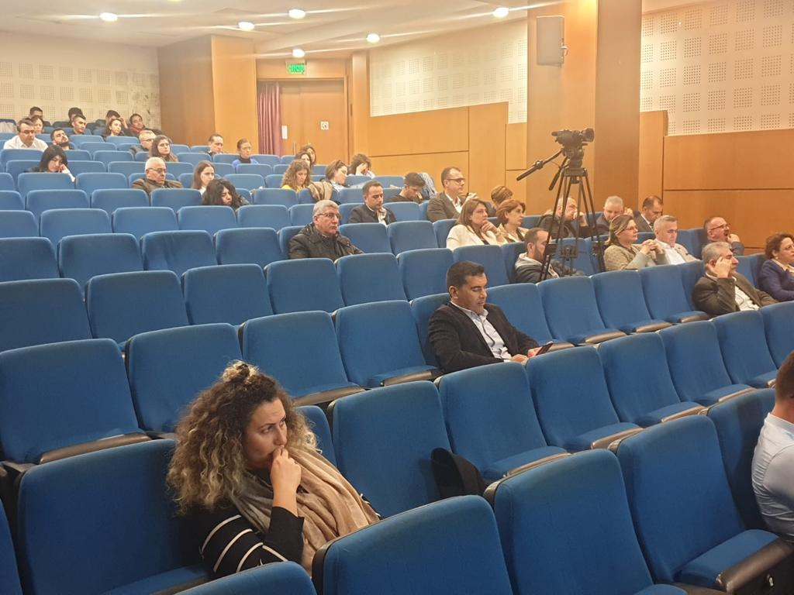

Participant List:
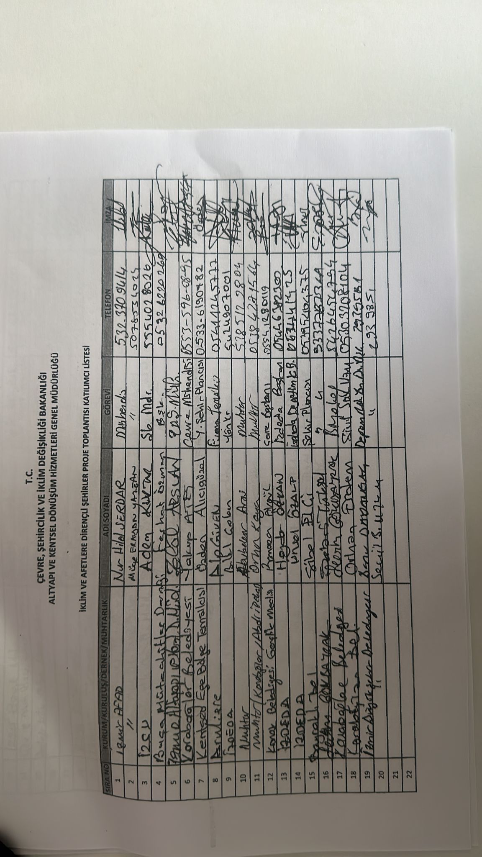
Signature
Telephone
Title
Name
Institution
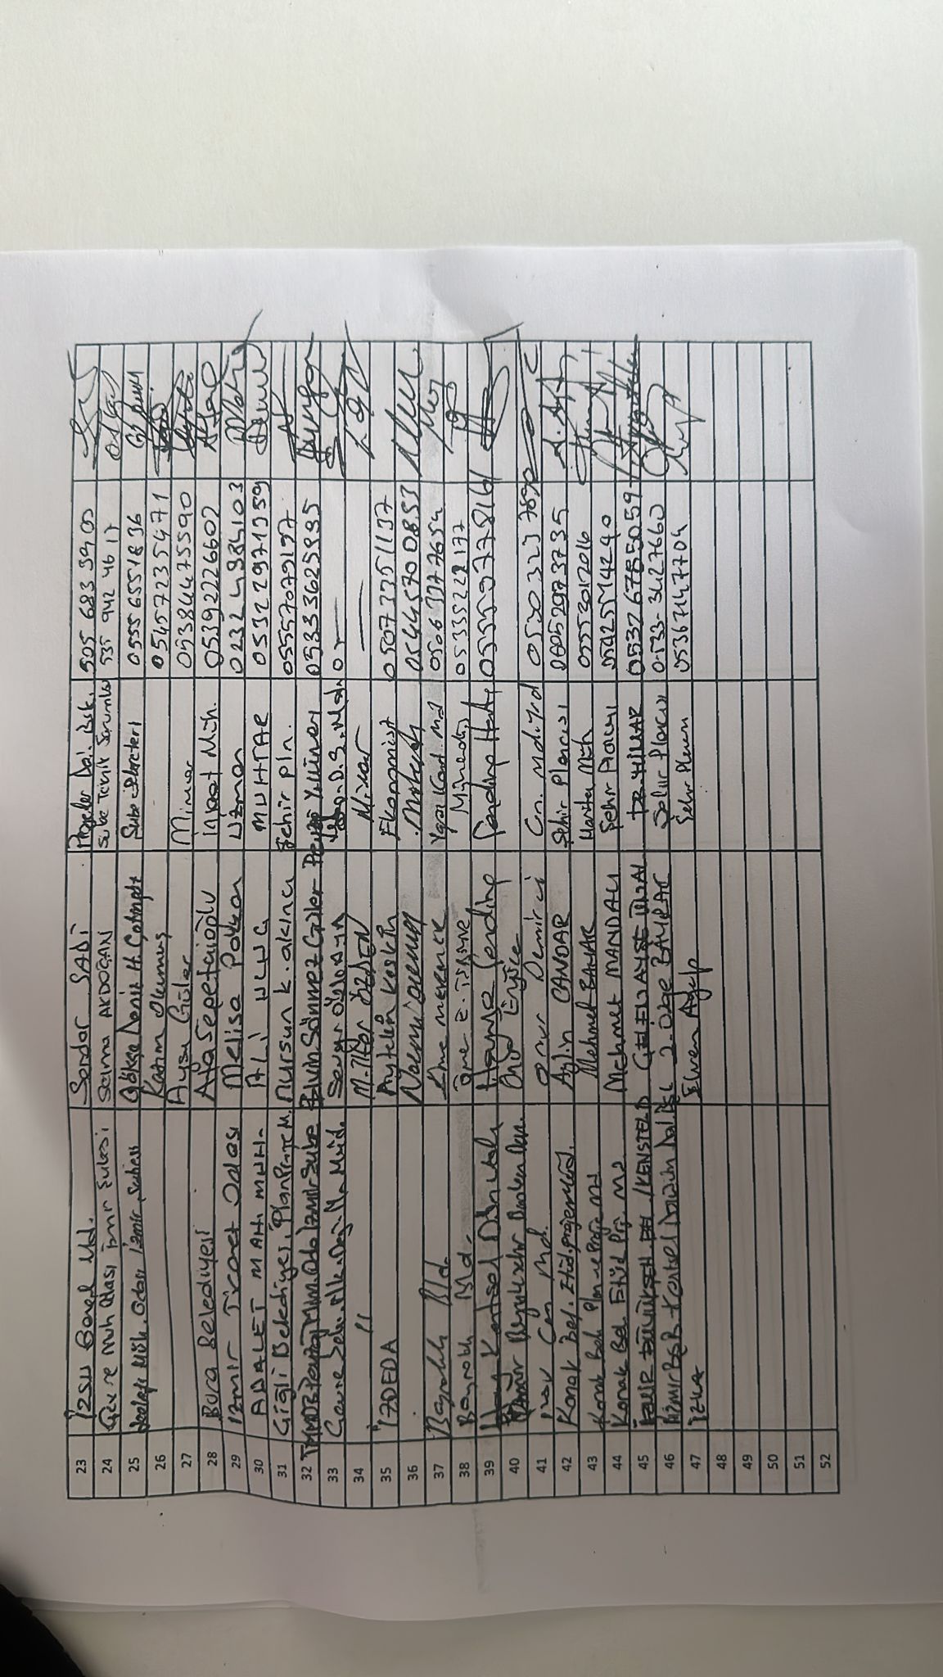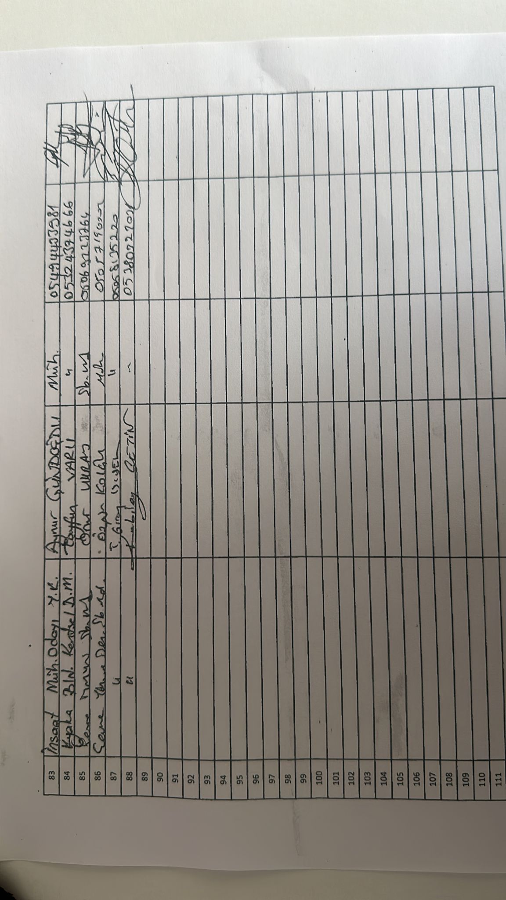

Annex-8 Consultations of Final Drafts of Environmental and Social Documents (Manisa)
The consultation of the final drafts of the environmental and social documents in Manisa was held on April 11, 2023. 54 people from public institutions, mukhtars and non-governmental organizations attended the consultation meeting. The opinions conveyed at the meeting, the meeting photo and the list of participants are presented below, respectively.
Questions and Comments Submitted at the Meeting:
- Cooperatives also need to be involved in the Project.
- Regarding tax and duty exemptions, payments such as "floor servitude" that do not contain the phrase "duty" in its name are made to municipalities. Exemptions to be made for “duty” payments within the scope of the project should also include these payments.
- The definition of “female-headed households” in the definition of vulnerable group should be explained more clearly since there is no such definition in the legislation.
- Can building block-based application be made without being in the definition of a risky area?
- Will parking be made compulsory in the buildings?
- Precautions should be taken against noise during the demolition of buildings.
- What kind of work will municipalities do on waste management?
- Newly constructed buildings should be constructed in accordance with urban aesthetics.
- Will there be renewable energy use in newly constructed buildings?
- There are fault lines that were not identified in the past but have been identified today. There should be no building construction on or near these fault lines. In that case, will the Project allow the building to be reconstructed elsewhere?
Responses to Submitted Questions and Comments:
- Within the scope of the project, the construction of more than 10 buildings in the same region will not be allowed. For this reason, if there are more than 10 buildings in a building-block based works, they will not be able to benefit from the loan given by the Project.
- Parking lots regulations will be complied with in buildings that have been identified as risky structures, demolished and reconstructed.
- Municipalities are obliged to fulfill their duties and responsibilities in the Waste Regulation.
- Renewable energy will be used in newly constructed buildings. Moreover, in addition to the loan interest to be given within the scope of the project, an extra discount will be applied according to the energy class of the building.
- This project will only support the buildings that will be built on the site of the demolished building. In this context, Project loan will not be utilized in the construction of buildings that will be constructed in a location other than the location of the demolished building for any reason.
Meeting Photo:
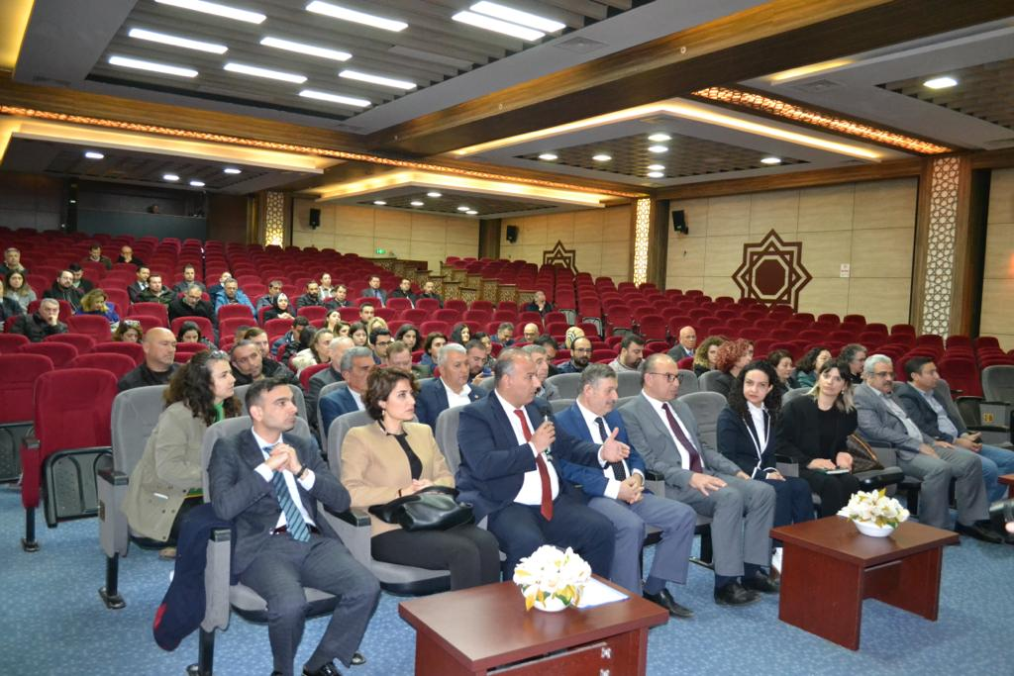
Participant List:
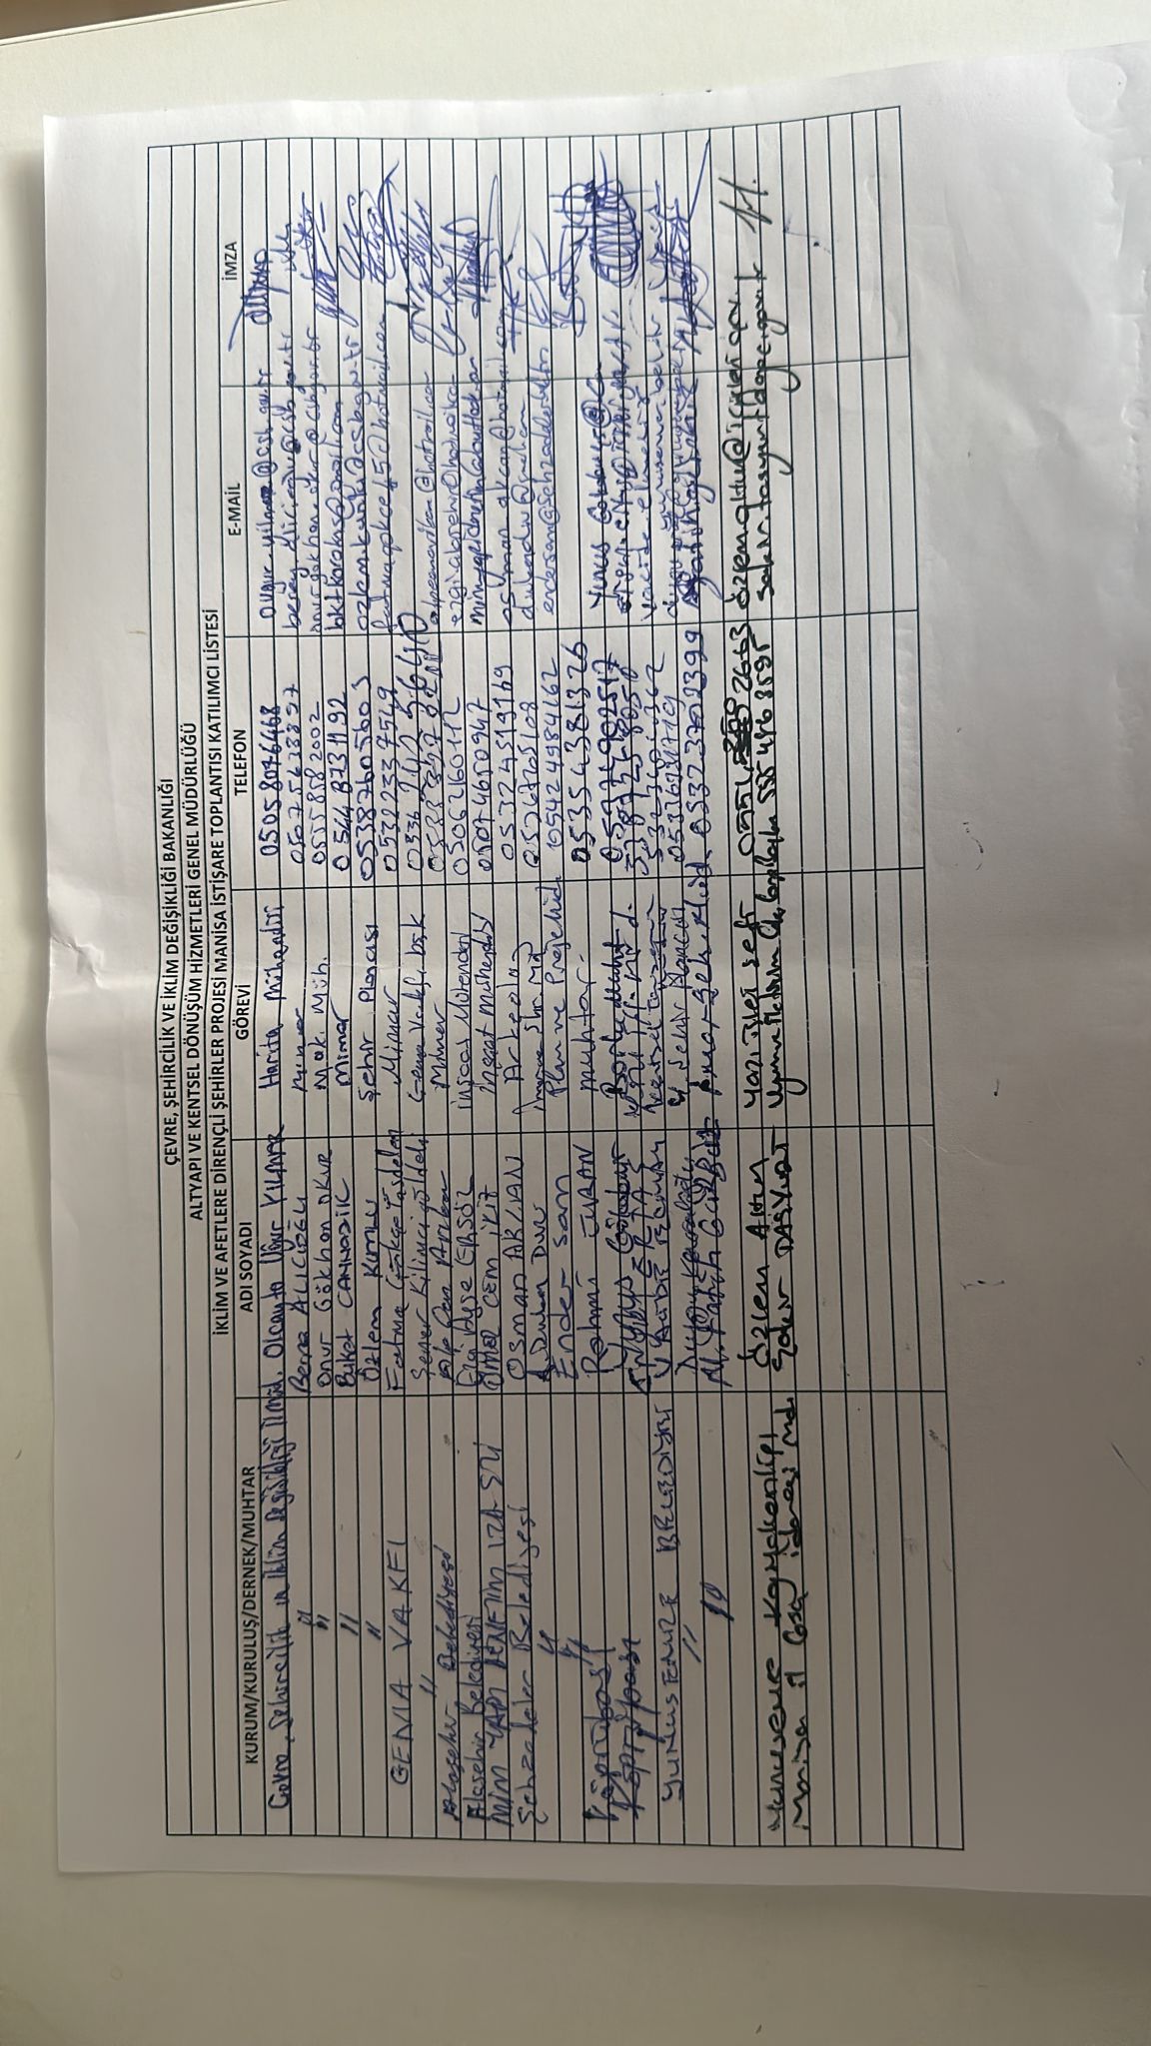
e-mail
Telephone
Title
Name
Institution
Signature
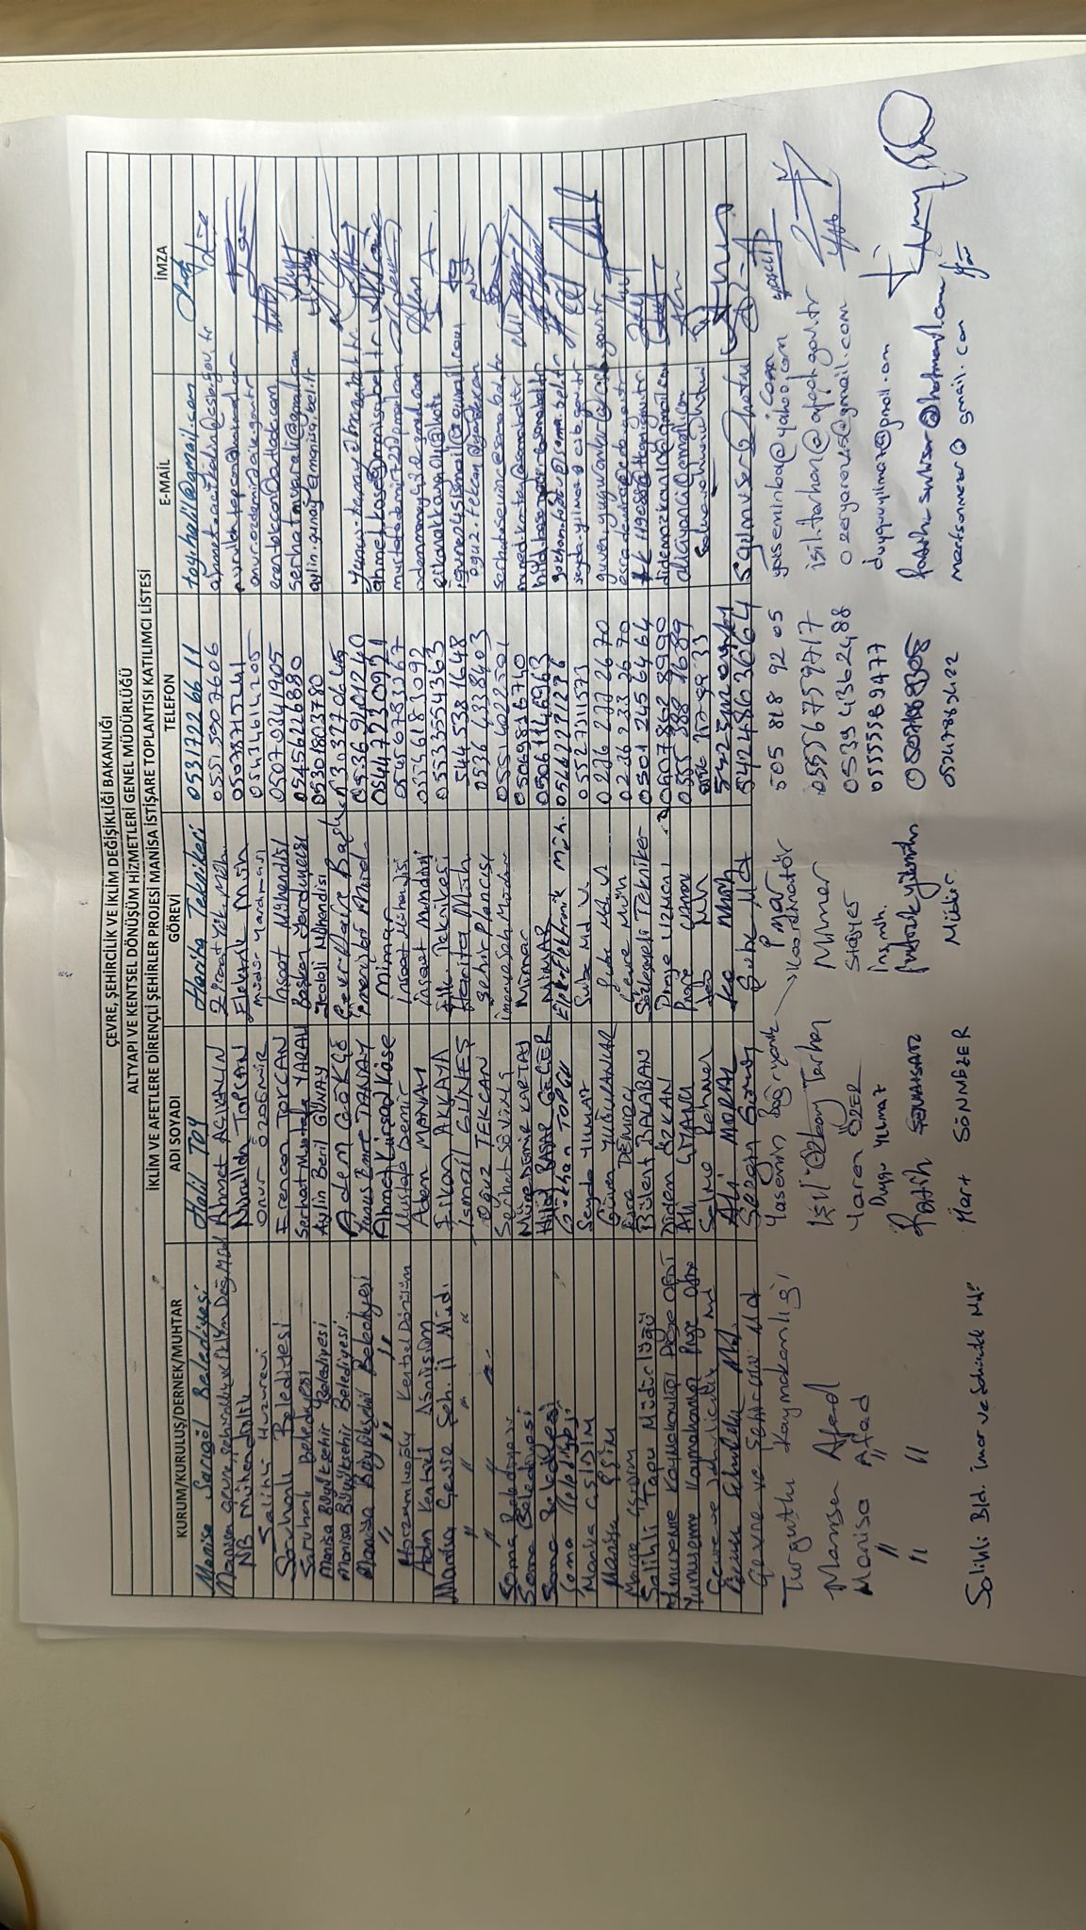
Signature
e-mail
Telephone
Title
Name
Institution

Annex-9 Consultations of Final Drafts of Environmental and Social Documents (Tekirdag)
The consultation of the final drafts of the environmental and social documents in Tekirdağ was held on April 5, 2023, at the Yahya Kemal Beyatlı Cultural Center. 165 people from public institutions, mukhtars and non-governmental organizations attended the consultation meeting. The opinions conveyed at the meeting, the meeting photo and the list of participants are presented below, respectively.
Questions and Comments Submitted at the Meeting:
- Currently, housing finance products are provided with interest rates starting from 0.69% per month in first-hand houses for middle-income citizens. The loan to be given within the scope of the project should have more favorable conditions than this. In addition, studies should be carried out to ensure that people who cannot get approval for existing loans can also get approval for loans to be offered within the scope of this project.
- Although the most important elements of their buildings are damaged, there are people who are trying to prevent the building from being demolished. Therefore, it will not be easy to convince some citizens, especially the elderly. Therefore, it is necessary to conduct public awareness. In addition, work should be done on requesting documents related to "risk" in the sales transactions of residences/workplaces.
- The MoEUCC should work to ensure that people living in protected areas do not become victims.
- Support for risky building owners should also be valid if these people come together and establish cooperatives.
- Prioritization should be made while implementing the Project, as some regions are more risky than other regions.
- Risky structure transformation should be done on “area basis” instead of “building basis”. Even though the citizens make their own building stronger, they are still in danger due to the risk of neighboring buildings. In addition, when a loan-enhanced or newly constructed building is damaged due to the partial or complete collapse of neighboring buildings, there should be insurance to fully cover this damage.
- If the location of the risky building is where the fault line passes or where there is a risk of construction due to other reasons, then the owners of these buildings will not be able to benefit from this Project. Therefore, the MoEUCC should produce other projects for those living in such areas.
- To rebuild on the ground where some risky buildings are located, a lot of money will have to be spent on the foundation. Constructions, where buildings can be built by spending less money will ensure more efficient use of the loan obtained from the World Bank. Therefore, the Project needs to support a broader application rather than just transformation on the basis “risky structure”.
- When urban transformation is done by the contractor, there is an increase in precedent. Some municipalities prefer site-based transformation more.
Responses to Submitted Questions and Comments:
- During the development phase of the project, detailed studies were carried out in the field with the experts of the World Bank. As a result of these studies, the scope of the Project has been determined as the transformation of risky structures, and the MoEUCC and Metropolitan Municipalities continue to work on areas determined as transformation and disaster areas on a field basis, with the Government’s own budget.
- Since every building which is determined as risky within the scope of Law No. 6306 is already “risky”, no prioritization will be made on the basis of these buildings or quota will not be applied on the basis of province/district. In order to benefit from the project, the order of application will be taken as a basis.
- The application conditions of the loan to be given within the scope of this project will be more suitable than the existing loans and the interest rate will be lower. In addition, this low interest rate is offered to certain groups with an additional discount, so that the Project can appeal to wider audiences.
Meeting Photo:
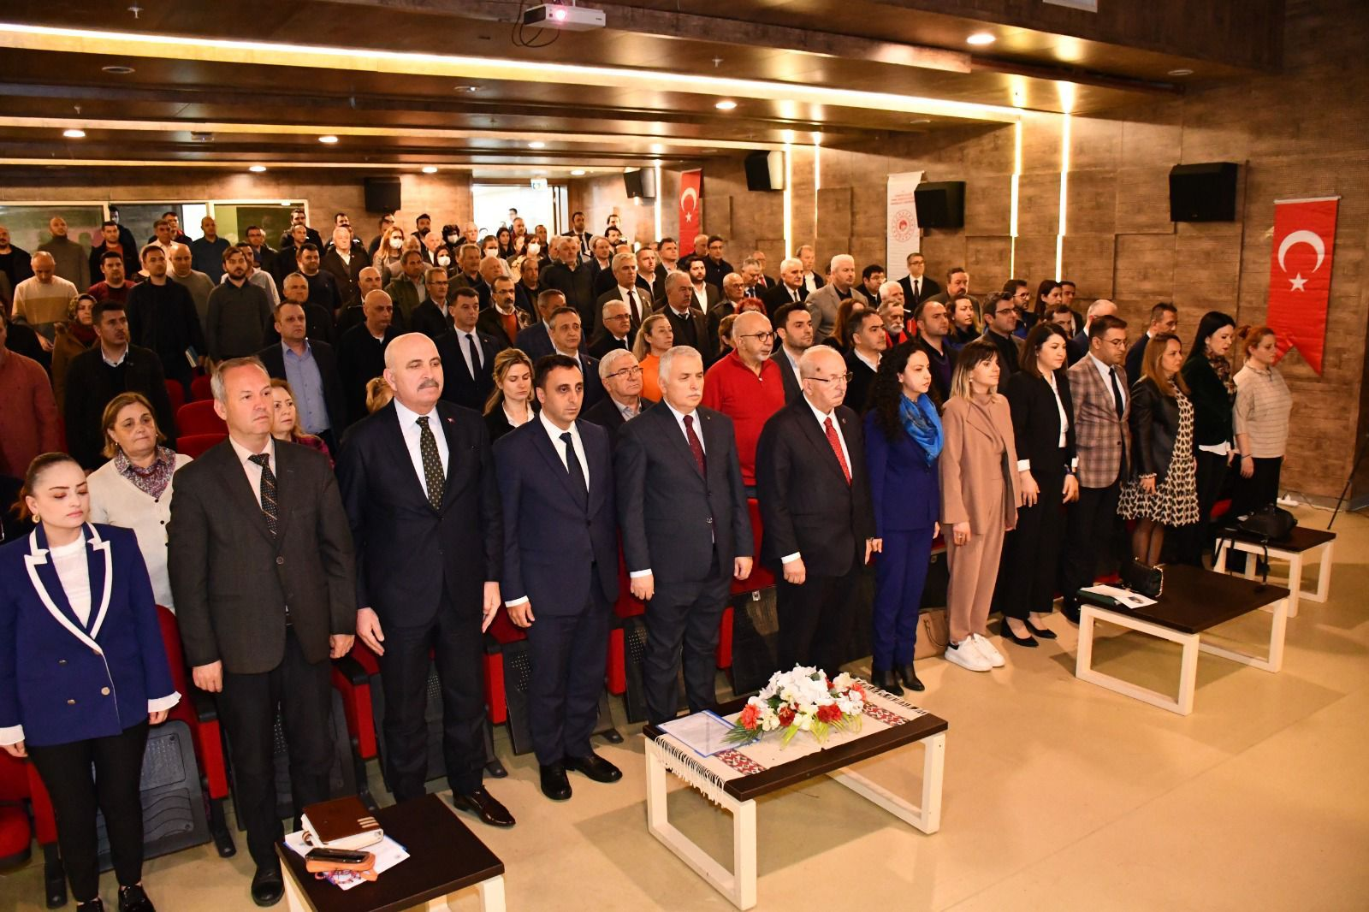
Participant List:
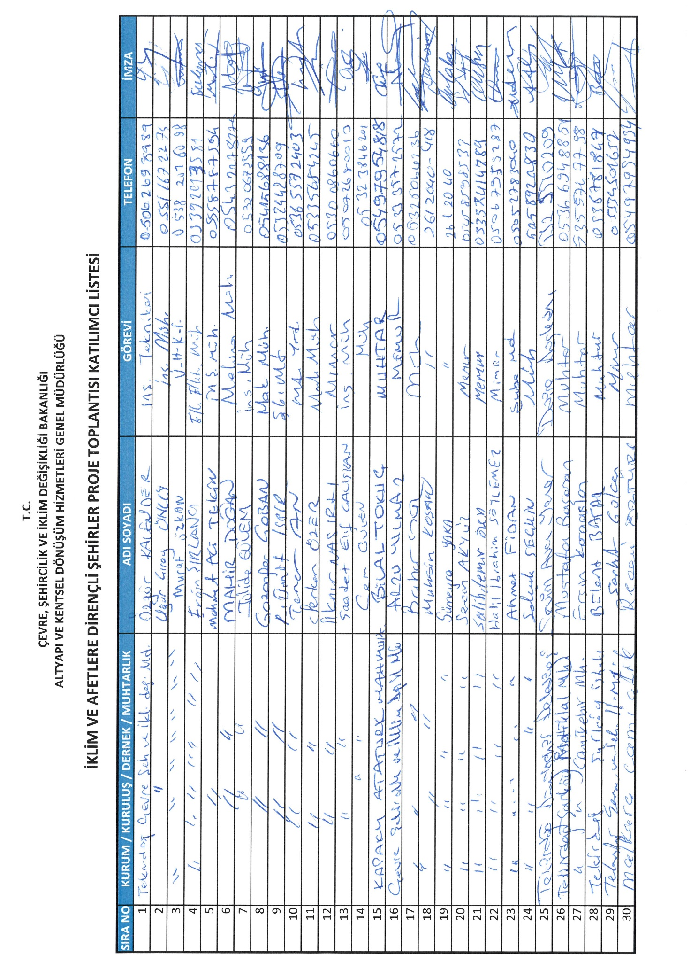
Institution
Name
Title
Telephone
Signature
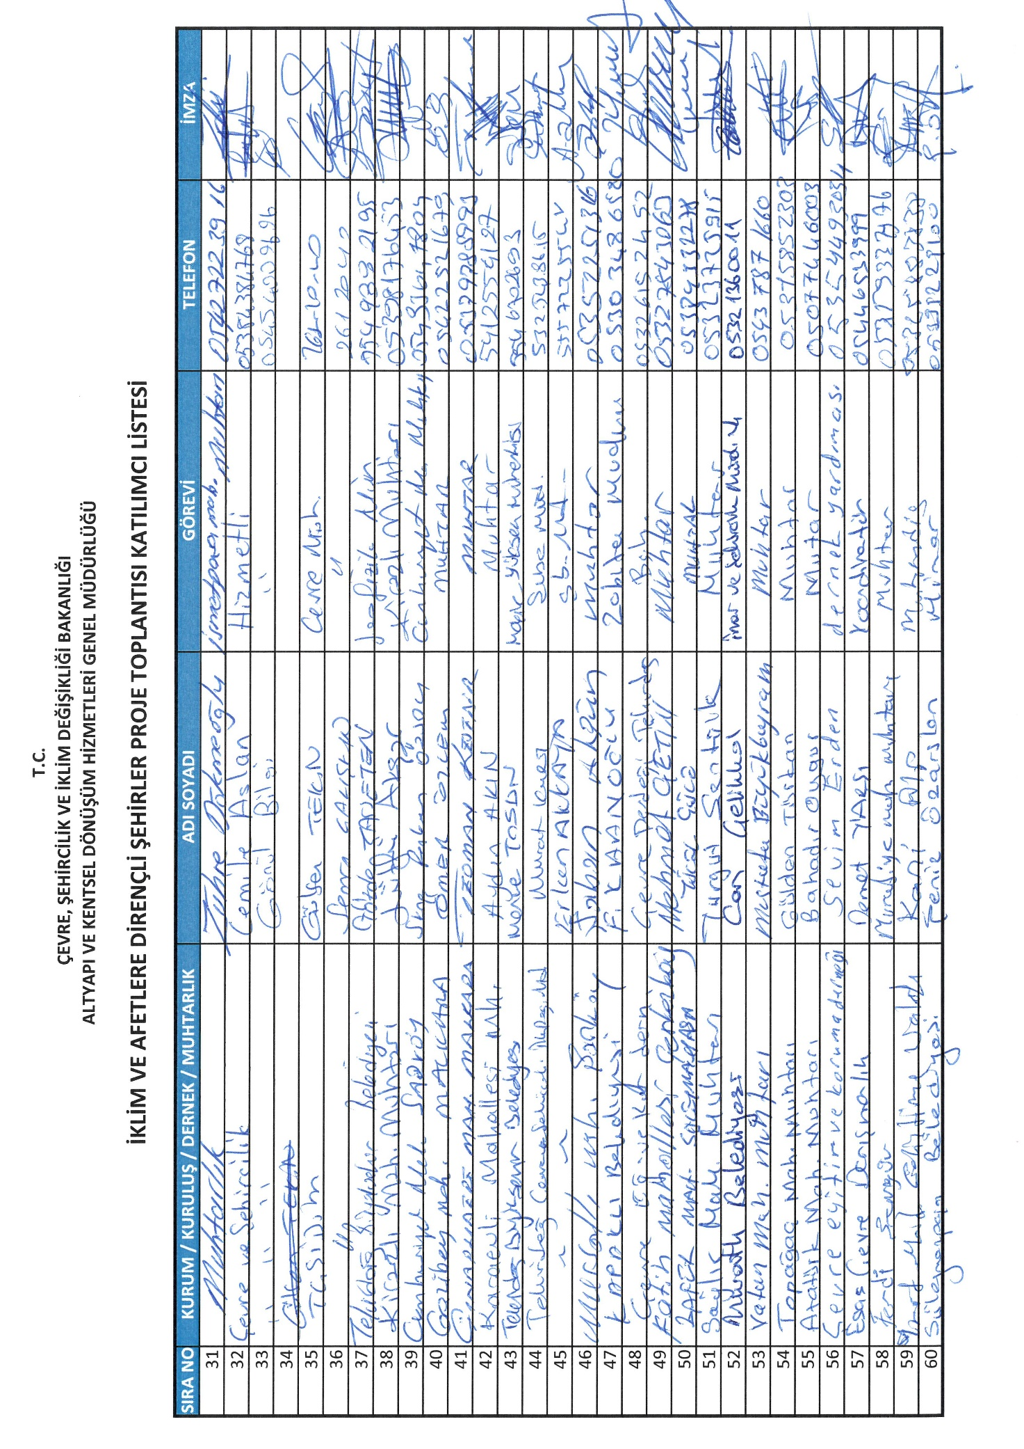
Institution
Name
Title
Telephone
Signature
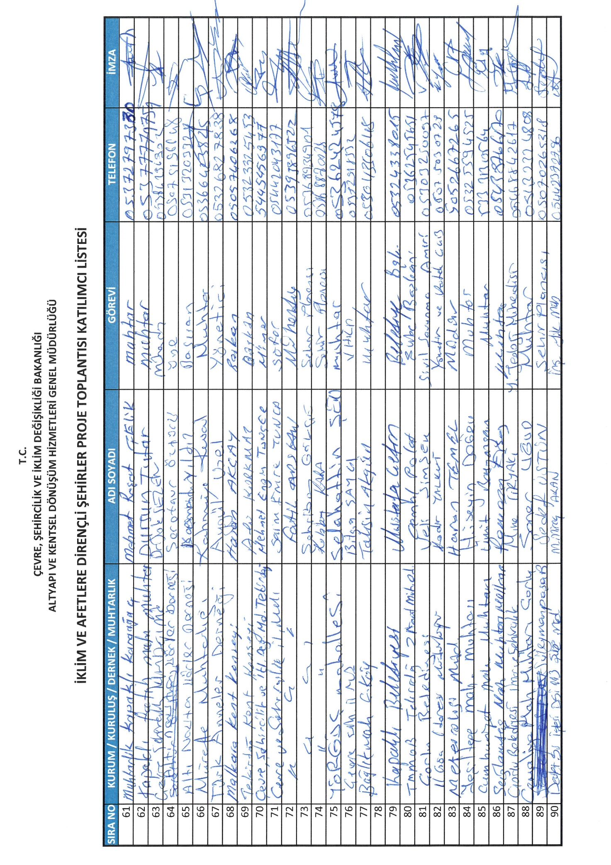
Institution
Name
Title
Telephone
Signature
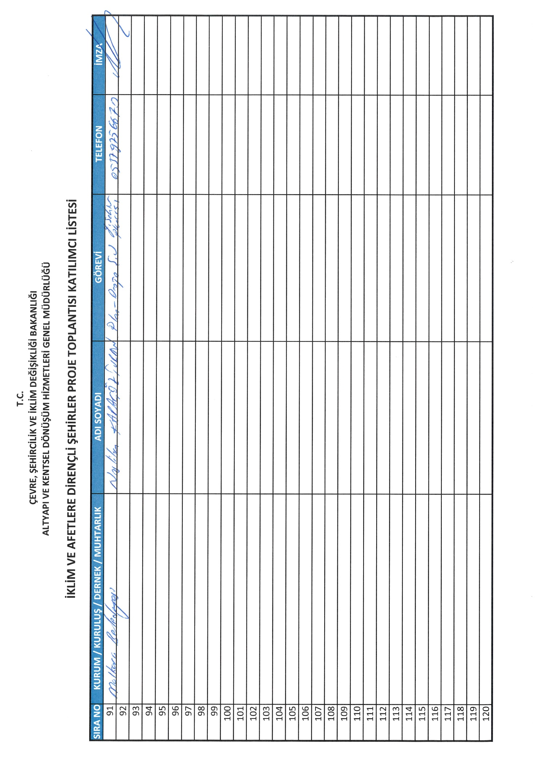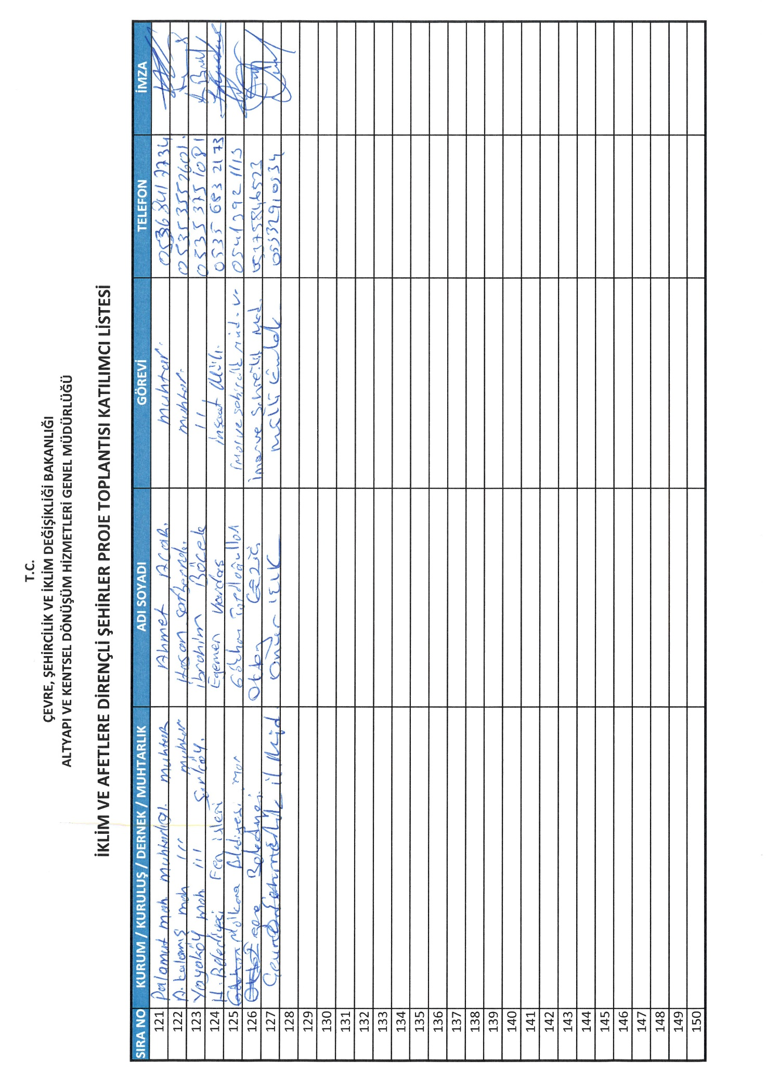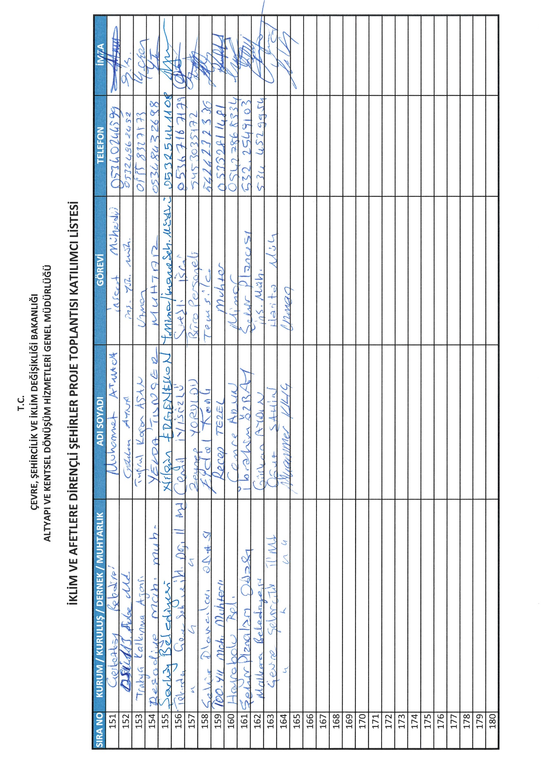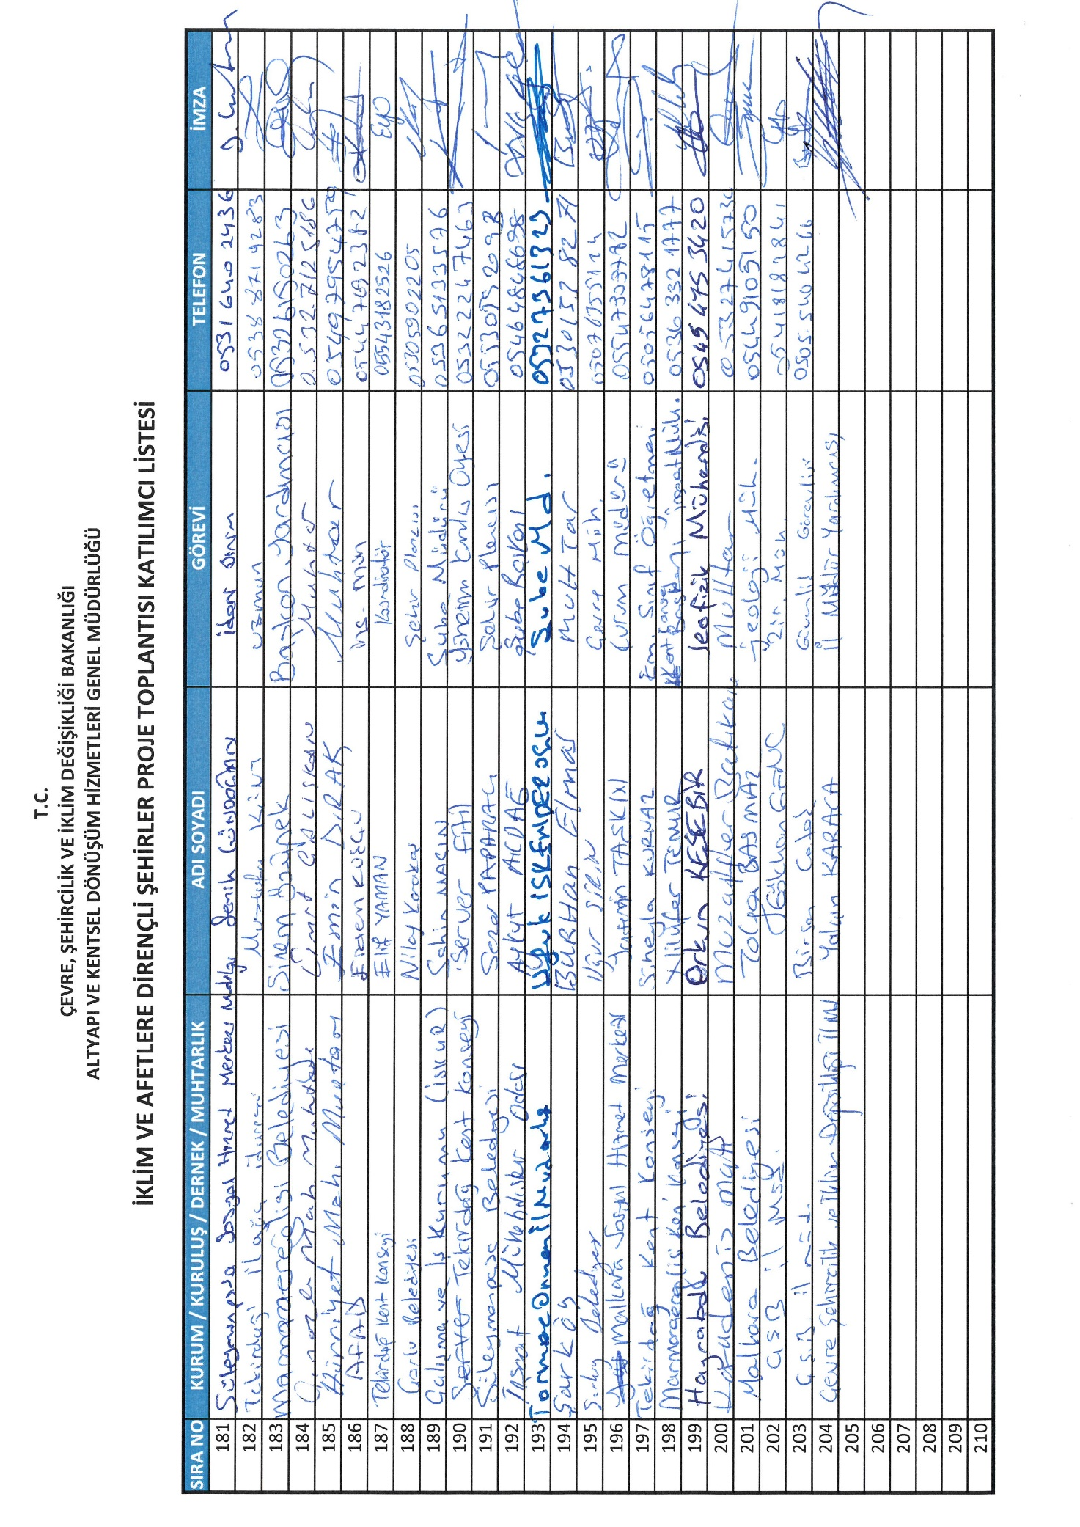
Institution
Name
Title
Telephone
Signature
Signature
Telephone
Title
Name
Institution

Annex-10. Grievance Register Form
İKLİM VE AFETLERE DİRENÇLİ ŞEHİRLER PROJESİ
/ CLIMATE AND DISASTER RESILIENT CITIES PROJECT
ŞİKAYET KAYIT FORMU / GRIEVANCE REGISTER FORM

Şikayetin Alındığı Yer/  Location of Complaints Received |  | Tarih/  Date
Alan Yetkilinin Adı/  Name of Person in Charge |  | Şikayet Kayıt No/  Complaint Register Number
Şikayete Konu Alanın Koordinatları/
Coordinates of The Area Subject To Complaint
ŞİKAYET SAHİBİ HAKKINDA BİLGİ / COMPLAINANT INFO
Şikayet Sahibi kimlik bilgilerini vermeden anonim olarak doldurabilir, ancak kendisine geri dönüş şeklini bu formda belirtmesi gerekmektedir. / The Complainant may submit application anonymously, however in this form the Complainant should indicate the feedback mechanism to respond.
Ad Soyad/  Name Surname |  | Şikayetin Geliş Yolu /  Form of Complaint:
TC Kimlik No/  Identification Number |  | Telefon- Ücretsiz hat /  Phone –Free phone line
Telefon/ E-Posta  Telephone/ E-mail |  | İstişare Toplantısı/  Consultation meeting
Mahalle-Köy-İlçe-İl/  Neighborhood-Village –District - Province |  | Dilekçe / Petition
ŞİKAYET DETAYLARI / DETAILS OF COMPLAINT
Şikayet Konusu /
Complaint

Şikayet sahibi tarafından talep edilen çözüm /
Solution requested by the Complainant

Şikayeti Alan Yetkilinin Ad Soyad ve İmzası / Şikayet Sahibinin Ad Soyad ve İmzası / Name Surname and Signature of the Registerer Name Surname and Signature of Complainant

Annex-11. Grievance Closure Form

İKLİM VE AFETLERE DİRENÇLİ ŞEHİRLER PROJESİ/ CLIMATE AND DISASTER RESILIENT CITIES PROJECT
ŞİKAYET KAPATMA FORMU / GRIEVANCE CLOSURE FORM

Şikayet Kapatma Numarası:
Grievance Closure No:
Alınması Gereken Acil Önlemleri Tanımlayın:
Identify the urgent actions
Alınması Gereken Uzun Vadeli Önlemleri Tanımlayın (Gerekli ise):
Identify the long term actions (if necessary)
Tazminat Talebi Bulunuyor Mu?  Is there a claim for compensation? | Evet/Yes Hayır/No
DÜZELTICI FAALIYETIN KONTROLÜ VE KARARI / CONTROL AND DECISION OF CORRECTIVE ACTION
Düzeltici Faaliyetin Aşamaları  Stages of Corrective Action | Verilen Sürenin Sona Erdiği Tarih Ve Yetkili Kuruluşlar  Date of Expiration of the Given Period and Authorized Institutions
1.
2.
3.
4.
5.
6.
7.
8.
9.
10.

Resilient under this Project will refer to a building complying with the structural requirements provided under the Earthquake Regulation that has been updated and entered into force on January 1, 2019.
Commercial banks (public and private) will be selected by the MoEUCC based on expressions of interest and according to criteria acceptable to the WB outlined in the Project Operations Manual (POM), including adequate financial standing, and compliance with the prudential norms of the Banking Regulatory and Supervision Agency.
In cases where owners rent out their risky housing units, tenants would be eligible for the rental subsidy to relocate during building retrofitting or reconstruction.
This will be mostly housing but may include a small number of commercial units in mixed-use buildings.
As per the Law No. 6306, urban transformation of risky residential buildings is a voluntary process initiated with risk detection assessments of individual buildings at the request of homeowners, except for cases where buildings are deemed at risk of imminent collapse. Any owner of a single-family home or of a unit in a multi-family building can request a building risk assessment, which is conducted by a licensed evaluator and includes opportunities for objection. The assessment results may recommend either retrofitting or reconstruction. Once a building is officially designated as risky in the property register, agreement of at least 2/3 of the homeowners on the reconstruction is required by law; those owners who choose not to participate may be bought out by the other owners or sell their property at market rates. After this process is complete, owners may apply for a loan under the Project. Technical support will be provided for homeowners to apply for loans and manage contracts with developers under Component 1.
Seismic resistance, as defined under this Project, refers to a building complying with the structural requirements per the 2019 Building Earthquake Regulation.
City-wide risk assessments were completed for Kahramanmaras, Tekirdag, and Manisa as part of the technical assistance provided by the WB. Some seismic risk assessment and risk reduction planning studies are also available for Izmir and Istanbul.
The area of all five provinces was obtained from https://www.harita.gov.tr/il-ve-ilce-yuzolcumleri
The population of all five provinces was obtained from TurkStat, Address Based Population Registration System, 2021
Per capita GDP figures were obtained from TurkStat, Gross Domestic Product by Provinces, 2020
Istanbul Governorship Provincial Directorate of Disaster and Emergency, Istanbul Provincial Disaster Risk Reduction Plan. https://istanbul.afad.gov.tr/kurumlar/istanbul.afad/PDF-Dosyalar/irap_istanbul.pdf
Izmir Governorship Provincial Directorate of Disaster and Emergency, Izmir Provincial Disaster Risk Reduction Plan. https://izmir.afad.gov.tr/kurumlar/izmir.afad/E-KUTUPHANE/Il-Planlari/Izmir-IRAP.pdf
Based on figures from the United States Geological Survey
Bogazici University Kandilli Observatory and Earthquake Research Institute estimate magnitudes as 7.7 and 7.6.
Up until March 15, 2023, https://tdvms.afad.gov.tr/event_spec_data
Adapted from Global Rapid Post-Disaster Damage Estimation (GRADE) Report “February 6, 2023, Kahramanmaraş Earthquakes, Türkiye Report”, GFDRR, WB. February 20, 2023, and updated with the Press Bulletin No.36 of AFAD on March 3, 2023. https://www.afad.gov.tr/kahramanmarasta-meydana-gelen-depremler-hk-36
Manisa Governorship Provincial Directorate of Disaster and Emergency, Manisa Provincial Disaster Risk Reduction Plan. https://manisa.afad.gov.tr/kurumlar/manisa.afad/Haberler/2021/IRAP/MANISA-IRAP.pdf
Tekirdag Governorship Provincial Directorate of Disaster and Emergency, Tekirdag Provincial Disaster Risk Reduction Plan. https://tekirdag.afad.gov.tr/kurumlar/tekirdag.afad/Kutuphane/TEKIRDAG_IRAP_.pdf
Through a pre-prepared standard stakeholder engagement and grievance mechanism information form for the province level, which includes a contact phone number, e-mail address and contact address.
Standard brief memo containing the project content and purpose
Through a pre-prepared standard stakeholder engagement and grievance mechanism information form for the province level, which includes a contact phone number, e-mail address and contact address.
Standard brief memo containing the project content and purpose

