EEAcademy November 2019
​ |   EEAcademy NEWS  Up-to-date EEAcademy events & activities  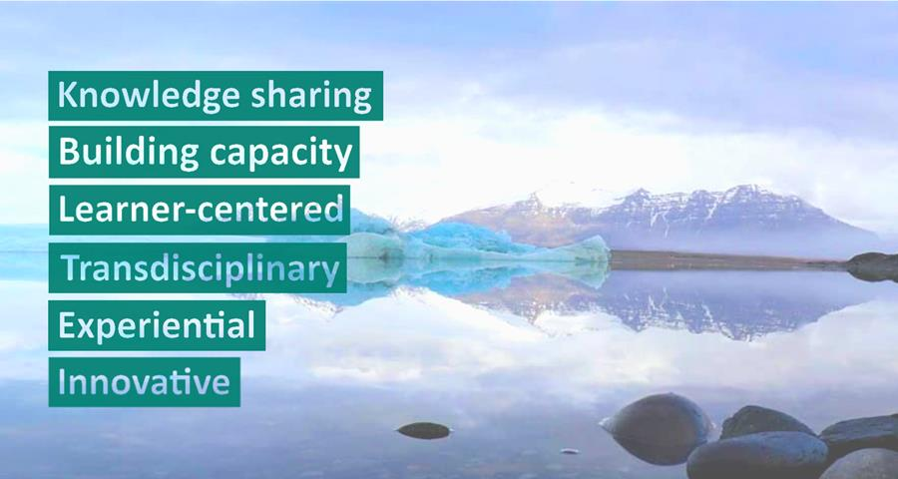 |  |  | ​

​ | New e-learning course  We have the pleasure to announce our very first EEAcademy e-learning course on Integrated Environmental Assessments, published for the time being on the platform EU Learn only. It will soon be available publicly.  The e-learning format is part of the EEAcademy’s continuous effort to experiment with new learning approaches enabling knowledge innovation, this time accessible from the comfort of your couch.  The course provides participants with an introduction to framing and design as well as the key tools and methods of Integrated Environmental Assessment.  Learn more here |  | ​

​ |  | Open Call: Expert Pool  Are you an expert in areas such as sustainability transitions or environmental policies? Then we encourage you to become part of our Expert Pool.  Being a hub for knowledge development on systemic challenges, sustainability transitions and integrated assessments, we are always looking for experts who can support the EEAcademy.  Please click below for more details on available roles and do not hesitate to contact us should you have any questions.  Apply here | ​

​ | EEAcademy ENI Summer School  This years ENI Summer School on Integrated Environmental Assessments took place in Copenhagen at the end of August. It was very well received, with 80 % of participants rating their overall satisfaction as excellent.  Participants particularly emphasized how they gained competences in systemic thinking, knowledge on how to incorporate SDGs in Integrated Sustainability Assessments and a more holistic view of assessments and sustainability.  We would like to thank all participants for their valuable feedback. |  | ​

​ |  | EEAcademy Alumni Network  We would like to invite you to join the EEAcademy Alumni Network on LinkedIn, which offers a unique opportunity to maintain and grow the exceptional network established during EEAcademy events. It was created for all who have been involved or participated in EEAcademy activities and who wish to stay informed about the project.  You can join by filling in the application form, and subsequently joining our LinkedIn group. We look forward to welcoming you there. | ​

​ | The European environment - state and outlook 2020  The EEA's flagship report and most comprehensive assessment to date: The European environment - state and outlook 2020 (SOER 2020), will be launched on the 4th December 2019, so keep an eye on the EEA's website and EEAcademy Alumni Group.  In particular, the report addresses the systemic character of today’s environmental challenges, as well as provides insights into how Europe can respond to today’s unprecedented environment, climate and sustainability challenges. |  | ​

​ | 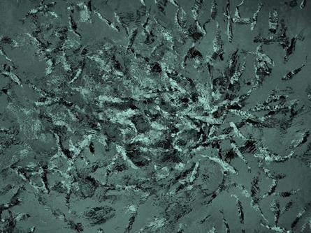 | Short reading: Knowledge for a sustainable XXI century  This background paper draws on the SOER 2020 assessment of Europe's current sustainability challenges and identifies specific knowledge needs and innovations required to address them.  Read more here | ​

​ | Further readings |  | ​
​ | Longer read  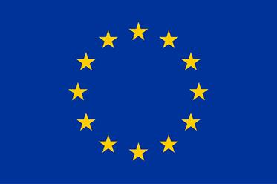  European Commission -  Von der Leyen's Agenda for Europe  Ursula von der Leyen, the candidate for President of the European Commission has published the political guidelines for the EC 2019 - 2024.  With priorities such as the European Green Deal and a focus on the implementation of SDGs, the guidelines below will be informative for anyone interested in sustainability transitions in the European context.  Read more about the guidelines | Longer read    Sustainability transitions: policy and practice  This recently published EEA report focuses on the practical implications of transitions research for policy and practice.  As such it is highly relevant for EEAcademy Alumni looking to expand their knowledge on the operationalization of transitions thinking in Europe.  Read more about the report | ​

Read more about EEAcademy at www.eea.europa.eu/eeacademy.
You can contact us at EEacademy@eea.europa.eu

Bültende yer alan haberlerin detayları için aşağıdaki linklerden erişim sağlayabilirsiniz:
- https://www.eea.europa.eu/about-us/tenders/call-for-expression-of-interest-1?utm_medium=email&utm_campaign=EEAcademy%20News%20-%20Issue%202%20November%202019&utm_content=EEAcademy%20News%20-%20Issue%202%20November%202019+Preview+CID_12a0fc0bce6edc1853f81e552267a347&utm_source=EEA%20Newsletter&utm_term=Apply%20here

- https://www.eea.europa.eu/about-us/who/eeacademy/knowledge-for-a-sustainable-xxi-century/view?utm_medium=email&utm_campaign=EEAcademy%20News%20-%20Issue%202%20November%202019&utm_content=EEAcademy%20News%20-%20Issue%202%20November%202019+Preview+CID_12a0fc0bce6edc1853f81e552267a347&utm_source=EEA%20Newsletter&utm_term=Read%20more%20here

- https://ec.europa.eu/commission/sites/beta-political/files/political-guidelines-next-commission_en.pdf

- https://www.eea.europa.eu/publications/sustainability-transitions-policy-and-practice?utm_medium=email&utm_campaign=EEAcademy%20News%20-%20Issue%202%20November%202019&utm_content=EEAcademy%20News%20-%20Issue%202%20November%202019+Preview+CID_12a0fc0bce6edc1853f81e552267a347&utm_source=EEA%20Newsletter&utm_term=Read%20more%20about%20the%20report

