Curriculum vitae
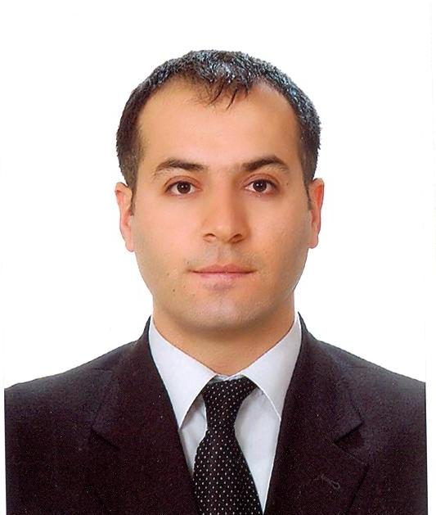
1. Family name: ECER
2. First names: Mehrali
3. Date of birth: 23 February 1976 /Niğde-Turkey
4. Nationality: Turkish
5. Civil status: Married
6. Telephone: 0312 474 03 49/54
7. Contact: mehrali.ecer@csb.gov.tr
8. Education:
Institution  (Date from-Date to) | Degree(s) or Diploma(s) obtained:
Dokuz Eylül University, İzmir/Turkey (1993-1997) | B.Sc. in Environmental Engineering
Survey in the field, İzmir/Turkey (1995-1996) | Summer Practice
ÇEVSUTEK Construction Limited Company, İzmir/Turkey (1996-1997) | Summer Practice
Dokuz Eylül University, İzmir/Turkey (1997-1998) | English Course, Foreign Language Schools

9. Language skills: (1 - excellent; 5 - basic)
Language | Reading | Speaking | Writing
Turkish | Native Language
English | 1 | 1 | 1

10. Computer Skills: MS Office Programs (Word, Excel, PowerPoint, etc.)
11. Present position: General Director of European Union and Foreign Relations General Directorate and Head of Operating Structure
12. Years within the firm: Since 2000

13. Key skills:
- Communication of environmental issues to other disciplines
- Working effectively within teams of international experts
- Excellent interpersonal and team work skills
- Willing to learn new subject and apply them
- Ability to finalize the issues on time

14. Specific experience in the region:
Country | Date from – Date to
Turkey | 2000– Present

15. Professional experience:
 | Date from-Date to |  | Location | Position |  | Description
June 2019 – |  | Ankara, Turkey |  | General Director  &  Head of Operating Structure | Ministry of Environment and Urbanization, General Directorate of EU and Foreign Relations
January 2019 – June 2019 |  | Ankara, Turkey |  | General Director  &  Head of Operating Structure | Ministry of Environment and Urbanization, General Directorate of EU and Foreign Relations
July 2018 – January 2019 |  | Ankara, Turkey |  | Head of Department  &  Head of Operating Structure | Ministry of Environment and Urbanization, Department of EU and Foreign Relations
2014-2018 |  | Ankara, Turkey |  | Head of Department | Ministry of Environment and Urbanization, General Directorate of Environmental Management, Department of Climate Change
2010-2014 |  | Ankara, Turkey |  | Unit Coordinator | Ministry of Environment and Urbanization, General Directorate of Environmental Management, Department of Climate Change, Unit of Greenhouse Gases Monitoring and Emission Trade
2006-2010 |  | Ankara, Turkey |  | Environmental Engineer | Ministry of Environment and Forestry, General Directorate of Environmental Management
July 2004 – November 2005 |  | Kars, Turkey |  | Environmental Monitor | Botaş Petroleum Pipeline Corporation “Bakü-Tbilisi-Ceyhan Crude Oil Pipeline Project Directorate”
September 2001 – May 2004 |  | Eskişehir, Turkey |  | Environmental Engineer | Gedikoğlu Construction Limited Company
May 2000 – June 2001 |  | Kayseri, Turkey |  | Planning Engineer | Mimataş Textile Industry Corporation

16. Other relevant information:
16.1. Main Activities and Responsibilities:
- EU Funded Projects
- Infrastructure and Capacity Building Projects
- Grant Management Projects
- Climate Change and Global Warming
- UNFCCC, Kyoto Protocol
- Emission Trading Mechanism
- GHG Emission Inventory, MRV
- National Communications of Climate Change, Biennial Reports of Climate Change
- International Climate Change Negotiations
- National Policies and Strategies of Climate Change
- Construction Activities (Topsoil stripping, welding, coating, trenching, lowering, backfilling, hydrostatic testing, reinstatement and bio-restoration)
- Waste Management Activities
- Responsibilities for monitoring and reported of construction activities and waste management in accordance with the requirements of ISO 14001 (Environmental Management System), EIA (Environmental Impact Assessment Report).
- Participating in internal interface meetings at construction site as required
- Ensuring that all environmental non-compliance situations are documented and reported
- Water and wastewater treatment systems, water and wastewater chemicals, water and wastewater analysis equipment etc.
- Responsibilities for Project ,design , construction , montage , maintenance and consultant duties
- Report to data of production , stock control and productivity

16.2. Certificates and Courses:
- Training program of "Capacity Building for Kyoto Protocol Flexibility Mechanisms" organized by JICA in Japan
- International Meetings held within the United Nations Climate Change Framework Agreement since 2007
- Performance Management System Training and Certificated. Ernst & Young, 2005
- Environmental Compliance Training. BOTAŞ “BTC” , 2004
- Social Policy and General Community Relations Awareness Training, BOTAŞ “BTC” , 2004
- Waste Management and Spill Prevention and Control Training, BOTAŞ “BTC”, 2004
- Reinstatement and Bio-restoration Training, BOTAŞ “BTC”, 2004
- Health and Safety Leadership Course, BOTAŞ “BTC”, 2004
- Health and Safety Awareness Training (Personal Protective Equipment, Risk Management, Emergency Response, Safety Observation Reporting etc.) BOTAŞ “BTC”, 2004
- Defensive, Off-Road and Anti-Skid Driving Training and certificated, BOTAŞ “BTC”, 2004

